Assignment 1 - Module 3 - Docker Containarization

1. Git clone:

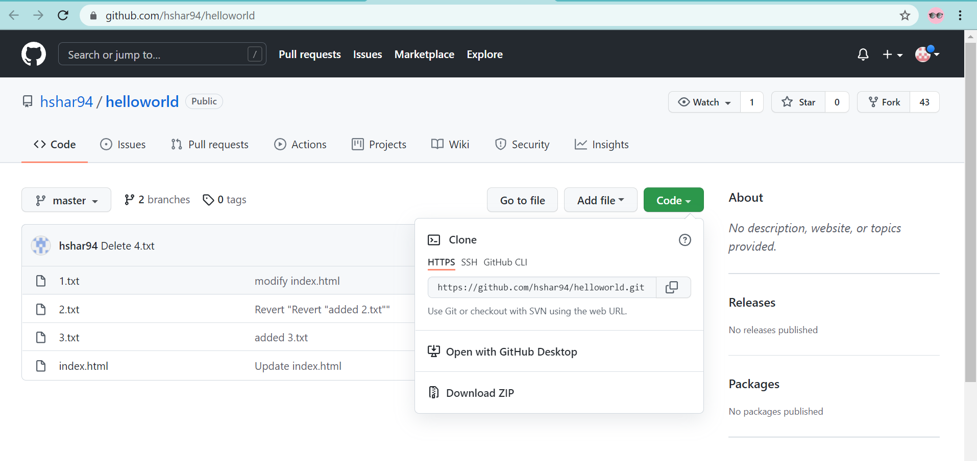

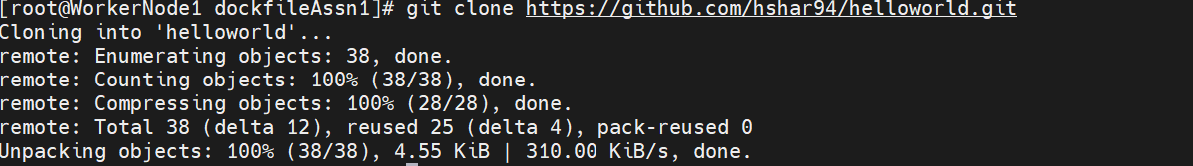

1. Extract index.html from git cloned folder

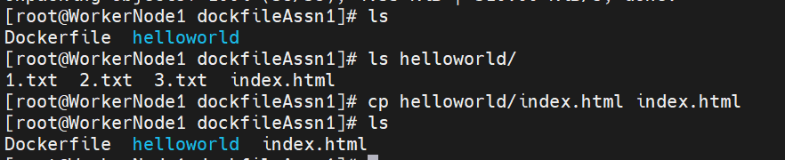

1. Docker file

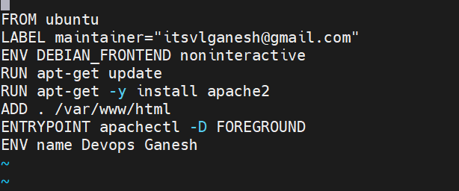

Build:

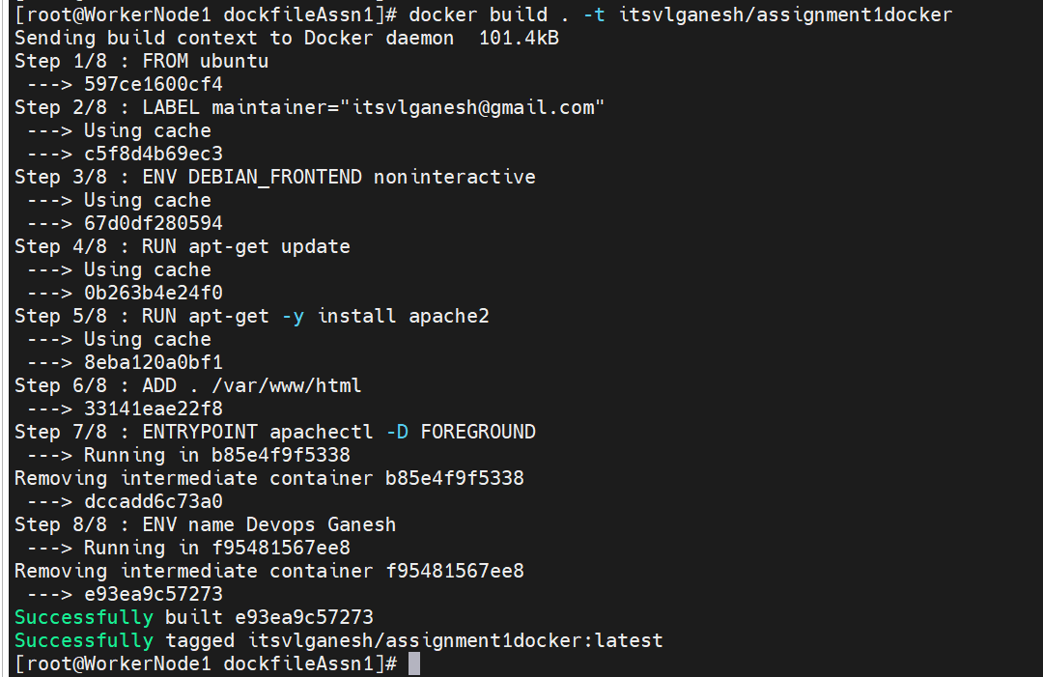

Run container & test:

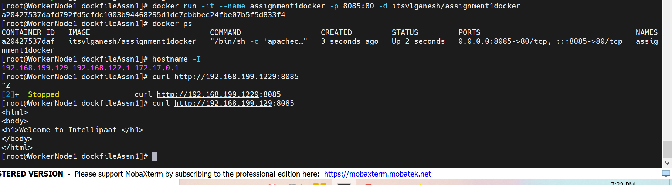

1. Push to docker hub

