ADDITIONAL CREDITS COMPLETION REPORT

SUBMITTED

IN PARTIAL FULFILLMENT FOR THE AWARD OF THE

DEGREE

OF

BACHELOR OF SCIENCE

IN

INFORMATION TECHNOLOGY

SEMESTER VI

2023 – 2024

SUBMITTED BY

RAJ RAGHUNATH MOGARE

ROLL NO:239665

PIN NUMBER:3736495

ABC ID: 806171773968

MULUND COLLEGE OF COMMERCE (AUTONOMOUS)

S.N. ROAD, MULUND (WEST), MUMBAI – 400080

2023 – 24

TABLE OF CONTENTS

|  |  |  |
| --- | --- | --- |
| Sr. No. | Title | Pg. No |
| 1 | Office Automation & Web Designing |  |
| 2 | Robotic Process Automation with UiPath |  |
| 3 | Python For Data Science |  |
| 4 | Communication Skills |  |
| 5 | DevOps Fundamentals |  |
| 6 | Cloud Computing |  |

**Report on Completion of Certificate Course**

**Year of the Study 2021-22 Semester __I**

**Course Details:**

**1. Course Title:** Office Automation & Web Designing

**2. Duration, Start and Completion Date:** 40 hours

**Course Objectives:**

* Introduction to web design principles and concepts.
* HTML fundamentals including tags, elements, and semantic markup.
* CSS basics for styling HTML elements, including selectors, properties, and layout techniques.
* Introduction to JavaScript for basic interactivity and DOM manipulation.
* Responsive web design principles for creating websites that adapt to various devices.

**Learning Outcomes:**

* Skills acquired: Proficiency in Microsoft Office Suite (Word, Excel, PowerPoint),Basic HTML coding, Basic CSS styling, Basic JavaScript for web interactivity.
* Application of Knowledge: The acquired skills in Microsoft Office Suite are immensely useful in various professional settings, allowing for efficient document creation.Knowledge of web designing basics allows for the creation of personal websites, portfolio sites, or small business web pages.

**Conclusion:**

The course provided a comprehensive understanding of web design principles and technologies. Practical projects and exercises helped reinforce theoretical concepts. The acquired skills are highly applicable in various IT roles and projects. Overall, the course has added significant value to my skill set and understanding of web development.

**Acknowledgments:**

The instructor provided an exceptional guidance and support throughout the course. He completely helped us in clearing the all the doubts that faced during the entire course.

**Attach Course Completion Certificate**

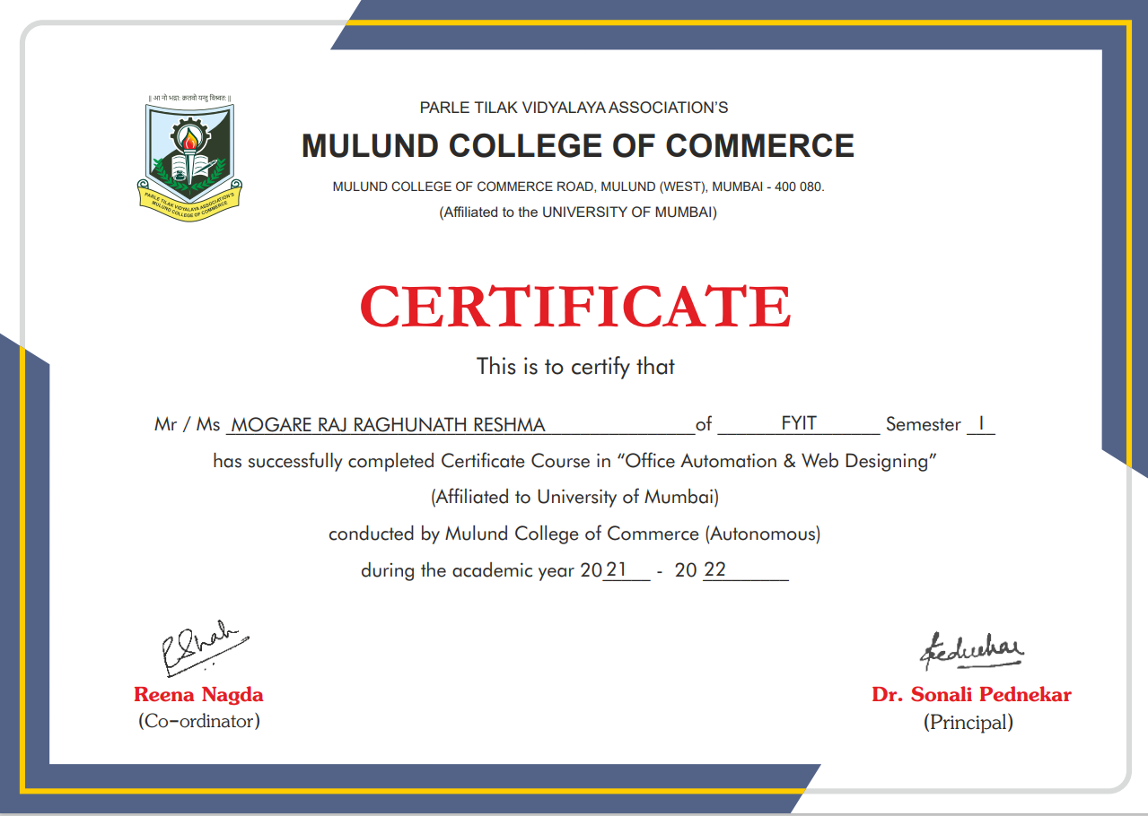

**Report on Completion of Certificate Course**

**Year of the Study 2021-22 Semester __II__**

**Course Details:**

**1. Course Title:** Robotic Process Automation with UiPath

**2. Duration, Start and Completion Date:** 40 hours

**Course Objectives:**

* Equipping students with practical skills in automation technology, which is increasingly in demand across industries for optimizing processes and improving efficiency.
* Providing a foundational understanding of RPA concepts and tools, which are relevant for developing solutions to automate repetitive tasks in IT projects.
* Fostering critical thinking and problem-solving abilities through designing and implementing automated workflows, which are transferable skills applicable to various IT roles.
* Enhancing students' understanding of integration techniques by integrating RPA solutions with existing IT systems.
* Cultivating an appreciation for the potential of automation technologies in driving digital transformation and innovation in organizations, which is essential knowledge for IT professionals.

**Learning Outcomes:**

* Skills acquired: Proficiency in using RPA tools i.e. UiPath, designing and implementing automated workflows,data manipulation and validation techniques ,error handling strategies in automation processes
* Application of Knowledge: The acquired skills in RPA have numerous practical applications in professional settings. For instance, proficiency in RPA tools enables individuals to automate repetitive tasks in various domains such as data entry, report generation, and data validation, leading to significant time and cost savings for organizations.

**Conclusion:**

Participating in the "RPA (Robotics Process Automation)" course was an enriching experience that provided valuable insights into automation technologies and their applications in modern businesses. The hands-on approach to learning, coupled with practical exercises and case studies, facilitated the application of acquired knowledge in real-world scenarios.

**Acknowledgments:**

I extend my gratitude to the instructor for their expertise and guidance throughout the "RPA (Robotics Process Automation)" course. Their dedication to providing comprehensive instruction and support during practical exercises significantly contributed to my understanding of automation technologies. Additionally, I am thankful to the online platform for facilitating seamless access to course materials, interactive sessions, and resources that enriched my learning experience.

**Attach Course Completion Certificate**

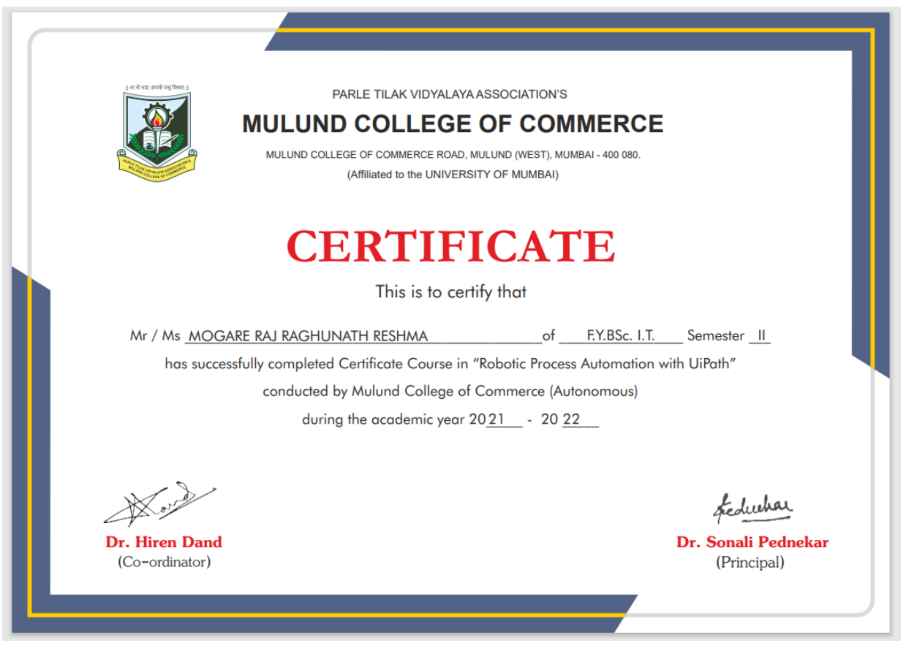

**Report on Completion of Certificate Course**

**Year of the Study 2022-23 Semester __III__**

**Course Details:**

**1. Course Title:** Python for Data Science

**2. Duration, Start and Completion Date:** 40 hours

**Course Objectives:**

* Equipping students with practical programming skills in Python, a versatile language widely used in data science and IT-related fields.
* Providing a foundational understanding of data analysis and manipulation techniques, which are essential for processing and interpreting large datasets in IT projects.
* Fostering critical thinking and problem-solving abilities through hands-on experience with data science libraries, enabling students to extract insights and make data-driven decisions.
* Enhancing students' understanding of machine learning concepts and techniques, which are increasingly important in IT roles involving predictive analytics and artificial intelligence.
* Cultivating an appreciation for the role of Python in driving innovation and solving complex problems in various industries, which is valuable knowledge for IT professionals.

**Learning Outcomes:**

* Skills acquired: Proficiency in Python programming language, data manipulation with Pandas, data visualization with Matplotlib and Seaborn, basic machine learning concepts with Scikit-learn.
* Application of Knowledge: The acquired skills in Python for data science have numerous practical applications in professional settings. For instance, proficiency in Python enables individuals to perform data analysis tasks such as cleaning, transforming, and visualizing datasets, which are crucial for gaining insights and making informed decisions. Moreover, knowledge of machine learning concepts allows for the development of predictive models and 6 data-driven solutions to solve business problems.

**Conclusion:**

Participating in the "Python for Data Science" course was an enriching experience that provided valuable skills and knowledge in Python programming and its applications in data science. The interactive learning environment, coupled with practical exercises and projects, facilitated the application of acquired knowledge in real-world scenarios.

**Acknowledgments:**

Participating in the "Python for Data Science" course was an enriching experience that provided valuable skills and knowledge in Python programming and its applications in data science. The interactive learning environment, coupled with practical exercises and projects, facilitated the application of acquired knowledge in real-world scenarios.

**Attach Course Completion Certificate**

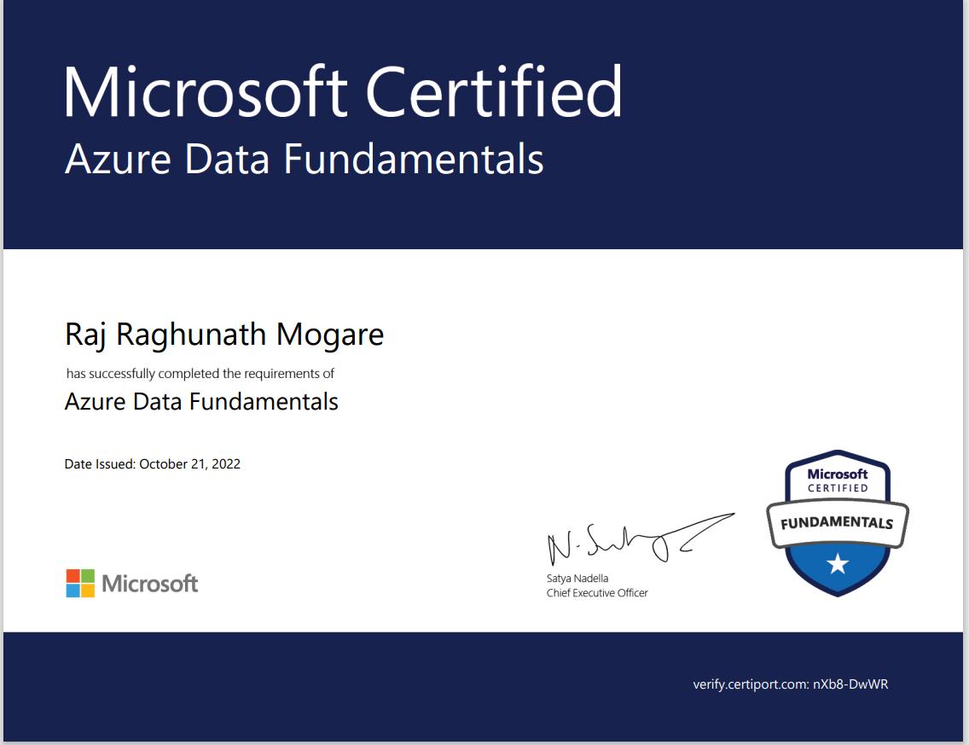

**Report on Completion of Certificate Course**

**Year of the Study 2021-22 Semester ___IV__**

**Course Details:**

**1. Course Title:** Communication Skills

**2. Duration, Start and Completion Date:** 40 hours

**Course Objectives:**

* Enhance Verbal Communication: Develop proficiency in expressing ideas clearly and effectively through spoken language.
* Improve Written Communication: Strengthen writing skills to convey messages accurately and persuasively in various formats.
* Develop Interpersonal Communication Skills: Cultivate the ability to interact effectively with others, including active listening and empathy.
* Master Nonverbal Communication: Learn to interpret and utilize body language, gestures, and facial expressions to enhance communication.
* Polish Presentation Skills: Acquire techniques for delivering engaging and impactful presentations, including public speaking and visual aids.

**Learning Outcomes:**

* Clear Expression: Participants will be able to articulate thoughts and ideas concisely and coherently in both verbal and written forms.
* Active Listening: Develop the skill of active listening, allowing for better comprehension and response during interpersonal interactions.

**Conclusion:**

In conclusion, the Communication Skills course has equipped participants with essential tools and techniques to excel in various communication scenarios. Through a combination of theoretical knowledge and practical exercises, participants have enhanced their ability to express themselves clearly, listen actively, and interact confidently with others. The course has empowered individuals to communicate effectively across different mediums and situations, laying a strong foundation for personal and professional success.

**Acknowledgments:**

I would like to express my heartfelt gratitude to [Instructor's Name] for their expert guidance and unwavering support throughout the Communication Skills course. Special thanks to my peers for their active participation and insightful contributions, making the learning experience truly enriching. I also extend my appreciation to [Name of Institution or Organization] for providing the platform for this transformative journey. This course has equipped me with invaluable skills that will undoubtedly shape my personal and professional communication for years to come. Thank you to everyone involved in making this course a success.

**Attach Course Completion Certificate**

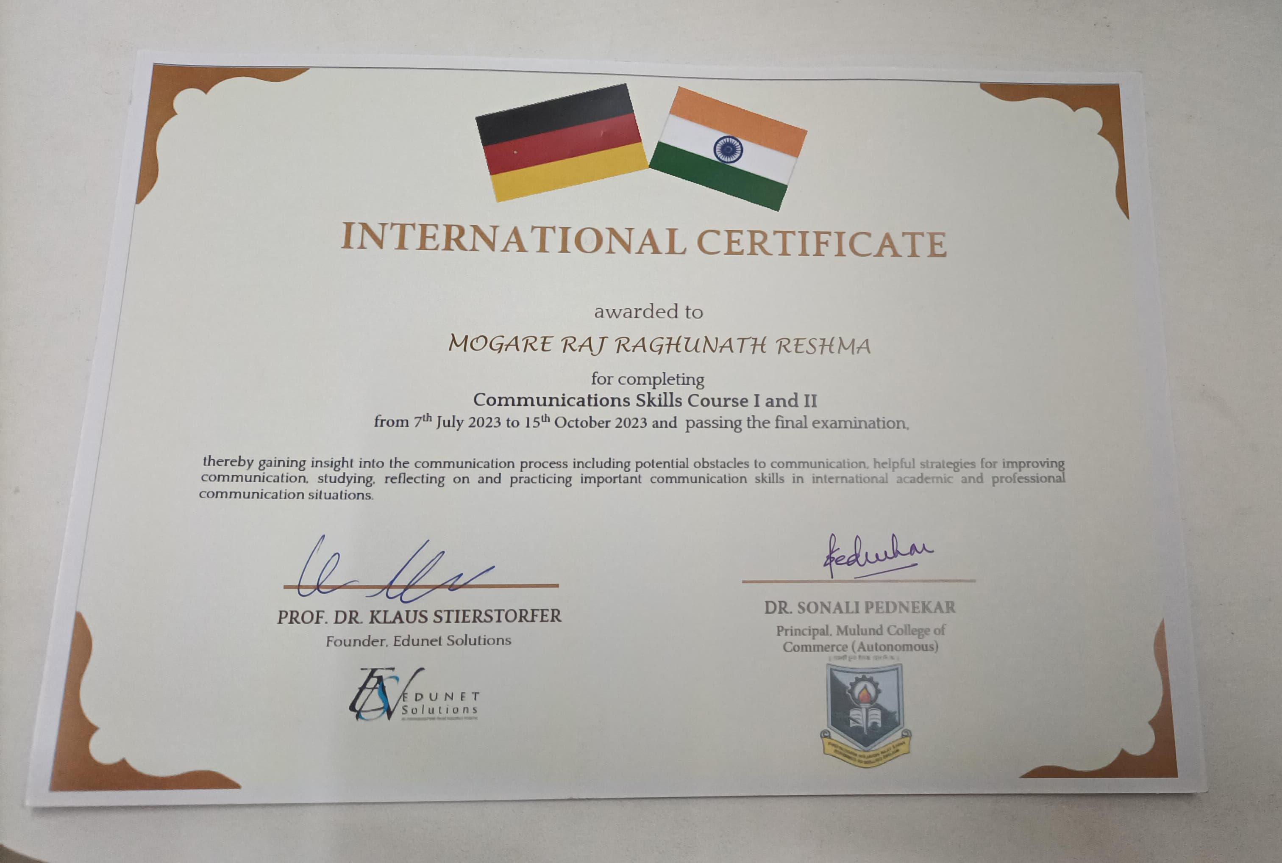

**Report on Completion of Certificate Course**

**Year of the Study 2023-24 Semester __V__**

**Course Details:**

**1. Course Title:** DevOps Fundamentals

**2. Duration, Start and Completion Date:** 40 hours

**Course Objectives:**

* Understand modern software development practices.
* Gain proficiency in tools for automating infrastructure deployment.
* Learn about collaboration and communication practices in DevOps culture.
* Acquire skills in managing and monitoring IT infrastructure.
* Prepare for roles involving efficient deployment and management of IT systems.

**Learning Outcomes:**

* Skills acquired: Continuous integration and continuous delivery (CI/CD), Infrastructure as code (IaC), Configuration management, Monitoring and logging, Collaboration and communication.
* Application of Knowledge: These skills are applied in practical life by enabling automation in software development processes, ensuring consistency and scalability in infrastructure management, and facilitating effective communication and collaboration among development and operations teams. For example, CI/CD pipelines automate the build, test, and deployment processes, reducing manual errors and speeding up software delivery.

**Conclusion:**

The DevOps course provided me with a comprehensive understanding of modern software development and deployment practices. I gained practical experience in setting up CI/CD pipelines, managing infrastructure using IaC principles, and implementing effective monitoring and logging solutions.

**Acknowledgments:**

I express my sincere gratitude to the instructor for their guidance and expertise throughout the DevOps course. Their practical insights and hands-on approach greatly enriched my learning experience.

**Attach Course Completion Certificate**

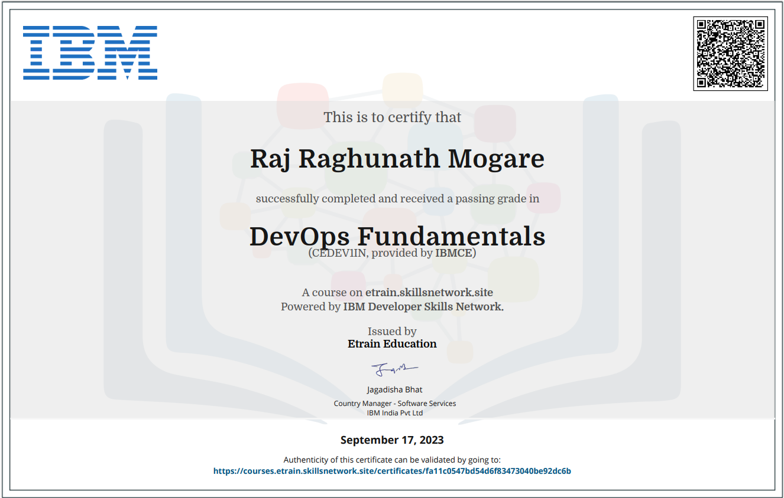

**Report on Completion of Certificate Course**

**Year of the Study 2023-24 Semester __VI__**

**Course Details:**

**1. Course Title:** Cloud Computing

**2. Duration, Start and Completion Date:** 40 hours

**Course Objectives:**

* Understand fundamental concepts of cloud computing.
* Gain proficiency in utilizing Azure services for various purposes.
* Learn about identity and access management, security, scalability, and cost management.
* Acquire skills in designing and deploying cloud-based solutions.
* Prepare for roles involving the implementation and management of cloud infrastructure and services.

**Learning Outcomes:**

* Skills acquired: Cloud computing fundamentals, azure service deployment and management, identity and access management (IAM), security best practices in Azure, scalability and cost management in Azure.
* Application of Knowledge: These skills are applied in practical life by enabling organizations to leverage Azure's infrastructure and services for building and deploying applications, managing data, and improving productivity and efficiency.

**Conclusion:**

The Cloud Computing course provided me with a solid foundation in cloud computing concepts and practical experience in working with Azure services. I gained insights into designing and deploying cloud-based solutions, implementing security best practices, and optimizing costs in Azure 12 environments.

**Acknowledgments:**

I extend my heartfelt gratitude to the instructor for their comprehensive guidance and support throughout the Cloud Computing with Azure course. Their expertise and dedication greatly contributed to my understanding and mastery of Azure services

**Attach Course Completion Certificate**

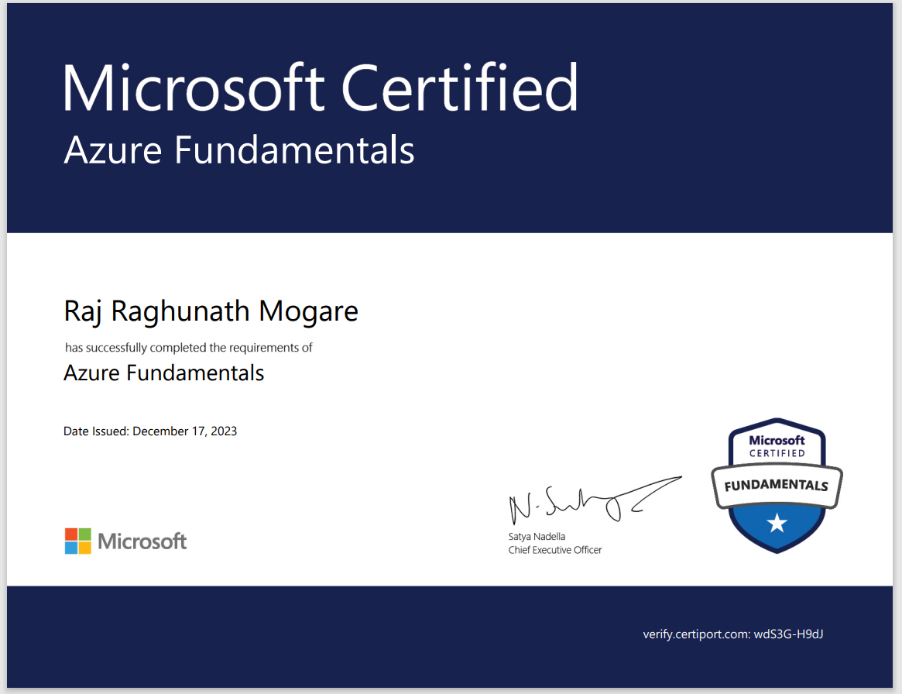

**Date:**

**CERTIFICATION OF COMPLETION OF 12 ADDITIONAL CREDITS**

This is to certify that Mr. Raj Raghunath Mogare of TY.BSc. Information Technology, Sem VI - Roll Number 239665 has successfully completed 12 additional credits.

Coordinator

Dr. Hiren Dand