**EXPERIMENT 8**

**TITLE**:-Classification using SVM - Breast Cancer Dataset and Comparing with Logistic Regression

**AIM**:-Comparing with Logistic Regression and Logistic Regression

**PROCEDURE**:-

1. Import Pandas, numpy, matplotlib, Standard Scaler or Minmax Scaler libraries respectively.
2. Load digits dataset.
3. Convert this numpy array into Dataframe.
4. Fill missing values if any.
5. Apply LabelEncoder.
6. Split Independent and Target values using traintestsplit.
7. Apply Logistic Regression on training set.
8. Check the accuracy score.
9. Also make a confusion matrix as it is a classification problem.
10. Apply svm.SVC on training set.
11. Check the accuracy score.
12. Also make a confusion matrix as it is a classification problem.
13. Here we can observe that accuracy of Logistic Regression is more than SVM.

**Results :**

**1. Logistic Regression :**

**Accuracy :-**

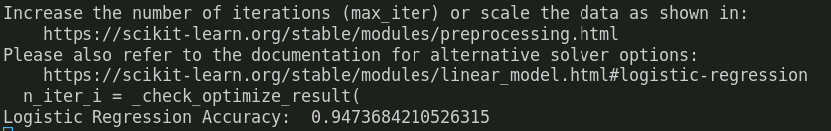

**Confusion Matrix :-**

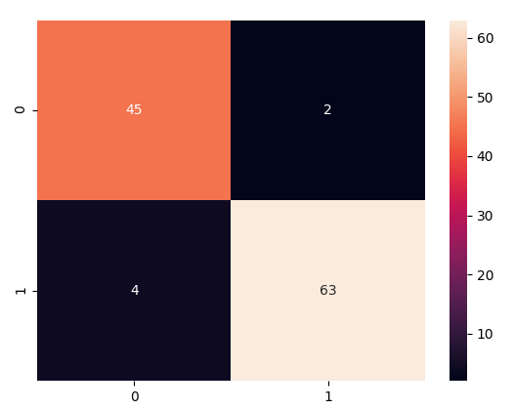

**2. SVM :**

**Accuracy :**

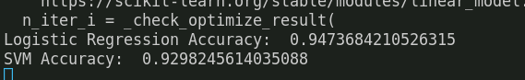

**Confusion Matrix :**

