**EXPERIMENT 10**

1. **TITLE**:-Regularization using Lasso and Ridge Regression with preprocessing - using Melbourne_housing Dataset

**AIM**:-Regularization using Lasso and Ridge Regression

**PROCEDURE**:-

1. Import Pandas, numpy, matplotlib, Standard Scaler or Minmax Scaler libraries respectively.
2. Load Melbourne_housing dataset.
3. Delete rows with missing values if any.
4. Apply One Hot Encoding.
5. Split Independent and Target values using traintestsplit.
6. Apply LinearRegression, Lasso and Ridge on training set.
7. Check the accuracy score of each.

**Results :**

**Linear Regression Accuracy :-**

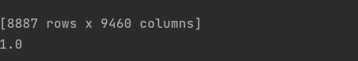

**Lasso Accuracy :-**



**Ridge Accuracy :-**

