**EXPERIMENT 7**

**TITLE**:-Multiclass Classification using Logistic Regression - Digit Dataset

**AIM**:-Multiclass Classification using Logistic Regression

**PROCEDURE**:-

1. Import Pandas, numpy, matplotlib, Standard Scaler or Minmax Scaler libraries respectively.
2. Load digits dataset.
3. Convert this numpy array into Dataframe.
4. Fill missing values if any.
5. Apply LabelEncoder.
6. Use standard scaler or minmax scaler.
7. Split Independent and Target values using traintestsplit.
8. Apply Logistic Regression on training set.
9. Check the accuracy score.
10. Also make a confusion matrix as it is a classification problem.

**Results :**

**Accuracy :-**

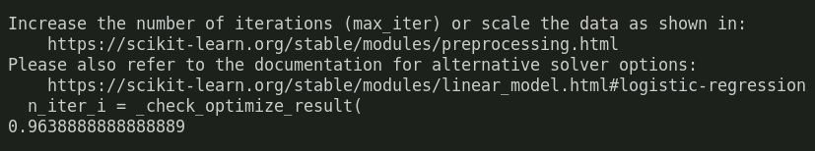

**Confusion Matrix :-**

