**EXPERIMENT 12**

**TITLE**:-Principal Component Analysis on Iris Dataset for dimensionality Reduction

**AIM**:-Principal Component Analysis for dimensionality Reduction

**PROCEDURE**:-

1. Import Pandas, numpy, matplotlib, Standard Scaler or Minmax Scaler libraries respectively.
2. Load salaries dataset.
3. Convert this numpy array.
4. Fill missing values if any.
5. Apply LabelEncoder.
6. Apply pca on features and transform converted features
7. Split Independent and Target values using traintestsplit.
8. Apply SVM or any classification algorithm on training set.
9. Check the accuracy score.

**Results :**

**Accuracy :-**

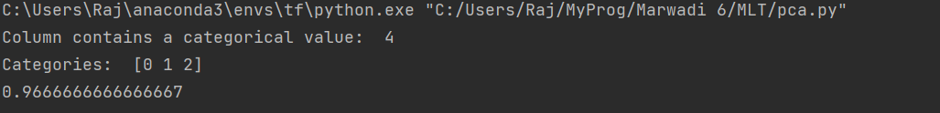

**Confusion Matrix** :-

