**EXPERIMENT 4**

**TITLE**:-Polynomial Regression – With Sample Data

**AIM**:-Implement polynomial regression using sampled data.

**PROCEDURE**:-

1. Import Pandas, numpy, matplotlib libraries respectively.
2. Read the sample data as numpy array
3. First fit sample data in linear regression and predict.
4. Start plotting the coordinates.
5. For Polynomial regression we use polynomial_features.
6. We fit X in polynomial_features and get X_poly.
7. After then we simply apply linear regression and get y_poly_pred.
8. And check RMSE and R2 score.
9. For plot we need to use sort_zip = sorted(zip()) function.

**RESULT:-**

* 1. **Liner Regression**

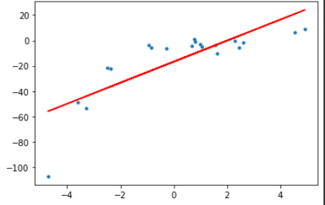



* 1. **Polynomial Regression**



