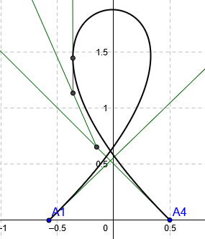

|  |  |  |  |  |
| --- | --- | --- | --- | --- |
| points | P0 | P1 | P2 | P3 |
| X | -0.5 | 2 | -2 | 0.5 |
| Y | 0 | 2.5 | 2.5 | 0 |