

**Discover Dollar Assessment - Software Development Internship to hire -25 Jan 2023**

Dear Candidate,

Thank you for your interest with Discover Dollar.

Discover Dollar started with a vision to help organizations to harness **full** potential of the data they have. More than 75% of enterprise data is in unstructured data. It can be in the form of email conversations, chats, discussions, meetings, invoices, and contract copies. This data has very important information but not harnessed to the fullest extent. Discover Dollar's mission is to help enterprises to create value harnessing this data, using data-first approach using data science, Al and cutting-edge technologies. For more details visit [www.discoverdollar.com](http://www.discoverdollar.com/)

Please follow us at our Linkedin

page: [https://www.linkedin.com/company/discoverdollar/mycompany/](http://www.linkedin.com/company/discoverdollar/mycompany/)

Glassdoor: [https://www.glassdoor.co.in/Reviews/Discover-Do11ar-Reviews-E2086958.htm](http://www.glassdoor.co.in/Reviews/Discover-Do11ar-Reviews-E2086958.htm)

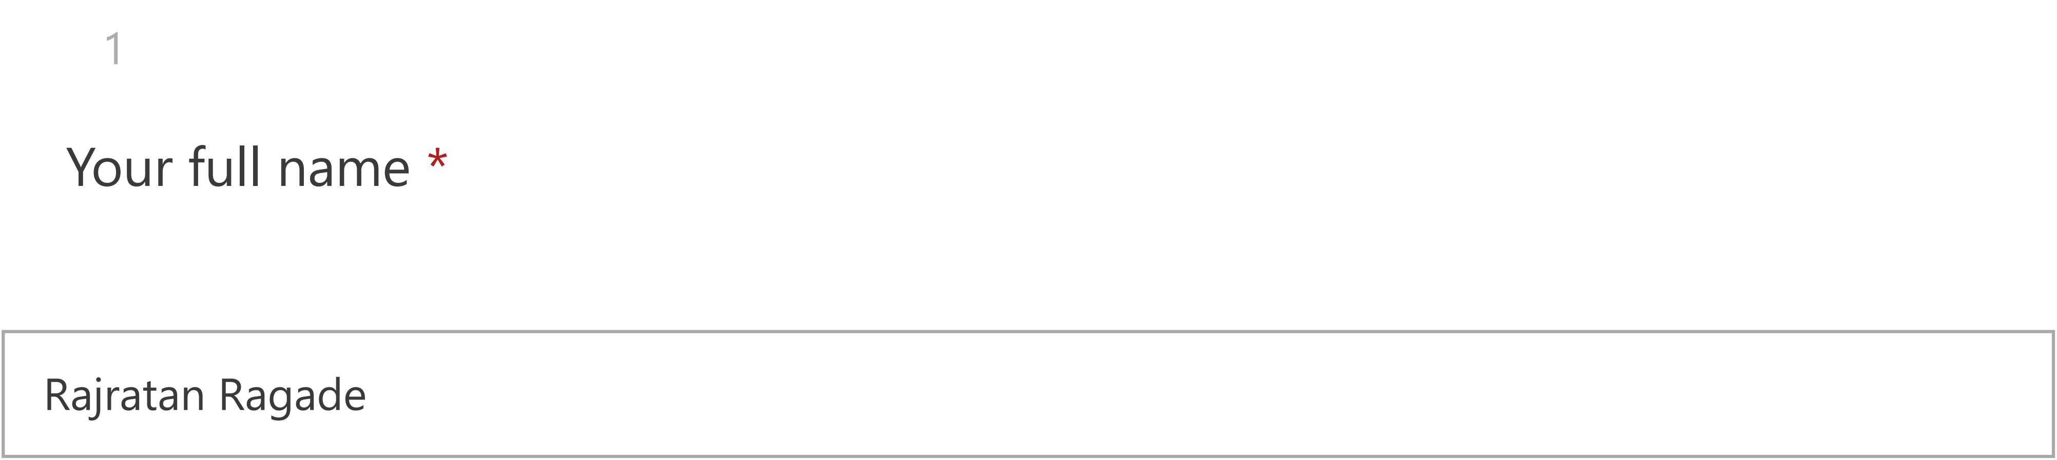

2

**Your College name** *

DSM college

3

**Your roll number\***

5

4

**Your email ID** *

[rraj.ragade@gmail.com](mailto:rraj.ragade@gmail.com)

5

**Your contact number\***

7249658770

6

Which set does the Figure belong to? (1 Point)

Figure **Set A**

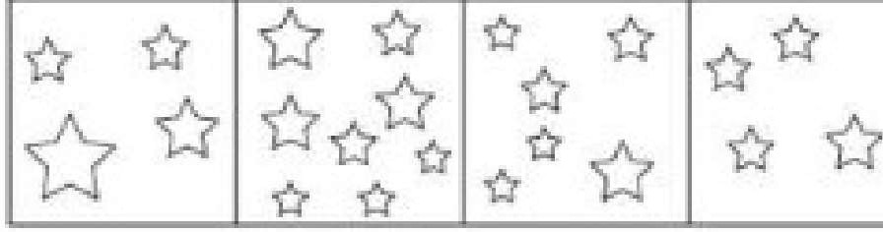

**Set B**

|  |  |  |  |  |
| --- | --- | --- | --- | --- |
| * | * * | **  *** | **  ****·* | '0** |

*

Set B

Neither set A nor set B Set A

7

##### Study the following program:

**main()**

{

##### char x [15], *ptr = x;

**scanf** ("%s", x);

##### change(&x[6]);

}

##### change(char a[])

{

##### puts(a);

}

##### If abcabcdefgdefg is the input, the output will be(1 Point)

abcdef defgdefg Garbage fgdefg

8

Between 1990 and 2000, what was the decrease in energy use for the PC Room, Meeting Rooms and Office Space combined? (1 Point)

|  |  |
| --- | --- |
| **Building Energy Us** | **.1990** |
| ***Tohll: 11,00\'il!Wh***  **12%**  **12% Meeting**  **Kiitchen Rooms**  **20%**  **PC Room**  **41%**  **Office**  **15% Space** | |

**B1.1ilding Energy Use 2000**

***Total; 15,000 Wli***

**14%**

**14% Meelirng**

**Kitchen Rooms**

**21%**

**PC Room**

**3-9%**

**12% Office**

**Space**

1,400kWh

1,450kWh

1,310kWh

#### Cannot say

9

Identify the correct order of a SQL statements (1 Point)

SELECT, WHERE, GROUP BY, HAVING SELECT, HAVING, WHERE, GROUP BY SELECT, WHERE, HAVING, GROUP BY SELECT, GROUP BY, WHERE, HAVING

10

A Train 125 m long passes a man, running at 5 kmph in the same direction in w hich the train is going in 10 seconds. The speed of the train is (1 Point)

50 kmph

45 kmph

55 kmph

54 kmph

11

if Xis mean of data in the series -5,9, X,50,15,7,8, what would be mode of this se ries?(1 Point)

None of the given options

8

4.1

9

12

A clock is started at noon. By 10 minutes past 5, the hour hand has turned throu gh (1 Point)

145°

155°

150°

160°

13

The section of the CPU that selects, interprets and sees to the execution of prog ram instructions(1 Point)

Memory Register unit ALU

None from listed

Control unit

14

A thief steals a car at 2:30 pm and drives it at 60kmph. The theft is discovered at 3 pm and the owner sets off in another car at 75 kmph when will he overtake th e thief. (1 Point)

4:30 pm 5:15pm 4:45 pm 5pm

15

Which set does the Figure belong to? (1 Point)

Fi,gure

**Set A**

|  |  |  |  |
| --- | --- | --- | --- |
| [!]  **0** | *® | -**1111**-**[11** | **0**  @ |

# Set B

|  |  |  |  |
| --- | --- | --- | --- |
| -**0**-[] | < ) | *(�i*  **0**. | **A!***_I\***{**[**.**!]  l |

Set B

Neither se A nor set B Set A

16

What will the result of num1 variable after execution of the following statement

#### s?

intj = 1, num1 = 5 while (++j <= 10)

{

num1++

} (1 Point)

13

14

11

12

17

Two men start together to walk to a certain destination, one at 3kmph and anot her at 3.75 kmph. The latter arrives half an hour before the former. The distance is (1 Point)

9.5km 8km 6km 7.5km

18

### At 3.40, the hour hand and the minute hand of a clock for and angle of (1 Point)

120°

125°

130°

135°

19

### How many times will the following loop execute?

**forU = S;j <= 10;j = j-1) (1 Point)**

0

**1**

Never Forever

20

Which of the following hardware components is the most important to the oper ation of a database management system?(1 Point)

mouse

high-resolution video display plotter

printer

high speed, large-capacity disk

21

Which set does the Figure belong to? (1 Point)

Figure

fRl

# Set A

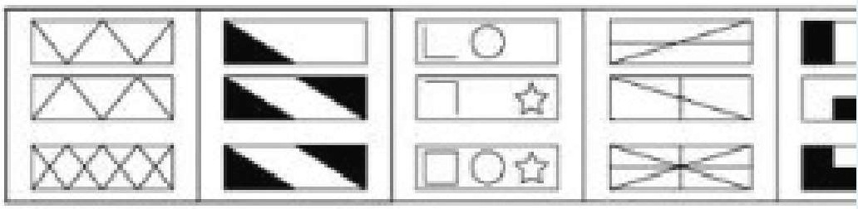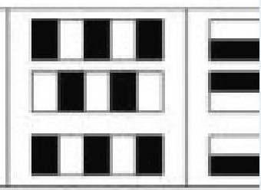I * I ■ ■11



'*

# Set B

*I

[ * I

I• ■ I I • •I

Neither set A nor set B Set A

Set B

22

Which set does the Figure belong to? (1 Point)

Figure

□,@

+$**A**

Neither set A nor set B Set A

Set B

23

## Set A

**Set B**

|  |  |  |  |  |
| --- | --- | --- | --- | --- |
| ,@ &  ) -  ~ $ | ~ (  ( 7 | } 7 )  $ ) @ | $ @  ,...,,  & @ | *1*• |

|  |  |  |  |  |
| --- | --- | --- | --- | --- |
| ..l. +  A[ *I*. *\* | □ **A.**  ++ **T** | *I* □  ...l. □ | [ [  *I* [ + | **A**  *I'* |

Group of instructions that directs a computer is called(1 Point)

Memory Program

None from listed Logic

Storage

24

Which set does the Figure belong to? (1 Point)

F'i,gure **Set A **

|  |  |  |  |  |
| --- | --- | --- | --- | --- |
| &  ***T.£.*** |  | *II* | • |  |
| Ii |

Set B

Set B Set A

Neither set A nor set B

25

The large silver clock states the time as 15:50.

The small silver clock displays the same time as the gold clock. The Bronze clock is small in size.

The gold clock is ten minutes behind the large silver clock. The Bronze clock is five minutes after of the Small Silver Clock

02 The Gold Clock is the same time as the Bronze Clock(1 Point)

True False

Insufficient Information

26

What are some ways you can support password security?(1 Point)

All the given options

Choose a password that is hard to guess, one that includes numbers, letters and special characters.

Never write down your passwords.

Change your password immediately if you think someone has inappropriately accessed your account.

27

The correct syntax for running multiple variable for loop simultaneously is. (1 Point)

for (i = O,j = O;i < n,j < n; i++,j += 5)

None of the mentioned

for (i = O; i < n; i++) for U = 0; j < n; j += 5) for (i = O; i < n;i++){} for U = O;j < n;j += 5){}

28

**Which object can be made by folding the given shape?(1 Point)**

# Object





**C D**

A C **B D**

29

Which set does the Figure belong to?(1 Point)

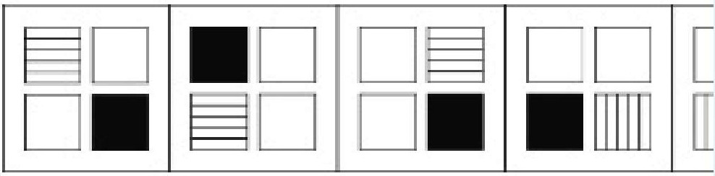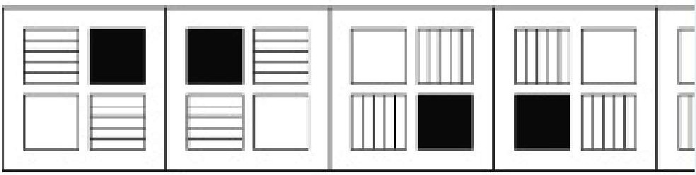Fi,gure **Set A**

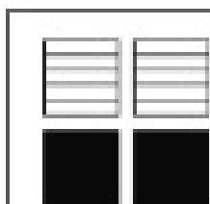

## Set B

Set B

Neither set A nor set B Set A

30

Multilateral development banks (MDBs) are international financial institutions es tablished by a group of countries that provide financial services and professiona I advice in order to further economic development. MDBs generally receive don ations from developed nations in the form of very-long team loans below the m arket rate of interest and through grants

Q3. Taking each line in the above argument as true, which statement must bed emonstrably false?(1 Point)

An aim of MDBs is to provide economic development. MDBs lend money as typically short-term loans.

MDBs are established as international ventures Developing nations will eventually pay back their loans.

31

What service is used to translate domain names to IP addresses?(1 Point)

NFS DNS NIS

None from listed SMB

32

The FIRST objective of a "Security Aware Employee" is to be able to:(1 Point)

Recognise a security threat Manage a security threat Avoid a security Threat Report a security threat

33

The physical layer of a network(1 Point)

All of the listed

controls error detection and correction None from listed

constructs packets of data and sends them across the network

defines the electrical characteristics of signals passed between the computer and communica­ tion devices

34

Which figure is a rotation of the object? (1 Point)

Object

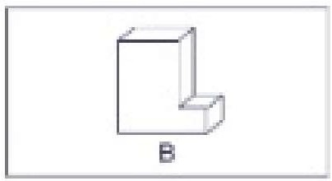

A



□

C B D A

35

Three ants are sitting at the three corners of an equilateral triangle. Each ant ran domly picks a direction and starts to move along the edge of the triangle. What is the probability that none of the ants collide?(1 Point)

1/8

2/3

1/4

1/6

36

Which of the following pairs of variables should not be analysed using Correlati on?(1 Point)

Systolic Blood Pressure - Cholesterol level FEV1 - Gender

Age-. Body Mass Index (BMI)

Liver enzyme concentration - Alcohol Consumption (units per week)

37

Which set does the Figure belong to? (1 Point)

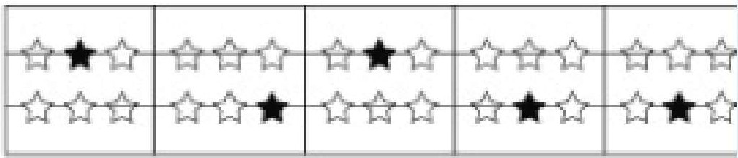**Fig1.ue S. tA**

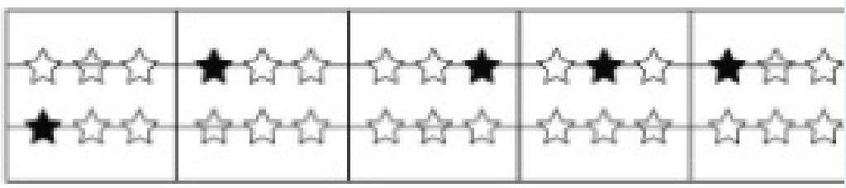S **t B**

Set A Se B

Neither set A nor set B

38

A matrix **X** has the dimension 2X2. If the eigenvalues of the matrix are 5 and 6, what would be the eigenvalues of **X2?(1** Point)

10 and 12

5 and 6

2.5 and 3

25 and 36

39

Hackers can crack your passwords by repeatedly trying to guess it. This passwor d cracking method is called:(1 Point)

Brute force attack Phishing attack

Denial of Service attack None of them

40

What are the assumptions of logistic regression?(1 Point)

No endogeneity, No autocorrelation Linearity

Normality and homoscedasticity, No multicollinearity All from listed

41

In SQL, which operator is used to compare a value to a specified list of values? (1 Point)

between in

like having

42

Information security is the responsibility of:(1 Point)

IT Security Department Top Management Security Guard

Everyone in the company

43

### What will this program print?

**main()**

{

### inti= 2;

{

**int i = 4, j** = S;

### printf("%d %d", i, j);

}

### printf("%d %d", i, j);

} **(1 Point)**

4545

None of the these

2525

4525

**44**

##### In a class of 50 students, below are the marks obtained in particular subject.

**What is the median of the marks? (1 Point)**

|  |  |  |  |  |
| --- | --- | --- | --- | --- |
| **Marks** | **15** | **30** | **37** | **42 48** |
| **Noof**  **students** | **1** | **8** | **13** | **20 8** |

37

34.4

42

10

45

(1 Point)

#### How does the matrix T

o_ 1 J [xl 1

#### = l O transform the vector v = *X2* when they are m

[

Rotate the vector by 180° None from listed

Rotate the vector by 90°

Project the vector on to the y-axis

46

In Python , what would be the output of the following statement:

Print("Discover" +"Dollar") (1 Point)

Incorrect Syntax Discover+Dollar Discover Dollar DiscoverDollar

47

Your supervisor is very busy and asks you to log into the HR Server using her us er-ID and

password to retrieve some reports. What should you do?(1 Point)

Decline the request and remind your supervisor that it is against Company policy. Ignore the request and hope she forgets.

It's your boss, so it's okay to do this.

**48**

Which set does the Figure belong to? (1 Point)

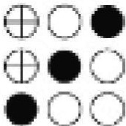Figure Set A

|  |  |  |  |  |  |
| --- | --- | --- | --- | --- | --- |
| **eE3e**  ,**e**_ **oEB**  ... **eEB** | Offiffi  **eoffi EGOe** |  | | ffiOO 18E:BEB  OCffi | **eff ffie effi** |
| EB4HP  **eme** | **,** |

|  |  |  |  |  |  |
| --- | --- | --- | --- | --- | --- |
|  |  | | | | |
| .o  ffi | ,o.•f  Qffi | f**oe**i**eo,E**  mo• | **Be•OO**  **a,eo**   * ·OO | **(**-**JOe**  **OeEB**  **ecm** | mo  **em** |

Set B

••• **i**

,

Set B Set A

Neither set A nor set B

49

The large silver clock states the time as 15:50.

The small silver clock displays the same time as the gold clock. The Bronze clock is small in size.

The gold clock is ten minutes behind the large silver clock. The Bronze clock is five minutes after of the Small Silver Clock

Q1. The Small Silver Clock displays the time as 16:00 (1 Point)

Insufficient Information False

True

50

If the Building Energy Use today is 6% less than it was in 2000, by what percenta ge is today's Building Energy Use lower than that of 1990? (1 Point)

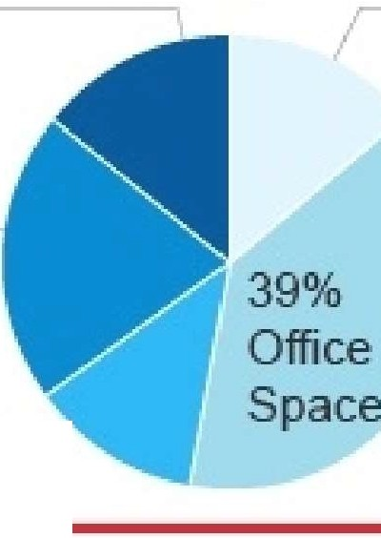

**Building** E1nergy **Use :moo**

*Toial: 15,000 kWh*

14%

Kitchen

14

Meetin Room

21%

PC Room

12%

Print Ro

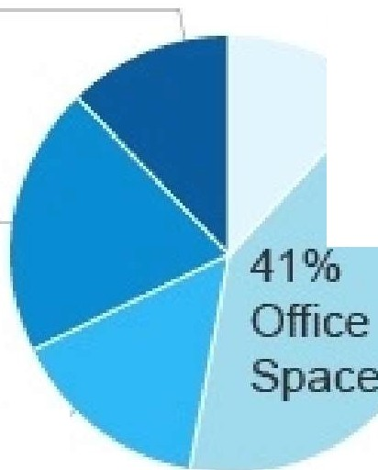Cannot say

**Buildi1ng Energy Use 1990**

*Total: 17,O{)(J kVllh*

12%

Kitchen

12%

Meeting

Rooms

*/,--*

20%

PC Room

15%

PlintRoo

17.8%

82.9%

17.1%

This content is created by the owner of the form. The data you submit will be sent to the form owner. Microsoft is not responsible for the privacy or security practices of its customers, including those of this form owner. Never give out your password.

Powered by Microsoft Forms I

The owner of this form has not provided a privacy statement as to how they will use your response data. Do not provide personal or sensitive information.

I Terms of use