1. TestCases

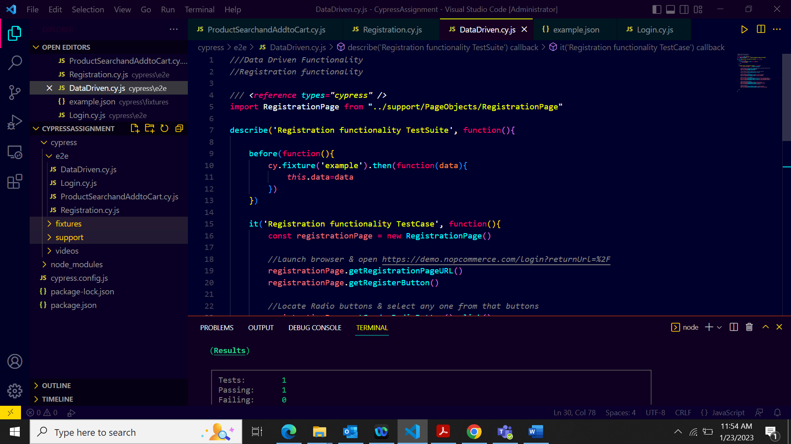

1. PageObject folder

1. FixtureFolder

1. Terminal Run Output

1. DashBoard output

