**C++ Cheat Sheet**

|  |  |
| --- | --- |
| CHAR_BIT | 8 |
| SCHAR_MIN | -128 |
| SCHAR_MAX | +127 |
| UCHAR_MAX | 255 |
| CHAR_MIN | -128 |
| CHAR_MAX | +127 |
| MB_LEN_MAX | 16 |
| SHRT_MIN | -32768 |
| SHRT_MAX | +32767 |
| USHRT_MAX | 65535 **(because no bit reserved for sign)** |
| INT_MIN | -2147483648 |
| INT_MAX | +2147483647 |
| UINT_MAX | 4294967295 **(because no bit reserved for sign)** |
| LONG_MIN | -9223372036854775808 |
| LONG_MAX | +9223372036854775807 |
| ULONG_MAX | 18446744073709551615 **(because no bit reserved for sign)** |

**Use <climits> header file**: This header defines constants with the limits of fundamental integral types for the specific system

MAX = 1e9+7 or **1000000007**

|  |
| --- |
| **MAX value of N Time complexity** |
| 10^9 O(log N) or Sqrt(N) |
| 10^8 O(N) Border case |
| 10^7 O(N) Might be accepted |
| 10^6 O(N) Perfect |
| 10^5 O(N * log N) |
| 10^4 O(N ^ 2) |
| 10^2 O(N ^ 3) |
| <= 160 O(N ^ 4) |
| <= 18 O(2N*N2) |
| <= 10 O(N!), O(2N) |

|  |
| --- |
| **NOTE: Short names include DT (Data Type)** |

**Containers**

1. **Vectors: Implementation by dynamic array.**

|  |  |  |
| --- | --- | --- |
| Member Functions | Return Values | Command Brief |
| vector<DT> v |  | Default, Empty vector |
| vector<DT>v{ } |  | Initializer List |
| vector<DT>v={ } |  | Initializer list |
| vector<DT> v(size) |  | Fill constructor |
| vector<DT> v(size, init_value) |  | Filled constructor |
| vector<DT> v2(itr1, itr2) |  | Deep copy, range based |
| vector<DT> v1(v2) |  | Deep copy, copy constructor |
| vector<DT>() | Returns Empty vector |  |
| v.assign(size, value) |  | Same as filled constructor but a function |
| v.assign(itr1, itr2) |  | Range based filling |
| vector<DT> v = { ________ } |  | Initialization |
| v.begin() | Iterator pointing to first element |  |
| v.end() | Iterator pointing to the post last element |  |
| v.rbegin() | Reverse Iterator pointing to the last element and this iterator traverse in reverse. |  |
| v.rend() | Reverse Iterator pointing to the element preceding first element and this iterator traverse in reverse. |  |
| v.size() | Unsigned Integer |  |
| v.max_size() |  | Maximum potential size of container |
| v.capacity() | Unsigned Integer | Init_size^n size (usually 2^n) |
| v.resize(size, value) |  | Makes and vector to the given size while filling empty spaces with value |
| v.shrink_to_fit() |  | Resizes to accommodate available elements. Capacity=Size. |
| v.at(index) | DT value | Returns value at index |
| Iterator loop, *itr is the element | *itr=value and itr is address location |  |
| v[index] |  |  |
| v.data() | A pointer to the first element in the array used internally by the vector. |  |
| v.front() | Returns leftmost element |  |
| v.back() | Returns rightmost element |  |
| v.clear() | Void | Removes all elements in the container. Size = 0. Capacity is intact. |
| v.emplace(itr, value) | Returns iterator to newly inserted element. | Inserts value before the location pointed by itr. |
| v.emplace_back(value) | Void | Similar to push_back(value) |
| v.empty() | Boolean | If container is empty or not |
| v.erase(itr1, itr2) | Returns iterator pointing to element after the one which was erased | If one argument is given, one element will be erased at location pointed by it. In case of 2, range is erased as [itr1, itr2). |
| Member Functions | **Return Values** | **Command Brief** |
| v.insert(itr, value) | Returns random access iterator pointing to first of newly inserted element(s). | Pushes before itr with value |
| v.insert(itr, count, value) | Returns random access iterator pointing to first of newly inserted element(s). | Pushes before itr with count number of values |
| v.insert(itr, itr_1, itr_2) | Returns random access iterator pointing to first of newly inserted element(s). | Pushes before itr with ellements between [itr_1, itr_2) |
| v.push_back(value) | Void | Appends value on right |
| v.pop_back() | Void | Pops value from right, size--; |

1. **List: Doubly Linked List**

|  |  |  |
| --- | --- | --- |
| Member Functions | Return values | Command Brief |
| list<DT> l |  | Empty list init. |
| list<DT> l(size) |  | Fill Constructor |
| list<DT> l(size, init_value) |  | Filled Constructor |
| list<DT> l(ptr1, ptr2) |  | Deep Copy, range based |
| list<DT> l( list2 ) |  | Deep Copy, copy constructor |
| l.assign(size, value) |  | Overriding |
| l.assign(itr1, itr2) |  | Overriding |
| list<DT> l = { ____ } |  | Initialization |
| list<DT>() | Returns Empty list | Used for returning empyu list |
| l.pop_back() | Void | Removes the last element in the list container, effectively reducing the container size by one |
| l.pop_front() | Void | Removes the first element in the list container,effectively reducing the conatiner size by 1. |
| l.push_back(value) | Void | Adds a new element at the end of the [list](https://cplusplus.com/list) container, after its current last element. Size++ |
| l.push_front(value) | Void | Adds new element at the front of the continer list, before current first element. Size++. |
| l.sort( comparator ) | Void, modifies | Sorts elements (increasing by default) as per comparator |
| l.size() | Unsigned Integer, size_type | Number of elements in the container list |
| l.unique( comparator ) | Void | **Notice** that an element is only removed from the list container if it compares equal to the element immediately preceding it. Thus, this function is especially useful for sorted lists. By default it will remove all duplicates in **sorted** list. A comparator function can be provided to reduce list via pair wise comparison |
| l.swap( list2 ) |  | Swaps all contents of container l with list2 container |
| l.begin() | Iteraor | Pointer to beginning element. |
| l.end() | Iterator | Iterator pointing to post last element. |
| l.empty() | Boolean | Returns true if there are no elements in the list conatiner. |
| l.front() | DT | Returns first element reference (alue but can be modified), not pointer/iterator. |
| l.back() | DT | Returns last element reference, not pointer/iterator. |
| l.clear() | Void | Deleted all nodes and reduces size to zero |
| l.insert( itr, times, value) | An iterator that points to the first of the newly inserted elements. | Inserts n (by default 1) times the value before location pointed by itr in the list conatiner l. |
| l.insert (itr, itr1, itr2) | An iterator that points to the first of the newly inserted elements. | Inserts elements in another container in range **[ itr1, itr2 )** before location pointed by **itr** in target list conatiner l. |
| l.erase(itr, itr2) | Returns iterator pointing to the elements past last removed element. | Removes element pointed by itr or all elements in **[ itr ,itr2 )** |
| l.max_size() | Unsigned Integer | Maximum number of elements a list can hold. |
| l.remove(val) | Void, modify | Erase by value. All occurences. Removes from the container all the elements that compare equal to val. |
| l.remove_if(comparator) | Void, modify | Removes from the container all the elements for which **Comparator** returns true. Comparator here has argument = &val (1 reference value of list) |
| l.reverse() | Void, modifies |  |
| l.splice(itr, list2) | Void, modifies | Transfer all from list2 in l before itr. |
| l.splice(itr, list2, itr2) | Void, modifies | Transfer one element at itr2 into l before itr. |
| l.splice(itr, list2, itr_start, itr_end) | Void, modifies | Transfer elements between [ itr_start, itr_end ) into l from list2 before itr. |

1. **Pair: Size 2 array**

|  |  |  |
| --- | --- | --- |
| Member Functions | Return Value | Command Brief |
| pair<DT, DT> p; | Reference to a pair, currently empty |  |
| pair<DT, DT> p(p2); OR = operator |  | Deep copy, copy constructor |
| pair<DT, DT> p(value1, value2); |  | Initialization |
| p = make_pair(value1, value2); |  |  |
| p.first | First member |  |
| p.second | Second Member |  |
| == operator | Boolean | Returns if content of both pair are same or not. |
| != operator | Boolean |  |
| Comparison Operators (>, <, >=, <=) | Boolean | Compares first element first and then if false checks second element as per the operator. For example, for < comparison is (a.first<b.first || (!(a.first<b.first) && a.second<b.second))  For a<=b, it is a.first<=b.first || (!(a.first<=b.first) && a.second<=b.second), OR simply !(b<a). |

1. **Stack: Linked List**

|  |  |  |
| --- | --- | --- |
| Member Function | Return Value | Command Brief |
| stack<DT> st |  | Creates an empty stack container |
| stack<DT> st(another_container) |  | Creates new stack from elements of another stl container with same DT |
| st.push(value) | Void | Pushes element on stack, size++ |
| st.pop() | Void | Removes top element, size-- |
| st.top() | Reference to top element | Element on top reference. Can be modified with st.top(). |
| st.empty() | Boolean | Is the stack container empty? |
| st.size() | Unsigned Integer | Number of elements in stack |
| st.swap(st2) | Void | Swap references to the containers |
| Comparison operator (==, !=, >, <, <=, >=) | Boolean | Returns on comparison with each element from bottom to top. If Camparison holds true throughout then returns true else false. |

1. **Queue: Linked List**

|  |  |  |
| --- | --- | --- |
| Member Function | Return Value | Command Brief |
| queue<DT> q |  | Creates an empty queue container |
| queue<DT> q(another_container) |  | Creates new queue from elements of another stl container with same DT |
| q.push(value) | Void | Pushes element into the queue at last, size++ |
| q.pop() | Void | Removes front element, size-- |
| q.front() | Reference to front element | Element on front reference. Can be modified with q.front(). |
| q.back() | Reference to last element, last added | Element at last reference. Can be modified with q.back(). |
| q.empty() | Boolean | Is the queue container empty? |
| q.size() | Unsigned Integer | Number of elements in queue |
| q.swap(q2) | Void | Swap references to the queues |
| q.emplace(value) | Void | Same as push(value) |
| Comparison operator | Boolean | Returns on comparison with each element from front to back . If Camparison holds true throughout then returns true else false. |

1. **Deque: 2 Queue**

|  |  |  |
| --- | --- | --- |
| Member Funcion | Return Value | Command Brief |
| deque<DT> dq |  | Constructs an empty container (o size) |
| deque<DT> dq(<size>, <value=0>) |  | Fill type, by default value is zero |
| deque<DT> dq(itr1, itr2) |  | Range constructor from another container |
| deque<DT> dq(<dq2>) |  | Copy constructor |
| deque<DT>dq { } |  | Initializer list initialization |
| = operator, dq = d2 |  | Assigns new contents to the container, replacing its current contents, and modifying its size accordingly. |
| dq.size() |  | Unsigned int = size_type |
| dq.begin() | Iterator pointing to the first element of the container |  |
| dq.end() | Iterator pointing to the 1 + last poistion of the conatiner |  |
| dq.assign(<size>,<const_value>) |  |  |
| dq.assign(itr1,itr2) |  |  |
| dq.at(index) | Returns reference to value at position n in the container | This is different from [] operator because it throws out_of_range exception when index run out of bound |
| dq.front() | Reference to the first eleemnt in the queue |  |
| dq.back() | Reference to the last element |  |
| [<index>] operator |  | Accesses value at index. Mutable |
| dq.emplace(itr,<value>) | Returns iterator pointing to the newly inserted elements | Inserts element with <value> at the poirion pointed by itr. |
| dq.emplace_back(<value>)  dq.push_back(<value>) | Constant order complexity |  |
| dq.emplace_front(<value>)  dq.push_front(<value>) | Constant order complexity |  |
| dq.empty() | Boolean |  |
| dq.erase(itr) //one element  dq.erase(itr1,itr2) //range based | An iterator pointing to the new location of the element that followed the last element erased by the function call. |  |
| dq.insert(itr,value)  dq.insert(itr, size, value)  dq.insert(itr, itr1,itr2)  dq.insert(itr, { … } ) | An iterator that points to the first of the newly inserted elements. | The deque container is extended by inserting new elements before the element at the specified position. |
| Out of range elements holds value zero. |  |  |
| dq.swap(dq2) |  | Swaps refernces to the containers |

1. **Bitset**

**Size=bitset string size. It converst integer into binary and captures bit values from msb. Same goes for initialization from binary c string.**

**NOTE: Indexing for position is from right to left.**

|  |  |  |
| --- | --- | --- |
| Member Funcion | Return Value | Command Brief |
| Bitset<size> x; |  | Bitset string initialized with zeros |
| Bitset<size> x(<Integer value>) |  | Bitset string initailauzed with integer value given |
| Bitset<size> x(binary c string) |  | Bitset string initailauzed with given **binary** string |
| x.set()  x.set(<position>, <with value>)  x.set(<position>) |  | Set all to 1  Set <with value> at position  Set 1 at position |
| x.all() | Boolean | All values set |
| x.any() | Boolean | Any value set |
| x.none() | Boolean | No value set |
| x.count() | Boolean | Count set values |
| x.size() | Size_t: unsigned integer | Size of Bitset |
| x.flip()  x.flip(<position>) |  | Flip the bit at position or flip all bits |
| x[<position>] |  | Access bit at position |
| x.reset()  x.reset(<position>) |  | Reset bit to zero at <position> or reset all bits to zero. |
| x.test(<position>) | Boolean | Checks if he bit at position is set |
| x.to_string<char,std::string::traits_type,std::string::allocator_type>(); |  | Converst bitset to string type |
| x.to_ullong()  x.to_ulong() |  | Converts bitset to corresponding decimal representation. |

1. **Map -> Sorted by keys**

|  |  |  |
| --- | --- | --- |
| Member Funcion | Return Value | Command Brief |
| map<DT,DT> mp | Const time | Initialize an empty map |
| map<DT,DT> mp(mp2) |  | Copy constructor |
| map<DT,DT> mp(map_itr1, map_itr2) |  | Range based |
| map<DT,DT>mp{ { … } … } |  | Initializer list initialization  Values are inserted according to the map DTs. |
| mp.begin() | Iterator to first element in the map |  |
| mp.end() | Iterator to the position after the last element in the map. |  |
| mp.rend() | Reverse end pointing iterator |  |
| mp.rbegin() | Reverse beginning pointing iterator |  |
| mp.clear() |  | Emptys the map. |
| mp.count(<key>) | 1 present /0 | Searches for the key (unique & sorted hear) |
| mp.emplace(<key>,<value>) | Returns pair of iterator pointing to the newly inserted k-v pair and true else if the key was already present it resturns corresponding iterator and false. | Inserts if the key is unique |
| mp.emplace_hint(<pos>,<key>,<value>) | Generally, logarithmic in the container size.  Amortized constant if the insertion point for the element is position.  Returns a bidirectional iterator to new/existing k-v pair. | Inserts a new element in the map if its key is unique, with a hint on the insertion position. |
| mp.empty() | Boolean | Checks if map is empty or not |
| mp.erase(itr)  mp.erase(<key>)  mp.erase(itr1, itr2) //remove within . //this range | Constant, log and linear time complexities.  Returns iterator to next k-v if removed via iterator. If removed via key, returns number of items erased. |  |
| mp.find(<key>) | Return iterator to found key or mp.end() if not found. |  |
| mp.size() |  |  |
| mp.swap(mp2) |  |  |
| mp.insert(pair)  mp.insert(map_itr1, map_itr2) | Returns pair of (iterator to newly inserted element/existing element and true/false). False if not inserted. |  |
| mp[<key>]=value  mp[<key>] | If key matches the key of an element in the container, the function returns a reference to its mapped value.  If k does not match the key of any element in the container, the function inserts a new element with that key and returns a reference to its mapped value. Notice that this always increases the container size by one, even if no mapped value is assigned to the element | Note: This always inserts and increase size by 1. |
| mp.at(<key>) | map::at, has the same behavior when an element with the key exists, but throws an exception when it does not. | Returns A reference to the mapped value of the element with a key value equivalent to <key>. |
| Mp.lower_bound(<key>) | Iterator pointing to the k-v pair in ordered map in which k is just equal to or greater than <key> |  |
| Mp.upper_bound(<key>) | Iterator pointing to the k-v pair in ordered map in which k is just equal to or greater than <key> |  |
| Mp.equal_range(<key>) | Returns the bounds of a range that includes all the elements in the container which have a key equivalent to k. | Because the elements in a map container have unique keys, the range returned will contain a single element at most.  **If no matches are found, the range returned has a length of zero** |

1. **Set (associative/ordered/key=value/unique)**

|  |  |  |
| --- | --- | --- |
| Member Funcion | Return Value | Command Brief |
| set<DT> s  set<DT> s() | Const time | Initialize an empty set |
| set<DT> s(s2) |  | Copy construction. |
| set<DT> s(itr1 , itr2) |  | Range based initialization |
| set<DT> s{ … }  set<DT> s ={ … } |  | Initializer list initialization |
| set<DT, comp_class> s  set<DT, comp_func_ptr> s |  | Ordering based on comp_class only bool function or bool function pointed by the function pointer. |
| = operator (s1=s2) |  | Assigns new contents to the container, replacing its current content. |
| s.begin() | Iterator pointing to the first element |  |
| s.end() | Iterator pointing to the element after the last one in the set. |  |
| s.empty() | Bool |  |
| s.count() | Unsigned int (1/0) |  |
| s.find() | Iterator to the element or set::end/s.end(). |  |
| s.clear() |  | Emptys the set |
| s.emplace(<value>) | If successfully inserted, returns a pair <itr to new element, true> else return a pair <itr to existing element, false> |  |
| s.insert(<value>)  s.insert(itr , itr2)  s.insert({ … })  s.insert(<hint_pos> , <value>) | For single valu insertion, If successfully inserted, returns pair<itr to new element in the container, true> else returns pair<itr to existing element, false>.  In case of insertion with hint it returns itr to new element in the set or existing element. |  |
| s.erase(<value>) | Log(n), returns number of elements erased. That is always 1 if present. |  |
| s.erase(<itr>) | Constant |  |
| s.erase(itr1, itr2) | Linear |  |
| s.upper_bound(val) | Returns itr to a value in set which is just greater than “val” |  |
| s.lower_bound(val) | Returns itr to a value in set which is equal to or graeter than val |  |

1. **Multiset (Set allowing multiple occurances of same values) (Uniqueness is compromised)**

|  |  |  |
| --- | --- | --- |
| Member Funcion | Return Value | Command Brief |
| multiset<DT> mset  multiset<DT> mset() | Const time | Initialize an empty multi set |
| Multiset<DT> mset(itr1 , it2) |  | Range based initialization |

|  |  |  |
| --- | --- | --- |
| Member Funcion | Return Value | Command Brief |
| multiset<DT> mset(mset2) |  | Copy construction-> Deep copy |
| multiset<DT, class_comparator>  Struct class_comp{  bool operator()(DT var1, DT var2) const { return var1 < var2; }  } | Returns mset with elements set according to user chosen order through class comparator |  |
| multiset<DT, bool(*)(DT, DT)>mset (func_name)  bool func_name(DT lhs, DT rhs) {  return lhs < rhs;  } | Returns mset with elements set according to user chosen order through comparator function. |  |
| multiset<DT> mset{ … }  multiset<DT> mset = { … } |  | Initializer List initialization |
| mset.begin() | Iterator |  |
| mset.end() | Iterator |  |
| mset.rend() | Iterator |  |
| mset.rbegin() | Iterator |  |
| mset.clear() |  | Empty the multiset |
| mset.count( val ) | Returns the number of elements in the multiset who are equal to **val**. |  |
| mset.emplace( val ) | Iterator (Bidirectional) pointing to the new element |  |
| mset.empty() | Boolean | Tels if the multiset is empty or not |
| mset.equal_range( val ) | Returns pair of 2 iterators. First pointing to the lower bound of val in mset and second pointing to the upper bound of val in the mset. |  |
| mset.find( val ) | Returns iterator to the val in mset else mset.end(). |  |
| mset.erase(val) //erases all occurances of val  mset.erase(itr) //erases value at itr, single  mset.erase( itr1, itr2 ) //erases from[ itr1, itr2 ) | Mset.erase(val) returns the number of elements deleted/erased. |  |
| mset.insert(val)  mset.insert(itr, val) //with hint  mset.insert(itr1,itr2) //range based insert from // another container | an iterator pointing to the newly inserted element in the multiset. |  |
| mset.upperbound( val ) | Returns iterator pointing to element (first) which is just greater than val. |  |
| mset.lowerbound( val ) | Returns iterator pointing to element in mset which is = or greater than val |  |
| mset.size() | Returns size_t, unsigned int | Size of mutiset container |

1. **MultiMap (Associative container allowing 1 Key holding multiple values. One to Many mapping)**

|  |  |  |
| --- | --- | --- |
| Member Funcion | Return Value | Command Brief |
| multimap<DT, DT> mmp  multimap<DT, DT> mmp() | Const time | Initialize an empty multi set |
| multimap<DT, DT> mmp(mmp2) |  | Copy construction |
| multimap<DT, DT> mmp(mmpitr1, mmpit2) |  | Range based initialization |
| multimap<DT1, DT2, class_comparator>  Struct class_comp{  bool operator()(DT1 var1, DT1 var2) const { return var1 < var2; }  } | Returns mmp with elements set according to user chosen order through class comparator |  |
| multimap<DT1, DT2, bool(*)(DT1, DT1)>mmp (func_name)  bool func_name(DT lhs, DT rhs) {  return lhs < rhs;  } | Returns mmp with elements set according to user chosen order through comparator function. |  |
| multimap<DT,DT> mmp{ {,}{,}{,}… } |  | Initializer List initialization |
| multimap<DT,DT> mmp = {{,},{,},{,}…} |  | Initializer List initialization |
| mmp.end() | Iterator |  |
| mmp.rend() | Reverse Iterator in beginning |  |
| mmp.begin() | Iterator |  |
| mmp.rbegin() | Reverse Iterator in the end+1. |  |
| mmp.clear() |  | Clears multimap contents |
| mmp.count(k) | number of elements in the container contains that have a key equivalent to k |  |
| mmp.emplace(val1, val2) | An iterator to the newly inserted element. | Logarithmic |
| mmp.erase(itr) // single erase by position (based on FIFO)  mmp.erase(key_val) // erase by key_val  mmp.erase(itr1, itr2) //range based erase | For the key-based version (2), the function returns the number of elements erased.  The other versions return an iterator to the element that follows the last element removed |  |
| mmp.find(key_val) | Searches the container for an element with a key equivalent to k and returns an iterator to it if found, otherwise it returns an iterator to multimap::end. |  |
| mmp.empty() | Boolean | Checks if the multimap container is empty. |
| mmp.equal_range(key_val) | The function returns a pair, whose member pair::first is the lower bound of the range (the same as lower_bound), and pair::second is the upper bound (the same as upper_bound). |  |

|  |  |  |
| --- | --- | --- |
| Member Funcion | Return Value | Command Brief |
| mmp.insert(pair<DT,DT>(key,val))  mmp.insert(mmpitr1, mmpitr2)  mmp.insert( {{ , }, { , }, { , }……} ) | Only the first one retuens the iterator pointing to the newly insserted element. |  |
| mmp.size() | Unsigned Int | Size of the conatiner. No. of elements in the conatiner |
| mmp.upper_bound(key_val) | Returns an iterator pointing to the first element in the container whose key just greater than key_val |  |
| mmp.lower_bound(key_val) | Returns an iterator pointing to the first element in the container whose key = or greater than key_val. |  |

1. **Unordered_set:** Equivalent to Hash table with V-V mapping.

|  |  |  |
| --- | --- | --- |
| Member Funcion | Return Value | Command Brief |
| unordered_set<DT> uset  unordered_set<DT> uset() | Const time  (For move const. as well) | Empty initialization |
| unordered_set<DT> uset(uset2) | WC=quadratic |  |
| unordered_set<DT> uset({ … })  unordered_set<DT> uset={} | WC=quadratic | Initializer list |
| unordered_set<DT> uset(itr1,itr2) | WC=quadratic | Range based Initialization |
| uset.begin() |  | Pointers pointing to the beginning element |
| uset.end() |  | Pointer pointing to the element after the end element. |
| uset.empty() | Boolean |  |
| uset.size() | Size_t | Number of values in the unordered set container. |
| uset.insert(val) //single value insertion  uset.insert(itr1, itr2) //range based insertion  uset.insert({ … }) //insert via init list | First return a pair of <itr bool> bool is true if insertion is successful. If inserted itr points to the newly inserted element, else it points to the the existing element, with bool=false. | WC for single value = linear  WC for range based or init list insertion is size*N+1 |
| uset.bucket(k) | Returns the bucket number where the element with value k is located.  A bucket is a slot in the container's internal hash table to which elements are assigned based on their hash value. Buckets are numbered from 0 to (bucket_count-1). |  |
| uset.bucket_count() | Returns the number of buckets in the unordered_set container.  A bucket is a slot in the container's internal hash table to which elements are assigned based on their hash value. | Usigned Int |

|  |  |  |
| --- | --- | --- |
| Member Funcion | Return Value | Command Brief |
| uset.bucket_size(<bucket_number>) | Returns the number of elements in bucket <bucket_number>. | The number of elements in a bucket influences the time it takes to access a particular element in the bucket. |
| uset.erase(itr)  uset.erase(<val>)  uset.erase(itr1, itr2) | Versions (1) and (3) return an iterator pointing to the position immediately following the last of the elements erased.  Version (2) returns the number of elements erased | WC=linear |
| uset.count(val) | Returns 1 or 0 |  |
| uset.find(val) | Iterator to the searched value | WC=linear or AC=constant |

1. **Unordered_map: Assocative conatiner equivalent to a hashmap.**

|  |  |  |
| --- | --- | --- |
| Member Funcion | Return Value | Command Brief |
| unordered_map<DT, DT> ump  unordered_map<DT, DT> ump() |  | Empty initialization. TC: const |
| unordered_map<DT, DT> ump(ump2) | WC: quadratic | Copy construction |
| unordered_map<DT, DT> umap(itr1, it2) | Note: itr are pointing to the content in the for of k-v pair | Range based initialization |
| unordered_map<DT, DT> ump={{k,v},{k,v} … }  unordered_map<DT, DT> ump({{k,v},{k,v}, … }) |  | Initializer List Initialization |
| ump.begin() | Iterator pointing to the first k-v pair |  |
| ump.end() | Iterator pointing to the location after the last K-V pair in the container |  |
| ump.bucket(k) | Returns the number of bucket where the k is located. K is the key. Returns the unsigned int |  |
| ump.bucket_count() | Unsigned int. Number of buckets in the container. It is not necessary that each bucket must contain something |  |
| ump.bucket_size(<bucket_number>) | Number of k-v pairs in the <bucket_number> bucket |  |
| ump.clear() |  |  |
| ump.count(key) | 1 if an element with a key equivalent to k is found, or zero otherwise. |  |
| ump.empty() | Boolean |  |
| ump.erase(itr)  ump.erase(<key>)  ump.erase(itr1, itr2) | Versions (1) and (3) return an iterator pointing to the position immediately following the last of the elements erased.  Version (2) returns the number of elements erased |  |
| ump.find(<key>) | An iterator to the element, if the specified key value is found, or unordered_map::end if the specified key is not found in the container. |  |
| ump.insert(<key>)  ump.insert({{k,v},{k,v}, ... })  ump.insert(itr1, itr2) | Version 1 Return pair <itr,bool> as expected and the other 2 versions returns nothing. | Inserts new elements in the unordered_map. |

|  |  |  |
| --- | --- | --- |
| Member Funcion | Return Value | Command Brief |
| ump[<key>] | If <key> matches the key of an element in the container, the function returns a reference to its mapped value. | Accessing method with insertion |
| ump.at(<key>) | Returns a reference to the mapped value of the element with key k in the unordered_map.  If k does not match the key of any element in the container, the function throws an out_of_range exception. | Accessing without insertion |
| ump.size() | Number of k-v pairs in the unordered map container. |  |
| ump.swap(ump2) | Exchange references to the 2 conatiners. That is ump points to ump2 and ump2 points to ump. |  |

1. **Unordered_multiMap: Same as Unordered map but this allows non-bijective relations. 1 key can point to multiple values.**

|  |  |  |
| --- | --- | --- |
| Member Funcion | Return Value | Command Brief |
| unordered_multimap<DT, DT> ummp  unordered_map<DT, DT> ummp() | Constant time complexity | Empty initialization. TC: const |
| unordered_multimap<DT, DT> ummp(ummp2) | TC: worst case is Quadratic construction | Copy construction. Deep copy |
| unordered_multimap<DT,DT> ummp(itr1,itr2) | TC: worst case is Quadratic construction | Range based initialization |
| unordered_multimap<DT,DT> ummp={{k,v},{k,v}…..}  unordered_multimap<DT,DT> ummp({{k,v},{k,v}….}) | TC: worst case is Quadratic construction | Initializer List construction. |
| ummp.bucket(key) | A bucket is a slot in the container's internal hash table to which elements are assigned based on the hash value of their key. Elements with the same key are located in the same bucket. Buckets are numbered from 0 to (bucket_count-1). | Constant complexity |
| ummp.bucket_count() | Returns number of buckets in the container’s internal implementation. Unsigned int | Constant complexity |
| ummp.bucket_size(<bucket_index>) | Note that bucket index cab be from 0 to bucket_count-1. It returns number of elements filled in the bucket with index = <bucket_index> | Linear |
| ummp.clear() | Truncate the container | Linear |
| ummp.count(key) | Unsigned Int. Linear | Searches the container for elements whose key is k and returns the number of elements found. |
| ummp.size() | Unsigned Int | Number of elements.pairs in this container. |
| mmp.empty() | Boolean: is empty? | Constant |

|  |  |  |
| --- | --- | --- |
| Member Funcion | Return Value | Command Brief |
| ummp.emplace(key,value) | Inserts the value to the corresponding key. A forward iterator to the newly inserted element is returned. | This may trigger rehash |
| ummp.insert(pair<DT,DT>(key,value))  ummp.insert(make_pair<DT,DT>{ key, value } )  ummp.insert({{key,value}, { } ….. })  ummp.insert(itr1, itr2) | Initializer list and ranges based insertion return no value. Else it returns the iterator to the newly inserted element. | Single element insertions:  Average case: constant.  Worst case: linear in container size.  Multiple elements insertion:  Average case: linear in the number of elements inserted.  Worst case: N*(size+1): number of elements inserted times the container size plus one. |
| ummp.find(key)  //ummp.find(key)->second will return first value inserted corresponding to the given key. | An iterator to the element, if the specified key value is found, or unordered_multimap::end if the specified key is not found in the container. |  |
| ummp.erase(itr)  ummp.erase(<key>)  ummp.erase(itr1, itr2) // range based removal. Itr must point to element in the conatiner. | Versions (1) and (3) return an iterator pointing to the position immediately following the last of the elements erased.  Version (2) returns the number of elements erased. | TC: Linear in the conatiner size |
| ummp.begin() | Bidirectional iterator |  |
| ummp.end() | Bidirectional iterator |  |

1. **Unordered_multiset: Same as the unordered set associative container but this allows the insertion of duplicates.**

|  |  |  |
| --- | --- | --- |
| Member Funcion | Return Value | Command Brief |
| unordered_multiset<DT> umset;  unordered_multiset<DT> umset(); | TC: constant | Returns an empty unordered multi set conatiner |
| unordered_multiset<DT> umset(itr1,itr2) | WC: Quadratic | Range based initialization |
| unordered_multiset<DT> umset(umset2) | WC: Quadratic | Deep Copy construction |
| unordered_multiset<DT> umset({k1,k2,k3….})  unordered_multiset<DT> umset={k1,k2,k3…} | WC: Quadratic | Initializer list initialization. |
| umset.bucket_count() | TC: constant , Unsigned Integer | Number buckets in the multi set conatiner. |
| umset.bucket(key) | TC: constant (based on hash). Unsigned Integer | Bucket number, the corresponding key belongs to. |
| umset.bucket_size(index) | TC: Linear, Unsigned integer | Number of elements in the bucket on the index = index |
| umset.begin() | Bidirectional iterator to start |  |
| umset.end() | Bidirectional iterator to last element + 1 |  |
| umset.clear() | Trancates the conatiner. |  |
| umset.count(key) | Gives the count of the element = key | Linear complexity |

|  |  |  |
| --- | --- | --- |
| Member Funcion | Return Value | Command Brief |
| umset.emplace(key) | An iterator to the newly inserted element.  Member type iterator is a forward iterator type. | Linear complexity in the worst case if hash hits. |
| umset.insert(key)  umset.insert(itr1, itr2)  umset.insert( {k1,k2,k3 ….} ) | Range based and initializer list insertion do not return anything. Else will return the iterator (foraward) to the newly inserted element. | Single element insertions:  Average case: constant.  Worst case: linear in container size.  Multiple elements insertion:  Average case: linear in the number of elements inserted.  Worst case: N*(size+1): number of elements inserted times the container size plus one. May trigger rehash. |
| umset.find(key) | Searches the container for an element with k as key and returns an iterator to it if found, otherwise it returns an iterator to unordered_multiset::end |  |
| umset.erase(itr)  umset.erase(key)  umset.erase(itr1,itr2)  // range based itr must point to elements in the conatiner. | Versions (1) and (3) return an iterator pointing to the position immediately following the last of the elements erased.  Version (2) returns the number of elements erased. | WC: Linear. |

1. **String**

|  |  |  |
| --- | --- | --- |
| Member Funcion | Return Value | Command Brief |
| string str()  string str |  | Empty Initialization |
| string str(itr1,itr2) |  | Range based initialization where iterators points to indices in another string. |
| string str(str2) |  | Copy contructor |
| string str(size , char)  string str(size, ascii_int) |  | Fill initialization |
| string str(c-string)  string str(c-string, int) |  | From c-string  From buffer |
| string str({characters list})  string str={character list} | NOTE: string str({string}) will work fine, but initializer list of string will either terminate the program or it will store unexpected value. | Initializer list initialization. |
| str.append(str2)  str.append(str2, index, length)  str.append(c-string)  str.append(c-string, length) //from strat  str.append(number_of_characters, char)  str.append(itr1, itr2)  str.append({ character list }) | Same as constructor but for append operation.  Add behind the existing value in the string. |  |
| str.size() | Size_t, unsigned integer | Length of the string |
| str.begin() | Iterator to the string position of str |  |

|  |  |  |
| --- | --- | --- |
| Member Funcion | Return Value | Command Brief |
| str.end() | Iterator to the ending +1 position in str. |  |
| str.assign(str2)  str.assign(str2, index, length)  str.assign(c-string)  str.assign(c-string, length) //from strat  str.ssign(number_of_characters, char)  str.ssign(itr1, itr2)  str.assign({ character list }) |  | Assigns a new value to the string, replacing its current contents. |
| str.at(index) | Return the character at the specified index or throws an out_of_range exception |  |
| str.back() | Reference to the last character in the string. | NOTE: Should not be called on an empty string |
| str.front() | Reference to the first character of string. | NOTE: Should not be called on an empty string |
| str.c_str() | Return a char * to the string maintained by the str reference |  |
| str.clear() |  | Erases the content of the string |
| str.compare(str2)  str.compare(c-string)  str1.compare(index1, length1, str / c-string)  str1.compare(index1, lenght1, str2, index2, lenght2) | Return 0 if equal, negative value if str1 has mismatching character smaller else positive value is str1 has mismatching character bigger. | Compares the value of the string object (or a substring) to the sequence of characters specified by its arguments. |
| str.copy(s, length_to_copy, index_in_str) | Returns number of charaters copied to s from str. | Copies a substring of the current value of the string object into the array pointed by s |
| str.empty() | Return bool if the string is of size == 0 |  |
| str.erase(index, charcters = ALL)  str.erase(itr) //single char  str.erase(itr1, itr2) | 1 returns this string itself  2,3 returns an iterator referring to the character that now occupies the position of the first character erased, or string::end if no such character exists. |  |
| str.find(str)  str.find(c-string)  str.find(str, from_index)  str.find(c-string, from_index) | The position of the first character of the first match.  If no matches were found, the function returns string::npos. | Searches the string for the first occurrence of the sequence specified by its arguments.  When index is specified, the search only includes characters **at or after** position “index” |
| str.find_first_not_of(str2 / c-string, index=0 ) | Returns index to such character else return string::npos | Searches the string for the first character that does not match any of the characters specified in its arguments.  When index is specified, the search only includes characters **at or after** position “index” |
| str.find_first_of(str2 / c-string, index = 0) | Returns index to such character else return string::npos | Searches the string for the first character that matches any of the characters specified in its arguments.  When pos is specified, the search only includes characters **at or after** position pos |
| str.find_last_not_of(str2 / c-string, index=0 ) | Returns index to such character else return string::npos | Searches the string for the last character that does not match any of the characters specified in its arguments.  When index is specified, the search only includes characters **at or before** position “index” |
| str.find_last_of(str2 / c-string, index = 0) | Returns index to such character else return string::npos | Searches the string for the last character that matches any of the characters specified in its arguments.  When index is specified, the search only includes characters **at or before** position “index” |
| str.insert(index, str2 / c-string)  str.insert(index, str2, index2, length2)  str.insert(index, c-string, first_n_characters)  str.insert(index, size_t, character) //fill  str.insert(itr, character)  str.insert(itr, itr1,itr2)  str.insert(itr, {charcter_list} ) | Iterator version return the iterator to newly inserted element. Rest returns *this. | Inserts additional characters into the string right before the character indicated by index |
| str[ index ] | Returns a reference to the character at position index in the string. |  |
| str+= str  str+= c-string  str+= character | Extends the string by appending additional characters at the end of its current value. Returns *this |  |
| str.pop_back() |  | Erases the last character |
| str.push_back(character) |  | Appends at last |
| str.replace(index, size, str / c-string)  str.replace(index, size, str, index2, size2)  str.replace(index, size, c-string, n_characters)  str.replace(index, size, length, character)  str.replace(itr1, itr2, {character_list})  str.replace(itr1, itr2, str / c-string)  str.replace(itr1, itr2, itr3, itr4)  str.replace(itr1, itr2, length, character) | String/c-string  Substring replace  Buffer replace in c-string  Fill replace with char  Initializer List replace | Replaces the portion of the string that begins at character “index” and spans size characters (or the part of the string in the range between [i1,i2)) by new contents |
| str.substr(index, length) | A string object with a substring of this object. |  |

1. **Tuple (Just like pair but can be variable size)**

|  |  |  |
| --- | --- | --- |
| Member Funcion | Return Value | Command Brief |
| tuple<DT1,DT2,DT3…..> tu | . | Empty init |
| tuple<DT1,DT2,DT3…..> tu(tu2) |  | Copy construction |

|  |  |  |
| --- | --- | --- |
| Member Funcion | Return Value | Command Brief |
| tuple<DT1,DT2,DT3……> tu(make_tuple(val1, val2, val3…..)) |  | Move initialization |
| tuple<DT1, DT2, DT3….> tu(val1,val2,val3……) |  | Initialization |
| tuple<DT1, DT2, DT3….> tu(DT4 val, DT2 val…..) | Implicit type conversion. DT4 to DT1 |  |
| Get<index>(tu) | Returns reference to the element at the index of tu tuple. |  |
| make_tuple(val1, val2, val3…..) | Generated tuple | Constructs an object of the appropriate tuple type to contain the elements specified in args. |
| tie(var1, std::ignore, var2) = tu  //tu has 3 elements and var1 will contain first element and var2 will contain 3rd element |  | Important if you need access to tu tuple elements in a single line. |
| tuple_cat(tu,tu2,tu3, casted(pair)) | Retuens new tuple containing all the elements of provided argument in a single tuple. |  |
| tuple_size< decltype(tu) >::value | Returns number of elements in a tuple whether they are declared or not. |  |

1. **Prority_Queue (Heap Implementation)**

|  |  |  |
| --- | --- | --- |
| Member Funcion | Return Value | Command Brief |
| priority_queue<DT> pq |  | Empty max heap initialization |
| priroty_queue<DT, vector<DT>, greater<int>> pq |  | Empty min heap initialization |
| priority_queue<DT, vector<DT>, comparator> pq  class comparator{  public:  bool operator() (DT lhs, DT rhs){  //lfh vs rhs comparison  }  }; |  | Coparator based Priority queue |
| priority_queue<DT> pq(itr1, itr2) //itr points to DT in some other container which are filled in here (this priority queue) |  | Range based initialization |
| pq.push(val) |  |  |
| pq.pop() |  |  |
| pq.top() | Peeks the top element in the daat structure |  |
| pq.empty() | Returns a boolean value if the heap is empty or not. |  |
| pq.size() | Return unsigned int (size_t) giving an idea about number of element in the heap |  |
| pq.emplace(val) | Effectively calls the member function emplace_back of the underlying container, forwarding args, and then reorders it to its location in the heap by calling the push_heap algorithm on the range that includes all the elements of the container. | Heap Insert. Same as push(). |

1. **Regex (Regular expression matching)**

|  |  |  |
| --- | --- | --- |
| Member Funcion | Return Value | Command Brief |
| #include<regex> |  | Header file |
| Regex re(“<pattern>”) |  | Initialize a regex pattern |
| Regex_match(“<search_str>”, re)  Regex_match(itr, itr2 , re) //itr points to string | Return boolean if there exist a match for the regex patter re in the search string. |  |
| Regex_replace(<search_str>, re, <replacing_str>) | Returns the new string made after replaing | We can use regex_matc flags to constraint our search. {ADV} |
| Std::smatch/cmatch sm; // based in search_str.  Bool found = Regex_search(search_str, sm, re)  If(found) cout<<sm.position(); | The std::regex_search function returns a Boolean value indicating whether a match is found. If a match is found, the match information is stored in the std::smatch object | This is how match index is found. |

1. **Chrono (Time Library)**

|  |  |  |
| --- | --- | --- |
| Member Funcion | Return Value | Command Brief |
| #include<regex> |  | Header file |

1. **Algorithm (General container based algorithms)**

|  |  |  |
| --- | --- | --- |
| Member Funcion | Return Value | Command Brief |
| #include<algorithm> |  | Header file |
| make_heap(itr1,itr2,comparaor) | Void | Arranges the given container elements as er the comarator which initially arrages as per the rules of max-heap. |
| push_heap(itr1,itr2, comparator) | Void | First we need to append the new eleements to the conatiner and the call push_heap over all* the container. Inserts in heap order as per the comparator. |
| pop_heap(itr1,itr2) | Void | Same as remove_min/remove_max operation on a heap(inplace). The popped element is now located at the last index. |
| Is_heap(itr1,itr2, comparator) | Bool | Returns if the containers element arrangement is folowing the heap order/described by the container.s |
| sort(itr1, itr2) |  | sorts |
| partial_sort(ir1, itr2, itr3, comparator)  partial_sort(ritr1, ritr2, ritr3, comparator) | Void. Example: [3,2,5,1,7]  Partial sort(begin, begin+2,end)  Returns [1,2, _ , _ , _] as 5,3,7 can be in any order by first 2 are partially sorted. | Only arranges itr2-itr1 number of elements in sorted order if collection were to be sorted from itr1 to itr3. |
| nth_element(itr1, pos_itr, itr2, comparator) | DT in the collection | Returns nth elements after elements between [itr1, itr2) are sorted/arranged as per comparator. It is a single step of partining in quick sort algorithm. |
| inplace_merge(fitr, mid_itr, litr, comparator) | Void (happens within a single conatiner). | Merges 2 ranges [fitr,mid) ans [mid,litr) which are sorted initially. (by comparator requiements) |
| is_sorted(itr1, itr2, comp); | Bool | Checks if the elements in range [itr2, itr2) are sorted in non-descending order. Or by comparator ordering. |
| stable_sort(itr1, itr2, comaparator) | Void  It uses extra space in order to optimize the sorting complexity. If extra space is not available it uses O(N.log(N)^2). | Sorts the elements in the range [first, last) in non-descending order. The order of equivalent elements is guaranteed to be preserved. |
| partition(itr1, itr2, F) | Void  F can be the lambda fuction called unary predicate logic based on what the partition is done. | Reorders the elements in the range [itr1, itr2) in such a way that all elements for which the predicate F returns true precede the elements for which predicate F returns false. **Relative order of the elements is not preserved.** |
| partition_point(itr1,itr2,F) | The iterator past the end of the first partition within [first, last) or last if all elements satisfy p. |  |
| is_permutation(itr1, itr2, itr3, itr4) | Bool  O(N^2) complexity. | Return true of false based on ans if the range pointeed in between [itr1, itr2) is a permuation/shuffled arragement of range [itr3, itr4). |
| Next_permuation(itr1, itr2) | Bool. Generates in the same container and return true if permutation was possible else false;  O(N): can be applied to string and linear containers. | Permutes the range [first, last) into the next permutation, where the set of all permutations is ordered lexicographically with respect to operator< or comp. |
| Prev_permutation(itr1, itr2) | Bool. Generates in the same container and return true if permutation was possible else false;  O(N): can be applied to string and linear containers. | Permutes the range [first, last) into the previous permutation, where the set of all permutations is ordered lexicographically with respect to operator< or comp. |
| count(itr1, itr2, target)  count(itr1, itr2, F) | Retuen uint: numbeer of elements satisfying the given condition (F), equality by default. O(N). F is the Unary predicate logic. | Returns the number of elements in the range [first, last) satisfying specific criteria.  1) counts the elements that are equal to value (using operator==).  3) counts elements for which predicate p returns true. |
| accumulate(itr1,itr2, init_val) | DT of init_val. | Returns sum of all elemets in range [itr1, itr2) + init_val. |
| partial_sum(itr1,itr2) | Void | Evalutes prefix sum in the same space (modifying the container). |
| inner_product(itr1, itr2, itr3, init_val)  inner_product(itr1, itr2, itr3, init_val, F1, F2) | Void. It uses the same space to compute the answer. Plus we can use it for other purpose as well. For example, F2 is inter_element binary operation / function (arr1[i] ___ arr2[i]). Where as F1 is a inter_result binary operation / funtion whose initial operand is init_val. | Computes inner product (i.e. sum of products) or performs ordered map/reduce operation on the range [first1, last1) and the range beginning at first2. |
| Adjacent difference |  |  |
| All_of() |  |  |
| Any_of |  |  |
| None_of() |  |  |

1. **Random**
2. **Wide String:** In the example above, we have declared two strings: normalString and wideString. The normalString is a normal string and contains ASCII characters. The wideString is a wide string, and the L prefix before the string literal indicates that it is a wide string.

Not all member functions of the std::string class apply directly to wide strings (std::wstring). The std::string class is specifically designed for narrow strings (sequences of char), while the std::wstring class is used for wide strings (sequences of wchar_t). Wide string uses “wcout” output stream operator to output the wide string unlike cout in normal/ narrow string.

**Files and I/O Streams**

**C++ 11 Updates:**

* **Typedef <DT> <alias>**
* **Modern Constructor:**

class MyClass {

public:

MyClass(int param1, double param2) : member1(param1), member2(param2) {

// Constructor body (if needed)

}

private:

int member1;

double member2;

};

* **Initializer list initialization:** All relevant STL containers have been accepted to use initializer list initialization. Apart from this can also be used to initialize public members of a class/struct. If we want to initialize private members from this kind of initialization, we can define our own contructor like this: __init__(const initializer_list<DT> v){ … } //can access elements of initializer_list via iterator.
* **Constructor Preference:** Initializer_list > Normal Constructor > Aggregate initialization.
* **Initializer List initialization mimics python like initialization.**
* Use of for each loop with refefrence argument
* **Use of auto**
* **NULL can be replaced with nullptr (**dedicated to represent pointers**).**
* **enum class**
* **override and final keyword:** In C++11, overide keyword is return when a virtual function is overriden in the child class. Final keywork on the class or the function showcases this class cannot have child or this function cannot be overriden.

**Class class_name final{ } / virtual void break() final{ }**

* **Constructor Delegation:** What if you want to call a constructor inside another constructor of same class.

**Class A { A(); A(int x){ A(); …. } } //This will give an error. To do this we can do like the folowing:**

**Class A { A(); A(int x):A(){ …. } } //Note A() will be called first, before A(int)**

* **delete keyword use for constructor, operator or polymorphic function.**
* **Computation of function in compile time using “constexpr” before function declaration/def.**

**Lambda function:** Used for functional programming.

**[](<parameters>) { }**

**auto f = [](<parameters>){ }; f(<parameters>);**

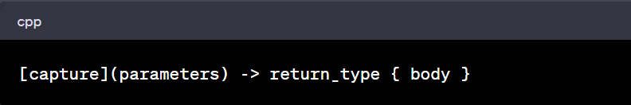

**Fuction callbacks:** Used for functional programming

**Template Programming**

**Exception handling**

Structure Member alignment (32bit system)

Dangling pointer

Free Store vs Heap

Pragma once

Preprocessors

Typedef

Using keyword in function body as typedef.

Try Catch flow

Operator precedence and Associativity

**Memory allocation is slow**

**Branch predictor**

**Instruction cache and**

**Enums over Branching**

Avoid Branching: ternary operator and Enums

**C++ 20 features:**

* **Coroutines:**

A coroutine is a function that can suspend execution to be resumed later. Coroutines are stackless: they suspend execution by returning to the caller and the data that is required to resume execution is stored separately from the call-stack.

In the context of C++20 coroutines, the term "stackless" refers to a specific type of coroutine implementation that doesn't rely on the regular call stack to manage its state. Traditional functions use the call stack to store local variables, function call information, and manage the flow of execution. In contrast, stackless coroutines have their own separate stack, often implemented as a heap-allocated structure, to manage their state.

NOTE: Coroutines cannot use variadic arguments, plain return statements, or placeholder return types (auto or Concept).

A function is a coroutine if its definition contains any of the following:

1. **co_await** expression — to suspend execution until resumed
2. **co_yield** expression — to suspend execution returning a value
3. **co_return** statement — to complete execution returning a value

**Coroutine structure:**

Each coroutine is associated with:

1. the promise object, manipulated from inside the coroutine. The coroutine submits its result or exception through this object.
2. the coroutine handle, manipulated from outside the coroutine. This is a non-owning handle used to resume execution of the coroutine or to destroy the coroutine frame.
3. the coroutine state, which is internal, dynamically-allocated storage containing:
   1. the promise object
   2. the parameters (all copied by value)
   3. some representation of the current suspension point, so that a resume knows where to continue, and a destroy knows what local variables were in scope
   4. local variables and temporaries whose lifetime spans the current suspension point.

**Flow:**

When a coroutine begins execution, it performs the following:

1. allocates the coroutine state object using operator **new**.
2. copies all function parameters to the coroutine state: by-value parameters are moved or copied, **by-reference parameters remain references** (thus, may become dangling).
3. calls the constructor for the promise object. If the promise type has a constructor that takes all coroutine parameters, that constructor is called, with post-copy coroutine arguments. Otherwise the default constructor is called.
4. calls promise.get_return_object() and keeps the result in a local variable. The result of that call will be returned to the caller when the coroutine first suspends. Any exceptions thrown up to and including this step propagate back to the caller, not placed in the promise.
5. calls promise.initial_suspend() and co_awaits its result. **Typical Promise types either return a std::suspend_always, for lazily-started coroutines, or std::suspend_never, for eagerly-started coroutines.**
6. when co_await promise.initial_suspend() resumes, starts executing the body of the coroutine.

Our coroutine returns a handle object. This Handle class/struct (“resumable” here) has a promise_type struct (nested class/struct) and this is what it looks like:

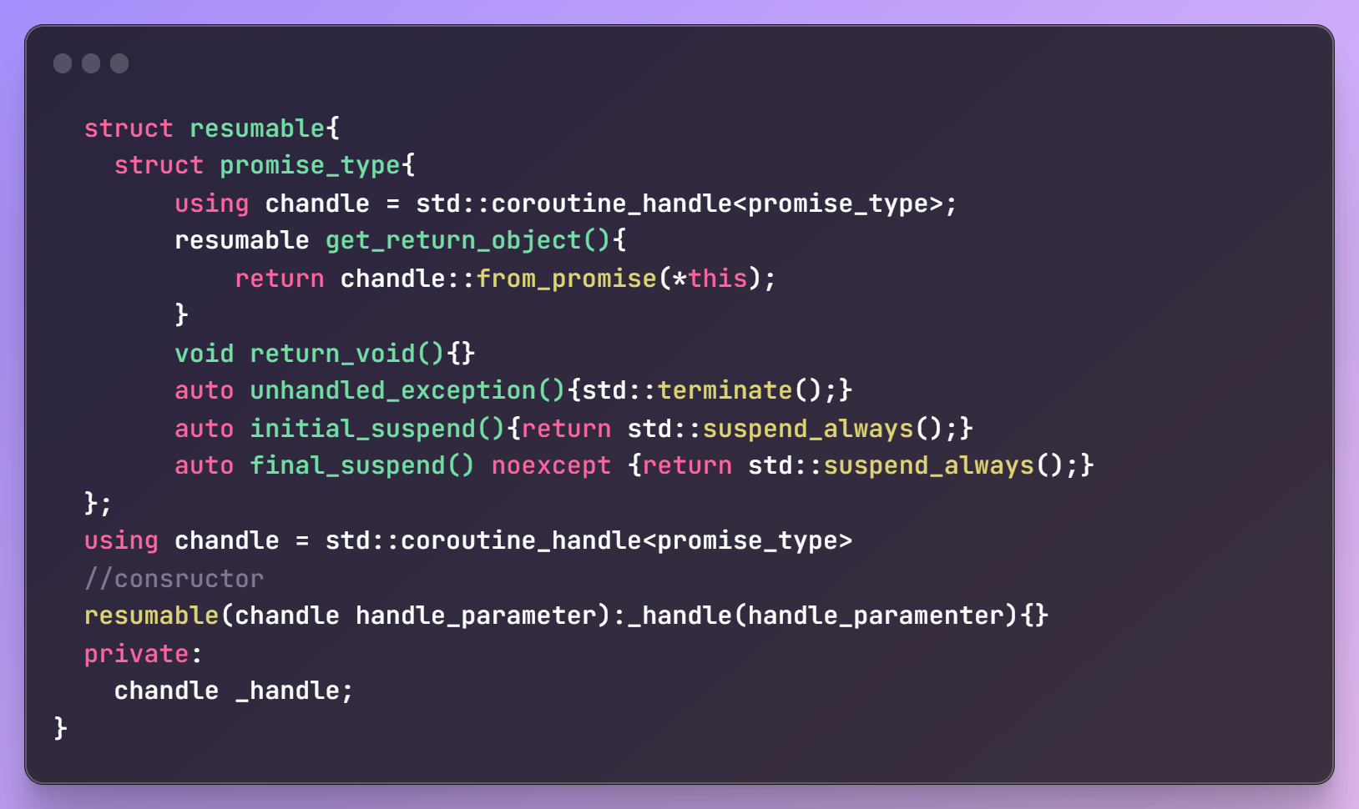

Note that since initial_suspend() function is called everytime we instantiate a coroutine handle, this function will tell if we want the coroutine to pause its execution and use *handle.resume()* from the caller to start coroutine manually {**using return std::suspend_always()**} or start coroutine execution as we instantiate the handle in the caller {**using return std::suspend_never()**}.

The coroutine handle has 3 template specializations: void, promise_type and std::noop_coroutine_promise. Lets first focus only on void and promise_type speciaizations. Rest we will do later.

Then our overall handle, coroutine and caller will look like:

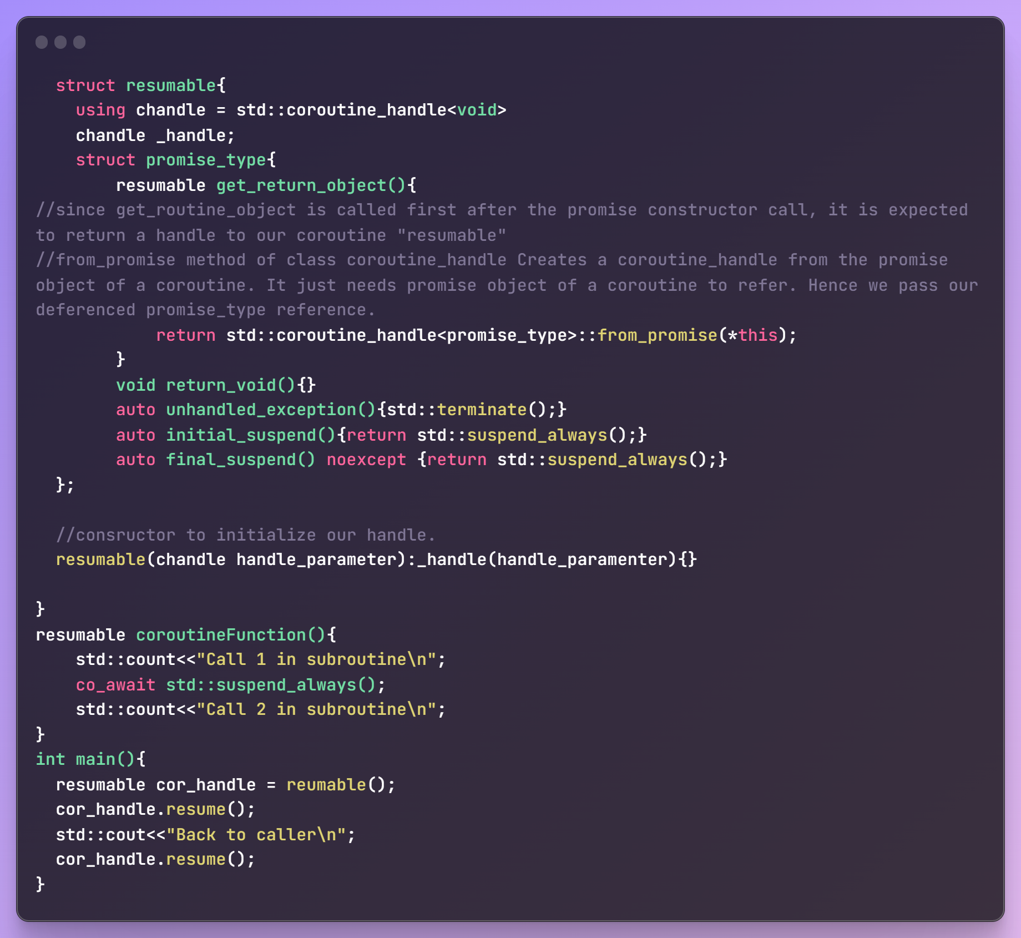

**C++ to Assembly: godbolt.com**

**HFT topics:**

* Const and const_cast<T>

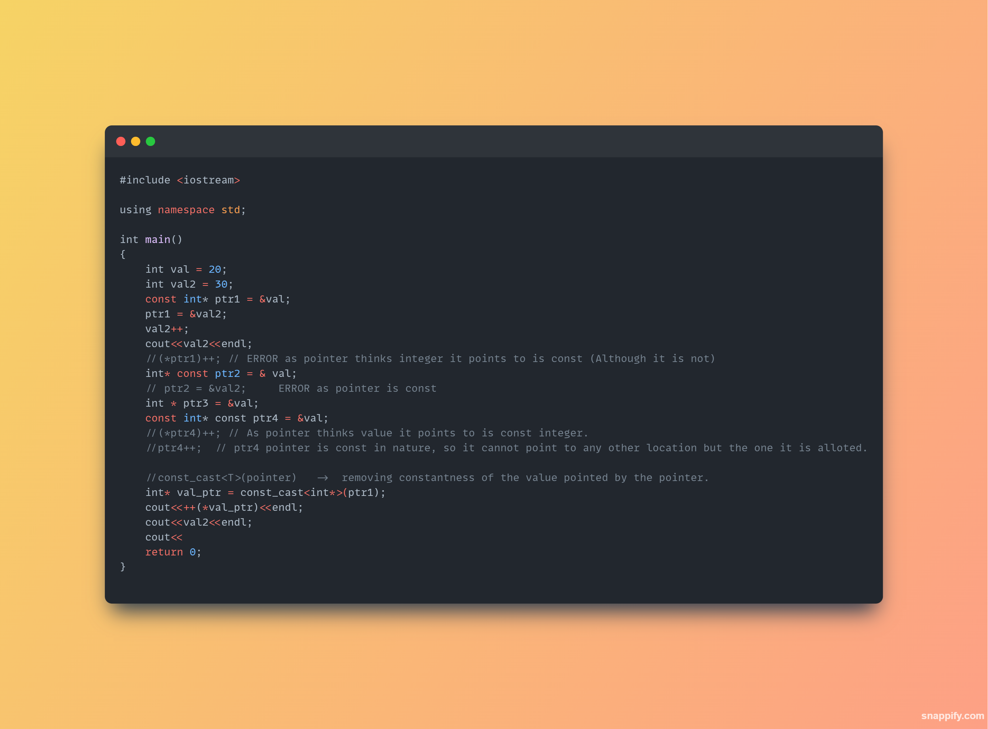

* **Difference between std::exit(), std::abort() and return() in c++:**
  + std::exit( status_flag_int ) and std::abort() are used to terminate the entire program. std::exit() allows you to specify an exit status code and performs memory cleanup (globals, allocated and statics), while std::abort() forcefully terminates the program without specifying an exit status code and without performing memory cleanup. The return statement is used to exit from a function and return a value to the caller, and when used in main(), it serves as a way to specify the program's exit status code to the OS (0 exit status code is considered to be a successful exit).
* **Custom terminate handler:** When a process encounters an unhandled exception, it will cause the program to terminate. But this will cause the program to abort abruptly. But if you want to handle somethings before exiting (in only abrubt termination case) we can have a custom terminate handler function which can be called like:

