**JavaScript**

Event Loop: (Single threaded, single call stack, Eeb APIs and Micro task Queue)

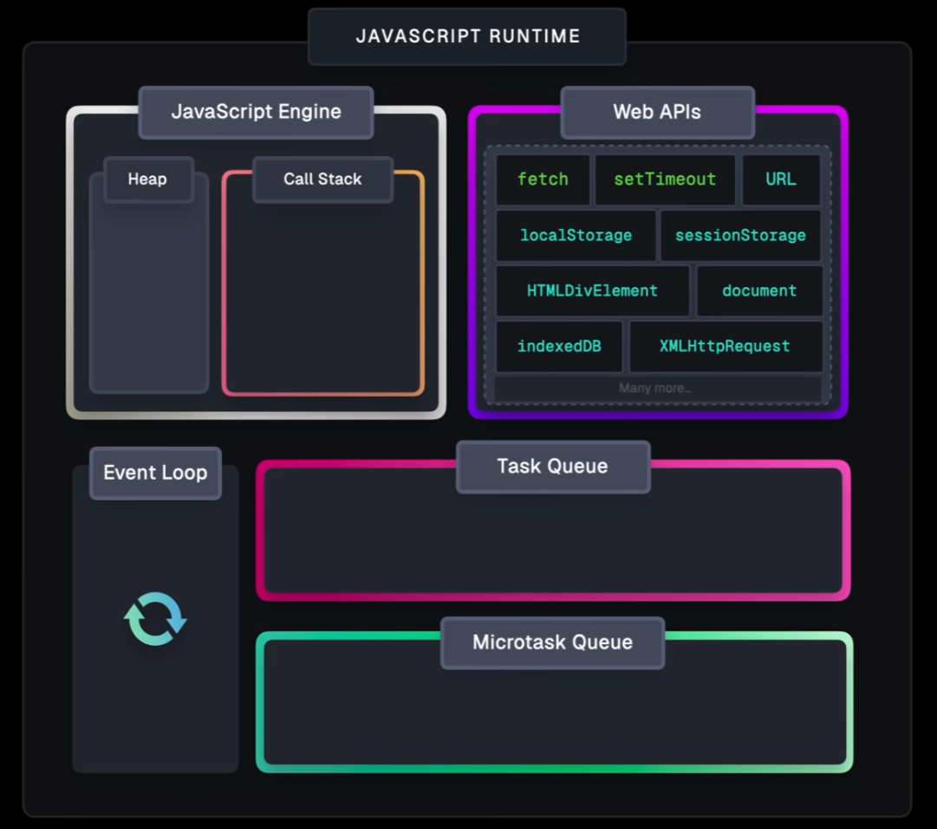

Browser environment:

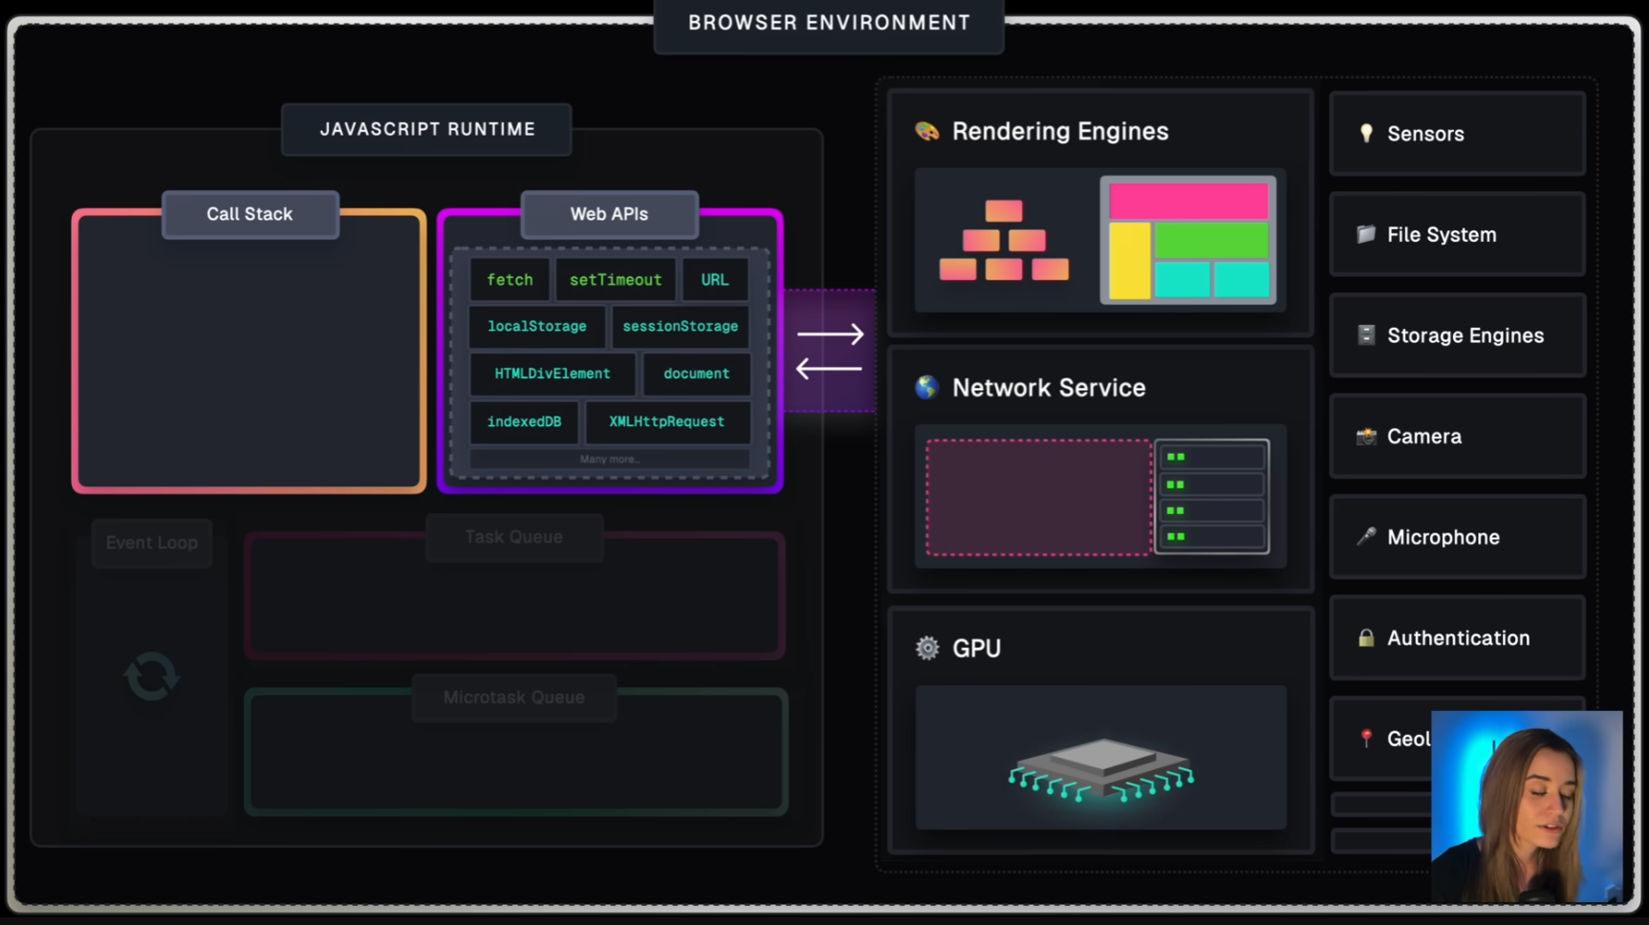

WebAPIs: