Trader-Performance-vs-Market-Sentiment
- Methodology & Key Steps
Part A: Data Preparation
  - Data Loading & Preview:
  - Loads the sentiment and trade datasets.
  - Performs initial inspection of columns and data types (e.g., ensuring timestamps are correctly formatted).
- Data Formatting & Merging:
  - Standardizes date formats to creating a common daily_date key.
  - Reasoning: Merging on a daily level allows us to attribute a specific market sentiment (e.g., "Extreme Fear") to every single trade executed on that day.
- Metric Creation:
  - Sentiment Grouping: Simplifies "Extreme Fear" into "Fear" and "Extreme Greed" into "Greed" for cleaner aggregation.
  - Trade Classification: Flags trades as is_win (Profit > 0) or is_long (Buy positions).
  - Aggregation: Calculates daily PnL, Win Rates, and Volume per sentiment group.
Part B: Insights
1. Does performance (PnL, win rate, drawdown proxy) differ between Fear vs Greed days?
Sentiment_Group | Closed PnL | Win Rate (%) | Size USD | Trade Count | Avg Loss (Drawdown Proxy)
Fear | 49.21208 | 40.78715 | 7182.011 | 83237 | -196.347
Greed | 53.88228 | 42.03112 | 4574.424 | 90295 | -164.614

Going through the table we can say, performance differs, but with a key shift: Greed days are now both more consistent and slightly more profitable per trade, whereas Fear days remain "High Risk" with larger bets but lower returns.
- Profitability & Consistency (Greed Wins): Unlike the previous dataset, Greed days now show a higher average PnL ($53.88) compared to Fear days ($49.21). This reinforces the "fair weather" advantage: during Greed, traders win more often (42.0% Win Rate) and make more money per trade.
- Risk Profile (Fear is Dangerous): Fear days are significantly riskier. While traders take much larger positions (avg size $7,182 vs $4,574 in Greed), they suffer from deeper average losses (-$196 vs -$164) and a lower win rate (40.8%).
Conclusion: The data indicates that during Greed, the market is "forgiving" traders who use smaller sizes but win more often and earn more. During Fear, traders "swing for the fences" with big positions but end up taking larger losses and earning less overall.
2. Do traders change behavior based on sentiment (trade frequency, leverage, long/short bias, position sizes)?
Sentiment_Group | Total Trades (Frequency) | Avg Position Size ($) | Long Ratio (%)
Fear | 83237 | 7182.011 | 49.50323
Greed | 90295 | 4574.424 | 47.08566

Based on the table, the trader’s behavior shifts drastically, characterized by larger, high-conviction bets during Fear and smaller, high-frequency speculation during Greed.
- Volume & Size (Whales vs. Retail): The data confirms a transition from institutional-style trading to retail speculation. Fear days see larger average positions (~$7,182), suggesting "smart money" accumulation. In contrast, Greed days see a +8.5% increase in volume (90,295 trades) but a sharp drop in trade size (~$4,574), indicating a flood of smaller players.
- Directional Bias (Persistent Shorting): Interestingly, traders remain Net Short in both environments (Long Ratio < 50%), but they are relatively more bullish during Fear. Having a long ratio of 49.5 % during Fear days whereas long ratio drops to 47.1%, showing that as sentiment improves, traders aggressively "fade the rally" by adding to short positions.
3. The Strategy Ideas
- Strategy: The "Fear Accumulator" (Smart Money Contrarian)
  - Concept: Mimic "Whale" behavior by accumulating positions during dips, but strictly manage size to avoid the statistical drag of Fear days.
  - The Data: Fear days show larger average bets ($7,182) but lower profitability (~$49/trade) and higher risk (Avg Loss -$196). Traders are relatively more bullish (Long Ratio 49.5%) here than in Greed.
  - The Rule: "When Sentiment = FEAR, adopt a position building style. Use the dip to accumulate larger positions (mimicking smart money) but reduce leverage. Since the 'win rate' is lower (40.8%), enter slowly in tranches rather than 'sniping' all at once. Be patient, as immediate profitability is statistically lower."
  - Target: Institutional/Whale traders looking for long-term entry.
- Strategy: The "Greed Momentum" (Ride the Wave)
  - Concept: Aggressively trade the trend. The market is "paying out" more consistently during these times.
  - The Data: Greed days are the "Sweet Spot"—highest win Rate (42%), highest Avg PnL (~$54), and safer drawdowns (-$165), despite smaller position sizes (~$4,574).
  - The Rule: "When Sentiment = GREED, switch to Maximum Active Participation. This is the most forgiving environment. Increase trade frequency and confidence, as both consistency (Win Rate) and payoff (Avg PnL) are at their peak. It is safer to use slightly tighter stops here compared to Fear days."
  - Target: Retail/Frequent traders capitalizing on forgiving market conditions.

4. Insights using segments
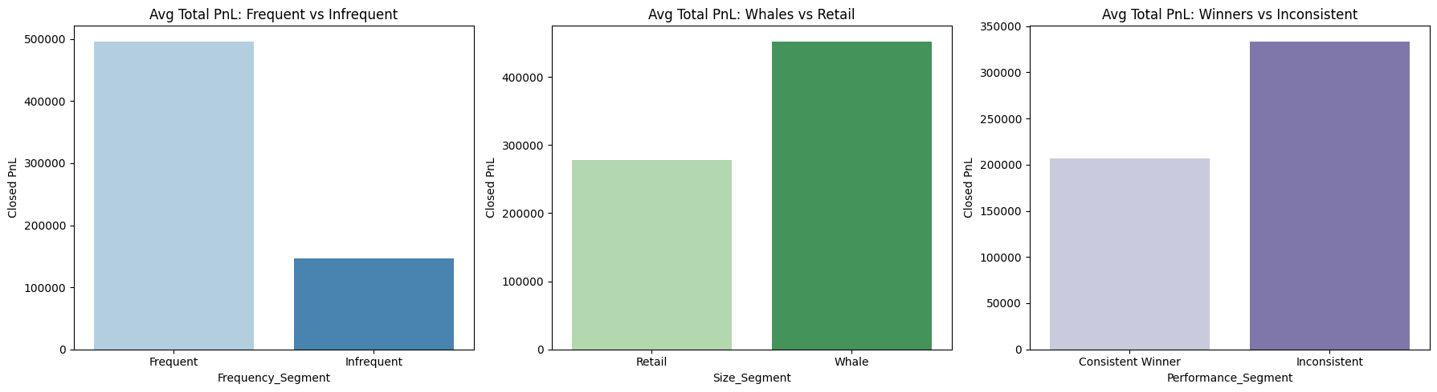
- The "Activity Multiplier": Profitability is highly correlated with market participation. Frequent Traders generated an average PnL of $496,528, which is 3.4x higher than Infrequent Traders (~$147,032).
- Capital Dominance (Whales vs. Retail): Larger capitalization provides a distinct competitive edge. Whales (Top 25% by size) earned an average of $452,713, significantly outperforming Retail traders who averaged $278,136.
- The "Consistency Paradox" (Quality > Quantity): Counter-intuitively, traders with a low win rate ("Inconsistent") are far more profitable with $333,668 Total PnL than those with a high win rate ("Consistent Winners").

