**Project Topic**

**System Information with Open-Source Software**

**LOVELY PROFESSIONAL UNIVERSITY**

**PHAGWARA, PUNJAB**



**Presented By**

**Name: Raj Singh**

**Registration Number: 11906052**

**Section: KE023**

**Roll Number: 7**

**Project GitHub Link: -** <https://github.com/suhelkhan2001/Sys_Info_Open_Source.git>

**Q. Using any Open Source Software to show system information utility, displays the Windows**

**product key and ID, a list of installed software, and all the currently running processes. Also, save**

**report in a simple text file.**

**Introduction**

**Description of the project: -**

🡪To accomplish this, the developer may choose to use various open-source tools, such as the Windows Management Instrumentation (WMI) or PowerShell, to extract system information. WMI is a powerful tool for querying and managing Windows systems, while PowerShell is a command-line shell and scripting language that can be used to automate system administration tasks.

**Objective of the project: -**

The main objective of this project is to develop a system information utility using open source software to display important system details on a Windows machine. Specifically, the utility will be able to display the Windows product key and ID, a list of installed software, and all currently running processes.

The project aims to provide a simple and easy-to-use tool that can extract and display system information in an efficient manner. By using open source software, the project also seeks to provide a cost-effective solution for Windows users who may not have access to expensive system information utilities.

Additionally, the project aims to provide the option for users to save the report in a simple text file, making it easier to share or refer to the information later.

Overall, the objective of this project is to provide a useful and efficient tool that can help Windows users better understand their system and troubleshoot any issues that may arise.

**Scope of the project: -**

The scope of this project is to develop a system information utility using open source software that will extract and display important system details on a Windows machine.

The utility will have the ability to display the Windows product key and ID, a list of installed software, and all currently running processes. This information will be gathered from the Windows operating system using open source tools such as the Windows Management Instrumentation (WMI) or PowerShell.

The system information utility will have a graphical user interface (GUI) or command-line interface (CLI) for users to easily view the information. Additionally, the utility will have the option for users to save the report in a simple text file for future reference.

The project will be limited to displaying information on Windows machines only. It will not include any system modification or optimization features. It will also not include the ability to gather information on networked computers or devices.

The scope of the project also includes using open source software to develop the utility, ensuring that the tool is free, flexible, and customizable. The project may also involve collaborating with other developers to improve the utility over time.

Overall, the scope of this project is to develop a simple, efficient, and cost-effective system information utility for Windows users, using open source software and tools.

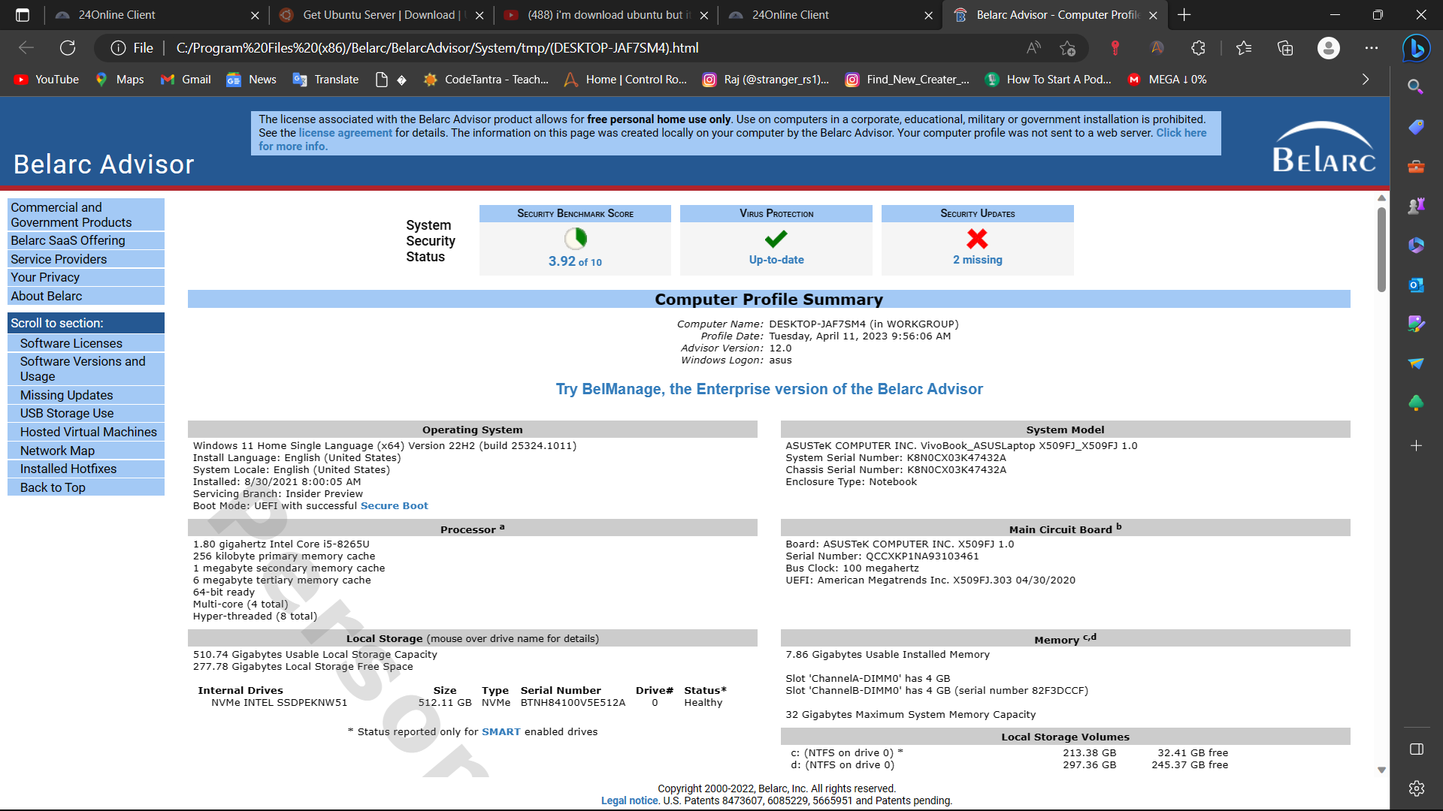

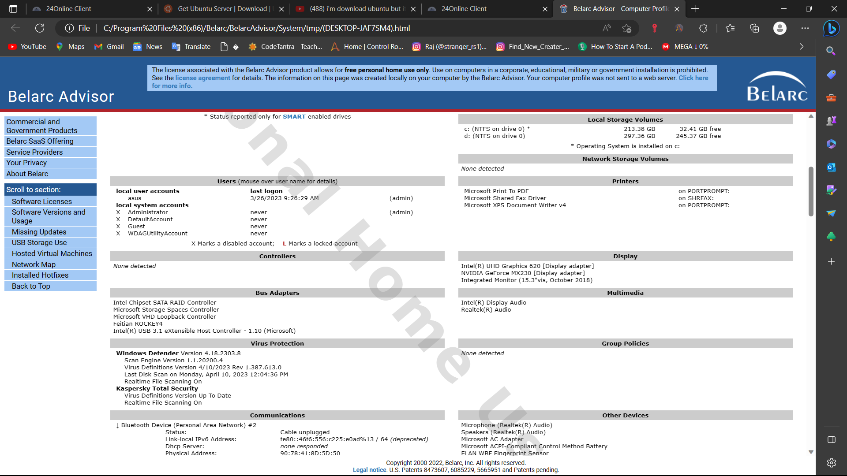

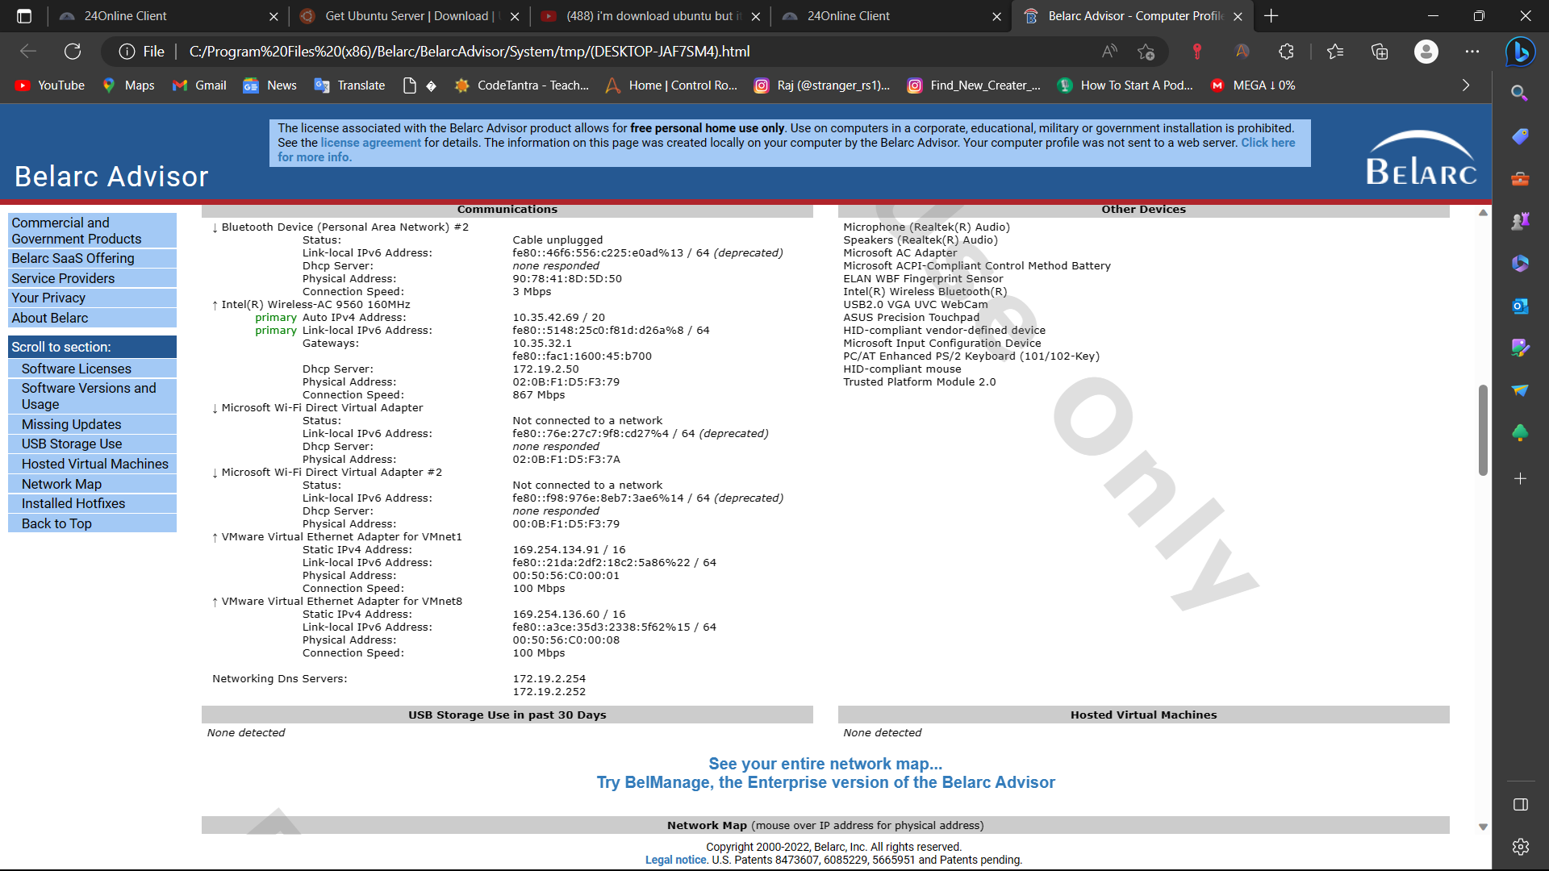

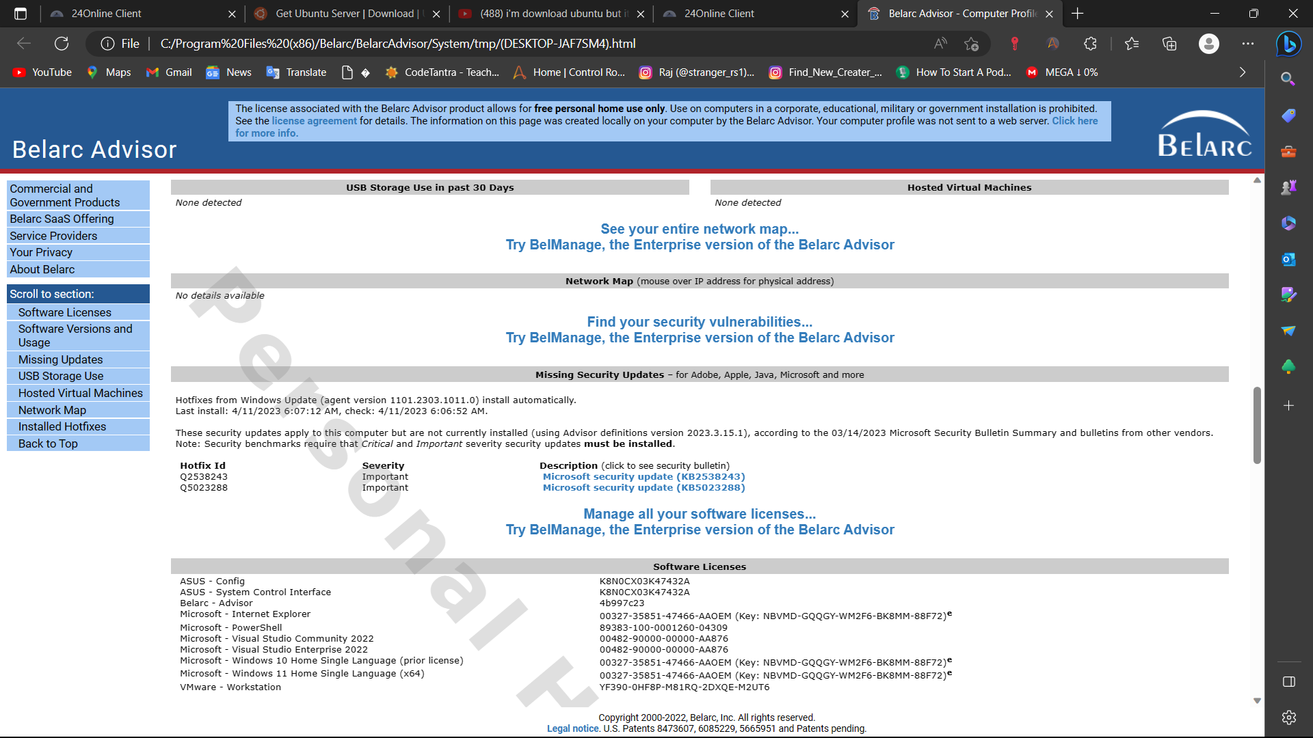

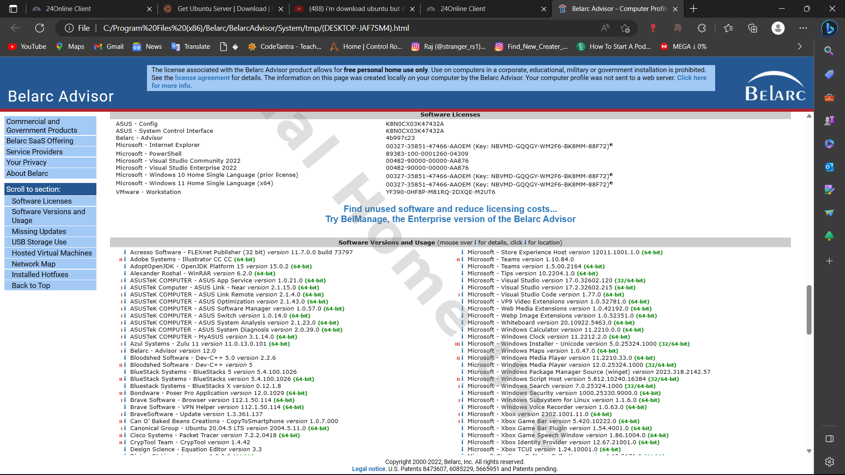

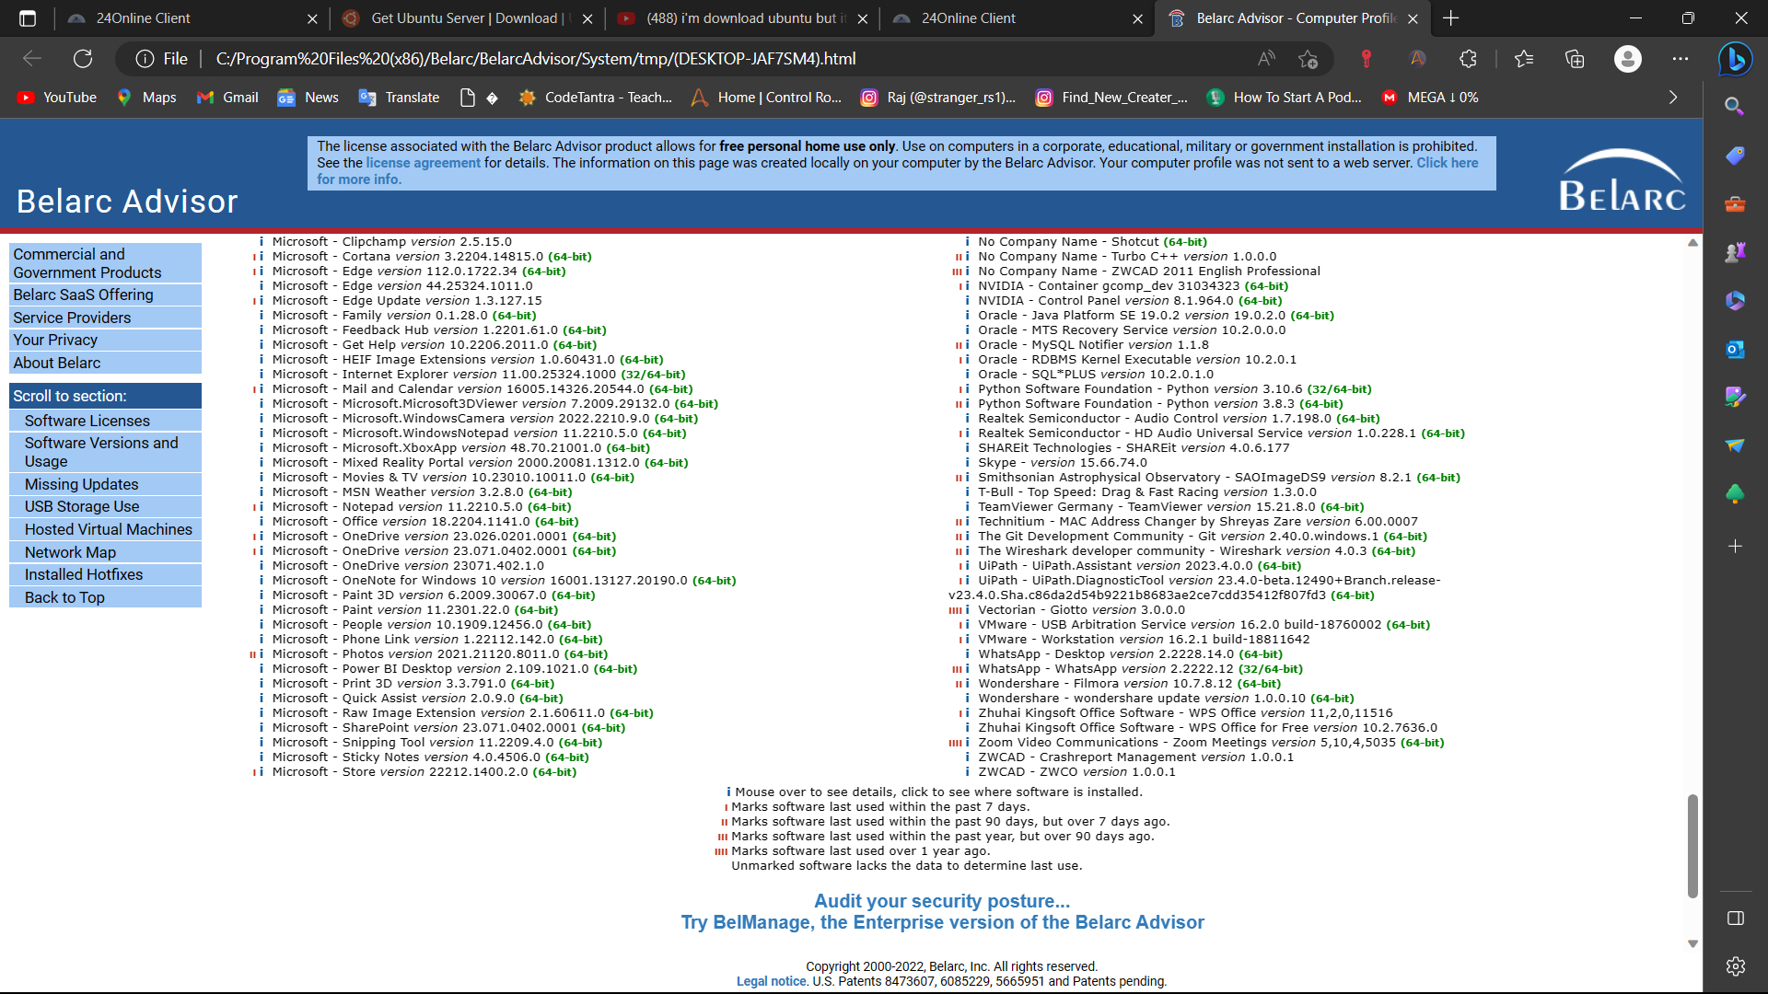

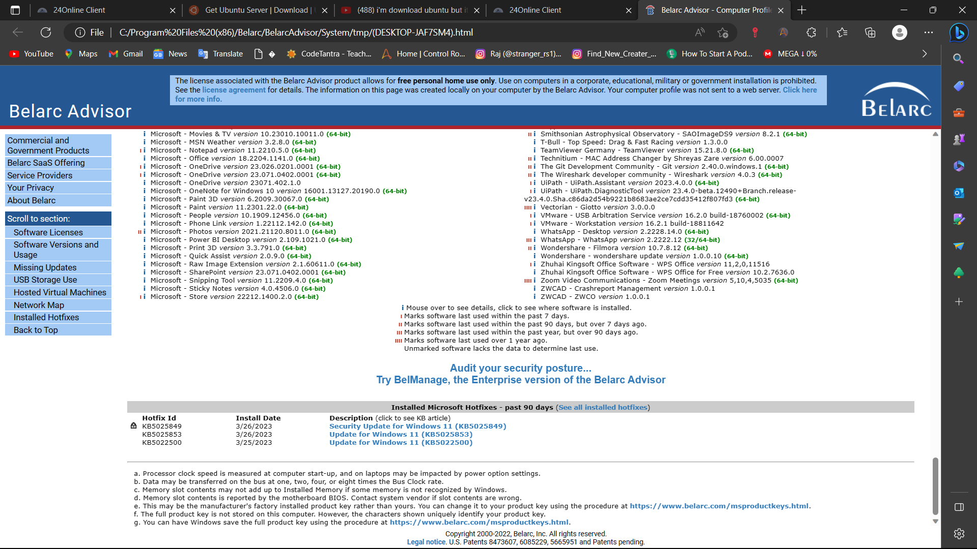

**Reference/ Bibliography**

Some general references and resources related to the topic of open-source software for system information and performance monitoring:

"hwinfo" official website: https://www.hwinfo.com/

"mpstat" man page: https://linux.die.net/man/1/mpstat

"free" man page: https://linux.die.net/man/1/free

"iostat" man page: https://linux.die.net/man/1/iostat

"sysstat" official website: <https://github.com/sysstat/sysstat>

"Top 10 Linux Performance Monitoring Tools" by Ravi Saive, published on Tecmint: https://www.tecmint.com/top-linux-performance-monitoring-tools/

"10 Tools to Monitor Your Linux Server – Network and System Monitoring" by Magesh Maruthamuthu, published on LinuxTechi: https://www.linuxtechi.com/10-tools-monitor-linux-server-performance/

"Linux System Monitoring: Top 12 Tools" by Jeffry R. Davis, published on Datamation: https://www.datamation.com/open-source/linux-system-monitoring-tools.html

"Linux Performance Monitoring and Tuning" by Brendan Gregg, published on the Oracle Technology Network: https://docs.oracle.com/cd/E37670_01/E37355/html/ol_perfmon_tuning.html

"Linux Performance Monitoring with perf" by Brendan Gregg, published on his website: http://www.brendangregg.com/linuxperf.html

