**BLOOD DONATION SYSTEM**

|  |
| --- |
| ***A Synopsis Submitted*** |
| ***In Partial Fulfillment*** |
| ***for award of Bachelor of Technology***  ***for***  **Web Technologies (BCSE0555)** |
|  |
| **In** |
| **COMPUTER SCIENCE AND ENGINEERING** |
|  |
| **By** |
|  |
| **Naman Pundir(2301330100130)**  **Raj Singh(2301330100160)**  **Manish Gaur(2301330100111)** |
|  |
| **Under the Supervision of**  **Mr. Surya Prakash Sharma**  **Assistant Professor, CSE**    **Department of Computer Science & Engineering**  **School of Computer Science and Information Technology**  **NOIDA INSTITUTE OF ENGINEERING AND TECHNOLOGY**  **GREATER NOIDA** |

## 2. Abstract

. The **Blood Donation Management System** is a web-based platform developed to simplify and automate the process of managing blood donors, donation records, blood inventory, and hospital or recipient requests. Traditionally, blood banks and healthcare organizations have relied on manual methods such as paper-based records or spreadsheets to manage donor information and track blood availability. These traditional approaches often lead to inefficiencies, human errors, data duplication, and difficulty in accessing critical information during emergencies. As the volume of donors, requests, and transactions grows, these issues become increasingly problematic.

This project proposes a **centralized and automated solution** that addresses these challenges by offering an interactive platform for blood donors, hospitals, and administrators. The system is developed using **HTML, CSS, and JavaScript** for the front end, and **PHP with MySQL** for backend operations and database management.

## 3. Introduction

In today’s fast-paced and technology-driven world, digital solutions have become essential for managing various aspects of daily life and organizational activities. Blood donation management is one such area where manual processes are still widely used, especially in local clinics, small blood banks, and charitable organizations. While larger hospitals may have access to sophisticated donor management systems, smaller entities often face challenges due to a lack of affordable and efficient tools.

This project, titled **Blood Donation Management System**, is introduced as a practical and cost-effective solution to overcome these limitations. The system aims to digitize blood donation-related activities, making it easier to maintain donor records, track blood inventory, and manage requests from hospitals or patients—all within one centralized platform. With the growing need for organized blood donation services in both urban and rural areas, the system has broad applicability across healthcare institutions and non-profit organizations.

The introduction of such a system is not only relevant but also highly significant, as it addresses the growing need for **efficiency, transparency, and reliability** in blood donation processes. The scope of this project includes modules for donor registration, blood inventory management, donation tracking, and emergency request handling. The system will be accessible through a web browser, ensuring flexibility and ease of use for administrators, hospitals, and donors.

**Scope:**

**Donor registration and profile management**

**Blood inventory tracking and management**

**Hospital/patient request handling**

**Centralized and secure database for records**

## 4. Problem Statement

Blood donation management is a multi-faceted task that involves maintaining accurate records of donors, tracking blood inventory, responding to urgent blood requests, and organizing donation events. Many local blood banks, hospitals, and non-profit organizations continue to rely on paper-based systems or spreadsheets to manage these tasks. While such methods may work on a small scale, they quickly become inefficient and error-prone as the number of donors, donations, and requests increases.

Existing digital solutions, though advanced, are often tailored for large hospitals or government-run blood banks and come with high subscription fees, complex interfaces, and technical requirements. This makes them unsuitable for smaller clinics, NGOs, or community blood banks. Some of the major challenges include:

* **Mismanagement of donor records and eligibility tracking**
* **Lack of a proper system for managing blood inventory and availability**
* **Delays in responding to emergency blood requests**
* **Absence of an affordable and easy-to-use platform for small organizations**

Therefore, there is a clear need for a **lightweight, user-friendly, and cost-effective system** that simplifies the blood donation process while maintaining accuracy, transparency, and responsiveness.

## 5. Objectives

The main objectives of the **Blood Donation Management System** are to design, develop, and implement a digital platform that streamlines the management of donors, blood inventory, and blood request processes. The specific objectives include:

1. **To develop a web-based application** that provides centralized management of blood donation activities.
2. **To allow administrators to add, update, and manage donor details** efficiently, including blood type, donation history, and eligibility status.
3. **To provide functionalities for donor registration and record management**, including personal details, last donation date, and health status.
4. **To implement blood inventory tracking**, monitor available stock levels, and generate alerts or reports for low or expiring units.
5. **To introduce a request management system** that enables hospitals or patients to submit blood requests and allows administrators to track and fulfill them.
6. **To design the system to be scalable and flexible** for future enhancements such as integration with SMS/email notifications and mobile application development.

By achieving these objectives, the project ensures that blood donation management becomes more **efficient, reliable, and responsive**, especially in emergency situations where timely access to blood is critical.

## 6. Literature Review / Existing System

A study of existing blood donation management solutions reveals that most professional software systems are designed for large-scale hospitals or government-run blood banks, offering a wide range of advanced features such as hospital network integration, automated diagnostics, and extensive analytics. While these features are beneficial for large healthcare institutions, they are often unnecessary and overly complex for smaller clinics, community blood banks, or non-profit organizations. In addition, such systems usually require high subscription fees, making them financially inaccessible for small-scale users.

On the other hand, manual methods—such as spreadsheets or paper-based donor logs—lack essential features like donor eligibility tracking, automated reminders, inventory alerts, and secure data storage. These approaches are prone to human error, demand significant manual effort, and make data retrieval and real-time coordination difficult.

The proposed **Blood Donation Management System** stands out by combining the **affordability and simplicity** of manual methods with the **efficiency and reliability** of digital systems. It focuses on delivering the **most essential features** through a **clean, intuitive interface**, making it easy to use even for individuals with limited technical experience.

## 7. Proposed System

**Overview**:  
The proposed Blood Donation Management System will streamline donor registration, blood inventory management, and request handling through a web-based platform.

**Features:**

• Donor registration and management

• Blood donation record management

• Blood inventory tracking

• Blood request logging and status updates

**System Design Approach:**

* Database-driven design (MySQL/PHP backend)
* Responsive front-end (HTML, CSS, JavaScript)

**Advantages:**

* Cost-effective
* Easy-to-use interface
* Centralized data access
* Scalability for future features

## 8. Methodology

**Implementation Plan:**

1. Requirement Analysis
2. Database design (MySQL)
3. Frontend design (HTML, CSS, JS)
4. Backend development (PHP)
5. Integration & testing
6. Deployment

**Tools & Technologies:**

* Frontend: HTML, CSS, JavaScript
* Backend: PHP/XAMPP
* Database: MySQL
* IDE: VS Code/XAMPP

**Workflow Diagrams:**

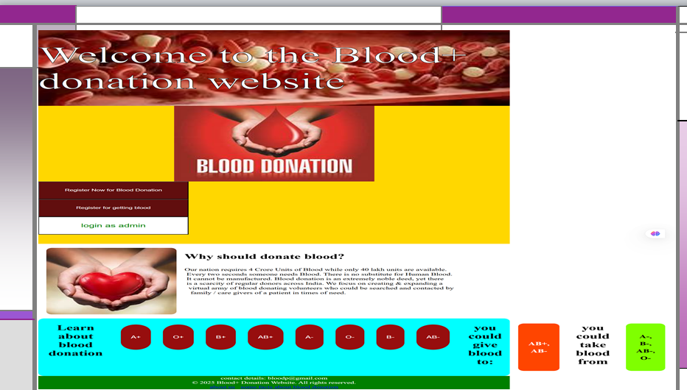

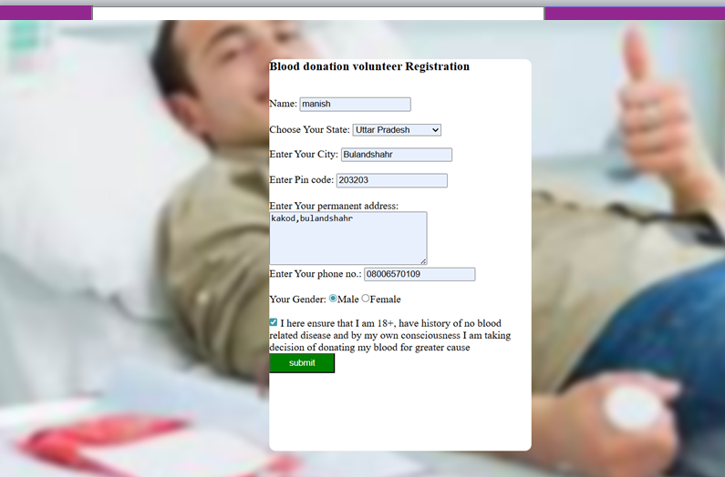 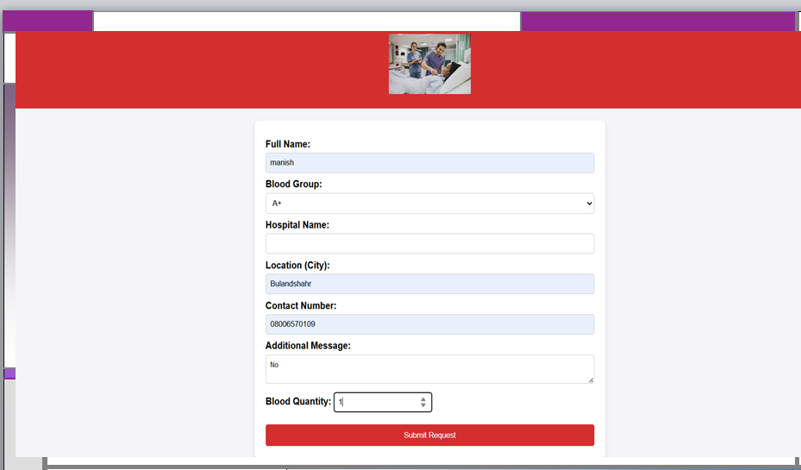 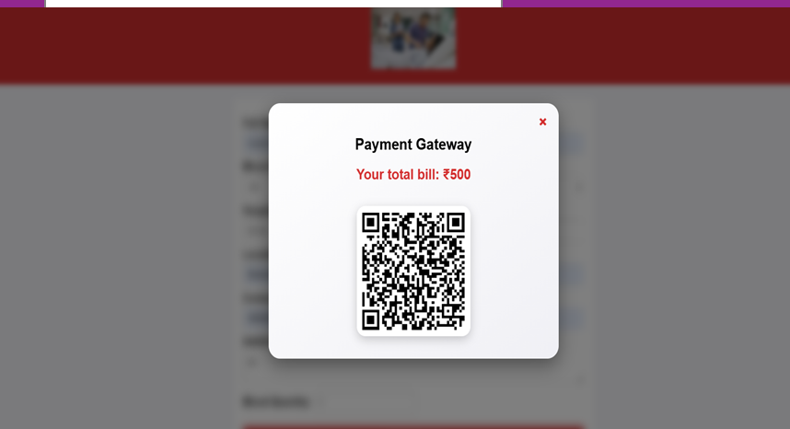

## 9. Hardware and Software Requirements

**Hardware:**

* Processor: Intel i3 or above
* RAM: 4GB minimum
* Storage: 500MB free space

**Software:**

* OS: Windows/Linux
* Database: MySQL
* Server: XAMPP/WAMP
* Browser: Chrome/Firefox
* IDE: VS Code/Notepad++

## 10. Expected Output / Results

The expected result of the project is a **fully functional web application** that automates blood donation management tasks in a structured and efficient manner. The system will provide a **secure login page for administrators or authorized staff**, leading to a dashboard that summarizes key activities such as available blood inventory, upcoming or overdue donor eligibility, and pending blood requests.

The **donor management module** will allow administrators to add, view, update, and delete donor records, including personal information, blood type, donation history, and eligibility status. The **inventory management module** will track blood stock levels by type and expiration date. The **request handling module** will display incoming blood requests from hospitals or patients, along with their fulfillment status and urgency.

The system will also be capable of generating **simple reports and summaries**, such as blood availability by type, recent donations, and fulfilled or pending requests. If time permits, **sample screenshots and mockups** of the system will be included to visually represent the expected output and user interface.

Bottom of Form

## 11. Applications

The **Blood Donation Management System** has wide-ranging applications across hospitals, clinics, community health centers, and non-profit organizations. Blood banks can use the system to keep donor records organized, monitor blood inventory, and respond to urgent blood requests efficiently. Healthcare NGOs and local clinics can implement it to manage donor outreach, schedule donation events, and maintain communication with regular donors.

For small organizations and rural health units, the system offers a **cost-effective alternative** to complex and expensive commercial software. It can also be extended to support regional blood banks, mobile blood drives, or hospital networks, providing flexibility across different healthcare settings. The application is **scalable and adaptable**, making it a practical tool for small clinics, blood donation campaigns, and even startups in the health tech space.

## 12. Future Enhancements

While the initial version of the **Blood Donation Management System** will focus on core functionalities such as donor management, blood inventory tracking, and request handling, several future enhancements can make the system even more powerful and efficient. One key improvement is the integration of **automated SMS or email notifications** to remind donors about upcoming eligibility for donation or to confirm appointment schedules.

A **mobile application version** of the system can be developed to make the platform accessible on smartphones, increasing convenience for donors, hospital staff, and administrators. Additionally, advanced data analytics and reporting tools can be introduced to provide insights into donation trends, blood usage patterns, and donor retention rates. Features such as **document uploads** for medical clearances, **digital certificates** for donors, and **chat-based communication** between donors and blood banks can further enhance usability.

These future enhancements will make the system more **robust, scalable, and suitable for a wider audience**, helping to improve the overall efficiency and responsiveness of blood donation management.

## 13. References

The development of the Property Management System is supported by a variety of resources, including standard web development tutorials and documentation. Websites such as **W3Schools, GeeksforGeeks, and PHP & MySQL official documentation** will serve as key references for coding and implementation. Additional resources include online guides for **HTML, CSS, JavaScript, and PHP**, as well as research papers and articles discussing the challenges and solutions in modern property management. Books on software development methodologies and database design principles will also contribute to the technical foundation of the project.