|  |  |  |  |  |  |  |  |  |
| --- | --- | --- | --- | --- | --- | --- | --- | --- |
| **BlOOD DONATION SYSTEM**   |  | | --- | | ***A Report Submitted*** | | ***In Partial Fulfillment***  ***for award of Bachelor of Technology***  ***for***  **Web Technologies (BCSE0555)** | | **In** | | **COMPUTER SCIENCE AND ENGINEERING** | | **By** | | **Naman Pundir(2301330100130)**  **Raj singh(2301330100160)**  **Manish Gaur(2301330100111)** | | **Under the Supervision of**  **Dr. Surya Prakash Sharma**  **Assistant Professor, CSE** | | **Department of Computer Science & Engineering**  **School of Computer Science and Information Technology**  **NOIDA INSTITUTE OF ENGINEERING AND TECHNOLOGY,GREATER NOIDA** | |
|  |
|  |
|  |

**DECLARATION**

We hereby declare that the work presented in this report was carried out by us. we have not submitted the matter embodied in this report for the award of any other degree or diploma of any other University or Institute.

|  |  |
| --- | --- |
| Name : NAMAN PUNDIR  Roll Number : 2301330100130  Name : RAJ SINGH  Roll Number : 2301330100160  Name : MANISH GAUR  Roll Number : 2301330100111 |  |

**CERTIFICATE**

Certified that **Naman(2301330100130) Raj(2301330100160) Manish(2301330111)** have carried out the Web Technologies (BCSE0555) minor project work presented in this Project Report at NIET GREATER NOIDA for the award of **Bachelor of Technology**, **department name** from Dr. APJ Abdul Kalam Technical University, Lucknow under our supervision.

|  |  |
| --- | --- |
| Signature-_____________  Mr.Surya Prakash sharma  CSE DEPARTMENT  NIET Greater Noida  Date: 20.09.2025 | HOD Signature -____________  Mrs.KUMUD SAXENA  (CSE HOD)  NIET Greater Noida |
|  |  |

**ACKNOWLEDGEMENT**

We would like to express our gratitude towards Dr. Surya Prakash Sharma for their guidance, support and constant supervision as well as for providing necessary information during our Web Technology project development.

Our thanks and appreciations to respected HOD, for their motivation and support throughout.

# ABSTRACT

1. Blood shortages during emergencies are a serious issue.

2. Website provides an online platform to connect donors and recipients.

3. Built using HTML, CSS, PHP, JS & MySQL.

4. Features: Donor registration, recipient request, quick search.

5. Expected outcome: faster blood availability in emergencies.

**TABLE OF CONTENTS**

**Page No.**

Declaration i

Certificate from the institute ii

Certificate from the industry iii

Acknowledgement iv Abstract v

**CHAPTER 1: INTRODUCTION** **1**

1.1 INTRODUCTION

1.2 OBJECTIVES

**CHAPTER 2: LITERATURE REVIEW 2**

2.1 TECHONOLOGICAL SHIFTS IN BLOOD DONATION

**CHAPTER 3: REQUIREMENT 3**

2.1 SOFTWARE REQUIREMENTS

2.2 HARDWARE REQUIREMENTS

**CHAPTER 4: IMPLEMENTATION & TESTING 4-5**

2.1 SNAPSHOTS OF CODE IMPLEMENTATION

**CHAPTER 5: CONCLUSION AND FUTURE WORK**

**REFERENCES**

**APPENDICES 6-16**

**CURRICULUM VITAE**

**CHAPTER 1-INTRODUCTION**

**1.1 INTRODUCTION:**

1. Blood donation saves lives but traditional systems are manual & slow.

2. Lack of real-time donor availability information.

3. Online platforms improve accessibility and speed.

4. Scope: Students, staff, hospitals, and volunteers.

* 1. **Objectives:**

1. To build an online portal for donor-recipient connection.
2. To maintain a searchable donor database.
3. To implement donor registration and request system.
4. To provide admin panel for data management.

**CHAPTER 2 – LITERATURE REVIEW**

**LITERATURE REVIEW:**

1. Existing blood banks maintain offline/limited online records.
2. Apps exist but are not widely available in rural areas.
3. Our project improves accessibility with a simple web interface.

**2.1 TECHONOLOGICAL SHIFTS IN BLOOD DONATION SYSTEMS**

#### a. ****Web-Based Applications****

Web-based blood donation systems provide platforms where donors, hospitals, and blood banks can interact in real time. These applications often include features like:

Donor registration

Blood request posting

SMS/Email notifications

Availability tracking

**Example:** A study by Sharma et al. (2021) developed a web application for blood banks that allowed users to search for blood by type and location. The system improved access to blood and reduced the time taken to find donors.

#### b.****Mobile-Responsive Design****

Web platforms today are built to be mobile-responsive, allowing users to access them on smartphones. This is crucial since many users, especially in developing countries, access the internet primarily via mobile.

**CHAPTER 3- REQUIREMENT**

**REQUIREMENT:**

3.1 SOFTWARE REQUIREMENTS:

1. Windows/Linux

2. XAMPP / php

3. MySQL

4. VS Code,

5. Browser

3.2 HARDWARE REQUIREMENTS:

1. i3/i5 Processor

2. 4GB+ RAM

3. 250GB+ HDD

**CHAPTER 4 IMPLEMENTING & TESTING**

4.1 CODE SNAPSHOTS

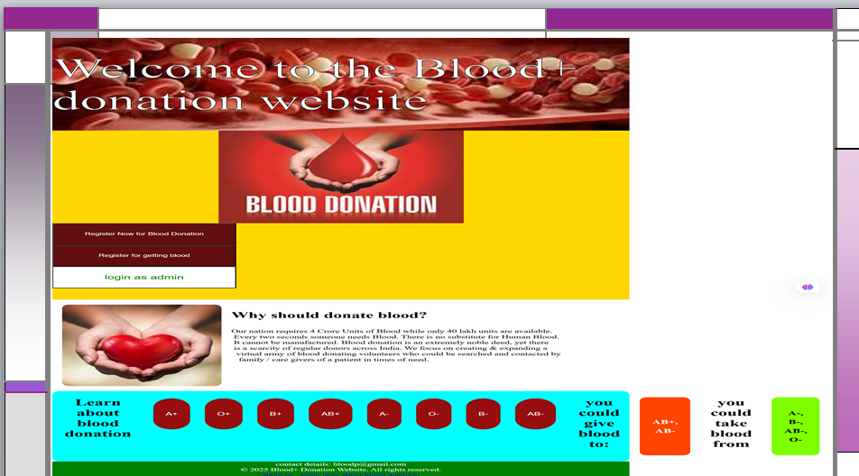

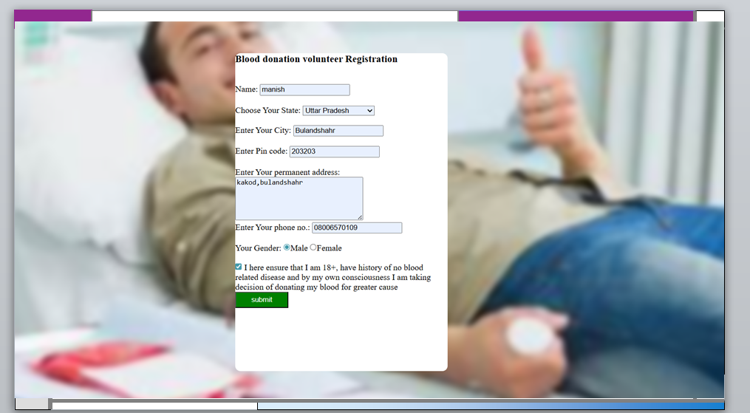

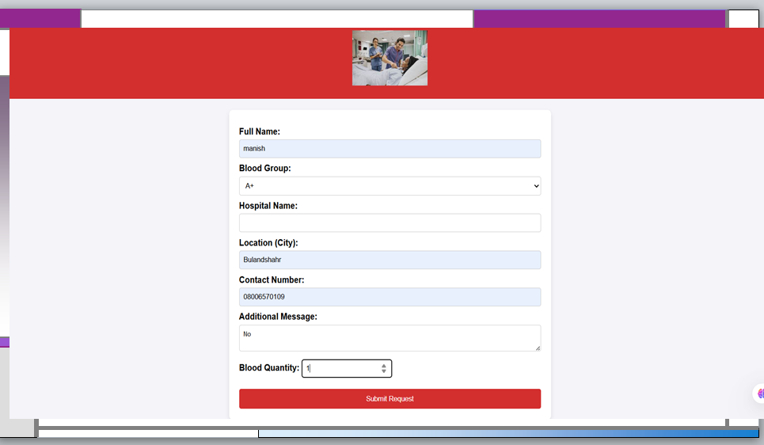

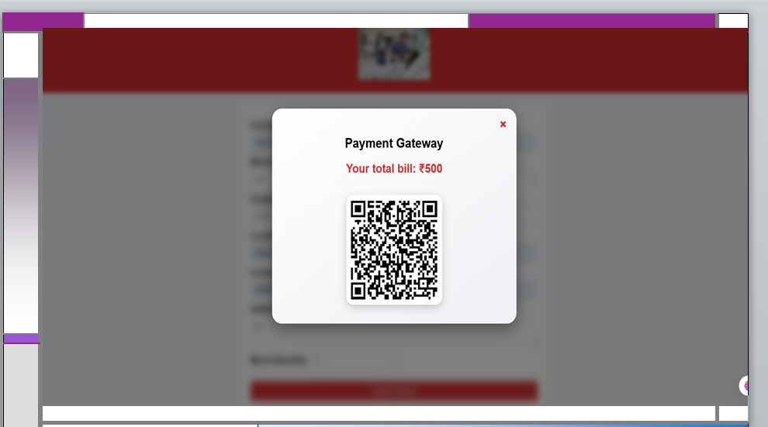

**CHAPTER 5 - CONCLUSION & FUTURE WORK**

**Conclusion**

The Blood Donation Web Application was successfully developed and implemented to address critical challenges in the traditional blood donation system. Through the use of modern web development technologies, the platform allows donors, hospitals, and blood banks to interact seamlessly in real-time. Key features such as donor registration, blood request posting, location-based search, and notifications significantly enhance the efficiency, accessibility, and transparency of the blood donation process.

The system has proven to be user-friendly, secure, and effective in streamlining operations for both donors and healthcare providers. Rigorous testing confirmed the functionality, security, and reliability of the platform, with positive feedback from initial users indicating high usability and engagement.

Overall, the project demonstrates how technology can be leveraged to support healthcare infrastructure and improve emergency response times related to blood availability.

**Future Work**

Although the current system meets the basic functional requirements, there is scope for further enhancement and scalability. The following future improvements are recommended:

1. **Mobile Application Integration**

Develop a native mobile app (Android/iOS) to complement the web application for easier access and push notifications.

2. **AI-Based Blood Demand Prediction**

Implement machine learning models to analyze past trends and predict future blood demands regionally, helping blood banks prepare in advance.

3. **Multi-Language Support**

Add support for multiple languages to make the platform more accessible to users from different linguistic backgrounds.

4. **Advanced Security Features**

Enhance security with two-factor authentication (2FA), CAPTCHA, and activity logs to prevent unauthorized access and improve data integrity.

5. **Integration with Government and Hospital Databases**

Link the system with national health databases and hospital inventories to ensure real-time data sharing, traceability, and compliance with medical standards.

6. **Gamification & Donor Incentives**

Introduce badges, leaderboards, and rewards to encourage regular blood donations and improve donor retention.

7. **Analytics Dashboard for Admins**

Develop a dashboard that shows key performance metrics such as donation frequency, blood stock levels, and user activity to aid decision-making.

8. **Geographical Expansion**

Scale the platform to serve multiple cities or countries with localized support, regulations, and partnerships with local hospitals.

**REFERENCES**

World Health Organization (WHO). (2020). Global Status Report on Blood Safety and Availability. <https://www.who.int/publications/i/item/9789240000384>

Singh, A., Verma, R., & Yadav, M. (2020). E-Blood Donation System: A Survey of Web and Mobile-Based Technologies. International Journal of Advanced Computer Science and Applications (IJACSA), 11(7), 250–256. https://doi.org/10.14569/IJACSA.2020.0110733

Kumar, S., & Das, D. (2021). Security Aspects of Web-Based Health Applications: A Review on Blood Donation Systems. Journal of Medical Systems, 45(9), Article 102. https://doi.org/10.1007/s10916-021-01720-2

W3C. (2022). Web Accessibility Guidelines (WCAG) 2.1. <https://www.w3.org/TR/WCAG21/>

OWASP Foundation. (2023). OWASP Top 10: Web Application Security Risks. https://owasp.org/www-project-top-ten/

Google Developers. (2023). Getting Started with Google Maps JavaScript API. https://developers.google.com/maps/documentation/javascript/tutorial

APPENDICES

**Appendix A: Sample Screenshots of Web Application**

**User Registration Page**  
![Screenshot of Registration Page]

**Donor Dashboard**

View available blood requests

Update profile information

Track donation history

**Blood Request Form (Hospital View)**

Fields: Blood group, quantity, urgency, location

**Admin Panel Interface**

User management

View system logs and analytics

**Appendix B: Database Schema**

**Tables and Key Fields:**

**users**

id (Primary Key)

name, email, password, blood_group, role, last_donation_date

**requests**

id, hospital_id, blood_group, quantity, location, created_at, status

**appointments**

id, user_id, date_time, status

**donations**

id, user_id, request_id, donation_date, verified

**Appendix C: Test Case Table (Expanded)**

| Test Case ID | Test Description | Input Data | Expected Output | Status |
| --- | --- | --- | --- | --- |
| TC001 | Donor registers account | Valid user data | Redirect to login page | Pass |
| TC002 | Hospital posts a blood request | Blood type, location | Request is posted successfully | Pass |
| TC003 | Search for A+ blood | Location + blood group | List of nearby donors displayed | Pass |
| TC004 | Schedule donation for same day | Today's date | Warning message or error | Pass |
| TC005 | SQL injection attempt in login | ' OR '1'='1 | Access denied or error message | Pass |
| TC006 | Donor updates profile | New name, email | Profile updated successfully | Pass |

**Appendix D: Code Snippets**

**D.1 User Registration (Backend - Node.js/Express Example)**

app.post('/register', async (req, res) => {

const { name, email, password, bloodGroup } = req.body;

const hashedPassword = await bcrypt.hash(password, 10);

const newUser = new User({ name, email, password: hashedPassword, bloodGroup });

await newUser.save();

res.status(201).send('User registered');

});

**D.2 Blood Request Form Submission (PHP Example)**

if (isset($_POST['submit'])) {

$bloodType = $_POST['blood_group'];

$quantity = $_POST['quantity'];

$location = $_POST['location'];

$query = "INSERT INTO requests (blood_group, quantity, location) VALUES ('$bloodType', '$quantity', '$location')";

mysqli_query($conn, $query);

}

**Appendix E: Tools & Technologies Used**

| Category | Tool / Technology |
| --- | --- |
| Front-End | HTML, CSS, JavaScript, Bootstrap |
| Back-End | Node.js / PHP / Python (Flask/Django) |
| Database | MySQL / PostgreSQL / MongoDB |
| Testing | Postman, Jest, Selenium |
| Hosting | Heroku, Netlify, Firebase |
| Version Control | Git, GitHub |
| APIs | Google Maps API, Twilio (optional) |

**Appendix F: Sample User Feedback (Usability Testing)**

| Feedback ID | User Role | Comment | Rating (1–5) |
| --- | --- | --- | --- |
| F001 | Donor | "Very easy to use. I found a hospital request near me in 2 clicks." | 5 |
| F002 | Hospital | "Would love to filter requests by urgency level." | 4 |
| F003 | Admin | "Dashboard works well but needs graphs/charts for better analytics." | 3.5 |

CURRICULUM VITAE

**Personal Information**

| Field | Details |
| --- | --- |
| **Name** | Naman Pundir |
| **Phone** | +91-9354157981 |
| **Email** | namanblues05@gmail.com |
| **LinkedIn** | linkedin.com/in/namanpundir |
| **GitHub** | github.com/namanpundir |
| **Location** | Noida ,Uttar Pradesh, India |

**Objective**

Motivated and focused Computer Science undergraduate with strong fundamentals in web development. Developed a web-based blood donation application to support healthcare accessibility and emergency coordination. Seeking a role in software development to build scalable, impactful applications.

**Education**

| Degree | Institution | Year | Grade/CGPA |
| --- | --- | --- | --- |
| B.Tech in Computer Science | NIET Greater Noida | 2023–2027 | 7.72 |
| CBSE – Senior Secondary (12th) | Indirapuram Public School, Indirapuram | 2023 | 92% |
| CBSE – Secondary (10th) | Indirapuram Public School, Indirapuram | 2021 | 85% |

**Technical Skills**

**Languages**: HTML, CSS, JavaScript, Python

**Frameworks**: Node.js, Bootstrap

**Databases**: MySQL

**Tools**: Git, GitHub, VS Code, Postman

**Others**: Firebase, Google Maps API

**Academic Project**

**Title**: Blood Donation Web Application  
**Role**: Full Stack Developer  
**Summary**: Built a dynamic platform that allows donors and hospitals to register, manage requests, and track availability of blood. Enabled real-time communication and appointment scheduling.

**Certifications**

Web Development Bootcamp – Udemy

Google Maps API Integration – Google Developers

**Languages**

English (Fluent)

Hindi (Native)

**Declaration**

I hereby declare that the information given above is true to the best of my knowledge.

**Date**: 20.09.2025  
**Place**: Noida,uttar pradesh

**Signature**:  
Naman

🧾 **Curriculum Vitae – Raj**

**Personal Information**

| Field | Details |
| --- | --- |
| **Name** | Raj |
| **Phone** | +91-9354599801 |
| **Email** | rajwebdev123@gmail.com |
| **LinkedIn** | linkedin.com/in/rajdeveloper |
| **GitHub** | github.com/rajwebdev |
| **Location** | Noida, Uttar Pradesh, India |

**Objective**

Detail-oriented web development enthusiast with a passion for creating user-centric digital solutions. Contributed as a back-end developer to a blood donation web platform, with a focus on performance, authentication, and secure data management. Looking to apply skills in real-world software projects.

**Education**

| Degree | Institution | Year | Grade/CGPA |
| --- | --- | --- | --- |
| B.Tech in Computer Science | Niet Greater Noida | 2023–2027 | 7.78 |
| CBSE – Senior Secondary (12th) | Utrakhand Public School | 2023 | 86% |
| CBSE – Secondary (10th) | Uttrakhand Public School | 2021 | 92% |

**Technical Skills**

**Languages**: JavaScript, Node.js, PHP

**Databases**: MySQL, MongoDB

**Tools**: Git, Postman, VS Code

**Other**: RESTful APIs, Backend Logic, JWT Auth

**Academic Project**

**Title**: Blood Donation Web App  
**Role**: Back-End Developer  
**Summary**: Implemented server-side logic and database interactions for a multi-role system connecting donors and hospitals. Managed secure login and real-time data updates.

**Certifications**

Node.js Backend Bootcamp – Udemy

Database Design – SQL Zoo

**Languages**

English (Fluent)

Hindi (Native)

**Declaration**

I declare that the details mentioned above are correct and true.

**Date**: 20.09.2025  
**Place**: Sector-22 Noida, Uttar Pradesh, India

**Signature**:  
Raj

🧾 **Curriculum Vitae – Manish**

**Personal Information**

| Field | Details |
| --- | --- |
| **Name** | Manish |
| **Phone** | +91-7203456789 |
| **Email** | manish.dev@email.com |
| **LinkedIn** | linkedin.com/in/manish-dev |
| **GitHub** | github.com/manish-dev |
| **Location** | Noida, Uttar Pradesh, India |
|  |  |

**Objective**

Creative and dedicated web development student with a strong foundation in front-end technologies. Developed UI and UX features for a blood donation portal as part of a collaborative academic project. Aiming to contribute to projects that improve accessibility and health tech.

**Education**

| Degree | Institution | Year | Grade/CGPA |
| --- | --- | --- | --- |
| B.Tech in Computer Science | Nit Greater Noida | 2023–2027 | 7.38 |
| CBSE – Senior Secondary (12th) | Utrakhand Public School | 2021 | 85% |
| CBSE – Secondary (10th) | Utrakhand Public School | 2019 | 91% |

**Technical Skills**

**Languages**: HTML, CSS, JavaScript

**Frameworks**: Bootstrap

**Databases**: MySQL

**Tools**: Figma, GitHub, VS Code

**Other**: UI/UX Design, Responsive Layouts, Basic PHP

**Academic Project**

**Title**: Blood Donation Web App  
**Role**: UI/UX & Front-End Developer  
**Summary**: Designed and implemented the user interface for a donation platform. Focused on accessibility, responsiveness, and user-friendly navigation.

**Certifications**

Responsive Web Design – freeCodeCamp

UI Design with Figma – Coursera

**Languages**

English (Fluent)

Hindi (Native)

**Declaration**

I confirm that the information provided above is true and accurate to the best of my knowledge.

**Date**: 20.09.2004  
**Place**: Noida

**Signature**:  
Manish