**To what extent can a health and lifestyle app create and sustain habits from after 2 weeks of use?**

Rajan Singh Bhamra

2034215

CSP354 Dissertation

Department of Computer Science

Swansea University

26th April 2024

**Declaration**

**Statement 1**

This work has not been previously accepted in substance for any degree and is not being con- currently submitted in candidature for any degree.

Signed ............RajanSBhamra................ Rajan Bhamra (2034215)

Date ..................26/04/2024................... Rajan Bhamra (2034215)

**Statement 2**

This thesis is the result of my own investigations, except where otherwise stated. Other sources are acknowledged by citations giving explicit references. A bibliography is appended.

Signed ............RajanSBhamra................ Rajan Bhamra (2034215)

Date ..................26/04/2024................... Rajan Bhamra (2034215)

**Statement 3**

The University’s ethical procedures have been followed and, where appropriate, ethical approval has been granted.

Signed ............RajanSBhamra................ Rajan Bhamra (2034215)

Date ..................26/04/2024................... Rajan Bhamra (2034215)

**Abstract**

This project is a health and lifestyle application. It is used to evaluate the question “To what extent can a health and lifestyle app create and sustain habits from after 2 weeks of use?” The cause of this is the Covid 19 pandemic, which was the cause of a fall in mental and physical health. In addition to this, it worsened existing health problems and created new problems such as depression and anxiety. The aim of this app was to create an inclusive and personalised workout app. Its main features contain a fitness section, a diet planner, a routine scheduler and a mental health section. Existing apps were found to lack innovation, accessibility for newcomers, and adaptability to current circumstances, while also being time-consuming. To address these shortcomings, the methodology used was to first survey a large group to get information about current health and fitness habits. Then, after choosing a group of healthy testers (who all have android phones) they were be surveyed about more specific issues. This information was used as guidance in creating the app, which the testers used for 2 weeks. They were then surveyed one week after deleting the app. The results are that; it did create habits, many of which are sustainable. Key innovative features, such as incorporating real-life workout videos instead of animations and implementing automated adjustments for weight, sets, and reps (in regards to exercise), were particularly well-received and contributed to behavioural changes. Additionally, the introduction of small, consistent adjustments to routines was found to have a lasting impact on users' habits. Testers reported experiencing improvements in their overall lifestyle, including being more rounded, having higher quality physical health and mental well-being. This concludes that a health and lifestyle app CAN create and sustain habits after 2 weeks of use.

**Acknowledgements**

I would like to acknowledge everyone who helped and participated in my study. I would like to express gratitude to Professor Jennifer Pearson for her guidance and support in this study. I would like to show appreciation to the testers, and value for their willingness to test the app and provide me feedback which helped complete the study.

**Contents Page:**

**1.0 – Introduction ----------------------------------------------------------------------------------------------------7 1.1 – Background of the Study --------------------------------------------------------------------------7**

**1.2 – Problem Statement---------------------------------------------------------------------------------7**

**1.3 – Research Objectives--------------------------------------------------------------------------------8**

**2.0 – Motivation---------------------------------------------------------------------------------------------------- 10**

**2.1 – Impact of the Pandemic on Mental Health--------------------------------------------------10**

**2.2 – Bi-directional Benefits of Physical Health to Mental Health -------------------------- 10**

**2.3 – Simple and Accessible Platforms---------------------------------------------------------------11**

**2.4 – Inclusivity in Applications------------------------------------------------------------------------11**

**2.5 – Existing Fitness Apps -----------------------------------------------------------------------------11**

**2.5.1 – Nike App---------------------------------------------------------------------------------12**

**2.5.2 – MyFitnessPal----------------------------------------------------------------------------13**

**3.0 – Project Aims--------------------------------------------------------------------------------------------------13**

**3.1 – Functional Aims------------------------------------------------------------------------------------13**

**3.2 – Technical aims--------------------------------------------------------------------------------------14**

**4.0 – Project Development---------------------------------------------------------------------------------------15**

**4.1 – Contextualising the Project---------------------------------------------------------------------15**

**4.2 – User Requirements and Needs Analysis----------------------------------------------------16**

**5.0 – Project Tools & Management---------------------------------------------------------------------------17**

**5.1 – Waterfall Methodology-------------------------------------------------------------------------17**

**5.2 – Gantt Chart Analysis-----------------------------------------------------------------------------18**

**5.3 – Chosen Development Tool---------------------------------------------------------------------19**

**6.0 – Implementation---------------------------------------------------------------------------------------------19**

**6.1 – Requirement Use Case ---------------------------------------------------------------------------19**

**6.2 – Frontend Development---------------------------------------------------------------------------20**

**6.3 – Backend Development--------------------------------------------------------------------------- 23**

**6.3.1 – Email Authentication------------------------------------------------------------------23**

**6.3.2 – Picture and Video Storage-----------------------------------------------------------23**

**6.3.3 – User Data Storage---------------------------------------------------------------------24**

**6.3.4 – Storing Diet Data-----------------------------------------------------------------------24**

**6.3.5 – Storing Nutrition Information------------------------------------------------------24**

**6.3.6 – APIs and Server Side------------------------------------------------------------------24**

**6.4 – Quality Assurance---------------------------------------------------------------------------------25**

**6.5 – Application Deployment-------------------------------------------------------------------------25**

**6.6 – Application Maintenance------------------------------------------------------------------------26**

**6.7 – Application Support-------------------------------------------------------------------------------27**

**7.0 –Evaluation-------------------------------------------------------------------------------------------------------27**

**7.1 – Evaluation of Functional Aims------------------------------------------------------------------27**

**7.2 – Evaluation of Technical Aims--------------------------------------------------------------------27**

**7.3.1 – Form 1 (Generic User Data) Evaluation------------------------------------------28**

**7.3.2 – Form 2 (Testers Pre App Usage) Evaluation-------------------------------------28**

**7.3.3 – Form 3 (Testers Post App Usage) Evaluation-----------------------------------28**

**7.3.4 – Form 4 (Testers Post App Deletion) Evaluation--------------------------------33**

**8.0 – Conclusion------------------------------------------------------------------------------------------------------33**

**8.1 – Future Work---------------------------------------------------------------------------------------- 33**

**9.0 – References ----------------------------------------------------------------------------------------------------34**

**10.0 – Appendices--------------------------------------------------------------------------------------------------36**

**1.0 – Introduction**

**1.1 - Background of the Study**

Mental health is defined as having positive psychological and emotional wellbeing [1]. Physical health is defined as a state where all internal and external body aspects function as they are supposed to [2].

After the 2019 Covid-19 pandemic that killed 1 million, there are still around 20 million who are in the process of ‘recovering’ [3]. Due to such past events, there is a need to maintain physical and mental health standards, which can be achieved through a healthy lifestyle, consisting specifically of consistent diet, exercise and mental health checkups. In regards to mental health, based on a study containing 593 people, 48% of those had clinical depression and 51% of them had anxiety and depression [4]. There is also a high positive correlation between physical fitness and mental health, and this can even improve sleep and also decrease the effects of psychological disorders [5].

To enhance these benefits and to make them actionable, this dissertation will be focused on the design and creation of an inclusive and personalised workout app. Its main features contain a fitness section, a diet planner, a routine scheduler and a mental health section. The fitness section contains a personalised workout plan for the major muscle groups; the diet planner contains options for 4 different diets (vegan, vegetarian, kosher and halal). The mental health section contains meditation exercises, as well as a chatbot, in order to simulate human interaction.

**1.2 - Problem Statement**Top of Form

|  |  |
| --- | --- |
| **Highest Rated Pre Pandemic Apps** (Play Store) | **Highest Rated Post Pandemic Apps** (Play Store) |
| 1) MyFitnessPal (2005) - 50M+ downloads | 1) FitOn (2018) – 5M+ downloads |
| 2) NikeTrainingClub (2009) – 50M+ downloads | 2) Centr (2019) – 1M+ downloads |
| 3) Strava (2009) – 50M+ downloads | 3) Jennis Fitness (2020) – 100,000 downloads |
| 4) Headspace (2010) – 50M+ downloads | 4) Future (2020) – 100,000 downloads |
| 5) Fitbit (2007) – 10M+ downloads | 5) Tonal (2018) – N/A – Requires hardware |

*Figure 1 – Highest rated apps table.*

One problem with current fitness and health apps is that they are lacking variety and innovation. The first generation of fitness apps such as “NikeTrainingClub” (2009) and “Strava” (2009) incorporated aspects such as GPS though the running and cycling features (as seen in *Figure 1*). This caused them to achieve a high number of downloads. “MyFitnessPal” was also extremely innovative in dietary control and nutrition tracking across a range of foods. However, recent health and fitness apps have not incorporated many new features. Newer apps, such as “FitOn” (2018) and “Centr” (2019) do not have any new or innovative features. This is a common theme, where other new fitness apps such as “Jennis Fitness” (2020) does not have any new and innovative features. However, this is not true for all modern apps, as “Tonal” (2018) does have new features but requires a hardware accessory; as the app is part of a tech ecosystem and not a standalone app like the others.

Another problem with fitness apps is that they are not inclusive to newcomers. There are not many workout explanations or tutorials per workout for newcomers. Very few apps (such as “NikeTrainingClub”, “Freeletics” and “Sworkit”) have live demonstrations. However, all apps by “LeapFitnessGroup” which is the parent creator for apps like; “Home Workout” (100M+ downloads) and “Workout for Women: Fit at Home” (50M+ downloads) have animated video explanations. This is extremely unrealistic and not beginner friendly. Newcomers who are learning certain exercises cannot see crucial things such as positioning on a real machine, hand placement / adjustment on a bar and stretches of certain muscles. This makes it much more difficult to replicate the workouts, and could possibly lead to injury if done incorrectly. In addition to this, modern fitness apps such as “Centr” (2019) and “Jennis Fitness” (2020) are done by celebrities, and have an overemphasis on high intensity workouts, without catering to beginner issues such as low motivation, understanding the slow learning curve and focusing on building consistency. Furthermore, most of these apps are not completely free and require subscriptions to see certain features, which may deter beginners from getting the full experience. This may lead to boredom and disengagement.

A third problem with workout apps is that they are they are extremely time consuming. With the food entry section in “MyFitnessPal”, it can be extremely overwhelming, confusing and time consuming. It requires the user to input every item of food eaten the second they ate it in the exact quantity which can be time consuming. Whilst it may work with the initial motivation period, it can lead to some users becoming inconsistent and skipping meals, snacks and days, which defeat the functionality of the app. There are also certain workout apps (such as “Centr”)which require the user to enter the number of sets, reps and weight for every workout, which also has a similar effect of being overwhelming and leads users to be inconsistent. There is very little guidance in understanding issues of newcomers such as snacking.

A fourth problem with certain health and lifestyle apps is that they don’t adapt to current affairs. In the UK (since 2022) the cost of living cost and food cost has risen [6]. This is shown from the O.N.S. as prices of good as services rose by 9.6% in October 2022, and the inflation rate was 4.2% in January 2024 [6]. Health and fitness apps have not adjusted to these changes in regards to flexibility of the meal plans. There are very few choices for those on a low budget, or with varied dietary choices (such as needing Kosher, Halal, Vegan or Vegetarian meals). Furthermore, due to inflation, this has caused increased stress from financial concerns, which also leads to a disruption in regular day – to – day routines. Many of these apps are not visually showing analytics of day to day routines, which causes users to not be consistent, or potentially continuously miss out on having a healthy routine.

**1.3 - Research Objectives**

The primary objective of this project is to create an inclusive and personalised gym and fitness application. Its specific features include a gym planner, diet section, routine section and a mental health section. Then, the question “To what extent does a fitness app create and sustain habits after 2 weeks of use” will be evaluated. There are some secondary objectives, such as in-depth exploration of the importance of health apps and understanding the causes, effects and psychology of mental health. This information will be used for identifying and implementing the best individual points and functions for app development.

The app will contain a fitness tracker. In this section, there will be 4 main parts, which will make a minimum 3 day workout split. This split will train all muscles equally, whilst giving ample time for resting and recovery. There will be a section for push day, pull day and leg day. Push day focuses more on back and biceps, pull day focuses more on chest, triceps and shoulders. It will be beginner friendly. It will also be inclusive and accessible for new users, as the application will change the workouts depending on how much equipment they have. There is also gonna be a motion section, which will aim to focus on stretches, posture and mobility exercises, as well as grip strength. This will take a holistic approach, and has a range of avenues to practicing self-care.

The next section is a diet planner. There will be meal options for breakfast, lunch and dinner. In each meal options, there will be alternate diet options, such as having kosher meals, vegan meals, vegetarian meals and halal meals. These meals plans will be budget friendly, flexible and inclusive. The ingredients contains can be used multiple times across a range of diet plans. There will also be a section where users can input the food they have eaten; which includes all meal plan foods and additional major foods such as chicken, rice, bread and donuts. The application will then use this to give them an estimate of how much carbohydrates, proteins, sugars, fats and fiber they have eaten, as well as calories consumed. It will also give advice if the user needs more of a certain type or nutrition, or if they have eaten too much of the certain type. It will use this data (and the provided weight input) to estimate how much weight the user has gained or lost.

The next section will be a routine planner. This will allow the user to tick off 5 morning actions and 5 evening actions. After the user ticks them off and submits each day, a bar graph will appear, visually outlining the morning or routine action and how many times it has been completed (maximum out of 14 as it is a 2 week trial). There will also be a pie chart, to also visually show the number of times a certain action has been done compared to the others. The aim of this is to give multiple ways of visualising the routine, having a final goal (2 weeks) and comparing across the other routine aspects to make it all equal and consistent. There will also be the option for the user to set a daily alarm for the morning and evening section, which will aim to help keep bringing them to the app, leading to consistency.

The next section will be a life structure section. The aim of this is to focus on the user’s mental health. The main focus of this section is having a chatbot. The use of this chatbot is to simulate talking to a human. The chatbot will ask about the user’s day, feelings and emotions. Depending on the answers given, the chatbot will also give generic advice on certain situations and recommendations based off key words such as “overworked” and “burned out”. If the user inputs a word signaling a mental health problem that needs to be addressed, such as “depression”, “anxiety” or “suicidal”, it will give the same as before, as well as the links to professional health services. There will also be a page explaining how to use each section (such as the chatbot) for convenience.

2.0 - **Motivation**

**2.1 – Impact of the Pandemic on Mental Health**

The pandemic had many impacts on the mental health of people, such as depression, anxiety and psychological impacts, some of which may have been worsened by the loneliness [7]. There have been increased levels of stress all round, some of which may have been due to financial pressures from job closures, or a busier household life and a lack of leisure activities. Young children, especially, have had impacts to their education and social lives. As a result of the isolation, there has been less chance for students to develop social awareness skills, which has also caused negative attitudes towards seeking help and a fear of opening up [8]. Furthermore, students in general have suffered from poor social growth. A greatly impacted time period is going into adulthood. There have been missed personal milestones (such as missed graduation ceremonies, standardised tests and university admissions) which have impacted future prospects. Key skillsets have not been developed and are missing. Due to these cancellations, it has also lead to a loss of opportunities in extracurricular activities, which also lead to less personal growth and social interaction.

Another example group that the pandemic affected were computer scientists and software engineers. They are suffering from the negative effects of long hours and finding a sense of belonging [9]. This lack of sleep can lead to both mental and physical problems [10], as due to the workload, they do not get much time to focus on a healthy diet and consistent exercise. There are also intense workloads and short deadlines, leading to burnout. Furthermore as there are impractical expectations and a lack of job safety [10], they can also feel isolated and disconnected. There is a constant struggle as technology is constantly evolving, and this requires much more time and effort to be spent on work. This may also lead them to having a perfectionist mindset and being too achievement orientated [10], in order to fully complete the workload under the short deadlines. These factors can collectively cause increased stress levels, and may also be very common in other professions.

**2.2 – Bi-directional Benefits of Physical Health to Mental Health**

There is a natural bi-directional positive correlation between mental health and physical health. Common benefits of prolonged exercise betters mental issues such as quality of life, better cognitive function and boosted self-esteem [11]. This can lead to better motivation in day to day life activities. This, in turn, can release more endorphins and promote feelings of happiness, which could decrease feelings such as anxiety or depression. Furthermore, due to boosted self-esteem, this may further reduce stress due to a better quality of sleep.

This may also better a person’s work life balance. Due to less stress and a feeling of satisfaction from exercise, someone may be more motivated in their careers or ‘side hustles’, which can lead to financial control.

**2.3 – Simple and Accessible Platforms**

Having mobile applications that are accessible is of high importance. Phone features and personal aspects like motivations, goals and showing the difference between male and female aspects should be done in a way that furthers how often the app is used [12].

Being accessible to users can cause habits to be created quickly. If certain features are easy to use, users would be more likely to use it to track their progress. Furthermore, this can create clear instructions, which can help users utilise app features better. Furthermore, pairing this with visually appealing interfaces can make for better user engagement and could encourage more frequent app usage. All this combined will make it easier for newcomers to use the app.

Accessibility can also lead to better goal creation and achievement, as having personalised features may be tailored towards individual user needs. User features such as fitness levels, behavior, aims and preferences need to be well thought as one generic app will not work for all [13]. Having good progress tracking can allow users to monitor progress over time, increasing motivation. Furthermore, recommending workouts based off user’s needs and requirements can increase the relevance of the app. It is important for apps to be accessible as users may not be motivated if any presented activity seems too intimidating [13].

Notifications and reminders hold a high importance in maintaining user engagement, as it allows for building accountability. Scheduled reminders will force users to perform workouts and log their changes in activities, which can motivate them to stay consistent. It can also show an increase in progress towards the goal. There may also be greater encouragement due to the positive reinforcement. This, in turn, can lead to creating responsibility and commitment.

**2.4 – Inclusivity in Applications**

Health apps need to be extremely inclusive to all. Apps must encompass exercise, diet and mindfulness to be classified as a lifestyle app [14]. The main things to encompass accessibility in a lifestyle app were having motivational aspects, effective communication, user centered content and design and accessibility [14]. As there are many existing apps in the market, it is important to have a group that contains the basics across health, fitness and consistency. There are many diverse users, all of which have varying levels of fitness levels, preferences and abilities. Certain apps are focused entirely on weight training, certain apps focus entirely on health and diet, some focus entirely on yoga.

**2.5 – Existing Fitness Apps**

Mobile fitness applications have existed since the emergence of web 2.0 and the growth of the fitness industry in the early 2000s. Due to the “widespread adoption of phones with increasingly powerful technical capabilities” [15], they have proved themselves as a viable choice for users. Furthermore, as most mobile phone users “carry their phones with them everywhere” [15], they are extremely convenient. Regarding the use of the apps being on a mobile phone, having a guided user interface can allow for a pleasant experience, and can take away the overwhelming nature of fitness. Having workouts structured in an easy-to-access way can provide great benefits and is more likely to incentivize the user to continue with the app usage, as much of the stressful mental planning and thinking has been preset. This can allow the users to focus on the workouts themselves, rather than the stigma of trying to ‘perfect’ their optimal workout plan.

Furthermore, as physical health issues are extremely common, having a workout app may incentivize those to keep fit, whilst staying in a mentally comfortable environment. Features such as heart rate sensors, GPS location (for running, cycling), and trackers for water and calorie intake are also available on most fitness apps. This can enhance the workout experience; and can be an example of apps providing better utility than a full-fledged gym, as there is an element of true personalization. All of these factors combined can showcase how (generically speaking) a fitness app can and historically has proven itself as a viable gym alternative in regards for personal fitness.

**2.5.1 – Nike App**

The Nike app is primarily a running and sports app, which evolved to encompass various Nike branded apps. The Nike app is created by Nike Inc. The initial app is the Nike Run app allowed users to track their running activities, providing essential metrics such as distance, time, and calories burned. In addition to this, a different app called the Nike Training Club (NTC) emerged, which offers more than 85 custom workouts, each of these containing instructional videos and audio support [15]. These workouts are tailored to individuals of varying strengths, ages, abilities, and confidence levels. This shows the app caters to a broad user base.

One major benefit of this app is having customised workouts plans. This fosters exercise flexibility, including options for home workouts, and boosting confidence, particularly among beginners. Furthermore, there is the choice to ‘train with others’, as there is a strong community from having a well-developed branding. This feature does not link to my app as mine is focusing more on an individual’s growth, however having an option in the future to compete against with friends while monitoring each other’s progress (in a way that does not damage self-esteem) is a good choice. Regarding my potential introduction of this feature, I could use skill classes so there is a fair level of competition. This is a potential gap in the market for this feature. Additionally, the app's association with the Nike brand extends its reach, potentially increasing the adoption of Nike products among a wider audience.

However, there are some drawbacks to this app. The first one is the high premium costs, which are used to unlock the full potential of the app. This could also act as a potential limitation factor for experienced users and may deter them from using the app by stopping them from progressing. Furthermore, if one user is training for a specialised event (such as a sport) they would have to pay extra to get the required training. Also, the absence of nutrition tracking within the Nike app shows another drawback, as diet and exercise are closely intertwined, especially in regards to health benefits. The lack of options to align dietary habits with fitness goals could deter some users, leaving a noticeable gap in the market.

**2.5.2 - MyFitnessPal**

MyFitnessPal is a comprehensive nutrition app. It also has a small focuses on health and exercise like Nike. Its primary feature is nutritional analysis and food / hydration tracking. These features aim for users to reach their weight loss and weight goals in MyFitnessPal [16]. Users are able to log all their food eaten and the app will analyse it and recommend a course of action, based off the users’ goals. The app has a vast food database, which gives the users many options.

In relation to nutrition tracking, the first major benefit of this app is the large food database. As diet is part of a healthy lifestyle, MyFitnessPal has recognized this and shown / given alternative diets such as vegetarian, vegan and pescatarian diets. This also helps them have a large customer base, as the app appeals to a wider range of people. The second benefit of this app is the emphasis on goal setting. This is especially important as users who show positive behavior (such as healthy eating or consistency) in the first 7 days may be more likely to achieve their goals [16]. This focus leads to increased motivation, which will promote habit formations. Furthermore, as MyFitnessPal is a subsidiary of UnderArmour, it has similar benefits in the Nike app. These benefits include having a supportive community and social features in regards to exercise and general training. Unlike the Nike app, MyFitnessPal has boasted through ads of having a wider choice of integration with wearable tech from different brands.

However, there are drawbacks to MyFitnessPal. The app presents an incredibly daunting, steep learning curve. This may act as a deterrent and discourage users who fail to instantly grasp its features. This can lead to users not having any consistency (and therefore results) when trying to keep track of their diet. The effort and time required to meticulously track every meal and snack may also deter users, leading to incomplete data entry and inaccurate goal setting. This leads to incomplete data entered into the app, and subsequently the wrong goals to the users. This may lead to developing a risk of an eating disorder due to the possible obsession with calorie counting. Additionally, the premium subscription's steep price range may deter potential users, especially those without prior knowledge of the app's full capabilities. Unless there is a lot of pre-existing knowledge about how to use the app to its fullest potential, this may not persuade as many paid users in relation to free users. Intrusive ads in the free version can detract from the user experience.

3.0 – **Project Aims**

This section provides two different sets of aims; functional aims and technical aims. The functional aims focus on core functionalities and useable features of the application, such as workout planning. The functional aims are used to evaluate interactions between the user and the app functions. These aims aim to link with user goals and requirements. The technical features focus more on the performance and usability of the app, such as number of downloads and ratings. The technical aims are used to evaluate performance metrics post deployment.

**3.1 - Functional Aims**

* *App provides alternate gym plans depending on the different muscle group target requirement.*
* *App can provide a range of food plans for 4 different diets.*
* *App tracks estimated weight change by calories and shows focus on nutritional values of foods.*
* *App contains a basic chatbot used for giving basic advice about particular issues relating to mental health.*

These functional aims are designed to be tailored to a range of gym plans and differentiating goals, such as weight loss, weight gain and muscle building. This helps cater to the diverse and varied needs of different users, and can help their individual fitness needs, as users have the ability to log every bit of information and can have their engagement monitored. It also prioritises in data analysis per user, and can help empower different users into reaching their goals though their dietary and fitness habits.

The users will have a direct link and access to each specified aim. There is a dedicated gym section and a dedicated dietary section. In the gym section, there is the option do a personalised workout, and to input information per workout (such as sets and reps). This data is analysed and used as a base value for the next workout, making it as realistic as possible for the user.

In the dietary section, there is the option to users to look at specific means for breakfast lunch and dinner. Each meal time has its own list of 4 individual options (Vegan, Vegetarian, Kosher and Halal). The app also has a section inside the food planner that allows the user to input their meals throughout the day. It then uses the nutritional facts to evaluate the user’s diet and suggest changes or eat different foods with different nutritional values.

**3.2 - Technical Aims**

* *To provide an app that can be downloaded off the play store and has a minimum of a 3 star review.*
* *To provide an app that logs changes in weight lifted, sets, reps and has graph analytics to show the changes in values.*
* *To provide an app that has graph analytics in the routine section to show number of days that a user has done each routine action.*

These non-functional (technical) aims will be used to evaluate the app performance. In the app design, 5 individual sections have been created; an overview section, gym section, diet section, a routine section and a life structure section. As there are a large range of features, the feasibility of this has depended on technical knowledge and time management, although both of these have been mitigated by a study of the “Mobile App Development” module and the creation of the Gantt chart during the project proposal.

The app is created in android studio and is uploaded to the app store, currently downloadable for chosen testers. A 3 star app rating is chosen as a baseline to get a high number of users and feedback from users. The Play Store is a very popular ensures broad accessibility to a range of users, particularly Android users, meaning a higher customer base. However, getting and maintaining a 3 star rating (or above) is conditional on constant feedback and app improvements, and perhaps the addition of new features to keep up with current trends.

Keeping a daily track of time spent on the app is important in understanding user behavior and engagement. By monitoring this, I can gain insight into most commonly used sections and can use this in further app development; by enhancing most commonly used sections with new features or improving less used ones for a more equal usage. Having a high user retention and engagement can also show a higher quality of app, and this can lead to more users. However, I will need to take into consideration about user data protection and privacy, which I will do though the firebase database settings.

**4.0 - Project Management**

**4.1 - Contextualizing the Project**

The main objective of this app is to provide an alternative for current health apps, keeping the same functionality but providing it in a simpler way that better incorporates with post covid 19 lifestyles. The clear problem of current health apps are that they are too varied, and can seem too overwhelming. There are too many personalization choices and this can lead to an incomplete process.

The target users of this app is those aged 16 to 25. This age range encompasses early adults, teenagers and those in their first job. The app is not designed for any specific gender or fitness level, as it aims to provide a solution and improvement for each fitness level. The solutions provided do not take into account geographical location or income level. This shows the diversity of the customer base.

This app takes in a minimal amount of user input. Whilst it does not take into account behavior, psychology and attitudes, the app des require some user information. It requires base body statistics, such as weight, weight, equipment available, free time and weightlifting statistics. If the user does not know their weightlifting skills per workout, the app would use a generalized average for their height, age and gender.

This app does not require great technical proficiency. Its user interface is quite simplified, and the main sections are very clear cut. There is only one set of inputs required at the beginning and the app will use those to do the rest of the calculations going forward. The user input is a 6 page questionnaire, taking in basic information as stated in the previous paragraph. All questions are labelled with explanations, and there is no subjectivity about the answers left to the users’ discretion. Any user with the basic knowledge of operating a phone will have no issues using this software. There are also no wearable devices required.

The anticipated impacts to the user is that they are expected to have many benefits from this app, such as more motivation, confidence in skillset, healthier diet and a better fitness level. Linking back to the motivation of this dissertation, it will also have long term impacts such as having a sustainable behavior change. This is of high importance as it may help reduce anxiety and stress of the youth, but also help those currently working balance their time better, so there is less stress and pressure at work, and may even reduce long working hours. This may further lead to a community impact as workers who have used the app may be able to promote these ideas of healthier lifestyles to colleagues, family or friends, which can create new connections or strengthen existing ones.

**4.2 - User Requirements and Needs Analysis**

In order to build the app, I first started getting user information and requirements. The main way of gathering information came from using Google Forms. There is a mix of open questions, closed questions and Likert scales; all interchangeably used to get a wide range of answers.

The first survey I did (see *Figure 2, Figure 3, Figure 4*), was one about getting generic user information. I first started taking in details such as age and profession, to build a relatable character profile. The next step was to see how often they visit the gym; time spent in it, causes of going to the gym and most commonly used exercises. The next step was to analyses user dietary habits. As there is going to be a diet planner, common questions asked were about how often carbohydrates, protein and fiber focused meals were consumed, so I can tailor the diet plans. The next step after this was to understand the general user’s mental health. The aim of asking questions such as “What activities do you engage in to manage stress or improve your mental health?” and “Have you ever sought professional help for mental health?” was to see how comfortable they are talking about a chatbot and existing ways of mitigating mental issues.

*For the next step, I chose a group of people to act as testers. All of these people had an android phone. They were mainly ages 16 – 25 and were in the comp science / software engineering industry. However, I also chose some who were older than the age bracket, and some who did not fit into this work requirement to get a more varied feedback.*

The next survey (see *Figure 5*) was a consent form. This was mainly to make sure the users know they can leave whenever they want, what data will be required, and how long it will be taken for. They also show they have consent to be used for this project.

After the consent form, the next survey (*Figure 6*) was about the specific tester’s lives pre using the app. Questions here were more related to the pre specified app features, such as the gym planner, diet planner, routine tracker and mental health section. Questions in the gym section were about the exact types of workouts (and duration), so when creating the workout plans, I can have a realistic time frame. There was also a question about common mediums of recording gym data. This question was used to see how familiar the group is with an app, and how intuitive it needs to be for users. There was also an open ended question about describing their personal routines, so I can have a balance of existing actions and new actions.

Next this survey (*Figure 7*) took place post using the app. This took place just after the 2 week usage period. Questions here were more related to the general use of the app. Questions included in here were generically more about the ease of use of certain features such as the gym tracker, the routine and the diet planner. There are questions asking the user to evaluate the satisfaction of the routine planner to see if it made a difference. There are long answer questions such as “how did the app influence your gym attendance or dietary habits”. These are used to understand the extent to how the features affected each user personally.

The last survey (*Figure 8*) took place 1 week after the app was deleted. This survey is to test the question “What extent does the app create and sustain habits after 2 weeks of use”. In this survey, we evaluate the user’s habits compared to their answers in the first survey. One particular type of question is have you reverted back to your previous habits in regards to gym tracking or dietary habits. There is also a question about how well they have managed their mental health without the chat bot, this is used to see how necessary it was. Finally, the last questions are asking the tester if it had a long lasting impact; and how challenging it has been to maintain the habits (and what can be improved). This is where I get positive criticism on weak areas, so I can improve the app in the next rollout.

**5.0 - Project Tools and Methodology**

**5.1 – Waterfall Methodology**

Waterfall methodology is my chosen development method. Its definition is a “linear, sequential approach to the software development lifecycle” [11]. The primary reason for choosing this methodology (rather than the scrum or rapid application development methods), is due to the sequential approach taken, which ties in well considering the nature of my project. Waterfall methodology focuses on “logical progression of SDLC steps for a project” [11], meaning each phase relies on the previous one. All requirements of my application were known at the start, and using this methodology has kept me on track; and thus allowed me to develop the app well. A prime example of this is the base infrastructure of the application (such as sliding screens) set up first and knowing what key ‘main’ sections to have implanted; before detail and specifics were added in. This has allowed for a much better user experience in regards to ‘telling the app what you want’ and how the app uses the given information to plan and structure features in an efficient way.

Here is an overview of the main stages of the waterfall method:

* + 1 – Requirements Stage.
  + 2 – Analysis Stage.
  + 3 – Design Stage.
  + 4 – Coding Stage.
  + 5 – Testing Stage.
  + 6 – Operations Stage.

The way the waterfall method is structured greatly impacts the app’s development. There is a clear timeline and understanding of each component, which leads to much better planning. The exact structure of this methodology is seen in my Gantt chart, and I have stuck to it relatively well. This is enforced by the distinct milestones and each deliverable section (diet planner, fitness tracker etc.), and progress has been facilitated well.

Furthermore, due to the nature of the methodology, it has allowed me to document my work really well. Planning and understanding how to begin coding a framework for an application of this magnitude has shown itself to be a struggle, but this has been mitigated by comprehensive planning and documentation. As I am able to work through each section, I have not overlooked any crucial design and structure elements, and this has allowed for a much better workflow. This overall point about planning is enforced by the fact that I have proven able to be consistent in layout, design and structure for all components, giving the effect of a freer flowing app interface overall. This has created seamless user interface experience and the ease of use (in regards to consistency) has allowed for a better experience. Furthermore, as a secondary benefit, I have had much better time allocation, which has minimized the risk of incomplete features; or features skipped over entirely.

However, there has been a lack of flexibility in this method. As I am operating off a fixed structure, it is impossible to change any fundamental infrastructure, unless I was to take major steps back. This would have a high time cost and could potentially lead to an incomplete product if I cannot find new ways to re-include the despaired features per the specification. A similar drawback is having no space for changes mid coding. An example of this in relation to my app is my implementation of the gym section and adding in each specific workout per page versus using a vertical scroll view (the chosen implementation). As an overall point, this methodology has truly been a worthwhile choice. It has made my work extremely efficient.

**5.2 – Gantt Chart Analysis**

The Gantt chart is a chart used to plan and schedule a project, containing start and end points for every component [18]. I used the chart in order to plan when to create each major code section, such as the gym planner, diet planner or routine planner. The tool used to create it was Microsoft Excel. My time frame for this project started on the 3rd week of September 2023 and finishes on the 2nd week of May 2024.

Using the chart had many benefits; the first of which was that it covered all key milestones. It also gave ample time for completion of all parts, and the overlapping of tasks allowed for good guidance. Furthermore, it was chronologically structured and showed dependencies about certain tasks. Another benefit of it was that it showed a very realistic time frame, such as taking in things like exam periods. This allowed me to plan well.

However, the chart also had many drawbacks. The first of which was that it was extremely hard to stick to. There were many unprecedented things which took time such as other module deadlines. There was no time taken for learning individual concepts or implementing new APIs, such as adding in graphs. There was also misinformation about Google Play and uploading to the play store. Since November 13th 2023, there was a change in the way users uploaded to the play store.

Regarding the overall time frames for each milestone, there was a mix of well-chosen and poorly chosen timing. Certain milestones (such as “Choosing the project”) were not needed. There were also certain things such as creating the planners and app features which had ample time, but should have been broken down into further individual tasks. Doing all the coding tasks at once was extremely helpful, as concepts were transferable, which increased efficiency in coding the bulk of the project. Next time, I would add time frames to evaluate the app and make changes, as the design heavily fluctuated between initial layouts compared to after getting user criteria.

**5.3 – Chosen Development Tool**

Android Studio is my chosen development tool. The reason for making this my primary development tool is due to the fact that it is solely designed and developed to develop android apps, and there are “2.5 billion active users” [19]. This is enforced by its vast set of tools and various utilities (an example of which is the layout editor), as backed up by the quote “It provides a rich set of tools, emulators, and libraries tailored for Android development” [20].

“a powerful visual editor called the Layout Editor” [20] was a great benefit of using Android Studio. In regards to the design of the application, the drag-and-drop interface allowed me to much better visualise my application processes. This was furthered by my need of having a good user interface, and being able to see buttons, text boxes, switches (and to visually criticize the colour, size and placement of it all) really furthered the app utility and desired ‘seamless user interface’ I am implementing. Due to this, I was able to create it from the viewpoint of a user and understand the app usage from different perspectives.

Another important reason for choosing android studio is the usage of Kotlin. Kotlin is a java based language used for the creation of mobile apps. Considering the short time frame to build the app (less than 1 year) and the extent / vast functionality of the required app, coding as optimally and efficiently is of high importance. The language itself allows for much more code to be written with fewer lines of code, and the syntax is designed in such a way that debugging naturally takes much less time, as errors are more prominent and easier to fix at face value. The language is fully interoperable with Java, and has allowed me to combine in java specific frameworks and libraries seamlessly, which has furthered the app progress in a shorter time frame. Furthermore, in regards to the basics of the app code, having the option to code in a language that eliminates the need for NullPointerExceptions has allowed me to implement certain concepts quicker by having reduced runtime errors (which were caused by null pointers). In addition to this, “Google has also made Kotlin an official language for android development that uses power applications and can run on both Android and iOS.”[19]. This may help me to reach a more diverse customer base and have much more users.

**6.0. Implementation**

**6.1 Requirement Use Case**

After analysing the user requirements and the questionnaire results, I have created an example user case study, outlining the ideal person using the app;

*“We have a 22 year old girl, called Anne. She is in university, studying biology. Her current lifestyle only consists of university work and watching movies in bed. It is clear she is missing some structure in her life. In her past, she used to constantly go to the gym, as she realised there were many health benefits for her. She used to train for higher confidence and for her health, but stopped around the time Covid 19 happened. Due to her not exercising, her diet has slacked. She has considered journaling her thoughts and feelings about her current situation and having a routine off ideas from Instagram.*

*She feels overwhelmed with starting it all again. She got busy and anxious, and does not know where to start, how to plan her better lifestyle or how to stay consistent with her current workload. “*

**6.2 Frontend Development**

For the frontend development, I have focused on a good level of UX and a well thought out UI. For the usability, I have adhered to practices such as clear navigation, consistent layout and accessible colour contrast. Certain words are bold when necessary (headings in the gym section) and italics are used to highlight the importance of certain words. Buttons and controls are colour coded, highlighted and easily found / distinguishable across all pages, and its individual functional importance is clearly highlighted. This may help users with visual impairments. I used paper and pen for the original sketches. I used Microsoft Visio for the flowcharts. I used Microsoft Publisher for the sketches.

My colour scheme is taken from the look of gym apps. Here is my colour scheme and its explanation:

* + - Background Colour – (#152529) Black, clean simplistic background.
    - Header Colour – (#E03C00) Red, stand out and highlight information.
    - Text Colour – (#F5F5F5) White, contrasts against background, easy to read.
    - Accent Colour - (#4682B4) Light Blue, easy to read, not overpowering white text.
    - Miscellaneous Colour - (#333333) Grey, visible but not overpowering.

In regards to material design, I have used many features provided by Android Studio to create visually appealing and easy to use interfaces. Key examples include a recycler view for the diet section, a range of buttons, switches when taking in user information and a vertical scroll view in the gym section (specifically, pages about explaining how to do a particular type of workout). These ensure data is spread out well and clearly, nothing is crowded and each bit of information holds significance. Furthermore, I have also incorporated external libraries and the use of graphs in the routine section, in order to better visualise the changes in the routine and to see what individual activities can be improved on.

There is also a focus on HCI. I have used common psychological themes such as green meaning ‘good’ or ‘go’, and red meaning as ‘stop’ or ‘bad’. There is also image signaling which takes away the need for the user to think, and can interpret meaning though the image itself. This will create a seamless, free-flowing and an enjoyable user experience.

There are low-fi paper based designs. These are to signify the key important plans and structure. I incorporate into the design process and use these as a base structure. This has helped me create a responsive design, as I was able to adjust the positioning, looks and typography of each page. Based on the viewpoint, there are no issues if the buttons, switches or text inputs are too small.

*Figure 9* is a basic flow chart diagram showing the structure of logging in. It is very simple, only consisting of a basic login system. A login is needed to use the app as it is the best way to store user data and so the user can access and use all features of the app to the fullest extent.

*Figure 10* is a “low-fi” sketch about different pages designed for taking in the user information. The key info it takes is the biological sex of the user, their goals of the application and what specific areas they want to target. This is of high importance to have customised goals. Next, the application takes in the user height and weight (body statistics). This is primarily used for tracking weight loss. A person of different heights may have varying weight losses with the same process, and it is important to take that information into account. After this, the app takes into the personal gym statistics of the user. These act as a personal base value and calculations (in regards to weighted exercises). Finally, the app takes in some very basic personal details about the user’s lifestyle. It considers how much time they have free, and how much equipment they have. These are both taken into account and will vary the number of workouts, and the type.

*Figure 11* shows a basic plan and design of the routine section. Having visualisation technique and data tracking is extremely important, and this is where the concept of graphs was implemented. Using analytics has allowed me to improve the UX of the app; as it allows for a more natural and easier to understand change of the user’s life, and how close they are to reaching their goals.

*Figure 12* is a flow chart about using the gym app section. This is an overview of how it works.

* Take in inputs (gender, goal, focus areas, weight and height, target weight, reps and lifestyle)
* Display stats and changes over time
* If lost weight from last week, show it
* Show (bench press) weight, sets and reps increased over time
* If no equipment, show bodyweight push pull legs
* If little equipment, show basic push pull legs
* If full equipment, show full push pull legs
* If men, set reps and set as 3 x 10
* If women, set reps and set as 2 x 8
* Stop at 12 Reps, increase weight and drop to 8 reps. If keep increasing reps, increase weight
* If women, increase weight by 2Kg per week
* If men, increase weight by 5Kg per week

Food Diagram

* User can go onto food section and choose meals.
* User chooses breakfast, lunch or dinner.
* Is user kosher? Choose Kosher.
* Is user veggie? Choose veggie.
* Same for vegetarian and vegan.
* User can input daily food items eaten. They can choose from dropdown list about existing meals, and can choose item by single portion. Show in alphabetical order.
* Checks fats, carbs and cals of total stuff against a base value.
* If carbs over 40g, display warning.
* If x not hit a certain amount, say daily amount not met.
* Describe every item by healthy or unhealthy.
* Show line chart of daily fats, carbs, protein and sugars. Also show graph of kcal per day.

Routine Diagram

* Users can show their routine.
* Tick it off every day of every item. Graph shows increase or change of daily choice.
* E.g. “Did you forget to brush your teeth”

*Figure 13* shows a preliminary design of the food / diet section. It contains a base structure of the database (what different fields on Firebase show). It also shows the generic structure.

*Figure 14* shows a login system to create a username and password. There is a button to ‘solidify’ the credentials and add them to the database. If the credentials are incorrect (missing username, password or both), an error message pops up asking the user to provide both credentials. If the username already exists, the user is prompted to create an account with different credentials, or to log in with the existing credentials. After creating the login credentials, there is a button to take the user to the login system.

*Figure 15* shows a screenshot of the overview page. This overview page contains the email and password and the answers to the personal information taken in from the user. There is also a button to change the user information depending on requirements and needs. The app will adjust accordingly.

*Figure 33* shows a screenshot of the health system. When the user clicks on the food options, It provides a swipeable fragment and new app bar. The fragment choices are breakfast, lunch and dinner. Within each fragment, There is the option to switch between 4 diet choices; Vegetarian, Vegan, Kosher or Halal. Depending on the button pressed, it will change the recycler view output, showing the food choices.

*Figure 39* shows a screenshot of the routine section. Only the morning routine is visible in this screenshot. Within this morning routine checker visible, the user can tick off (using switches) the activity that they have or haven’t done. The app then displays a bar chart and a pie chart in order to show the percentages of completed tasks.

*Figure 16* shows an example of the gym app section. This particular page is to understand how to do certain workouts. A coding concept I have used here is the ‘scrolling screen look’, done by the vertical scollview. Whilst the structure needs to be further adjusted, the page will show the workout name, preparation, and key tips to perform it in the most optimal way. There is also an example of a video inputted in, which will contain a visual example of the specified workout.

The frontend technology used to create the pages was an XML file. All frontend is created in Android Studio. This is a file used for layout, which connects to a Kotlin file for the backend. XML files are extremely useful as they create flexible and responsive user layouts. They are able to adapt to different phone sizes and resolutions; this is done by using features such as LinearLayout and ConstraintLayouts. This means certain widgets are fixed in position and will always look the same, no matter the phone.

Another usage of XML files and Kotlin is the benefits to those needing accessibility features on their phones. One such use is the addition of content descriptions. This makes sure every picture, image and widget has a description for the screen reader. There are also accessibility checkers in the app, to ensure it is easy for all to use. One such example is the mimimum button or switch size, where they have to be bigger than 46dp height.

Regarding the frontend, there is also good integration with Android Jetpack components. Android Jetpack is a library provided by Google to handle recurring tasks. Certain components like LiveData and ViewModel are extremely useful as they simplify data management and show UI updates. This allows me to make the frontend views more responsive, as I can see where resources are going.

**6.3 Backend Development**

Firebase is Google application, used for web and mobile app development. It is commonly used for storing data. It has real-time databases, authentication, and analytics and cloud storage. It has real time data synchronization, and can be used with other firebase programs within the same mobile application. As the user base increases, it dynamically allocates resources to handle the increased load, which means it can handle high performance always.

**6.3.1 – Email Authentication**

For my login system, the application uses Firebase Authentication. This is used as it is a fast and secure way of ensuring user data protection. The user provides a username and password, which is stored in the firebase authentication library. There are options to use 3rd party authentication such as Google, Twitter or Facebook, but this application does not require that. On the sign up page, it takes in the email and password inputted. *Figure 14* shows a screenshot of the login page. Upon clicking the ‘sign up’ button, the credentials are stored here. Per user input, the database stores the identifier (email), the date created, the date signed in and the user ID. *Figure 18* shows a picture of the data stored in Firebase. There are options for email verification and password resets, but these features are not implemented.

**6.3.2 – Picture and Video Storage**

For pictures and videos, I am using Firebase Storage. I am using this primarily to show the example videos to users about certain exercises. This feature was chosen as all videos are the same for all users and are called in the same way. Fig x shows the videos stored in firebase. Firebase Storage provides low latency storage, which is of high value as there are many videos called. *Figure 16* shows the video called on the phone UI. *Figure 19* shows the code used to call a specific video. There are many ways to call the specific video in to the code. The way I used was calling in the full file path.

**6.3.3 – User Data Storage**

To store the user data, I am using Firebase Realtime Database. This is another form of cloud storage. I chose this due to the function’s scalability and querying usage. It also has a JSON like framework, where it uses no SQL. To store the user data, a randomly generated user id is created (per new account). This acts as the collection name. Inside each collection, there are several documents; the BodyAreaFocusDocument, HeightWeightDocument, WeightLiftedDocument, GymGoalDocument, EstimateMaxRepsDocument and the UnderstandLifeDocument. *Figure 20* shows the firebase document outline. The BodyAreaFocusDocument and GymGoalDocument documents store data about focusing on certain muscle groups. These may influence a weight change or rep change, varying on the user and what options are chosen. The UnderstandLifeDocument contains the time and equipment, and may influence the workouts. The HeightWeightDocument contains stats on the user’s body, and are used in the diet section of the app. The EstimateMaxRepsDocument data is used to act as base variables for certain workouts.

**6.3.4 – Storing Diet Data**

Firebase Realtime Database was used to store data for the diet food plans. Unlike the user data, many different collections were needed for the food plans. *Figure 21* and *Figure 22* shows how the diet plans were called in. One such coding concept was by using recycler views. In Firebase, the data is organised by categories. There is a collection for breakfast, lunch and dinner for kosher, halal, vegetarian and vegan foods. Within each collection, there is a document (which is the food name). Within each document, field1 refers to the main ingredients, field2 refers to secondary ingredients and field3 refers to condiments, or any excess ingredients remaining. *Figure 33* shows the food plans used on the mobile phone.

**6.3.5 – Storing Nutrition Information**

To store the nutrition data update things, I used Firebase Realtime Database. The way I used this was by adding in a new entry per each food and outlining the calories, fats, protein, carbs, sugars and fibers per meal. I then got the original values and added the new values using a switch and a button. The users’ personal stats dietary values are then updated on Firebase.

**6.3.6 – APIs and Server Side**

In my application, there are a few external APIs used. This is seen in *Figure 23*. One of which is Firebase. Firebase was used for data authentication retrieval and editing. This contained 4 different implementations. There is “com.google.firebase:firebase-auth:22.3.1”, “com.google.firebase:firebase-firestore:24.11.0”, “com.google.firebase:firebase-storage:20.3.0” and “com.google.firebase:firebase-database:20.3.1”. There is also an API used for graphs, this is called MPAndroidChart. Its exact implementation is “com.github.PhilJay:MPAndroidChart:v3.1.0". No external frameworks were used or required. By extension, Google Services is also used. There are no other third party integrations.

My application uses server side logic to handle authentication, authorization, validation and error handling. When a user signs up, they provide their email and password. This is seen in *Figure 17*. After they have stored this, Firebase stores these credentials on the cloud server. This is safe as no other users can access this apart from the database admin. After a successful creation of an account, Firebase creates a unique user Id for them to use. In my code, it is constantly referred to as “currentUser”. I use this to associate, call and send data to only this specific user account. This ensures there is data integrity and no other data is accidentally password around different accounts, or the wrong values are not changes. To enforce this, I use a lot of error handling. One common example is the usage of the logcat, where if something does not work, it exits the block gracefully and logs an error to logcat about the class, method, function and error. This is used to keep the code running smoothly.

Another usage of error handling is when uploading to Google Play. As seen in *Figure 24*, there were authentication issues.

**6.4 Quality Assurance**

After testing each new feature individually, I test the interaction between different modules and systems. Due to the short time frame of the project, I was not able to have any extended testing, nor having any automated testing. I only tested between each module myself in order to check base functionality worked and that the app did not crash on generic usage. There were a few case specifics such as trying various inputs on the login system, in order to make sure it ‘works’ no matter the various inputs, also considering existing data on the Firebase database. I did consider using tools such as Postman or RestAssured to test integration but the project simply did not require testing of that extent.

In regards to system testing, I have tried the app with a range of un-biased users. They have used the app over a period of 2 weeks at various stages in order to test and understand the app. This has allowed them to identify any issues with the development process and report back to me so I could fix it. One such example was testing the sign up on a tester’s mobile device; and checking authenticity to need a proper email address to sign up with, not a completely random set of strings. This was focusing on the connectivity between the login pages and the API Firebase, aswell as the ‘App Bar and Swipe able Fragments’. Another example is the full tests done by the Google Play team when uploading. Regression testing was not required.

Due to the nature of the project, there is not much user acceptance testing. One example will be the project fare, where Android users can download and test the project. I will also be able to test my app functionality against the aims specified above. There was also some acceptance testing when uploading to the play store, to make sure the project file was safe and it met closed testing criteria.

**6.5 - Deployment**

When uploading to the Play Store, I ran into certain unavoidable errors and conditions. One of these was timing. On November 13th 2023, Google Play changed the rules about uploading, such as needing 20 testers and testing over 2 weeks. There was also the issue of creating an account (took 1 week), and uploading my first API (took 10 days per upload due to review time). To keep my app being tested the best way possible, I created localized APIs and sent them out whilst major changes were being updated on the play store (which took est 1 week per update). To do this, I used Android Studios build menu to generate a signed bundle, which was personally sent out over WhatsApp. This skipped the need to constantly rely on play store per every minor update. This worked temporarily whilst new updates were rolled out after the Google Play store checks.

Uploading to the Play Store was a process that I had not fully accounted for in regards of complicatedness and time taken. The first step was to create a user account. In this step, I needed to upload government ID and have it checked, which took a week. This also included a £25 one-time fee.

The next major step was providing app information and creating store listing content. This contained details about the privacy policy, app access, ads, content rating, target audience, data safety, Covid19 requirements and any financial features.

After this, I created and uploaded a signed android bundle file. The key used was one generated by the play store. I then added in details about the app name, description, pictures and logo for the play store. This is seen in *Figure 36*. The next step was creating the app privacy policy. This is seen in *Figure 25*. I then selected the location and testers for the app.

The final step was to do closed testing. I had to send the code review to google, and then have it finally checked again to be submitted, so it can be used by the beta testers. The first attempt was unsuccessful, due to certain errors in regards to firebase data types, which is seen in *Figure 24*. The next attempt, however, was successful. This means my beta tester list is freely able to download and test the link only using the link I have provided for them.

**6.6 Maintenance**

To maintain the code, I used a few different methods. The first one was by using Android Studio itself. I monitored crash reports and error logs. This helped me identify, fix and prioritise bugs. It also told me about Firebase errors, which helped me fix problems more efficiently. These stopped critical errors coming though, and ensured my app was stable and reliable. This is shown to be true as Google Play testers reported my app to be safe and stable, meaning I was able to upload it to the play store.

For feature updates, I gathered information using the google forms and the specific app testers. They told me about features to fix and new features to add in. Even though I have not implemented them yet, I can plan and prioritise them for the future, based on changing user needs and market trends.

I have also used Android Studio and Google Play to provide me very basic performance metrics. This has helped me identify bottlenecks and areas for optimisation. In regards to Android Studio specifically, certain helpful features used were the Android Profiler, CPU Profiler, Memory Profiler and the Logcat. Using these features has made the code much more scalable.

I have not used much in the ways of security enhancements, due to the lack of need. However, I have used Firebase to keep data secure on cloud servers. I have also used the Google Play generated key instead of my own, meaning it is significantly less likely the app can be compromised / hacked in any way. Data is much more protected.

**6.7 - App Support**

In regards to user support, there will be an easy to use interface. There will be a tutorial, every button is highlighted and labelled, indicating on the purpose of it. Furthermore, I have used colour theory to highlight significantly important buttons and features. An example of this is at first use, if the user hasn’t entered their personal app use points, a pop up will occur. Next, there will be a pop up every 2 weeks asking the user to confirm if the app details are up to date. There is always an option to edit personal details; this will serve as a gentle reminder. In addition to this, there will be detailed *stuff* on the play store, outlining the generic app usage.

In regards to support, there is a section in the personal settings to email myself directly. This section contains my mobile and phone number, to assist with technical support, issued or general inquiries. Furthermore, there is also the option to leave reviews on the play store, which can be viewed by me, new users and existing users. These will ensure a positive user experience and satisfaction.

**7.0 – Evaluation**

**7.1 – Evaluation of Functional Aims**

My first functional aim was to provide alternate gym plans depending on the muscle groups targeted. I have successfully completed this aim, as seen in *Figure 30*, *Figure 31*, *and Figure 32*. *Figure 28* shows the code for updating the exercise data. My second functional aim was to provide a range of food plans for 4 different diets. This is successfully completed, as seen in *Figure 33*. The 4 varied diets are vegetarian, vegan, kosher and halal. My third functional aim is to track estimated weight change and show focus on nutritional values of foods. I have successfully completed this aim, as seen in *Figure 34*. It shows the current weight, target weight and the weight difference. Example of the code is *Figure 26*. The nutritional values of foods shown are the calories, carbs, proteins, sugars, fats and fiber. The fourth functional aim is to contain a basic chatbot used for giving advice based on mental health. This has been completed successfully, as shown in *Figure 35*. The example shows the user feeling anxious and tired, and getting responses for each.

**7.2– Evaluation of Technical Aims**

My first technical aim is to provide an app that can be downloaded off the play store and has a minimum of a 3 star review. *Figure 36* shows the app on the play store. *Figure 37* shows a 4 star rating given by different testers. The second technical aim is to log changes in weight lifted, number of sets and number of reps. *Figure 38* shows an example of the values for bicep curls changing, and displayed on the graph. The third technical aim is to provide graph analytics for the routine section, to show number of days the user has done each routine aspect. This has proven successful, as shown in *Figure 39*. It clearly shows the actions for the morning routine and how the values have increased as the days go on.

**7.3.1 – Form 1 (Generic User Data) Evaluation**

From form 1, we could identify from *Figure 40* that 35% never went to the gym and 24% only go once or twice a week. The most common reason for going to the gym (for those that do) is for the health benefits. The most common amount of time spent in the gym is 1 hour. As seen from *Figure 41*, 67% do strength training and 56% of the total may also do cardiovascular training. In regards to the diet, many do not have a diet plan. As seen from *Figure 42*, 30% of the group eats fruit and vegetables 5-6 times a week. 40% eat protein 5-6 times per week. 40% eat fiber 7+ times per week. 40% eat fiber 7+ times per week. This shows people have a generically healthy diet, and should have no issue following it.

**7.3.2 – Form 2 (Testers Pre App Usage) Evaluation**

The data from form 2 showed us that from the selected group, 80% of them exercise only 1 to 2 times per week, and do not have a gym split. This is seen in *Figure 43*. There was also a large section that used apps, to record the data, signifying this is app would be something they are common with. There was no proper diet tracking, creating an opportunity for change. For relaxation, personal hobbies such as “league of legends”, “Warhammer” and “motorbike riding” seemed the most common. Furthermore, as seen from *Figure 44*, time management was the main reason why some struggled to go to the gym.

**7.3.3 – Form 3 (Testers Post App Usage) Evaluation**

The data from form 3 showed us that right after using the app for 2 weeks, 80% had a 4 out of 5 rating for the gym tracker, and ALL of the testers found the food planner helpful in managing the diet. There was a mix between 3 and 4 star ratings on the evening schedule, with more rating higher for the evening scheduler. Furthermore *Figure 45* shows, 80% found the mental health section helpful. There was a good mix of chatbot usage and the meditation videos used. All users noticed improvements in the gym attendance, as they found it “encouraging”, “helped consistency” and made “tracking the weights easier”. The only unnecessary feature, however, was the morning planner and routine graphs, as some users felt their morning routines were quite good. There was no comment on the evening planner or section in this. As seen from *Figure 46*, the app has improved dietary habits too, as it introduced the users to newer, simpler foods, and helped increase nutrition in them. There were some features users would like improved, such as a wider set of home workout ideas, and implementing a possible voice search. There was also a request about having more engagement with a user base, and a possible leaderboard system. By looking at the comparison between form 2 and 3, we can tell there was an improvement across all aspects; physical health, diet and mentality.

|  |  |  |
| --- | --- | --- |
| Proof of Pull Day | C:\Users\rajan\AppData\Local\Microsoft\Windows\INetCache\Content.Word\Proof of Push Day.jpg |  |
| **Figure 30 – Proof of pull day exercise group.** | **Figure 31 - Proof of push day exercise group.** | **Figure 32 - Proof of leg day exercise group.** |
| Screenshot of food system breakfast fragment | screenshot of nutrition stuff | screenshot of mental health chatbot |
| **Figure 33 - Proof of diet planner for 3 means and 4 different diets.** | **Figure 34 - Proof of increase in nutrition values for one specific food input.** | **Figure 35 - Proof of user having a conversation with the chatbot.** |

|  |  |
| --- | --- |
| Screenshot of app on google play | example 4 star review |
| **Figure 36 – Proof of upload to Google Play.** | **Figure 37 – Proof of 4 star review on Google Play.** |
| screenshot of gym workout set rep increaser | C:\Users\rajan\AppData\Local\Microsoft\Windows\INetCache\Content.Word\screenshot of morning routine.jpg |
| **Figure 38 – Proof of graph increase for exercise weight, sets and reps.** | **Figure 39 – Proof of graphs to visualise and show morning routine.** |

|  |  |
| --- | --- |
|  |  |
| **Figure 40 - (Form 1) – How often users go**  **to the gym.** | **Figure 41 - (Form 1) – Type of exercise**  **in the gym**. |
|  |  |
| **Figure 42 – (Form 1) – Consumption of**  **different diets.** | **Figure 43 – (Form 2) – How often do the testers exercise.** |

|  |  |
| --- | --- |
|  |  |
| **Figure 44 – (Form 2) – Barriers preventing gym training.** | **Figure 45 – (Form 3) – How helpful has the mental health section been?** |
|  |  |
| **Figure 46 – (Form 3) – How have dietary habits helped?** | **Figure 47 – (Form 4) – Have users reverted back to original gym tracking methods?** |
|  |  |
| **Figure 48 – (Form 4) – How have dietary changed since app deletion?** | **Figure 49 – (Form 4) – Has the app had long lasting habits?** |
|  |  |
| **Figure 50 – (Form 4) – Would users return to a gym and health app like this in the future?** |  |

**7.3.4 – Form 4 (Testers Post App Deletion) Evaluation**

After looking from the data from form 4 (taken a week after app deletion), there were many habits that stuck. As seen in *Figure 47*, 80% did not revert back to their previous methods of gym tracking, showing this app had long lasting impact. Furthermore, as seen in *Figure 48*, dietary habits had also mainly improved, and are focusing on more vegetables and basic foods. There has also been an improvement in managing mental health without the app resources, as users have reported being more vocal about their issues, continuing healthy habits like gym and motorbike rides. One person, however, had some fluctuation, signifying there is more that can be added to that particular app section. As seen in *Figure 49*, 66% of the users reported having long lasting habits from the app. There were some alternative methods to replace the features, such as using YouTube to provide videos about cooking the specific food choices and google for the actual recipes. There are also some lessons that users learned from the app, such as “how to maintain my habits” and “handle weights without injuring myself” and “to carry on regardless”. This last comment signified that the consistently over the 2 weeks built discipline in this user. For the additional comments, they were positive comments about the app itself, it being easy to use and a great concept. There was some criticism, such as the app needing polishing and the routines were hard to stick to. One user reported “The app has helped me improve my lifestyle and form new habits that improve my quality of life, and I have changed my mind regarding the graph system as I have found it rather useful in later stages of using the app”. As seen in *Figure 50*, 80% would return to using a similar health app in the future.

**8.0 - Conclusion**

There were many highlights to this project, such as creating the app, testing it and producing it. The challenges were also present, such as learning to code in a new language, understand user requirements and put it on the play store. Using certain APIs (such as MPAndroidChart for the graphs) posed a challenge too.

**8.1 – Future Work**

In the short term, based off the tester’s feedback, I would like to refine existing features to enhance user experience. I can do this specifically my making a consistent look for all the app pages. I can also improve the depth of the chatbot and the routine section. I can also implement a leaderboard section to create a healthy competition and motivation between users (like in the Nike App). I can also integrate other social medias like Spotify to add in personalised workout and relaxation playlists. This may enhance the overall user experience.

In the long term, I can add in new feature such as voice activation. This can be used for searching capabilities to improve convenience and accessibility, perhaps for a different group of users (some of which may have disabilities). I can also expand the exercise capabilities by adding in machine learning which will offer even more personalised workout recommendations. These may account for new things such as rest periods and muscle recovery, which may further user goals. I can learn and incorporate software like Flutter to create the app for IOS, meaning it can be used on another operating system.

For a final conclusion, I can say that the app made a difference on this short term scale. I can conclude my hypothesis, which was “To what extent can a health and lifestyle app create and sustain habits from after 2 weeks of use?” The extent of this was a positive impact across physical health, mental health and diet, as well as some fluctuations with the routines.

There is a lot more scalability which can be implemented through more features, more time and more testers.

I would like to give a final thanks to Swansea University. I would also like to thank Professor Jennifer Pearson for supervising this project, aswell as thanks to all my testers.

**9.0 - References**

**[1]** - CDC, “About Mental Health,” *www.cdc.gov*, Nov. 23, 2021. <https://www.cdc.gov/mentalhealth/learn/index.htm#:~:text=What%20is%20mental%20health%3F>

‌**[2]** - S. Leist, “Research Guides: Health & Wellness: Physical Health,” *guides.vwu.edu*, 2021. https://guides.vwu.edu/c.php?g=20994&p=122669#:~:text=Physical%20Health%2DDefinition

**[3] –**  C. Del Rio, L. F. Collins, and P. Malani, “Long-term Health Consequences of COVID-19,” *Jama*, vol. 324, no. 17, Oct. 2020, doi: https://doi.org/10.1001/jama.2020.19719.

**[4] –** I. H. Bell *et al.*, “The Impact of COVID-19 on Youth Mental Health: A Mixed Methods Survey,” *Psychiatry Research*, vol. 321, Mar. 2023, doi: https://doi.org/10.1016/j.psychres.2023.115082.

**[5] –** A. Mahindru, P. Patil, and V. Agrawal, “Role of Physical Activity on Mental Health and Well-Being: a Review,” *Cureus*, vol. 15, no. 1, Jan. 2023, doi: https://doi.org/10.7759/cureus.33475.

**[6] –** Office for National Statistics, “Cost of Living Latest Insights ,” *www.ons.gov.uk*, Feb. 14, 2024. https://www.ons.gov.uk/economy/inflationandpriceindices/articles/costofliving/latestinsights

**[7] –** L. Kauhanen *et al.*, “A systematic review of the mental health changes of children and young people before and during the COVID-19 pandemic,” *European Child & Adolescent Psychiatry*, vol. 32, Aug. 2022, doi: https://doi.org/10.1007/s00787-022-02060-0.

**[8] –** D. Rickwood, F. P. Deane, C. J. Wilson, and J. Ciarrochi, “Young people’s help-seeking for mental health problems,” *Australian e-Journal for the Advancement of Mental Health*, vol. 4, no. 3, pp. 218–251, Jan. 2005, doi: https://doi.org/10.5172/jamh.4.3.218.

**[9] –** “JCDR - Addiction, Cell phones, ICD-10, Non substance dependence,” *jcdr.net*. https://jcdr.net/article_fulltext.asp?issn=0973-709x&year=2015&volume=9&issue=11&page=VC06&issn=0973-709x&id=6803

**[10] –** F. C. Hall and R. J. Noonan, “A qualitative study of how and why gym-based resistance training may benefit women’s mental health and wellbeing,” *Performance Enhancement & Health*, vol. 11, no. 3, p. 100254, Apr. 2023, doi: https://doi.org/10.1016/j.peh.2023.100254.

**[11] –** S. Biddle, “Physical activity and mental health: evidence is growing,” *World Psychiatry*, vol. 15, no. 2, pp. 176–177, Jun. 2016, doi: https://doi.org/10.1002/wps.20331.

**[12] –** Y. Yang and J. Koenigstorfer, “Determinants of Fitness App Usage and Moderating Impacts of Education-, Motivation-, and Gamification-Related App Features on Physical Activity Intentions: Cross-sectional Survey Study,” *Journal of Medical Internet Research*, vol. 23, no. 7, p. e26063, Jul. 2021, doi: https://doi.org/10.2196/26063.

‌**[13] –** S. Ghanvatkar, A. Kankanhalli, and V. Rajan, “User Models for Personalized Physical Activity Interventions: Scoping Review,” *JMIR mHealth and uHealth*, vol. 7, no. 1, p. e11098, Jan. 2019, doi: https://doi.org/10.2196/11098.

**[14] –** H. Shabir *et al.*, “The Barriers and Facilitators to the Use of Lifestyle Apps: A Systematic Review of Qualitative Studies,” *European Journal of Investigation in Health, Psychology and Education*, vol. 12, no. 2, pp. 144–165, Jan. 2022, doi: https://doi.org/10.3390/ejihpe12020012.

**[15] –**Dr Gayan Padmasekara, “Fitness apps, a Valid Alternative to the Gym: a pilot study,” *Journal of Mobile Technology in Medicine*, vol. 3, no. 1, pp. 37–45, Feb. 2014, Available: https://www.journalmtm.com/2014/fitness-apps-a-valid-alternative-to-the-gym-a-pilot-study/

**[16] –** M. Gordon, T. Althoff, and J. Leskovec, “Goal-setting And Achievement In Activity Tracking Apps: A Case Study Of MyFitnessPal,” *The World Wide Web Conference on - WWW ’19*, 2019, doi: https://doi.org/10.1145/3308558.3313432.

**[17] –** B. Lutkevich, “What is waterfall model? - Definition from WhatIs.com,” *SearchSoftwareQuality*, 2019. https://www.techtarget.com/searchsoftwarequality/definition/waterfall-model

**[18] –** Association for project management, “What is a Gantt chart? | APM,” *Apm.org.uk*, 2021. https://www.apm.org.uk/resources/find-a-resource/gantt-chart/

**[19] –** “Benefits of using Android Studio App Development for your Business,” *www.linkedin.com*. https://www.linkedin.com/pulse/benefits-using-android-studio-app-development-/ (accessed Apr. 22, 2024).

**[20] –** “Android Studio vs Visual Studio | What are the differences?,” *StackShare*. <https://stackshare.io/stackups/android-studio-vs-visual-studio#:~:text=In%20summary%2C%20Android%20Studio%20and>

**10.0 – Appendices**

This appendix contains screenshots of code, firebase proof and other necessary documents. Please see next page onwards.

Figure 2 - Form One: Generic User Info (Part One)

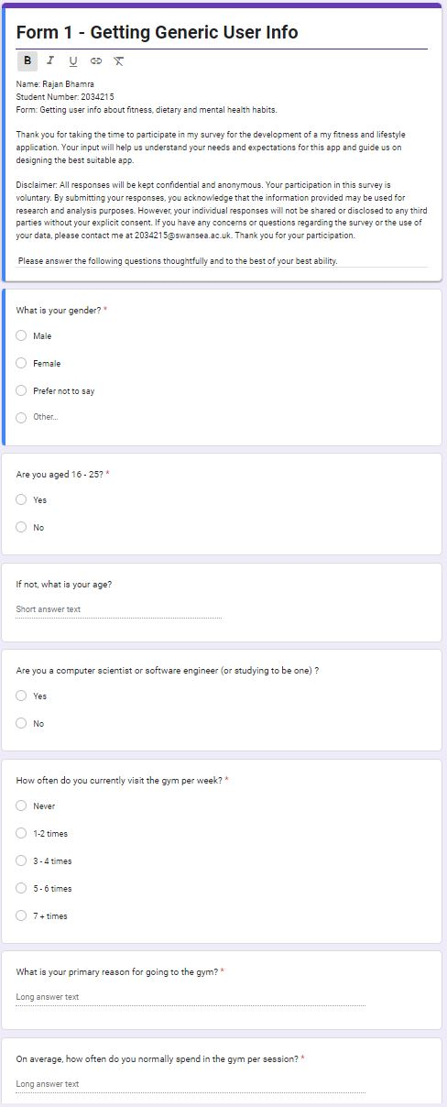

Figure 3 - Form One: Generic User Info (Part Two)

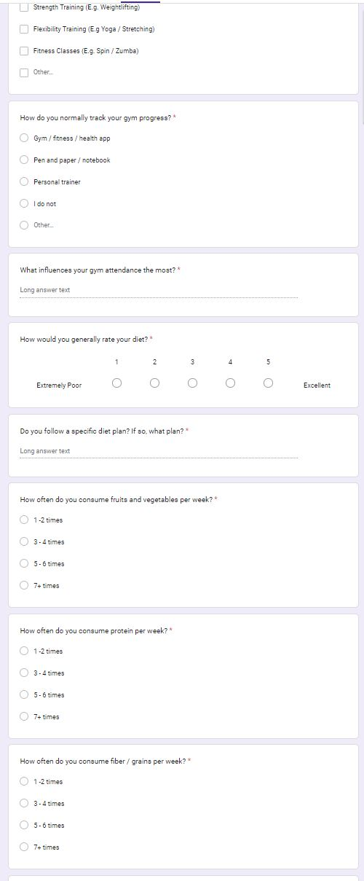

Figure 4 - Form One: Generic User Info (Part Three)

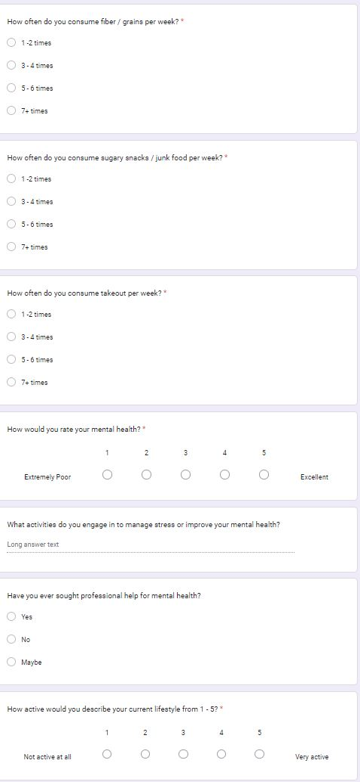

Figure 5 – Consent Form

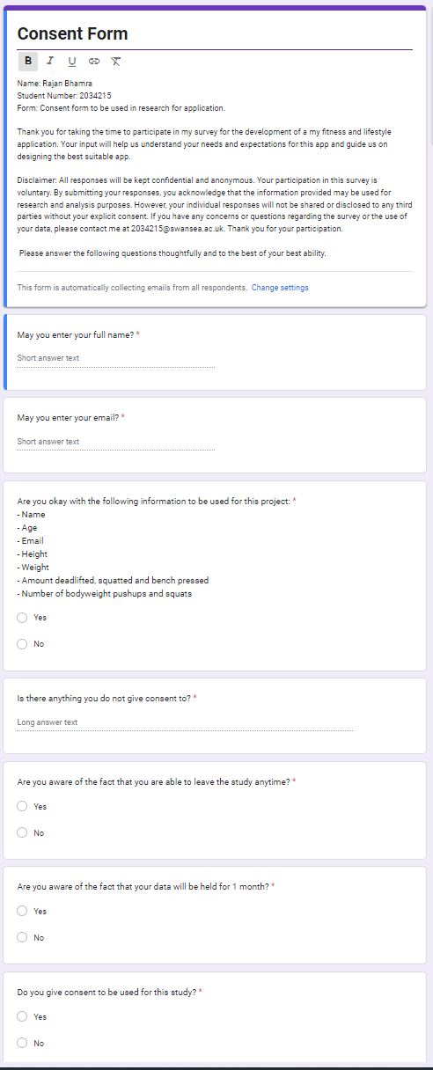

Figure 6 - Form Two: Pre Using the App

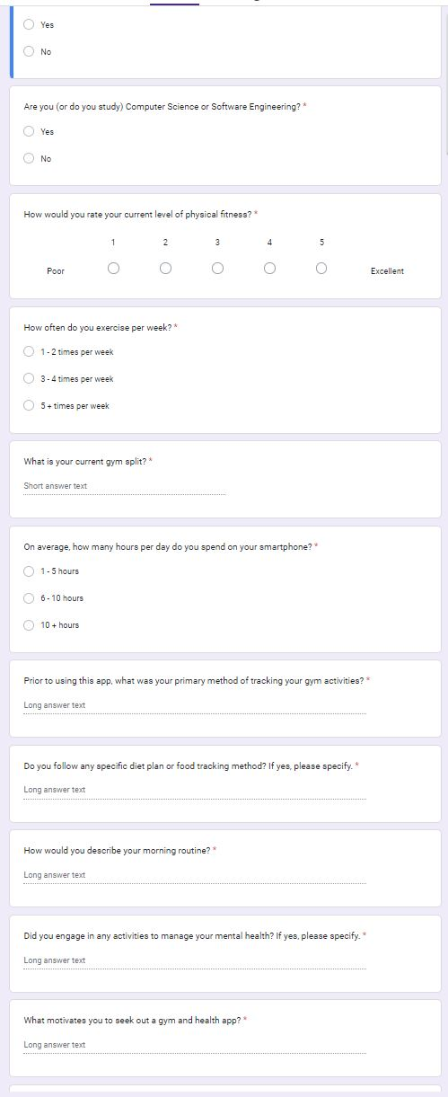

Figure 7 - Form Three: Users Just Finished Using The App

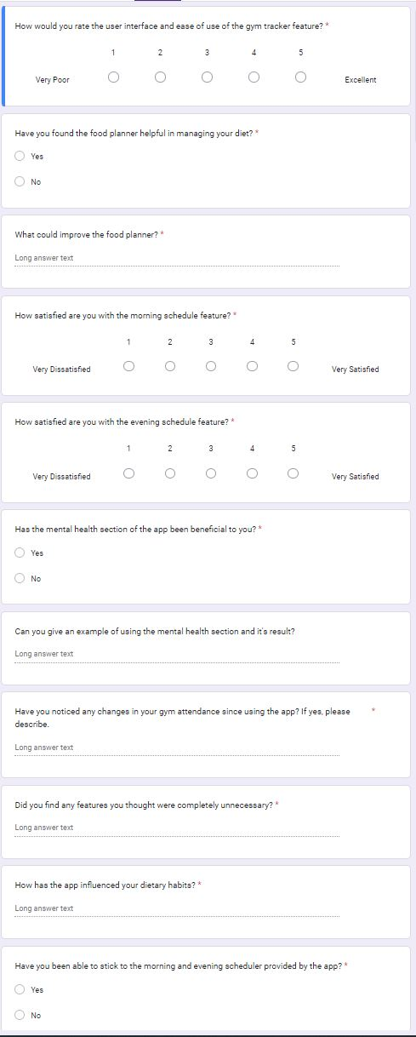

Figure 8 - Form Four: 1 Week Post App Deletion

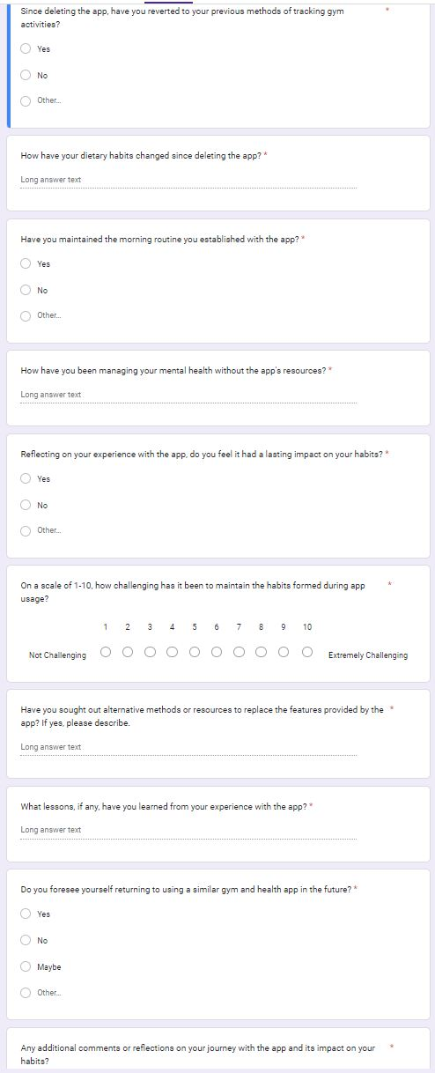

Figure 9 – Flowchart for Login System

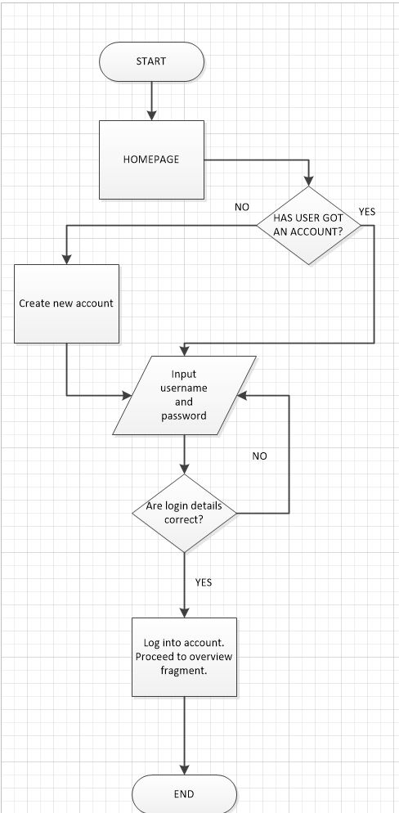

Figure 10 – Low Fi Paper Sketch

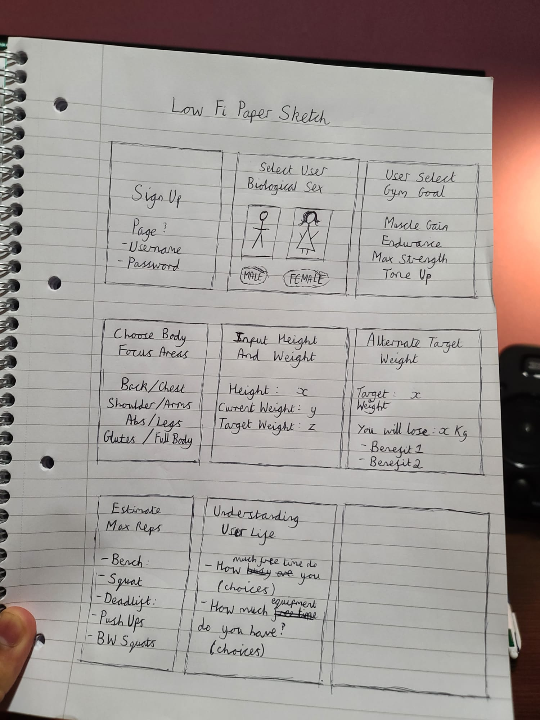

Figure 11 – Routine Diagram

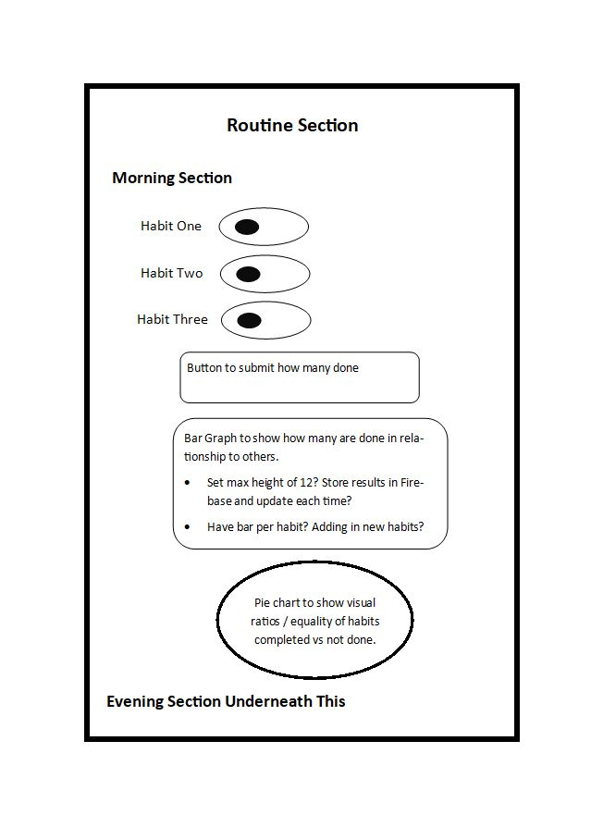

Figure 12 – Gym Explanation Flowchart

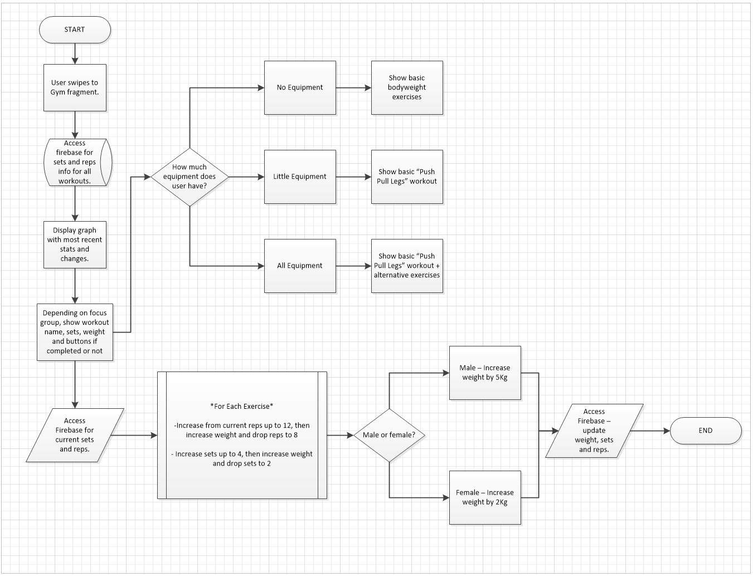

Figure 13 – Food Diagram

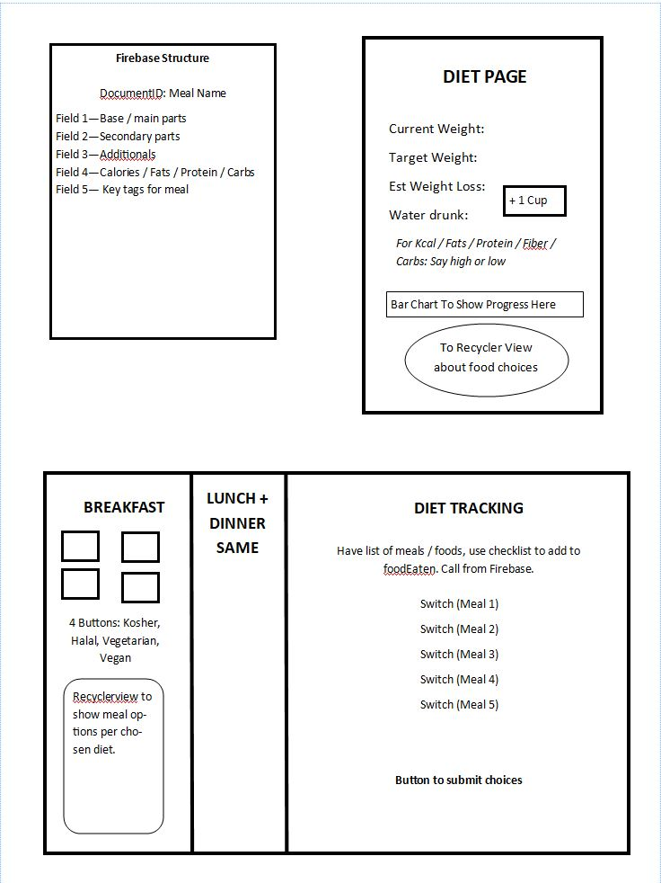

Figure 14 – Screenshot of Login System.

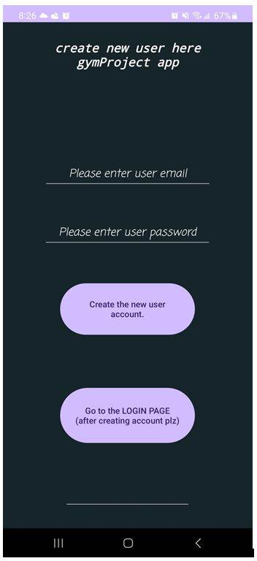

Figure 15 – Screenshot of Overview page.

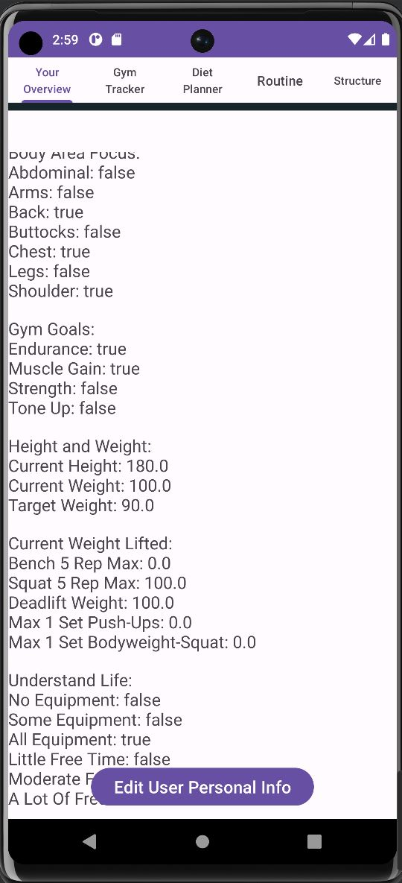

Figure 16 – Screenshot of gym workout explanation with video.

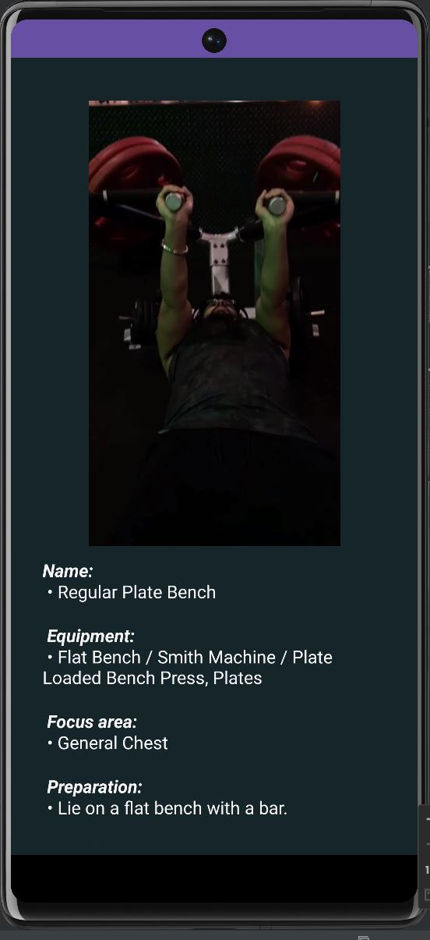

Figure 17 – Code for creating a new user account.

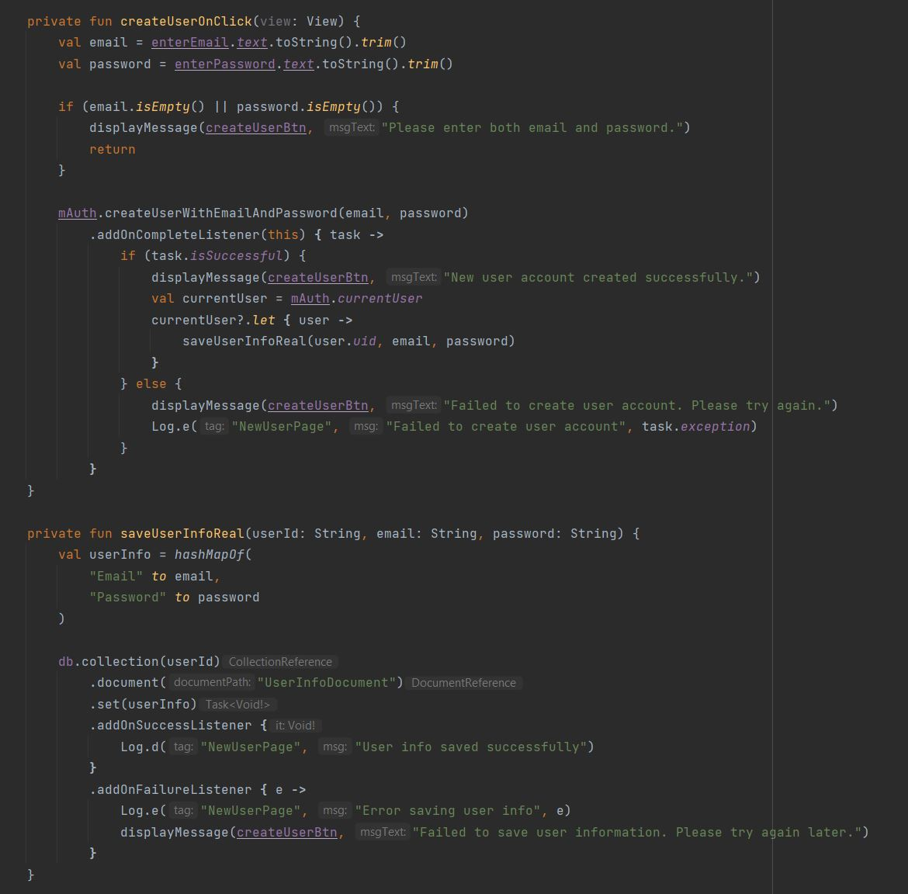

Figure 18 – Screenshot of Firebase authentication users page.

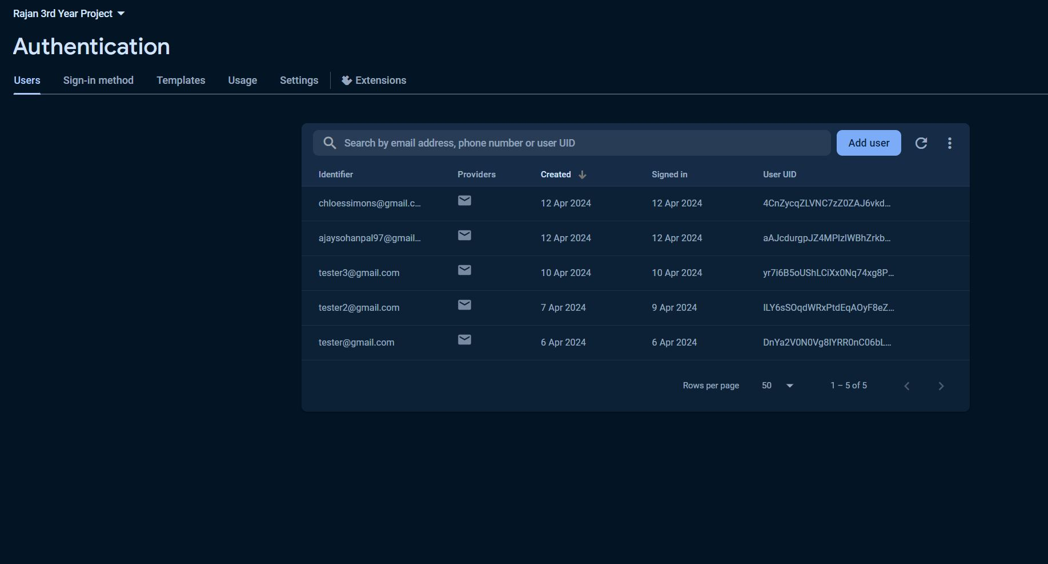

Figure 19 – Code to call specific video.

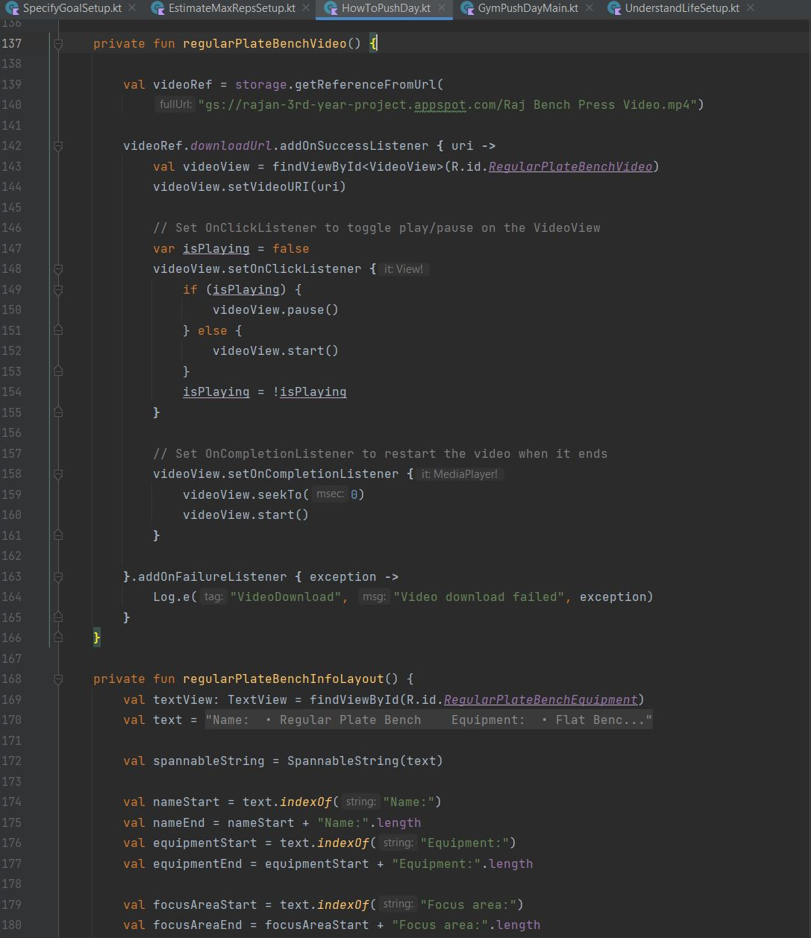

Figure 20 – Firebase Document Outline.

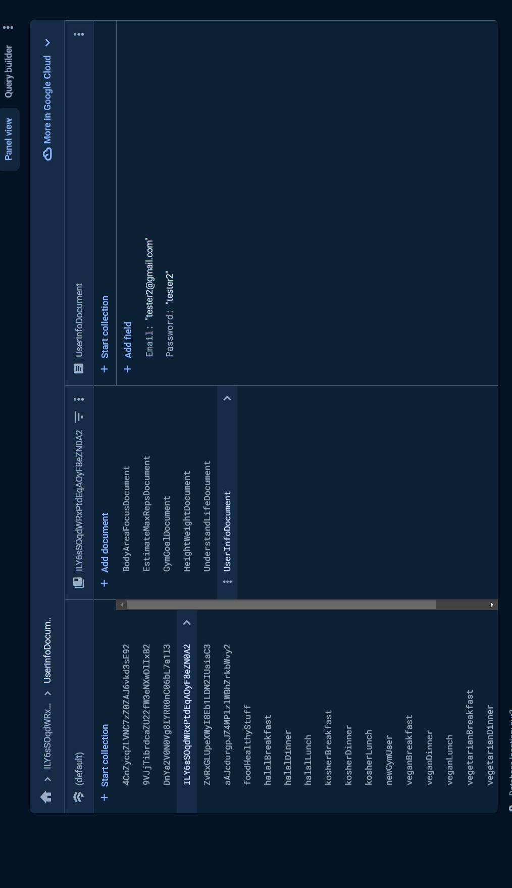

Figure 21 – Diet Plan food adapter.

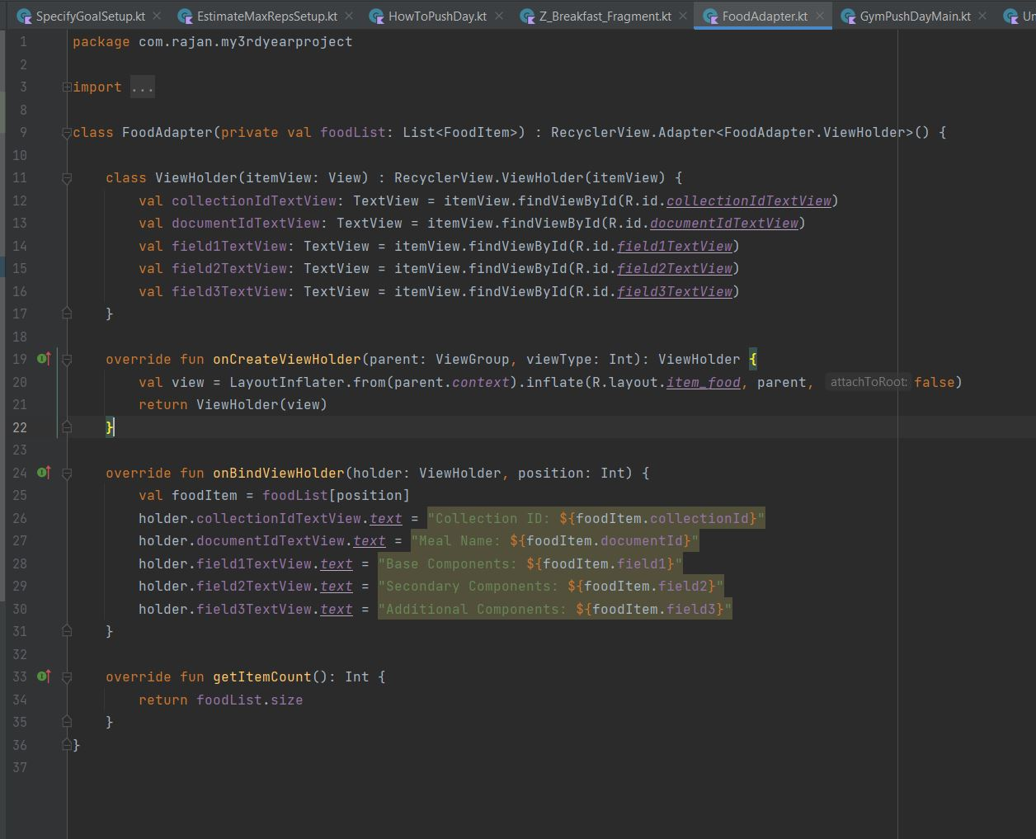

Figure 22 – Diet page fragment breakfast example.

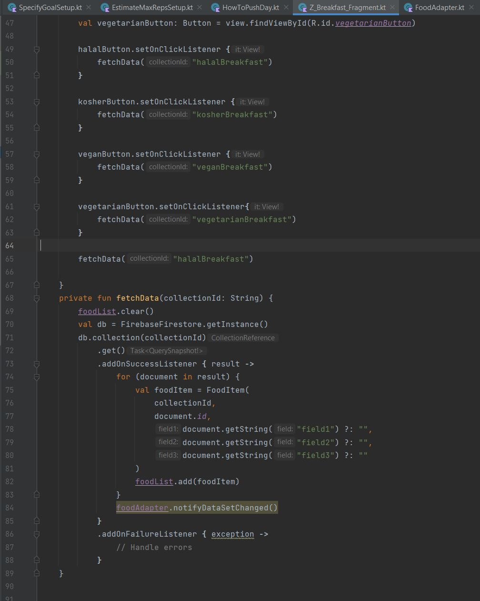

Figure 23– Screenshot of API dependencies.

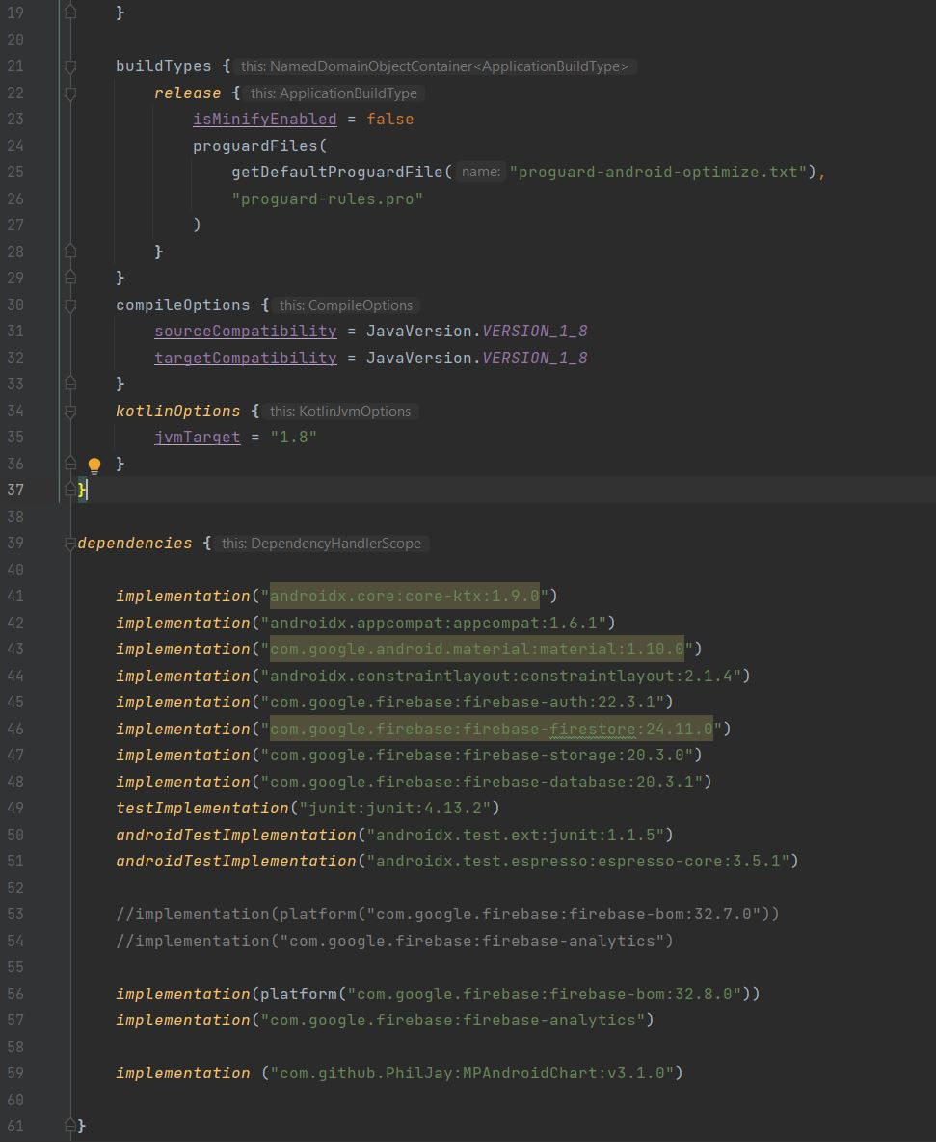

Figure 24 – Bad pre-launch report because of authentication issue.

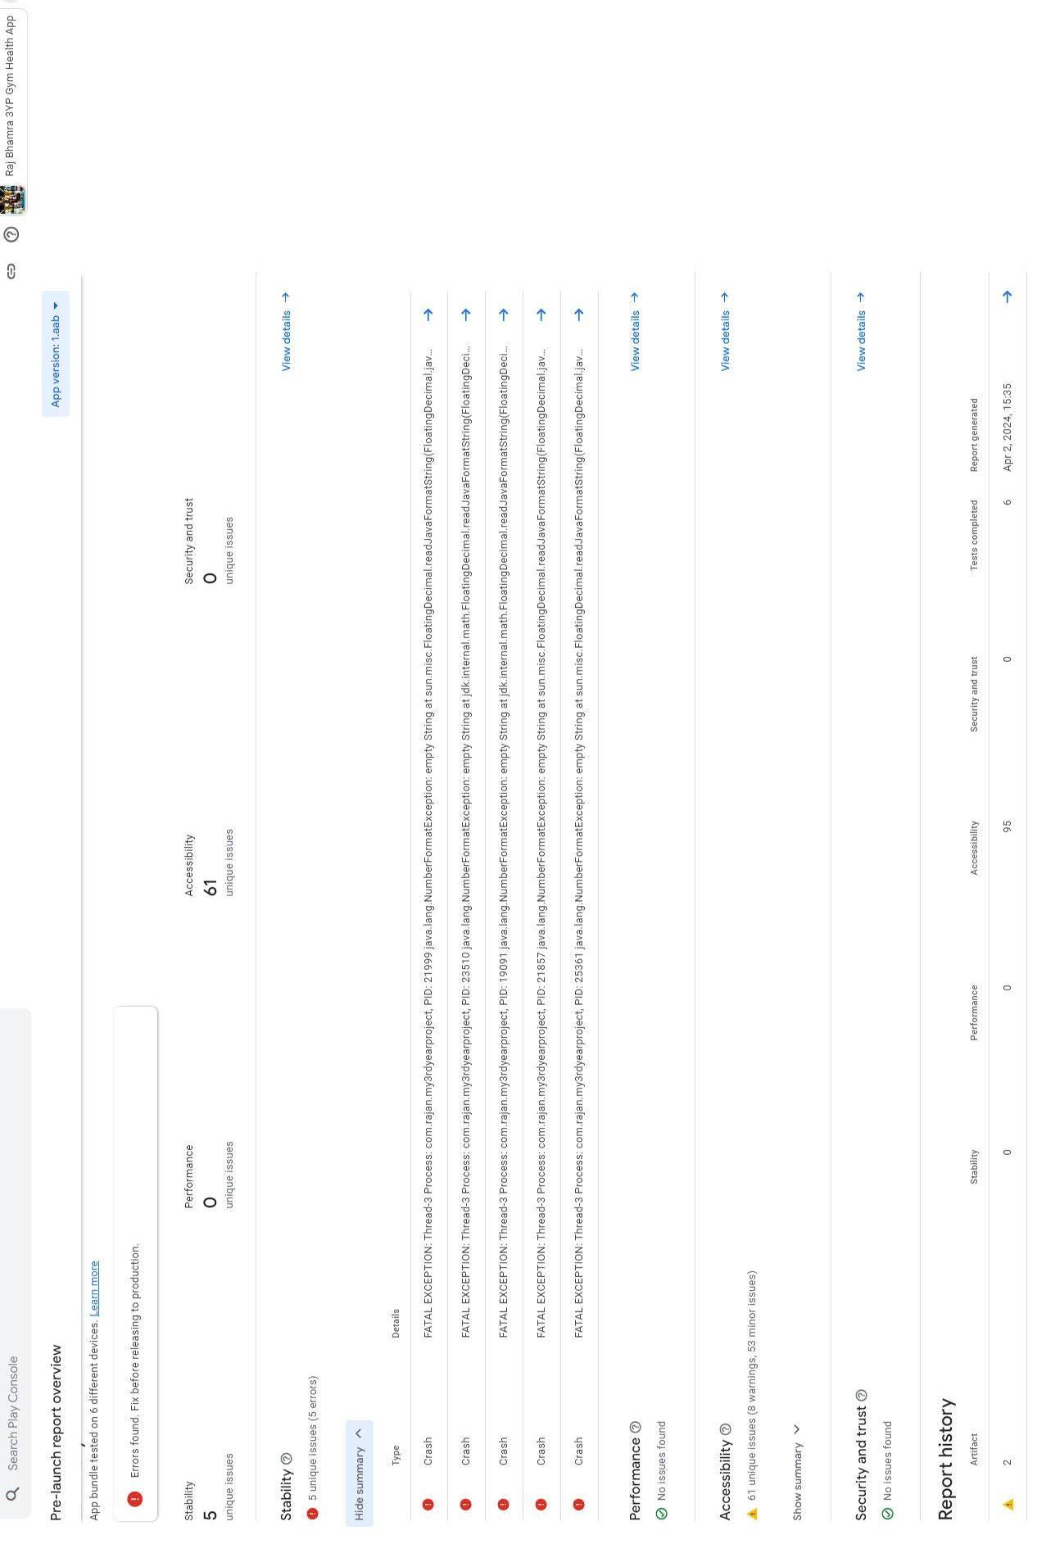

Figure 25 – Privacy Policy For App.

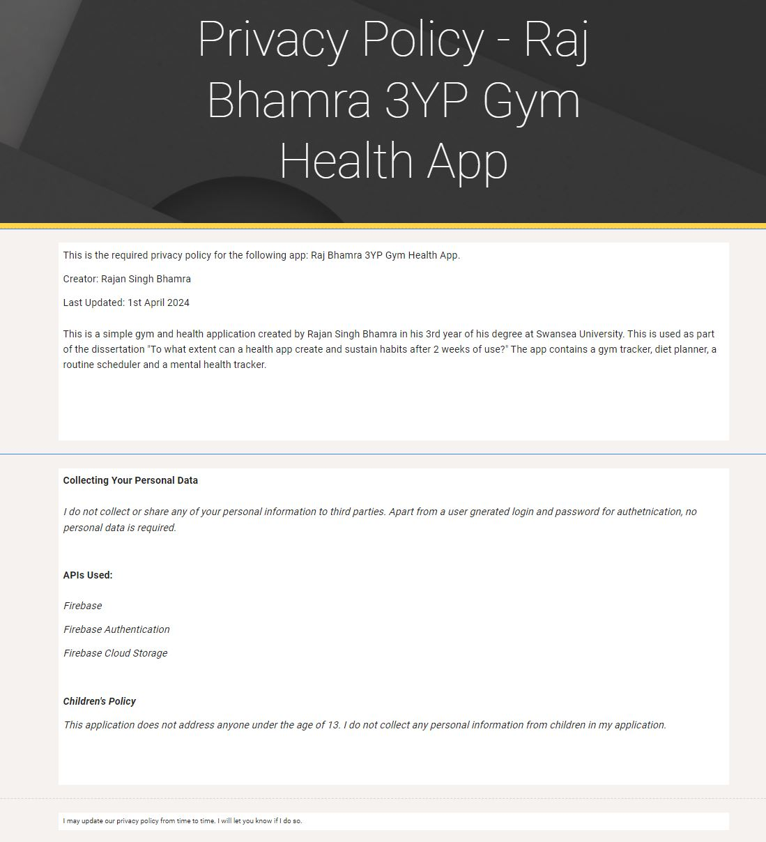

Figure 26 – Code for updating food nutrition.

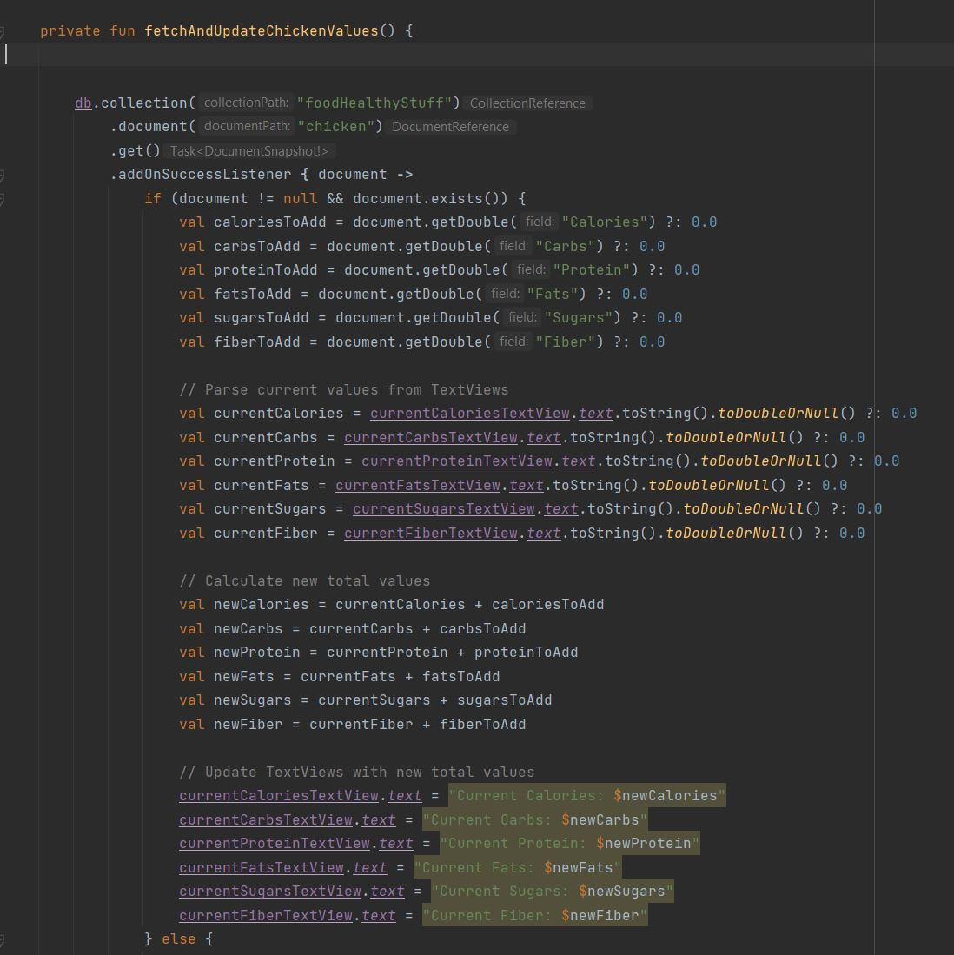

Figure 27 – Nutrition example in firebase.

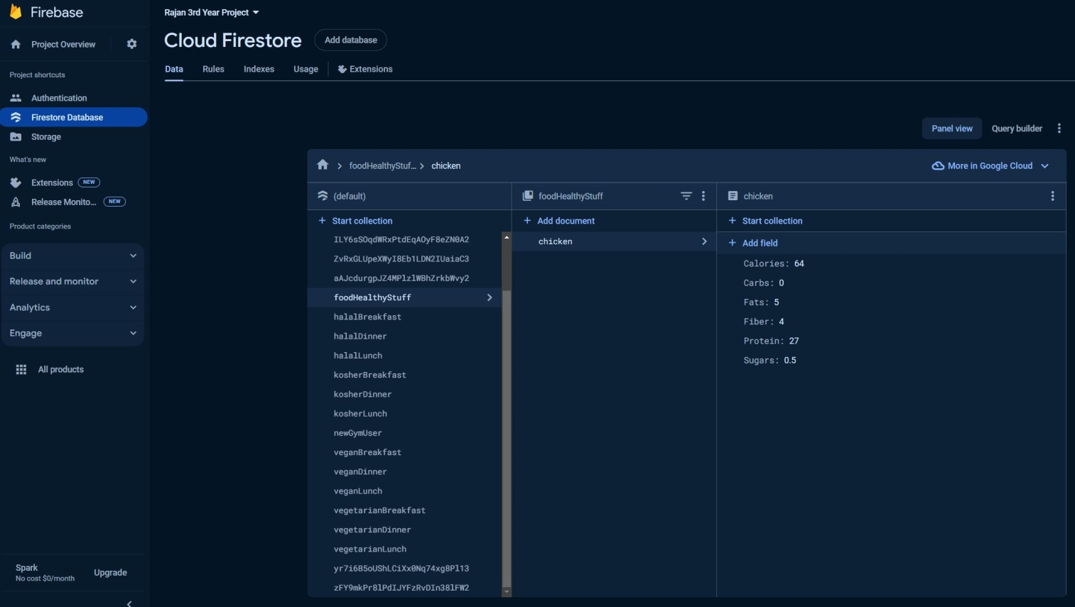

Figure 28 – Code for updating weights and sets and reps.

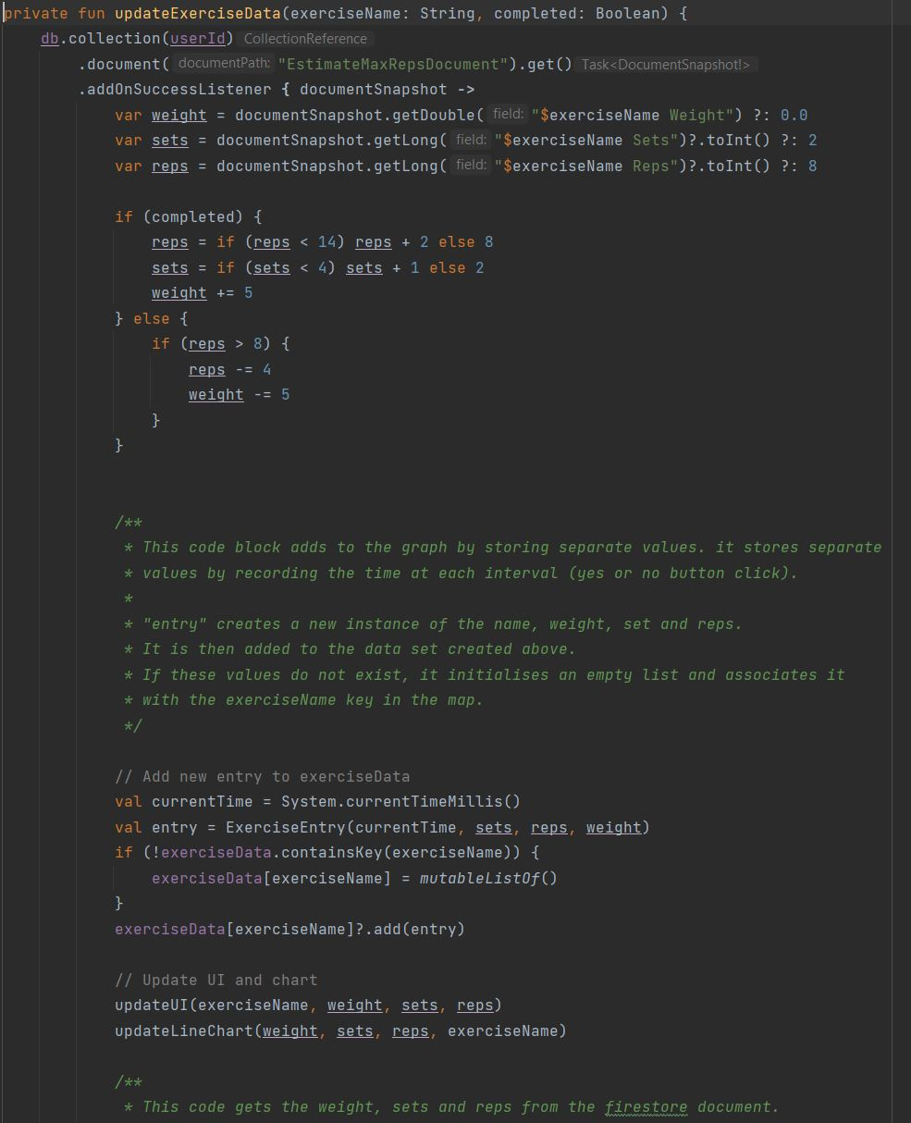

Figure 29 – Initial workout values.

