Name: M.V. Raj Varun
Reg No: 192411007
Course: CSA1027, Software Engineering

Experiments 1-3

1- Kanban Board to Visualize the Tasks

- Go to Jira and create an account and login
- Click ‘Create Project’ and select Kanban
- Click ‘Create’, then ensure the board has ‘To Do’, ‘In Progress’ and ‘Done’
- Click ‘Create Issue’ and add atleast 5 sample tasks
- Move the Tasks across the Columns to Simulate the Workflow.

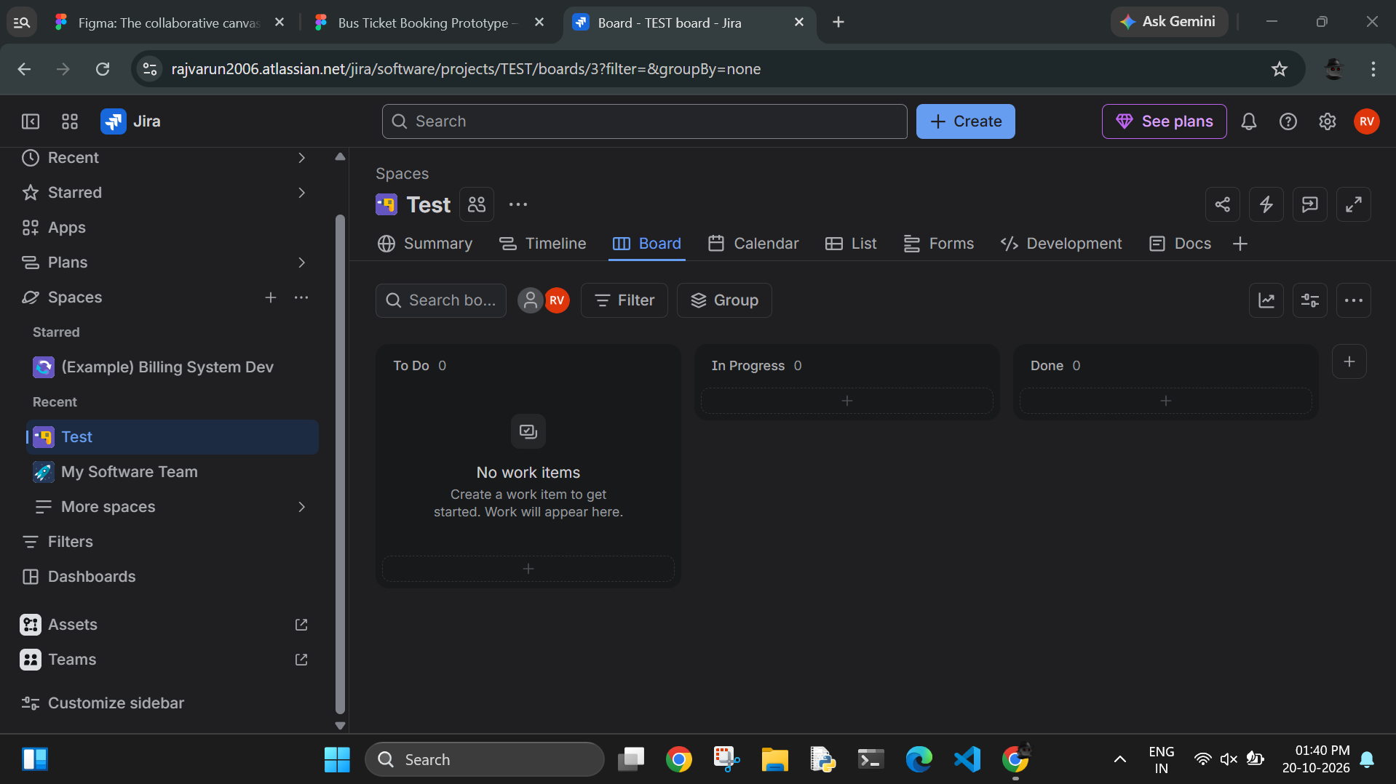

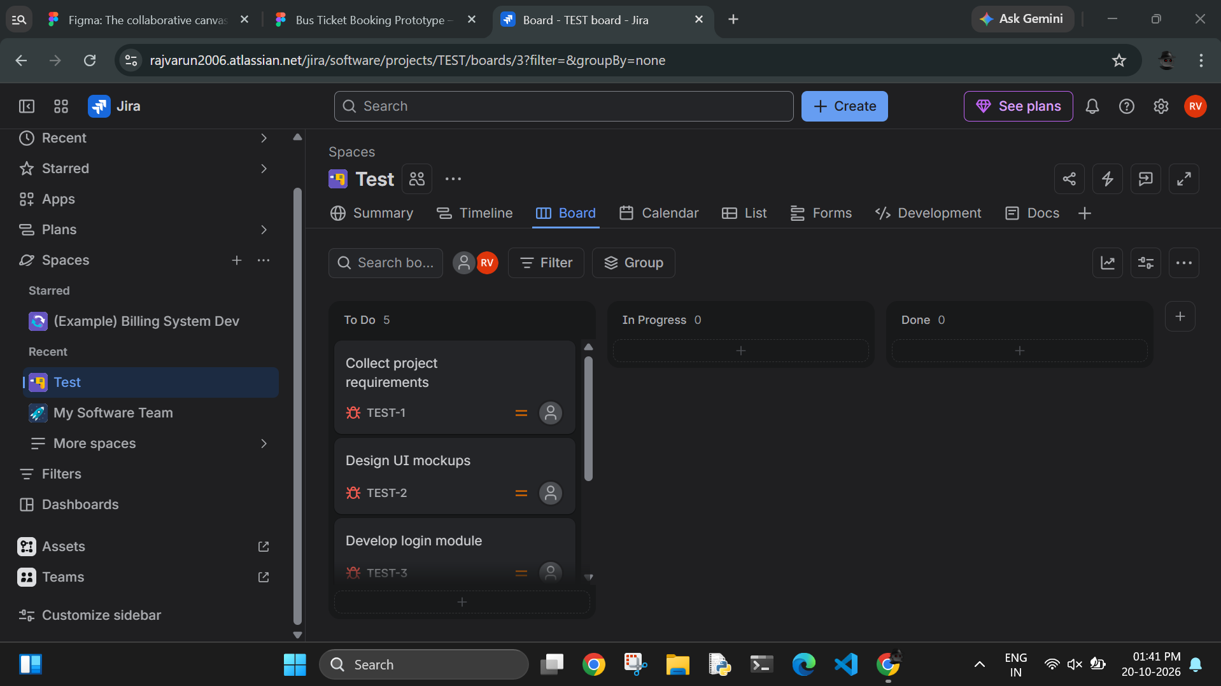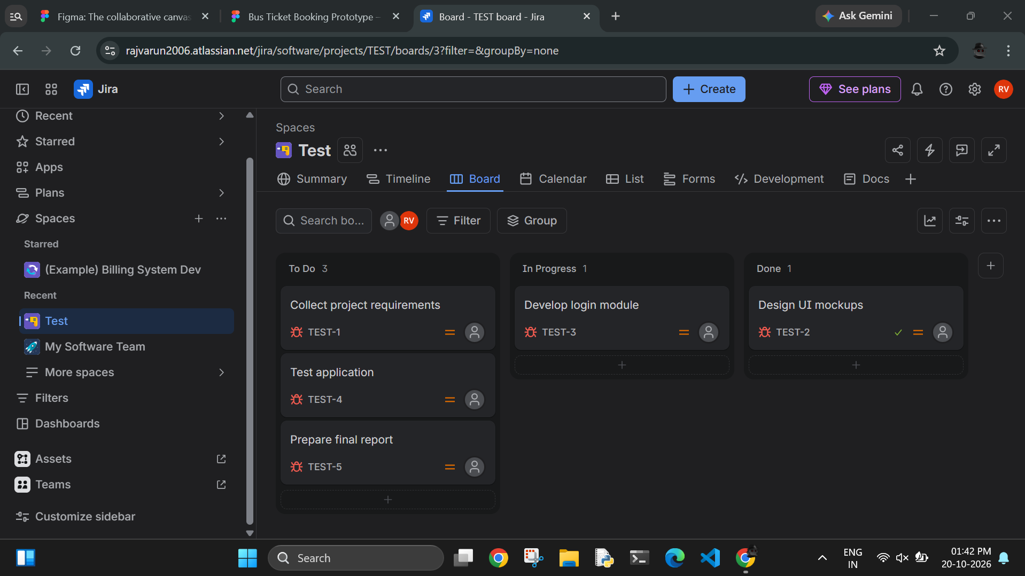

2 - Prototype of Bus Ticket Booking System in Figma

- Go to Figma and Login/Signup to account
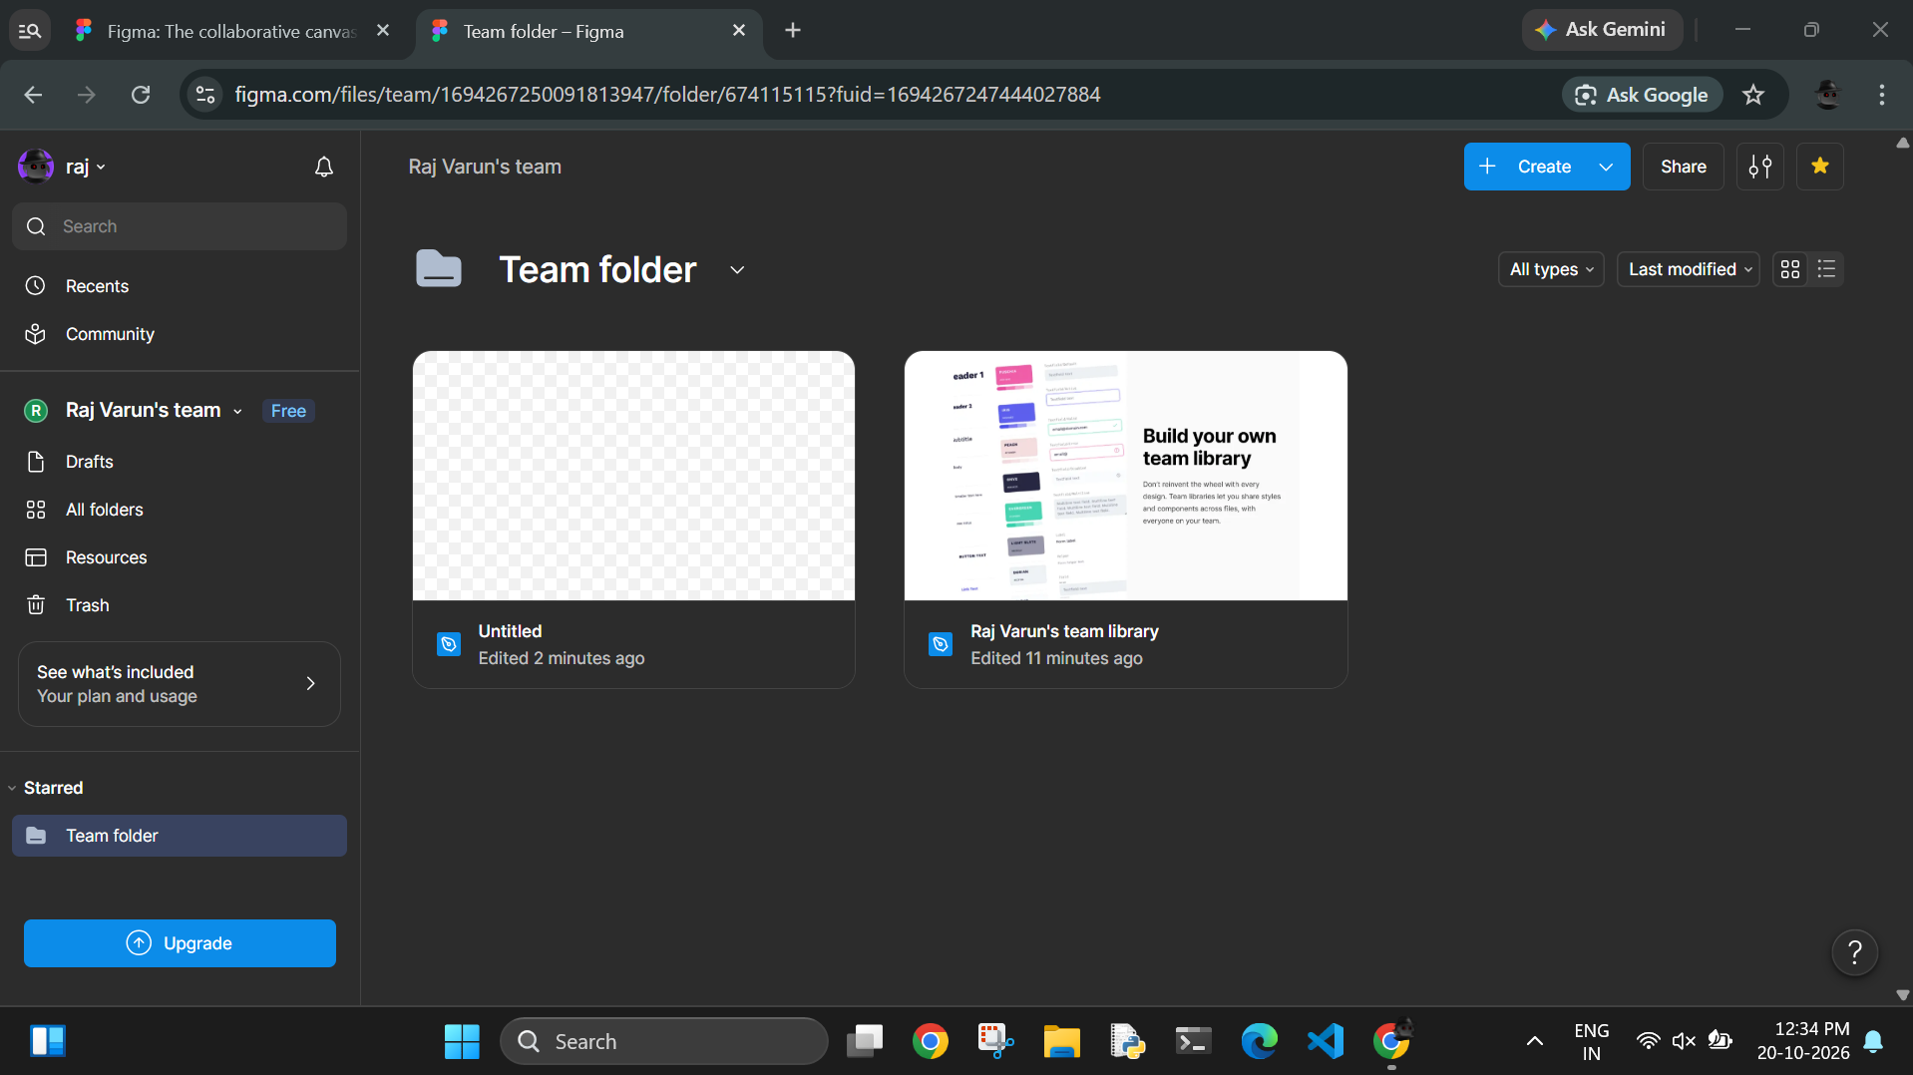

- Click ‘New Design File’
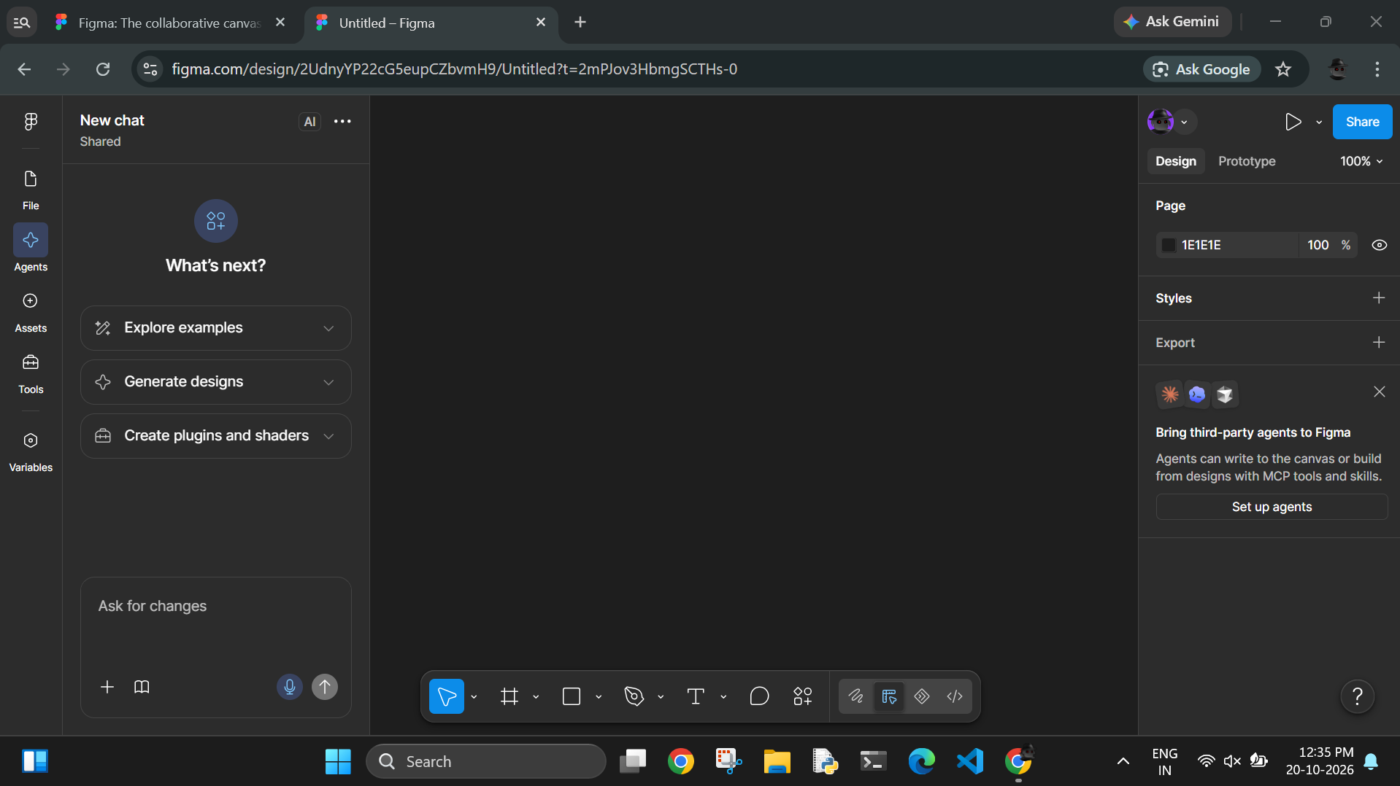

- Click Frame tool and select Android/iPhone
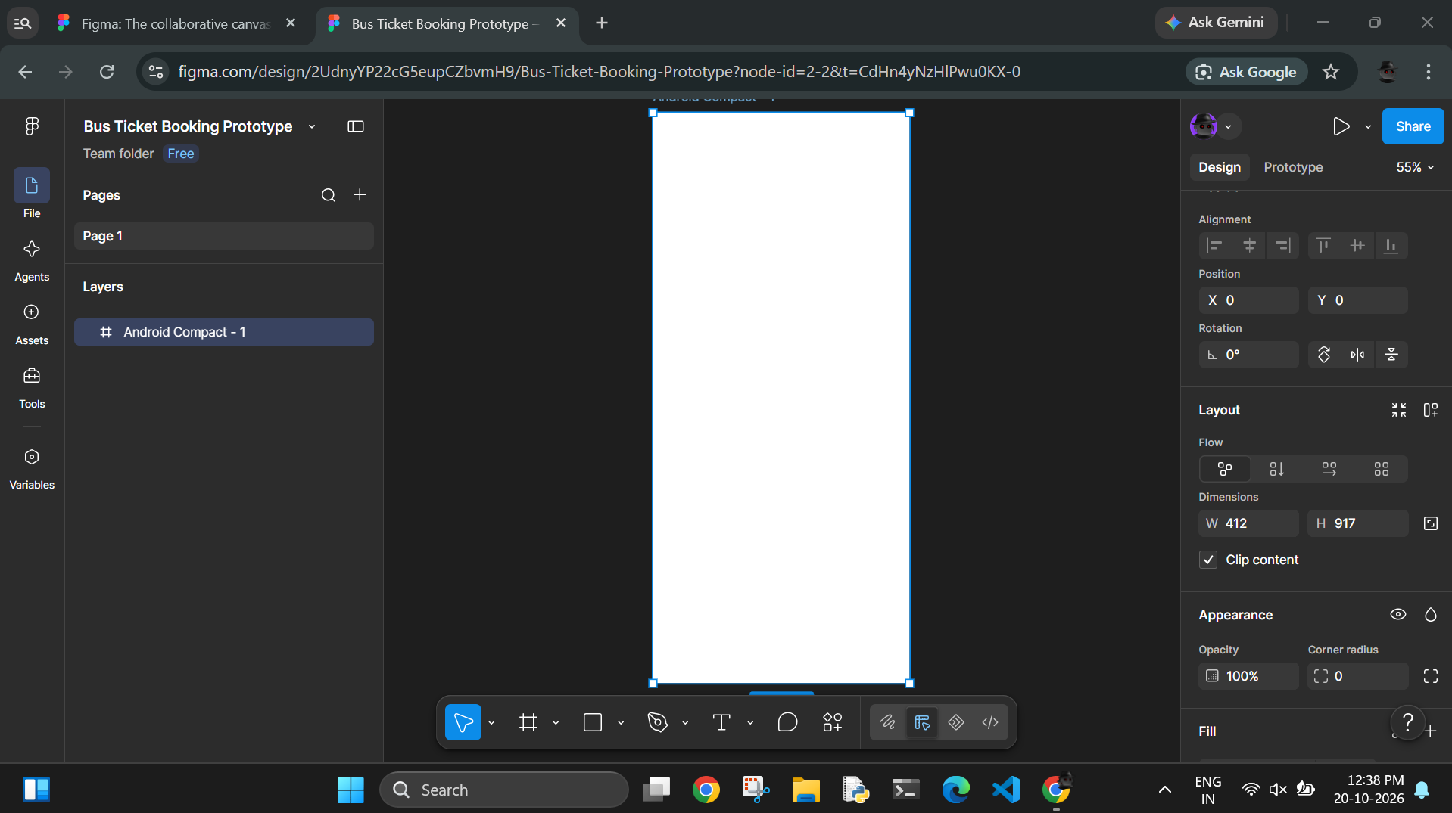

- Design Home Screen with header, input fields and a button
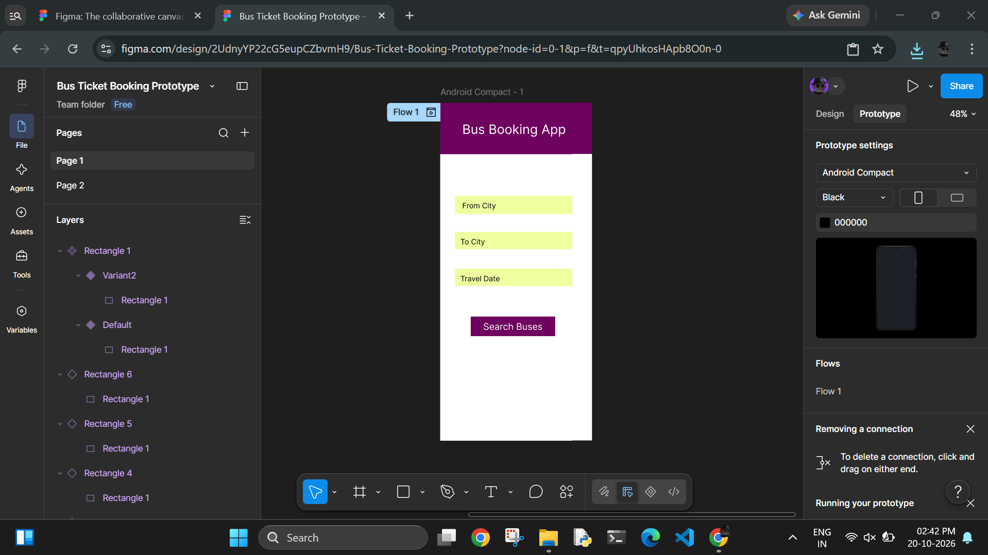

- Design a Bus List Screen by duplicating previous frame and create 2-3 sample bus listing with bus name, time, price and a book now button each
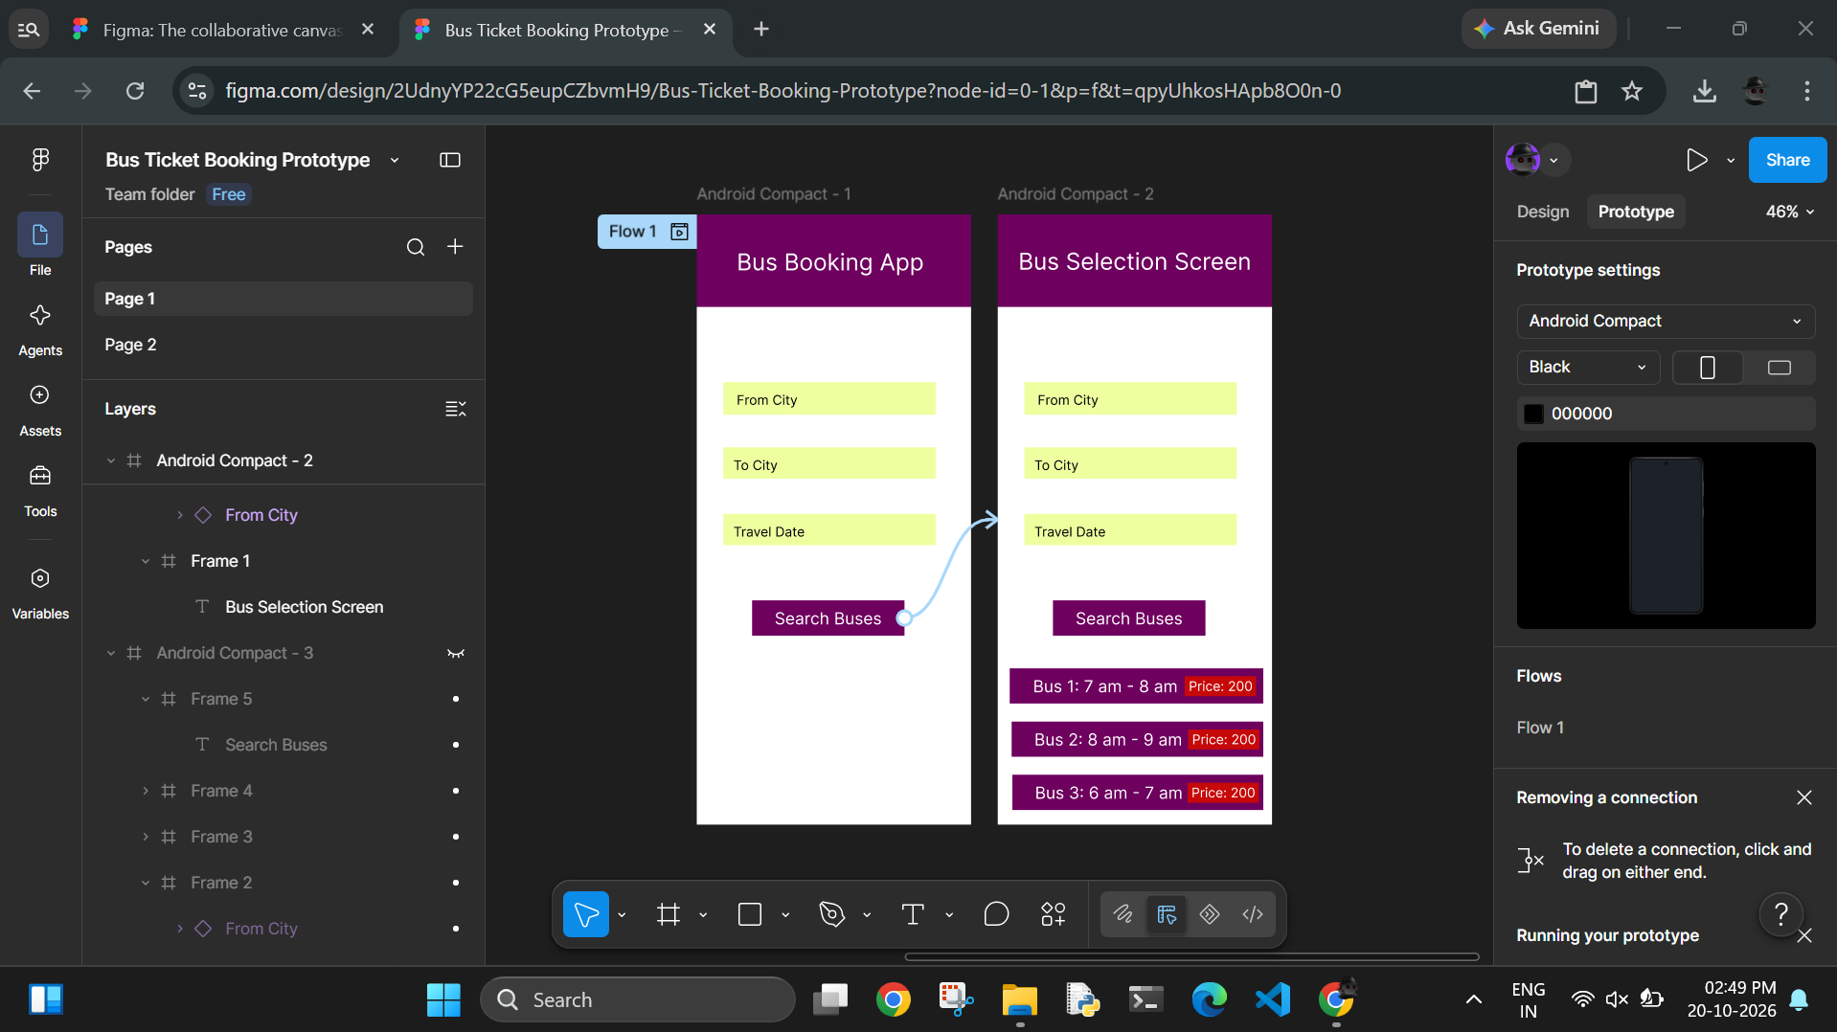

- Design a Seat Selection Screen by duplicating frame and adding seat grids and making sure that selected seat is in different colour and a ‘Proceed to Pay’ button
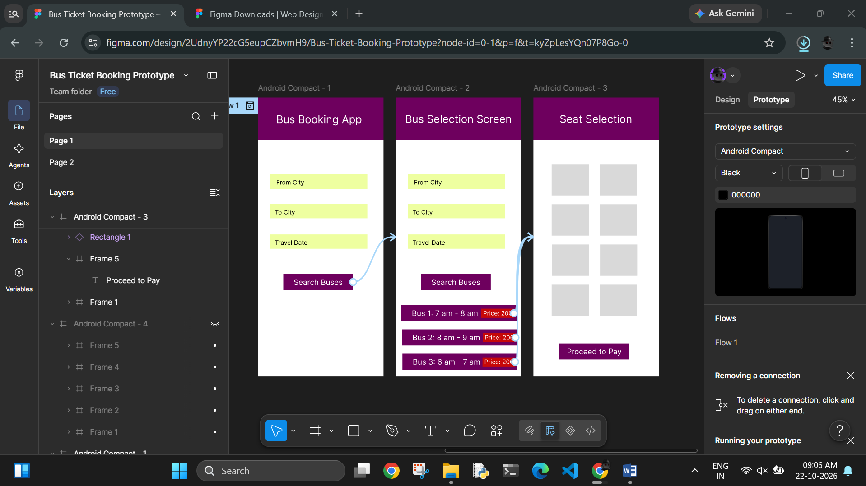

- Design a payment screen with ticket summary, total price, payment method, and a button for paying
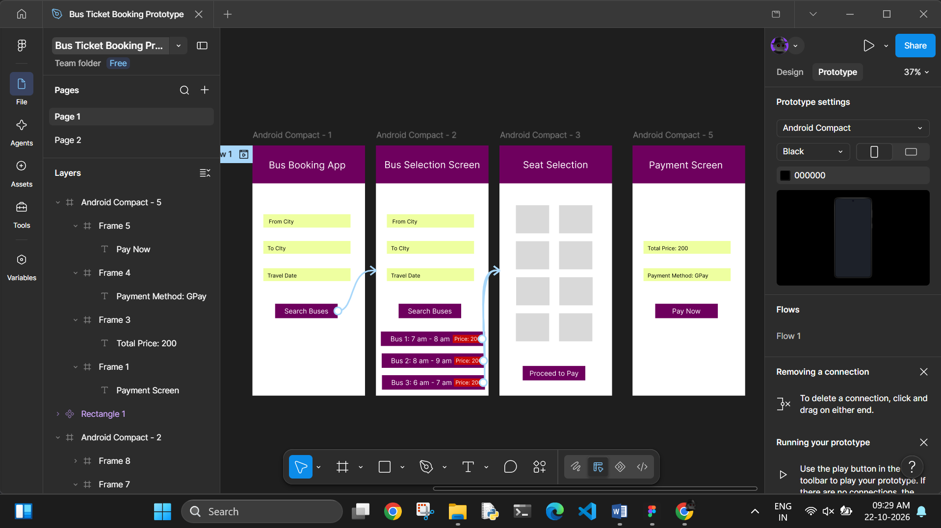

- Design a confirmation screen which shows that booking is confirmed and the ticket number, travel details and a download ticket button
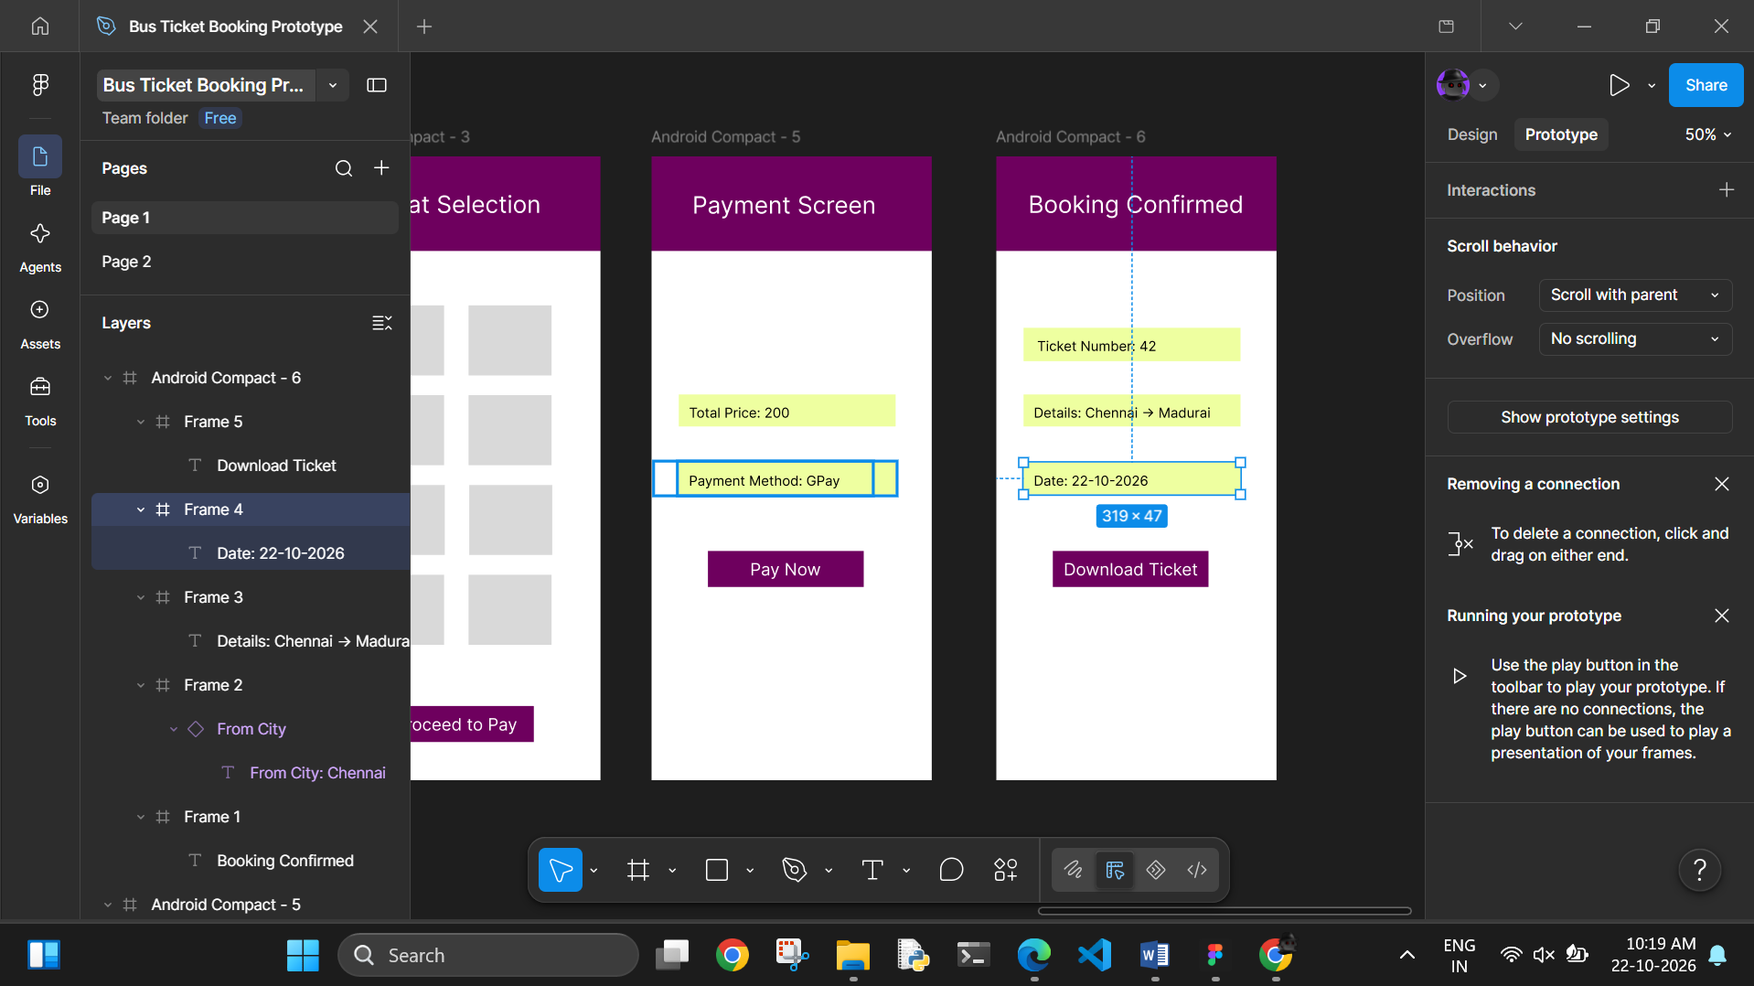

- Click the Prototype tab and connect:
- Search Buses → Bus List Screen
- Book Now → Seat Selection
- Proceed → Payment
- Pay Now → Confirmation
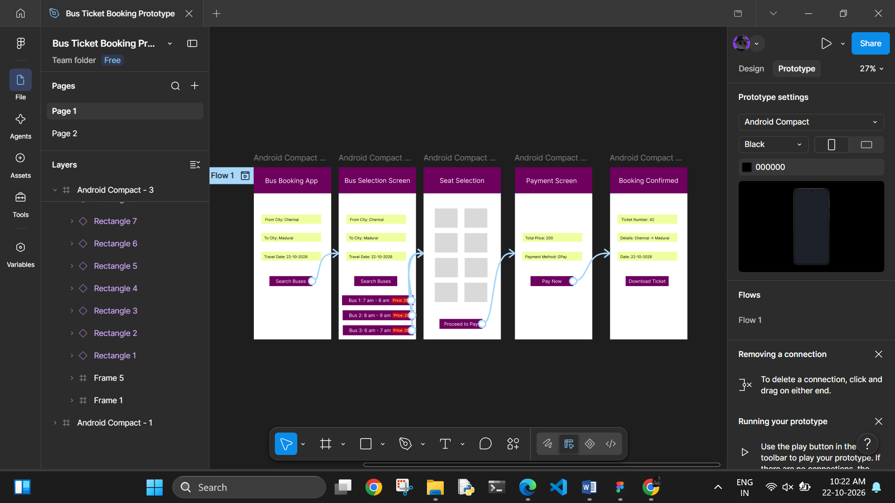

3 - Prototype E-Commerce App in Figma

