## ST ALBANS GOOD NEIGHBOUR SCHEME

Charity No. 1074638 Company No 3675149

# Safeguarding Policy

**Aims**

St Albans Good Neighbour Scheme (“SAGNS”) is committed to:

* Ensuring that the welfare of adults is paramount at all times
* Maximising people’s choice, control and inclusion and protecting their human rights
* Working in partnership with others in order to safeguard adults at risk
* Ensuring safe and effective working practices are in place.

**Introduction**

This Policy sets out the roles and responsibilities of SAGNS, when working alone and together with other agencies, in promoting adults’ welfare and safeguarding them from abuse and neglect.

**Scope**

This Policy applies to all volunteers at SAGNS and is intended to support them in their roles.

**Definition of adults at risk**

The definition is set out in the Care Act 2014. SAGNS’s safeguarding duty applies to any person aged 18 years and over who:

* has needs for care and support (whether or not the local authority is meeting any of those needs), **and**
* is experiencing, or is at risk of, abuse or neglect, **and**
* as a result of those needs is unable to protect themselves against the abuse or neglect, or the risk of it.

All adults who meet the above criteria may be defined as adults at risk.

**Types and indicators of abuse and neglect:**

TheCare Act 2014 and the Care and Support Statutory Guidancedefine the categories of abuse but emphasise that organisations should not limit their view on what constitutes abuse.

The main forms of abuse are set out in the table below. This is not an exhaustive list but an illustration as to the sort of behaviour that could give rise to a Safeguarding concern.

|  |  |
| --- | --- |
| Type of Abuse | Description of Abuse |
| **Physical abuse** | Including assault, hitting, slapping, pushing, misuse of medication, restraint or inappropriate physical sanctions |
| **Domestic violence/ abuse** | Including psychological, physical, sexual, financial, emotional abuse; so called ‘honour’ based violence. |
| **Sexual abuse** | Including rape, indecent exposure, sexual harassment, inappropriate looking or touching, sexual teasing or innuendo, sexual photography, subjection to pornography or witnessing sexual acts, indecent exposure and sexual assault or sexual acts to which the adult has not consented or was pressured into consenting, sexual exploitation. |
| **Psychological abuse** | Including emotional abuse, threats of harm or abandonment, radicalisation, deprivation of contact, humiliation, blaming, controlling, intimidation, coercion, harassment, verbal abuse, cyber bullying, isolation or unreasonable and unjustified withdrawal of services or supportive networks. |
| **Financial or material abuse** | Including theft, fraud, internet scamming, coercion in relation to an adult’s financial affairs or arrangements, including in connection with wills, property, inheritance or financial transactions, or the misuse or misappropriation of property, possessions or benefits |
| **Modern slavery** | Encompasses slavery, human trafficking, forced labour and domestic servitude. Traffickers and slave masters use whatever means they have at their disposal to coerce, deceive and force individuals into a life of abuse, servitude and inhumane treatment. |
| **Discriminatory abuse** | Including forms of harassment, slurs or similar treatment; because of race, gender and gender identity, age, disability, sexual orientation or religion. |
| **Organisational abuse** | Including neglect and poor care practice within an institution or specific care setting such as a hospital or care home, for example, or in relation to care provided in one’s own home. This may range from one off incidents to on-going ill-treatment. It can be through neglect or poor professional practice as a result of the structure, policies, processes and practices within an organisation |
| **Neglect and acts of omission** | Including ignoring medical, emotional or physical care needs, failure to provide access to appropriate health, care and support or educational services, the withholding of the necessities of life, such as medication, adequate nutrition and heating |
| **Self-neglect** | This covers a wide range of behaviour; neglecting to care for one’s personal hygiene, health or surroundings and includes behaviour such as hoarding |

**Responsibilities of SAGNS**

* To take action to identify and prevent abuse from happening.
* To respond appropriately when abuse has or is suspected to have occurred.
* To provide volunteers with basic safeguarding adults awareness training at a level according to their role, and to ensure volunteers are aware of their opportunities to attend training, and to support volunteers in accessing training.
* To ensure that SAGNS has a dedicated volunteer with an expertise in safeguarding adults. The Designated Safeguarding Lead is Sarah McAlister.
* To ensure that all volunteers who come in contact with adults with care and support needs have a DBS check in line with Disclosure and Barring Service requirements.

**Responsibilities of all volunteers**

* To follow the safeguarding policies and procedures at all times, particularly if concerns arise about the safety or welfare of an adult at risk.
* To participate in safeguarding adults training when provided by SAGNS or other agencies on its behalf
* To discuss any concerns about the welfare of an adult at risk with their Section Leader and the Designated Safeguarding Lead, Sarah McAlister.
* To contribute to actions required, once a welfare or safeguarding concern has been raised, including information sharing and attending meetings.
* To work collaboratively with other agencies to safeguard and protect the welfare of people who engage with the service.
* To remain alert at all times to the possibility of abuse.

**Reporting Abuse**

What to do if you think an adult at risk may be subject to abuse or neglect

If there is immediate danger to life, serious injury or a crime being committed, **call 999**

If there is no immediate risk to life, but police response is required due to the seriousness of the incident or potential loss of evidence, **call 101**

If there is no need to call 999 or 101, make a log of your concern and contact your Section Leader and the Designated Safeguarding Lead, Sarah McAlister on **01582 462234** or **07855 249956** as soon as possible

**What should you do?**

**Doing nothing is not an option** - If we know or suspect that an adult is being abused, we will do something about it.

* Follow the instructions in the flow chart above and take action to call the emergency services if necessary.
* If an adult discloses abuse or neglect, follow the guidance contained in **“If an adult discloses**” set out in Schedule 1 to this Policy.
* If you have a safeguarding concern, because an adult has disclosed, or for any other reason, make a log of your concern by completing the form “**Logging A Concern**” in Schedule 2 to this Policy and contact your Section Leader and the Designated Safeguarding Lead, Sarah McAlister as soon as possible.

The Designated Safeguarding Lead will then be able to review the concern raised, discuss the log you have made and take appropriate action if necessary.

If you are concerned about the referral you have made contact any SAGNS committee member whose details can be found on the SAGNS Fact Sheet.

Records about safeguarding concerns will be kept confidentially and in accordance with GDPR requirements. SAGNS requires all volunteers to maintain confidentiality at all times.

**What should the Designated Safeguarding Lead (DSL) do?**

When a welfare or safeguarding concern is raised, the DSL will discuss the concern with whoever has raised it, and review any log that has been written. Depending on the information presented, the DSL will take appropriate action in a timely manner.

Appropriate action may include notifying the police if a crime has been committed, and/or Hertfordshire Safeguarding Adults Board (HSAB) on **0300 123 4042** (24 hours a day), and, with advice from HSAB, relatives of the adult. It may include further discussions with the adult at risk and other relevant parties.

If the DSL believes that a referral should be made to HSAB, the DSL will ensure the adult at risk has consented to the referral before going ahead. If the adult at risk does not consent, but has an impairment of the brain and is unable to make a decision due to such impairment, under the Mental Capacity Act, or is being coerced by another party into refusing consent, the DSL will nevertheless make the referral.

In order to make a referral, the DSL will complete and submit a “**Hertfordshire safeguarding adult concern form**”, in Schedule 3 to this Policy, to HSAB within 24 hours of the concern being raised, or as soon as is reasonably practicable.

The DSL will take steps to ensure that an appropriate risk management plan is put in place to keep the adult at risk as safe as is reasonably practicable until other agencies have become involved and a plan has been put in place.

Adopted on: 12 November 2018

Next review date: 12 November 2019

**SCHEDULE 1**

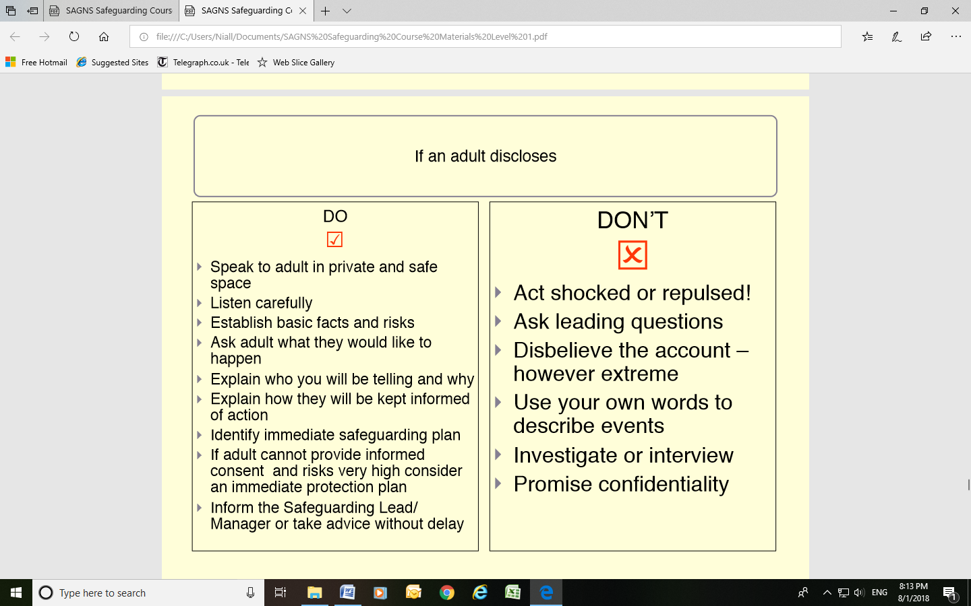

|  |  |
| --- | --- |
| **St Albans Good Neighbour Scheme – Logging a Concern** | |
|  | |
| **Name of vulnerable adult:** | |
| **Date:** | **Time:** |
| **Your name:....................................................................................................**  *(Print) (Signature)* | |
| **Position / job title:** | |
| ***Ask yourself why you are recording the incident. Record the following factually:*** | |
| **Who? / What? / Where? / When?**  *(please use additional paper if needed – record the date, location and your name at the top of the additional paper)* | |
| **Offer an opinion, if relevant.** *(How and why might this have happened?)* | |
| **Note of any action taken by you:**  **Name of person to whom your information is being passed:** | |
| ***Check to make sure that everything in your report is really clear – even to a stranger reading it in the future.*** | |

**SCHEDULE 2**

**Official use only:**

**To be filled in by the Designated Safeguarding Lead taking charge of this incident recorded.**

|  |  |  |
| --- | --- | --- |
| **Name:** | | |
| ***Position:*** | | |
| ***Please record the incident from the moment it was recorded to actions taken at the time and afterwards:*** | | |
| **Who contacted you?:** | | |
| **Time incident was logged to you:** | | |
| **Where did the incident happen?:** | | **When?:** |
| **What was reported to you?:**  *(please use additional paper if needed – record the date, location and your name at the top of the additional paper)* | | |
| **Actions implemented at the time:** | | |
| **Actions taken after the incident:** | | |
| **Sign:** | **Date:** | |

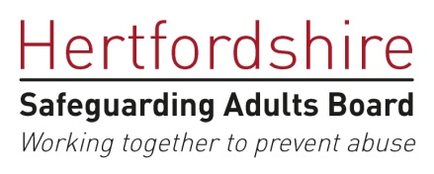**SCHEDULE 3**

**Hertfordshire safeguarding adult concern form**

|  |  |  |  |  |  |  |  |  |  |  |
| --- | --- | --- | --- | --- | --- | --- | --- | --- | --- | --- |
| **Personal details of adult at risk** | | | | | | | | | | |
| Name: | | | Mr/Mrs/Ms | | | | Dob: | | Gender: | |
| Current Address:  Postcode:  Tel no: | Home address *(if different):*  Postcode:  Tel no: | | | | | | | GP:  Surgery:  Tel no: | | |
| NHS no (if known):  Police URN:  Other ref no: | | | | | Ethnic origin:  preferred language/communication needs? | | | | | |
| **Allegation** | | | | | | | | | | |
| Date alleged abuse took place: | | | | | | Time (if known): | | | | |
| Where did the abuse happen: | | | | | | | | | | |
| **What type of abuse is suspected? Please check all appropriate** | | | | | | | | | | |
| Neglect/acts of omission | |  | | Sexual | | | | | |  |
| Self-neglect | |  | | Modern Slavery | | | | | |  |
| Domestic Abuse | |  | | Discriminatory (including hate crime) | | | | | |  |
| Psychological/emotional | |  | | Physical | | | | | |  |
| Financial/Material | |  | | Organisational | | | | | |  |
| Please provide a brief, factual summary of the concerns leading to the referral.  This should include what harm/injury or potential harm was caused? | | | | | | | | | | |

|  |  |  |  |  |
| --- | --- | --- | --- | --- |
| **Is anyone else at risk of harm?** | | | | |
| ***Please state*** | | | | |
| **Vulnerability of the adult at risk** | | | | |
| Physical disability | |  | Dementia |  |
| Learning disability | |  | Sensory impairment |  |
| Mental health | |  | Older person, frailty, temp illness |  |
| Substance misuse | |  | Terminal illness |  |
| Other | | | | |
| **Confidentiality and consent** | | | | |
| Has this referral been discussed with the service user?  **Yes or No?** | Has the service user given permission to share the concerns with appropriate others **Yes or No?** | | | |
| If the answer either/both of the above questions is **No**, please state the reasons for proceeding without consent? | | | | |
| What are the service user’s views and what outcome do they expect? | | | | |
| Does the service user have mental capacity to be involved in the enquiry and protection plan? **Yes/no/unknown**  Or, has a diagnosis or presents in such a way that indicates that a capacity assessment is required? **(*please state*)** | | | | |
| Has a capacity assessment been arranged or taken place? ***(please state)*** | | | | |
| **Details of the people involved in the incident** | | | | |
| Name: | | | DOB: | |
| Address: | | | Occupation: | |
| Relationship to service user? | |

|  |  |  |  |  |
| --- | --- | --- | --- | --- |
| **Immediate actions**  (Including any emergency medical treatment provided, evidence preserved, actions taken to prevent further abuse) | | | | |
|  | | | | |
| **Safeguarding plan** | | | | |
|  | | | | |
| **Please indicate other agencies alerted** | | | | |
| Health & Community Services |  | HPFT | |  |
| Police |  | CLDT | |  |
| Acute hospital |  | Hertfordshire Community NHS Trust | |  |
| GP |  | Other | |  |
| **Details of person completing the referral** | | | | |
| **Name:** | | | **Organisation:** | |
| **Contact number:** | | | **Date referral**  **form completed:** | |
| **Please return form to:** [Adult.Safeguarding@hertscc.gcsx.gov.uk](mailto:Adult.Safeguarding@hertscc.gcsx.gov.uk)  *NB This e-mail account is only monitored within office hours*  *9am – 5.30pm Mon – Thurs*  *9am – 4.30pm Friday*  *Telephone number for HCS emergency, out of hours service – 0300 123 4042* | | | | |