**Report**

**Push Notification**

1. **Task Description**

Push Notification - Create Push Notification Using Firebase and Display Push notification In Recycler view.

1. **Task Output Screenshot**

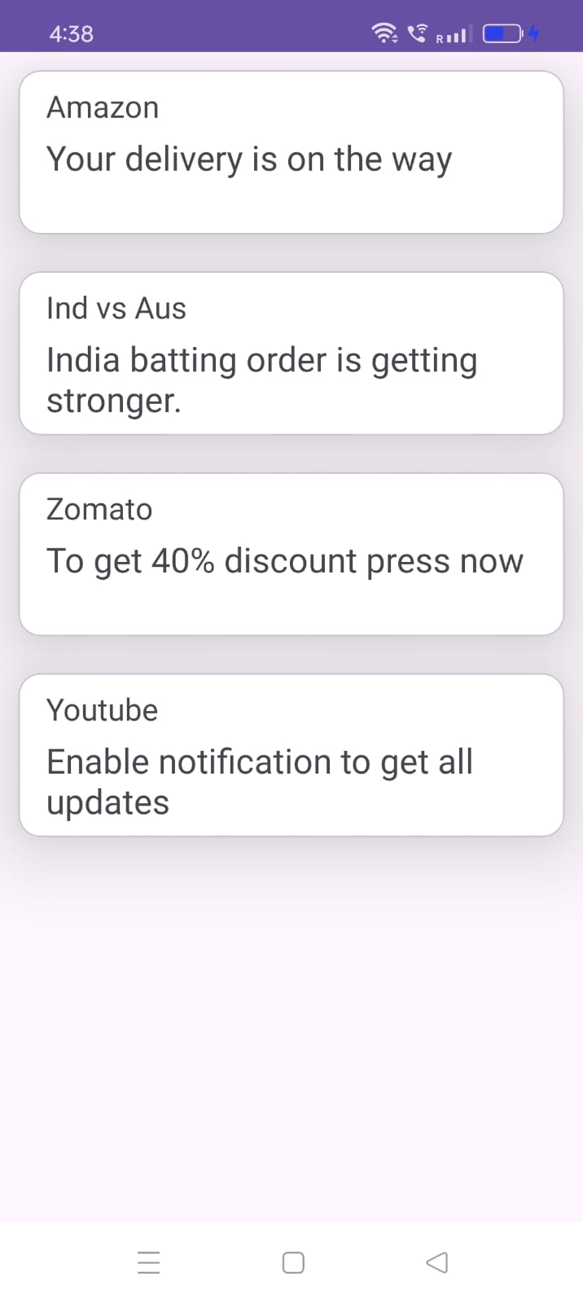

1. **Widget/Algorithm Used In Task**

* MaterialCard to show Push Notification.
* RecyclerView to show content in scrollable view.
* TextView Used For Display Static Content To User (Title, Description).
* Firebase connection for Push Notification.