**Report**

**Favourite/Wishlist Management :**

1. **Task Description**

Favourite/Wishlist Management - Create Add, Remove Favorite Functionality in List of Product. Display Data on Favorite Screen Which User Selected from Product List.

1. **Task Output Screenshot**

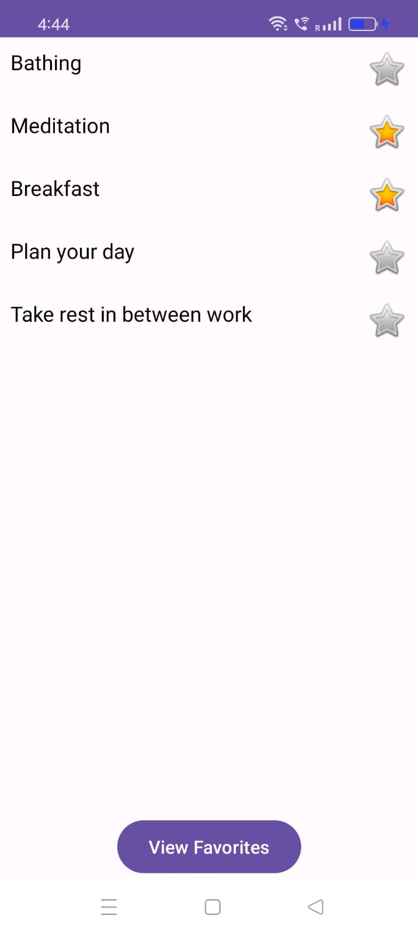

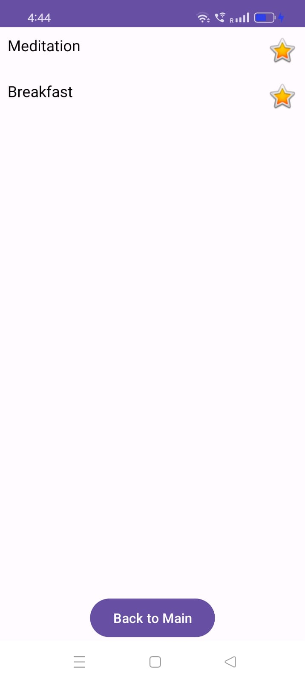

1. **Widget/Algorithm Used In Task**

* Imageview to star icon for favourite and unfavourate wishlist.
* Recyclerview to show content in scrollable view.
* Textview Used For Display Static Content To User (Wishlist items)
* Button functionality to click to see favourite list and again to back to normal list.