**Report**

**CRUD operation- Firebase**

1. **Task Description**

CRUD Operation Using Firebase - CRUD Operation of Category Using Firebase

1. **Task Output Screenshot**

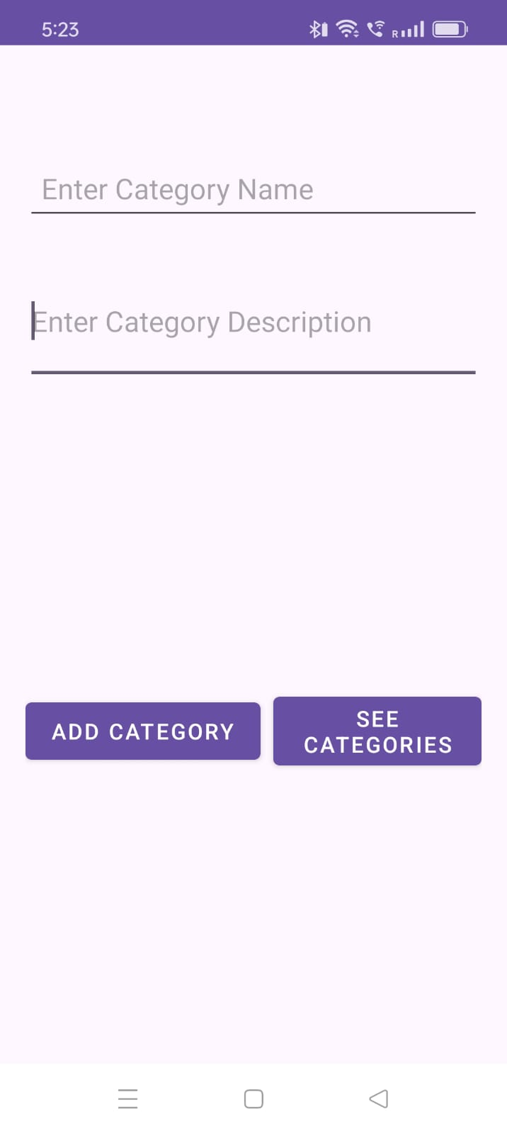 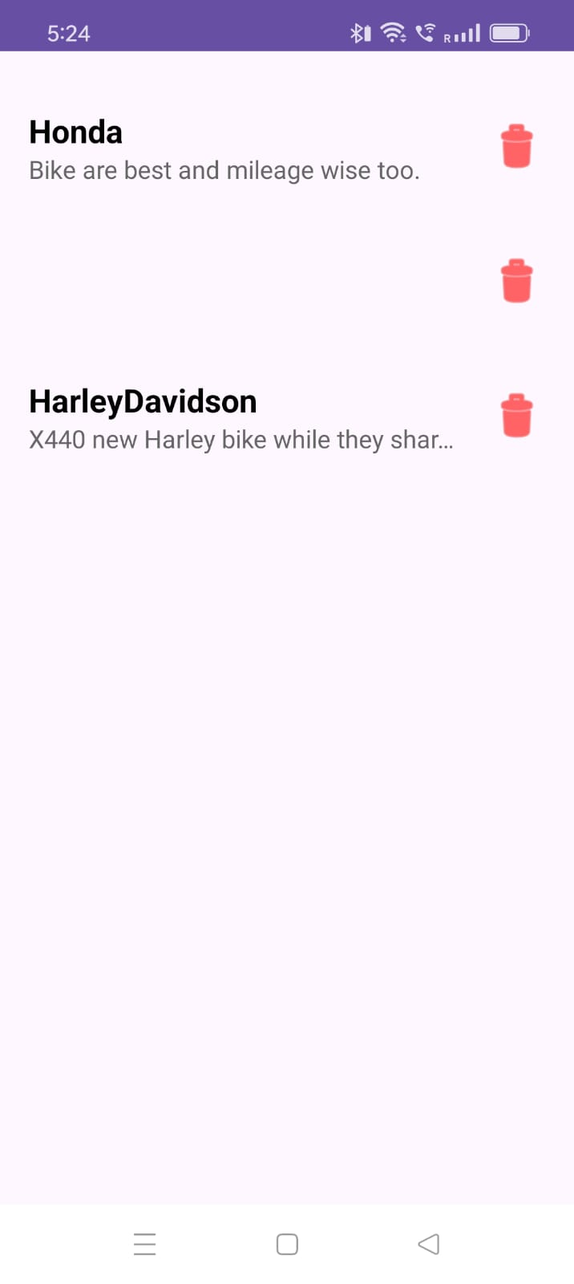

1. **Widget/Algorithm Used In Task**

* EditText - So user can enter details in this field (Categary – Name, Description).
* TextView - So user can view details and update.
* Button - So user can save details, another button to update details
* Materialcardview – To see save details in a block .