**Report**

**Room Database:**

1. **Task Description**

Room Database - Create User List and Add Form (Required At least 6 Fields). • User List using Recycler View and Display Data from Room Database. • Add Form Data Store in Room Database.

1. **Task Output Screenshot**

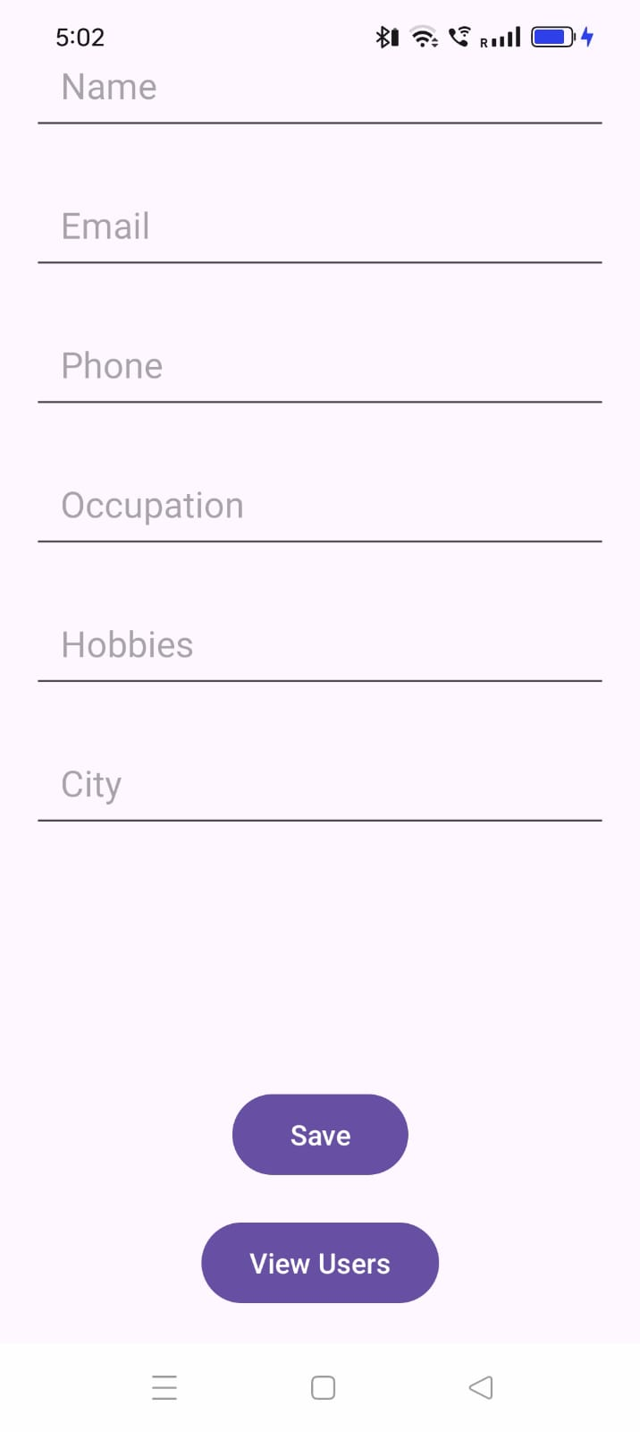 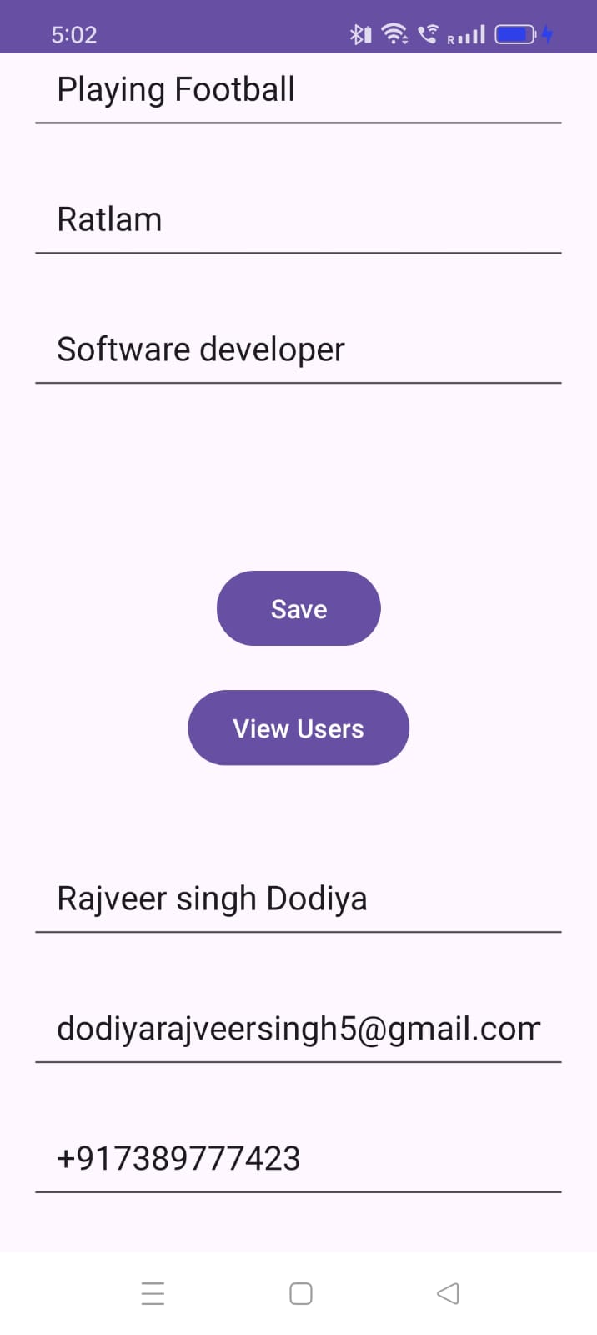

1. **Widget/Algorithm Used In Task**

* EditText - To enter details according to required field.
* Button - To save data.
* Recyclerview - To show scrollable view of save database.
* Dao Entities, DAOs (Data Access Objects), and Queries.