**Report**

**WebView**

1. **Task Description**

WebView - Create Custom WebView. Store Browse History, Clear History Functionality.

1. **Task Output Screenshot**

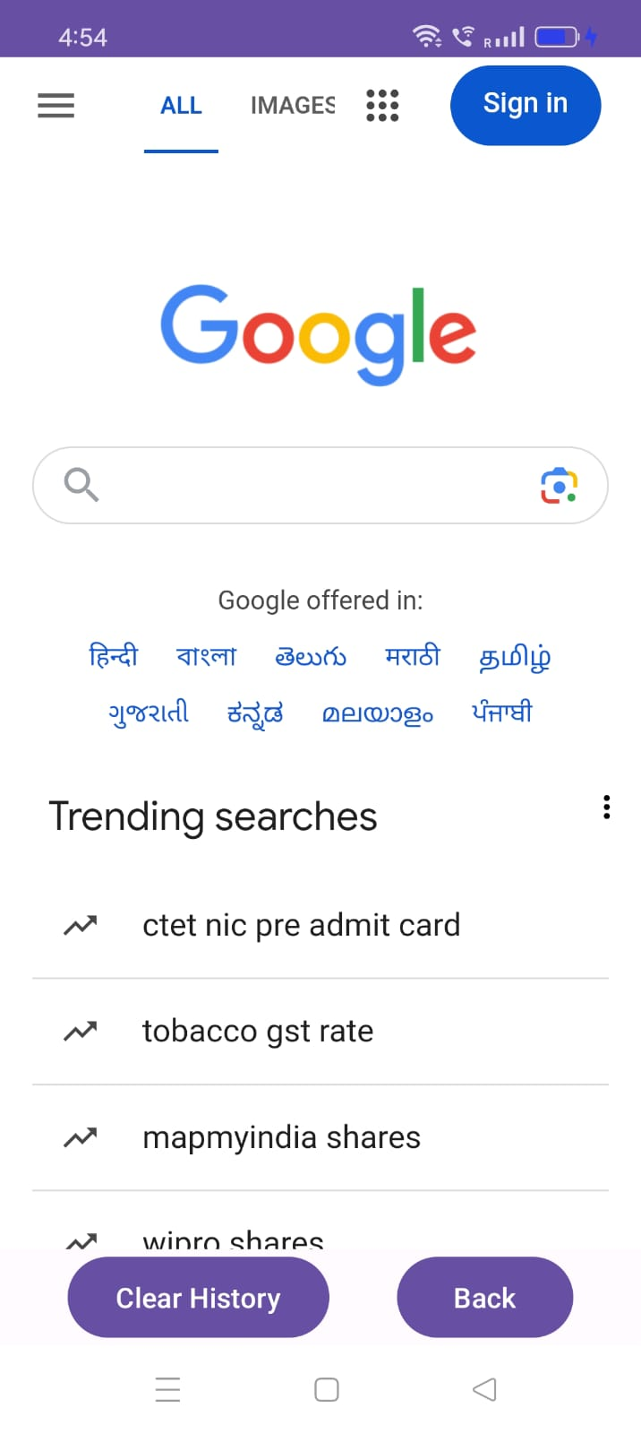

1. **Widget/Algorithm Used In Task**

* Button - To clear history.
* Button - To go back.
* Webview - To show Google page to user for search and to perform other functionality.
* It store history and on clicking button it delete history.