
The University of Azad Jammu and Kashmir, Muzaffarabad.

Software Engineering Fundamentals

Prepared By: | Raja Afzal Ajmal
Roll No: | 2024-SE-25
Lab | 01
Instructor: | Engr. Fahad Nasir
Session | 2024-2028
Course Name | Digitals Image Processing
Submission Date: | 22-October-2026

Department of Software Engineering

1. Lab Objective
The objective of this lab is to establish a functional Python environment for Digital Image Processing, configure Visual Studio Code with the Python interpreter, review core Python syntax, collections, functions, and control structures, install fundamental numerical and imaging libraries (NumPy, Pillow, Matplotlib), and verify environment imports.

2. Environment Setup & Tool Verification
Python 3 and Visual Studio Code were installed on the Windows system. The Python interpreter was added to the system PATH and linked within VS Code.

Command Prompt Verification
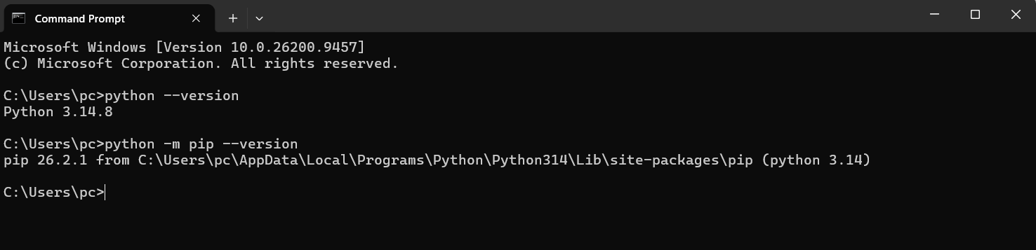
Figure 1: Command Prompt verification of Python and pip versions

3. First Python Program
A foundational script was created to test terminal output and file execution.

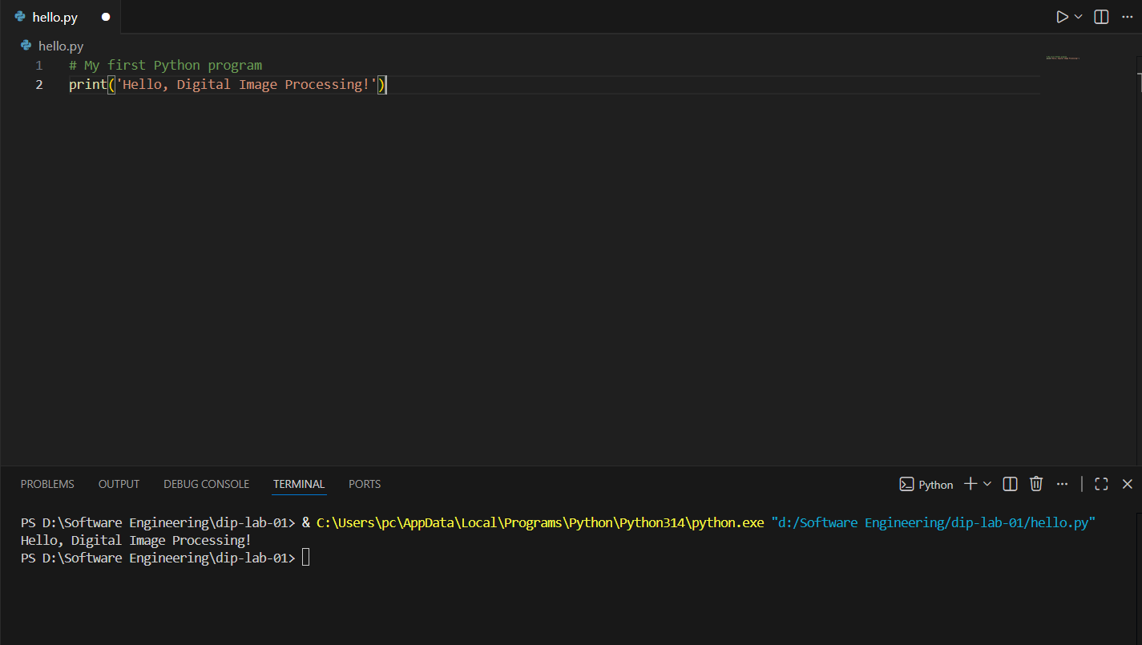
Figure 2: VS Code interface showing the selected Python 3 interpreter

4. Core Python Syntax & Exercises
Basics.py file was created in the Vs code and all six required exercises were implemented and executed, properly structured with labeled comments and clean console formatting.
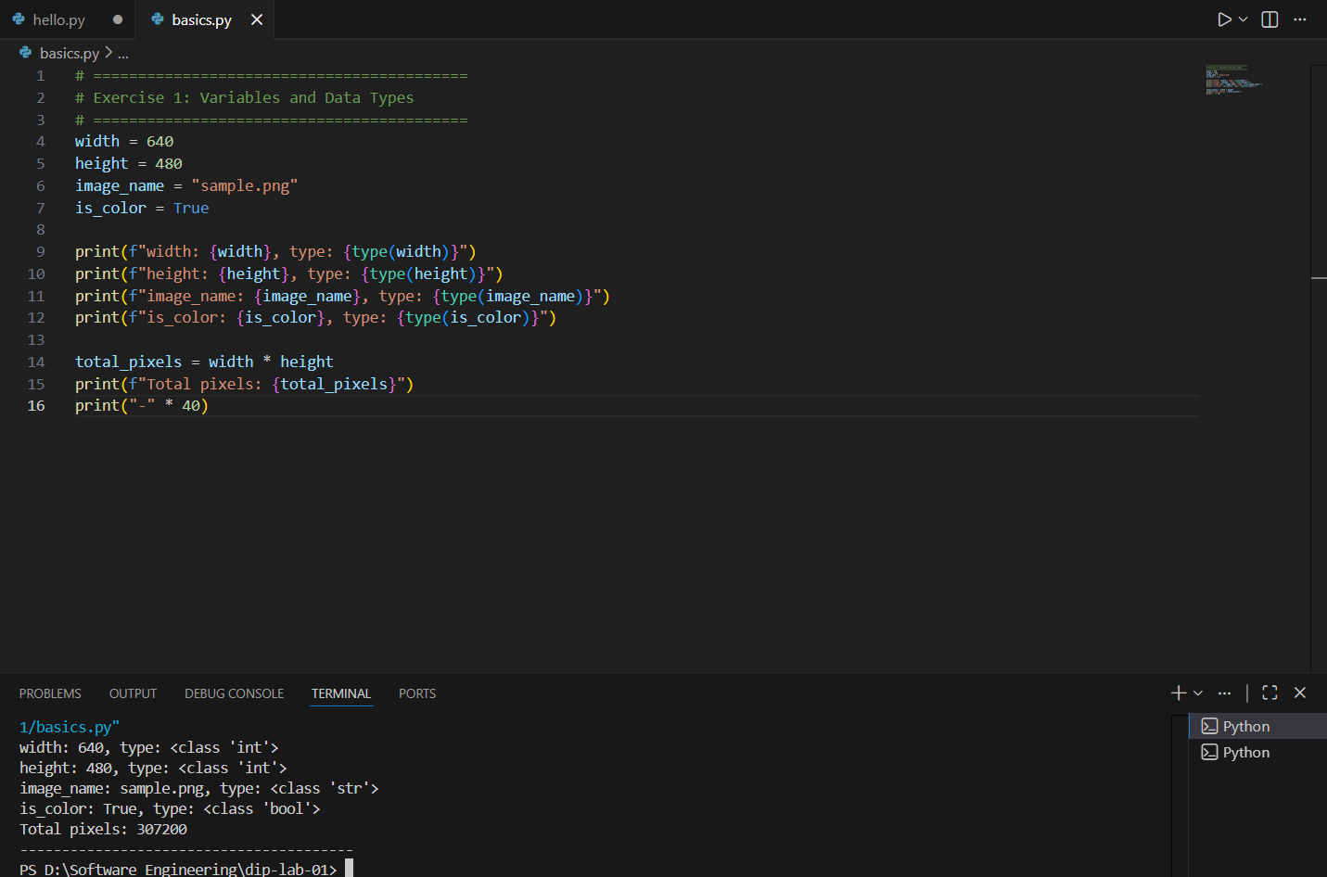
Figure 3: Source code and execution output for Exercise 1 in basics.py

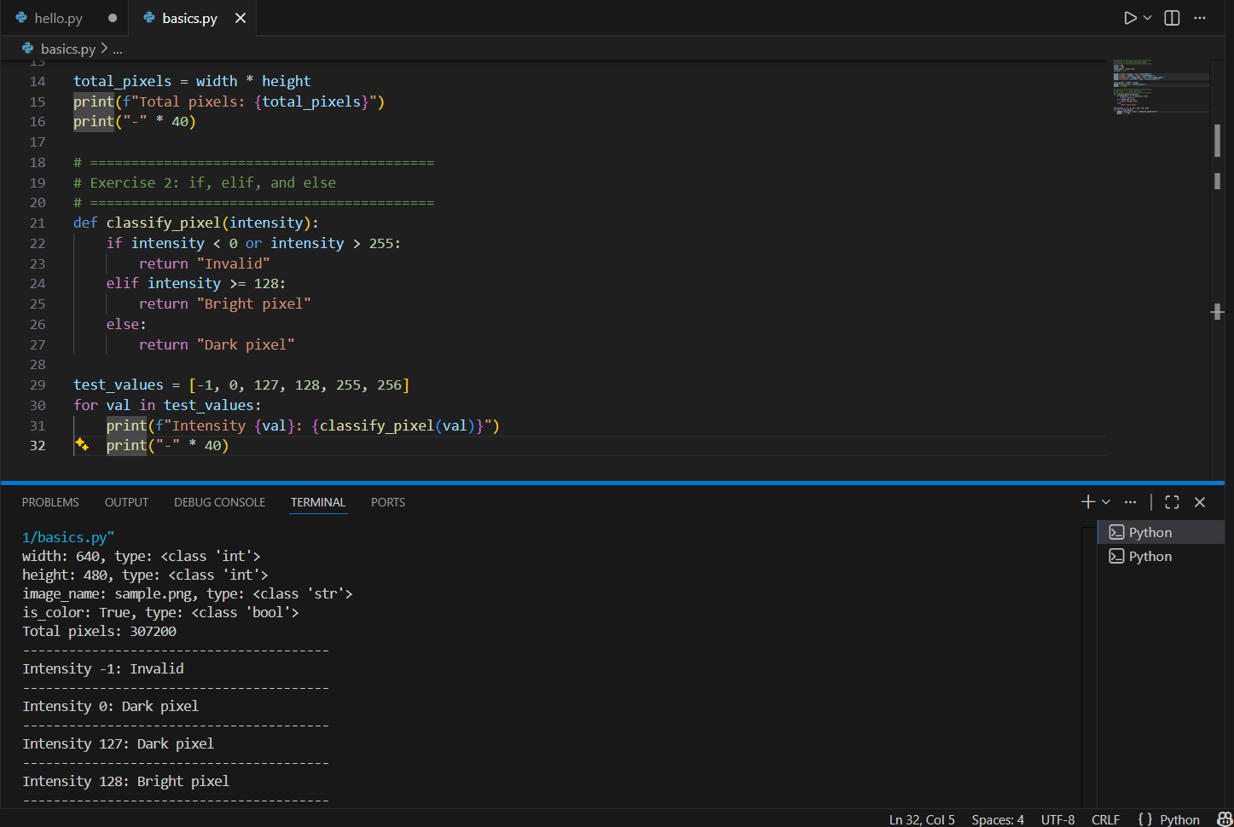
Figure 4: Source code and execution output for Exercise 2 in basics.py

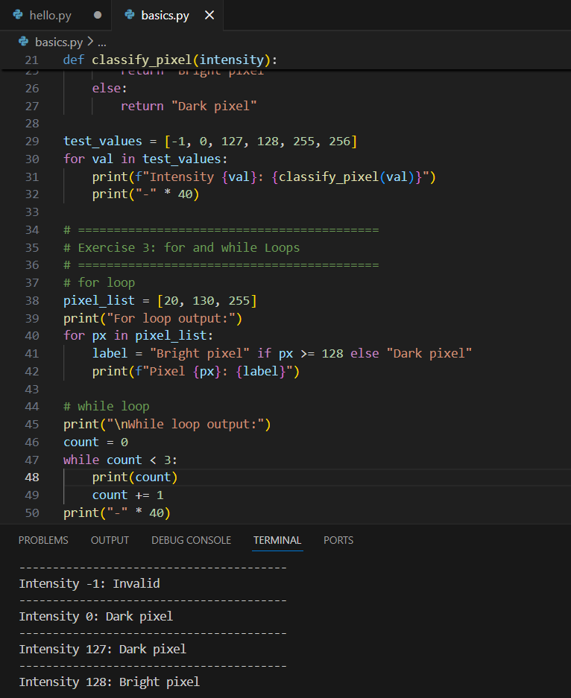
Figure 5: Source code and execution output for Exercise 3 in basics.py

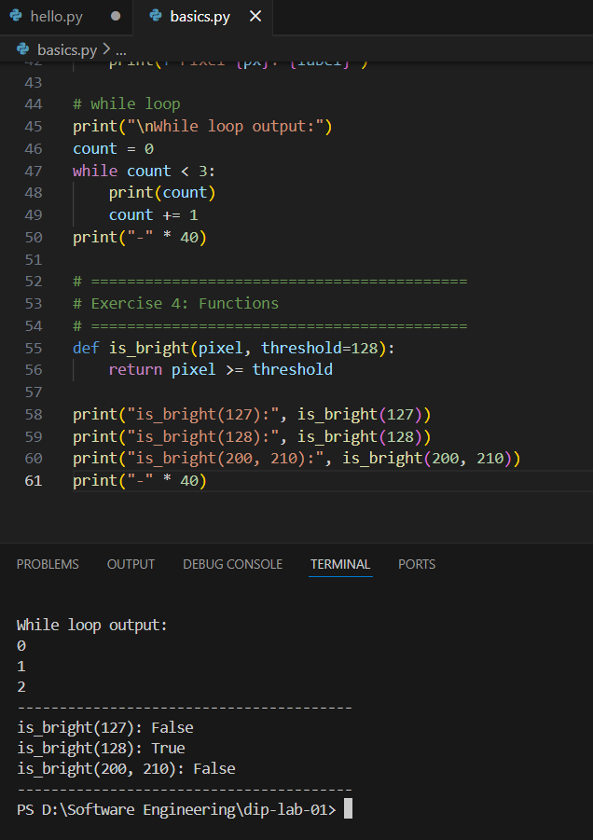
Figure 6: Source code and execution output for Exercise 4 in basics.py

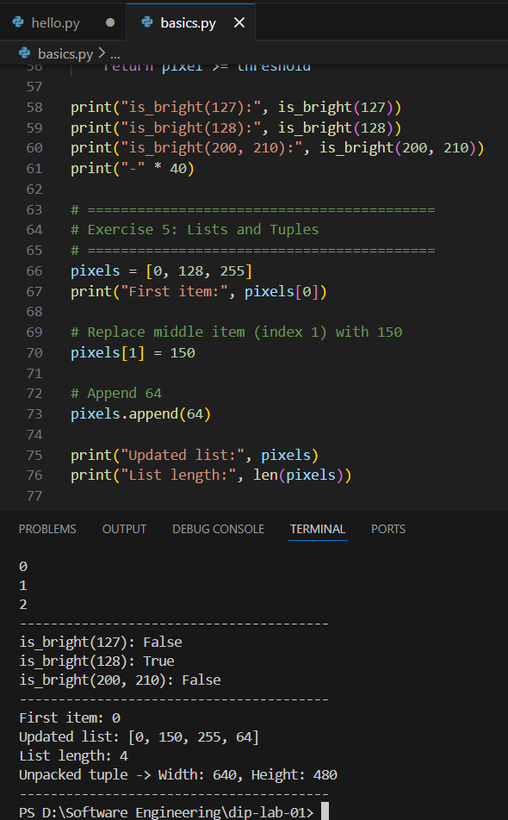
Figure 7: Source code and execution output for Exercise 4 in basics.py

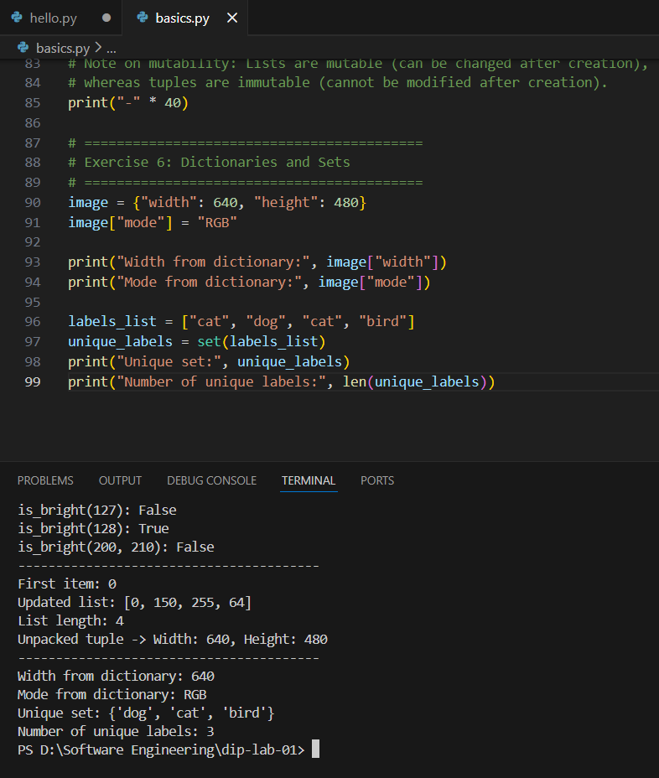
Figure 8: Source code and execution output for Exercise 4 in basics.py

Output:
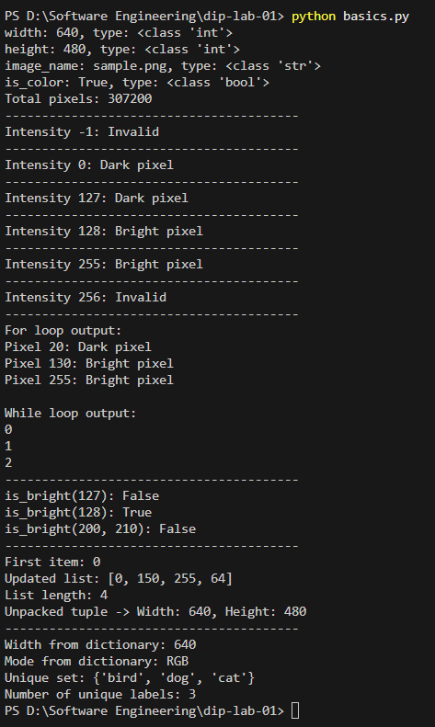
Figure 9: Execution output of all the exercises

5. Packages Installation & Import Verification

Package Installation
The necessary libraries for Digital Image Processing were installed using pip:
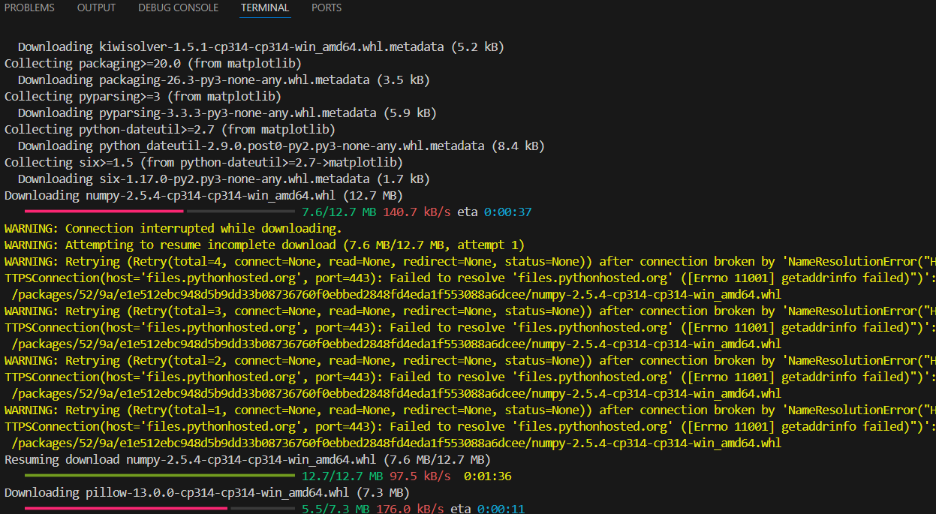
Figure 10: Installing the numpy pillow matplotlib

Package Show Verification
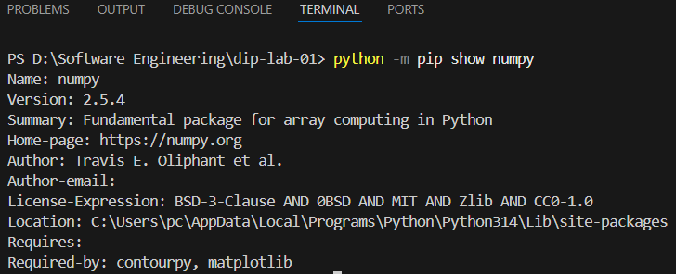

Source Code:

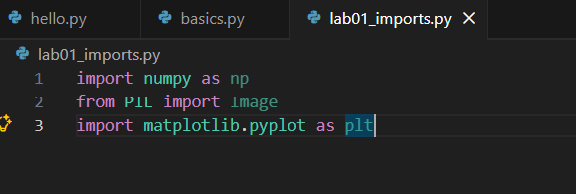
Figure 11: Source Code of Lab01_imports.py

Execution

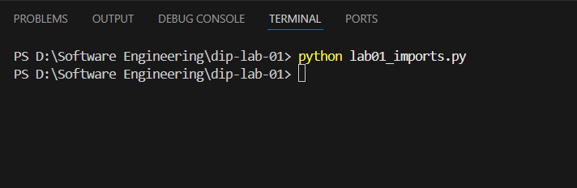
Figure 12: Execution of Lab01_imports.py

6. Technical Conceptual Explanations

1. List vs. Tuple Mutability (Exercise 5)
In Python, lists are mutable data structures, allowing elements to be modified, replaced, added, or removed in place after creation without altering the object's memory address. Tuples are immutable data structures; once instantiated, their element references and sequence order cannot be modified, making them ideal for fixed dimension pairs like image dimensions (width, height).

2. Python Interpreter vs. pip Package Manager
- Python is the high-level, interpreted programming language runtime that parses, translates, and executes source code (.py files).
- pip (Package Installer for Python) is the dedicated package management system used to search, install, update, and manage third-party external libraries from the Python Package Index (PyPI).

3. Purpose of Required DIP Import Statements
- numpy (as np): Provides multi-dimensional arrays (ndarray) for performing high-performance linear algebra, mathematical matrix operations, and pixel intensity grid transformations.
- PIL.Image (Pillow): Provides image load/save functions, file format conversions (PNG, JPEG), geometric transforms, and basic canvas manipulation.
- matplotlib.pyplot (as plt): Enables data visualization, histogram plotting, image matrix rendering, and multi-panel figure displays.

