
The University of Azad Jammu and Kashmir, Muzaffarabad.

Software Engineering Fundamentals

Prepared By: | Raja Afzal Ajmal
Roll No: | 2024-SE-25
Lab | 02
Instructor: | Engr. Fahad Nasir
Session | 2024-2028
Course Name | Digitals Image Processing
Submission Date: | 29-October-2026

Department of Software Engineering

Objective
To use NumPy, OpenCV, and Matplotlib to load, inspect, display, analyze, transform, and save a digital image, while correctly handling coordinates, color channels, histograms, resolution, and bit depth.
Image used: a color photograph of a car on a country road, downloaded from Unsplash and saved as car.jpg (3413 × 1920 pixels, well above the 300 × 300 minimum).
Tools: Python 3, VS Code, Jupyter notebook (lab02.ipynb), numpy, opencv-python, matplotlib, running inside the virtual environment .venv.

Step 1: Project and Virtual Environment
A project folder named dip-lab-02 was created and opened in VS Code. A virtual environment was created inside it, activated, and the required libraries were installed. A .gitignore file containing .venv/ keeps the environment out of version control and out of the submission.
Commands used
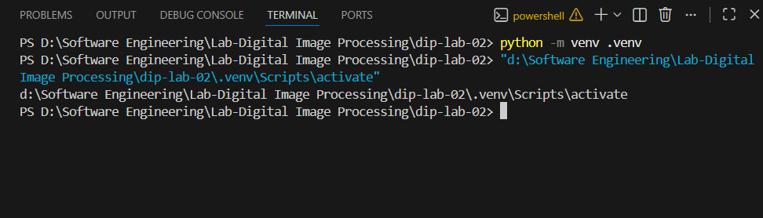
python -m venv .venv

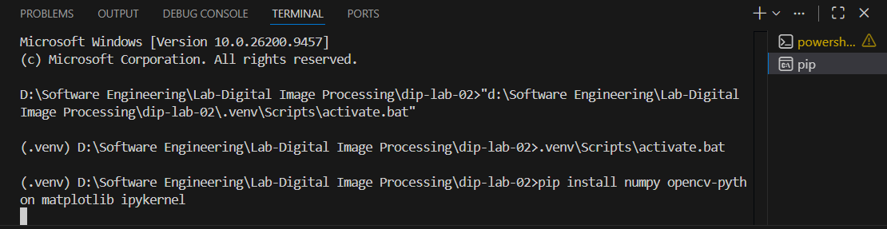
.venv\Scripts\activate.bat
pip install numpy opencv-python matplotlib ipykernel

Verification command
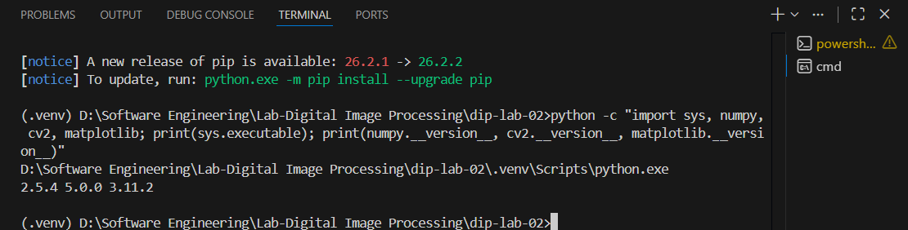
python -c "import sys, numpy, cv2, matplotlib; print(sys.executable); print(numpy.__version__, cv2.__version__, matplotlib.__version__)"

.gitignore contents
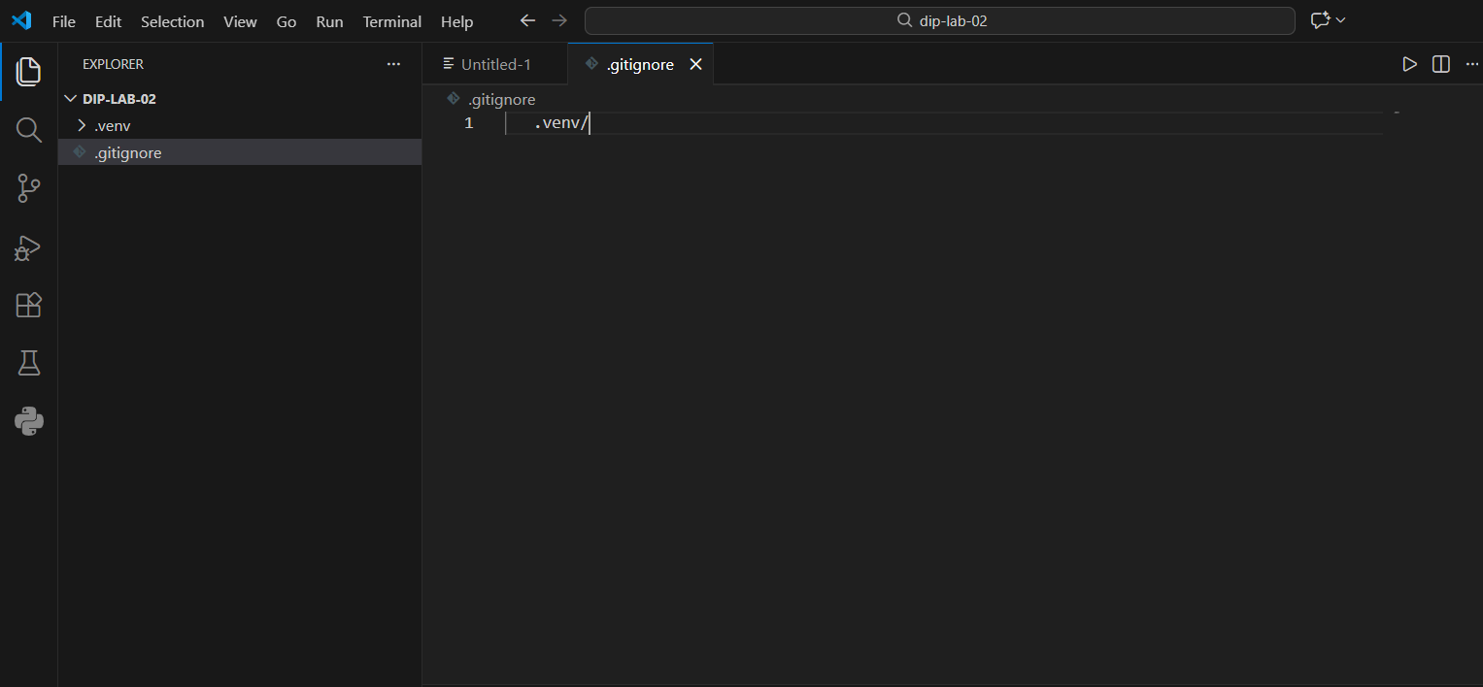

.venv/

Step 2: Load the Image
The libraries were imported with the standard aliases (np, cv, plt). The image was read with cv.imread(). Because cv.imread() returns None instead of raising an error when a file cannot be read, the code checks for None and raises FileNotFoundError explicitly.
Code
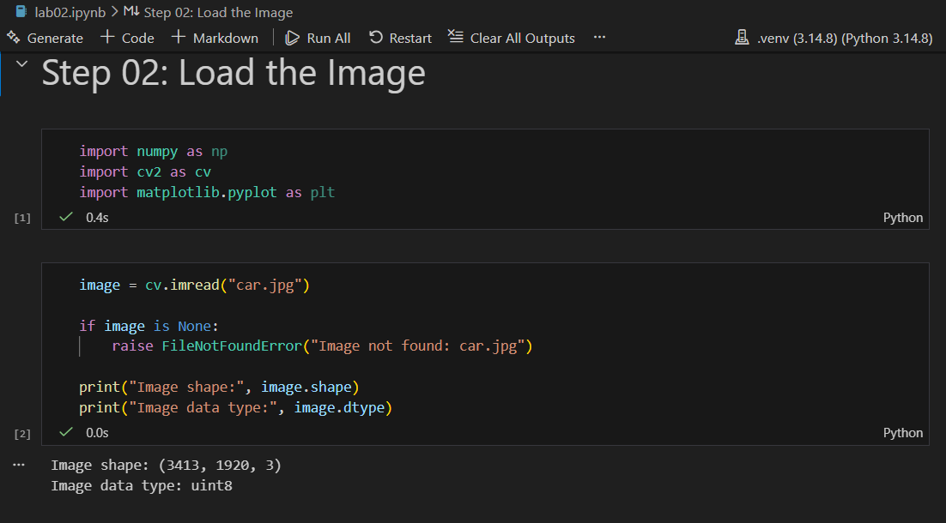

import numpy as np
import cv2 as cv
import matplotlib.pyplot as plt

image = cv.imread("car.jpg")

if image is None:
raise FileNotFoundError("Image not found: car.jpg")

print("Image shape:", image.shape)
print("Image data type:", image.dtype)
Result

Printed item | Value
Image shape (height, width, channels) | (3413, 1920, 3)
Image data type | uint8
The shape shows 3413 rows, 1920 columns and 3 color channels. The data type uint8 means each value is an 8-bit integer from 0 to 255. Both dimensions are well above 300 pixels, so the size requirement is met.

Step 3: Inspect the Image
The dimensions were unpacked from the shape, and pixels were read using [row, column] indexing. OpenCV stores color pixels in B, G, R order, so every pixel below is printed as (Blue, Green, Red).
Code
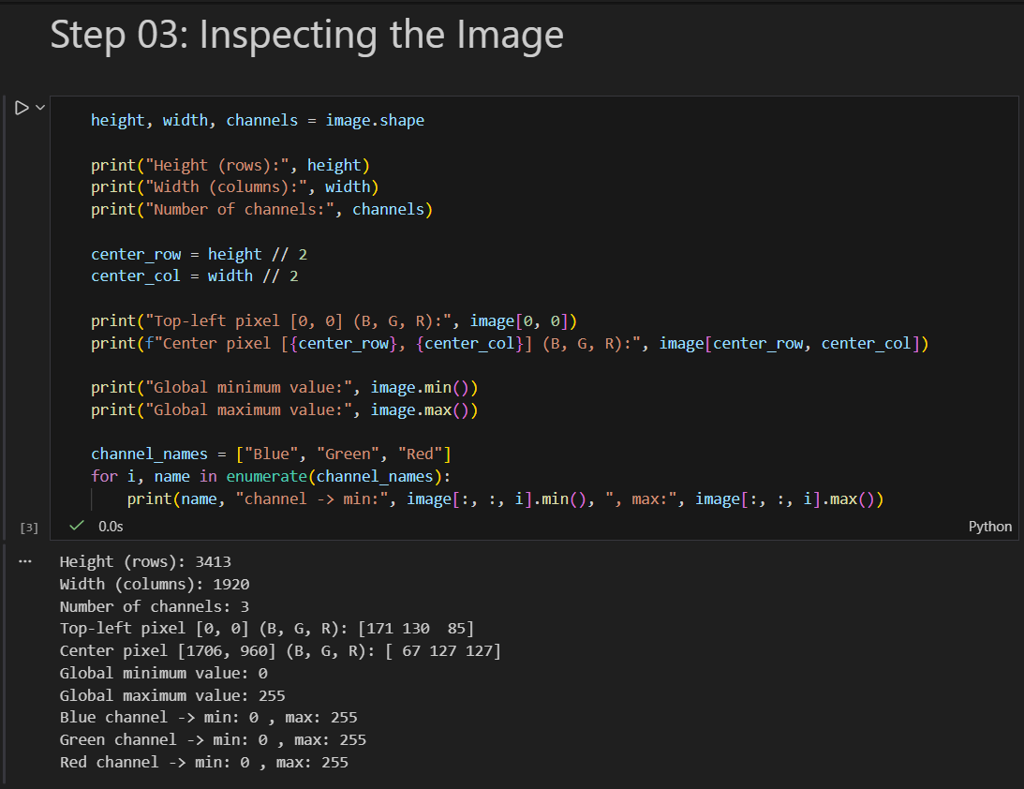

height, width, channels = image.shape

print("Height (rows):", height)
print("Width (columns):", width)
print("Number of channels:", channels)

center_row = height // 2
center_col = width // 2

print("Top-left pixel [0, 0] (B, G, R):", image[0, 0])
print(f"Center pixel [{center_row}, {center_col}] (B, G, R):", image[center_row, center_col])

print("Global minimum value:", image.min())
print("Global maximum value:", image.max())

channel_names = ["Blue", "Green", "Red"]
for i, name in enumerate(channel_names):
print(name, "channel -> min:", image[:, :, i].min(), ", max:", image[:, :, i].max())
Result
Measurement | Value
Height (rows) | 3413
Width (columns) | 1920
Number of channels | 3
Top-left pixel [0, 0] (B, G, R) | [171 130 85]
Center pixel [1706, 960] (B, G, R) | [ 67 127 127]
Global minimum / maximum | 0 / 255
Blue channel minimum / maximum | 0 / 255
Green channel minimum / maximum | 0 / 255
Red channel minimum / maximum | 0 / 255
The top-left pixel has the largest value in the blue channel and the smallest in red, which matches the blue sky at the top of the photograph. The center pixel has equal green and red values and a low blue value, an olive-green tone that matches the grass at the center of the photograph. Every channel reaches both 0 and 255, so the image uses the full brightness range, from the very dark tires and shadows to bright highlights.

Step 4: Convert Colors and Separate Channels
The image was converted from BGR to RGB with cv.cvtColor() so that Matplotlib shows the correct colors, and a grayscale version was created. The red, green and blue channels were separated by slicing the RGB array. A 2 × 3 figure shows RGB, red, green, blue, grayscale, and the unconverted BGR array displayed directly.
Code: conversion, channels, and 2 × 3 figure

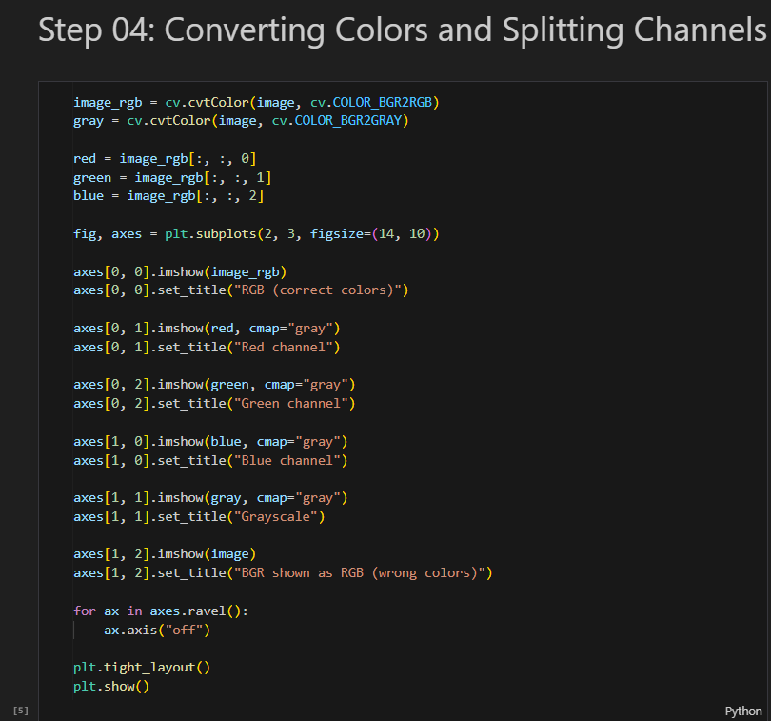
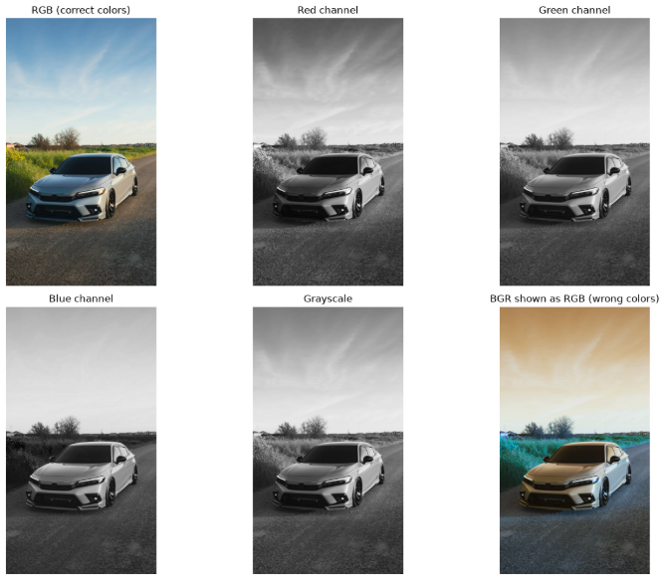

image_rgb = cv.cvtColor(image, cv.COLOR_BGR2RGB)
gray = cv.cvtColor(image, cv.COLOR_BGR2GRAY)

red = image_rgb[:, :, 0]
green = image_rgb[:, :, 1]
blue = image_rgb[:, :, 2]

fig, axes = plt.subplots(2, 3, figsize=(14, 10))

axes[0, 0].imshow(image_rgb)
axes[0, 0].set_title("RGB (correct colors)")

axes[0, 1].imshow(red, cmap="gray")
axes[0, 1].set_title("Red channel")

axes[0, 2].imshow(green, cmap="gray")
axes[0, 2].set_title("Green channel")

axes[1, 0].imshow(blue, cmap="gray")
axes[1, 0].set_title("Blue channel")

axes[1, 1].imshow(gray, cmap="gray")
axes[1, 1].set_title("Grayscale")

axes[1, 2].imshow(image)
axes[1, 2].set_title("BGR shown as RGB (wrong colors)")

for ax in axes.ravel():
ax.axis("off")

plt.tight_layout()
plt.show()

Code: center pixel RGB and HEX value
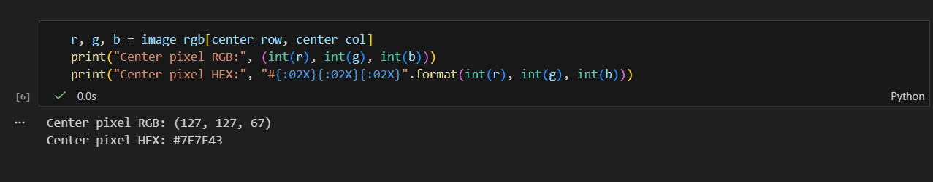

r, g, b = image_rgb[center_row, center_col]
print("Center pixel RGB:", (int(r), int(g), int(b)))
print("Center pixel HEX:", "#{:02X}{:02X}{:02X}".format(int(r), int(g), int(b)))
Result
Printed item | Value
Center pixel RGB | (127, 127, 67)
Center pixel HEX | #7F7F43
The RGB values are the same numbers as the BGR pixel in Step 3 in reverse order, which confirms the conversion.

Explanation: BGR versus RGB
OpenCV reads and stores color images with the channels in the order Blue, Green, Red (BGR). Matplotlib, and most other image tools expect Red, Green, Blue (RGB). If a BGR array is passed straight to Matplotlib, the red and blue channels are swapped, so the picture is displayed with wrong colors. In this photograph the blue sky appears orange-brown in the last panel of the figure, while the converted RGB version in the first panel shows the correct colors. Calling cv.cvtColor() with cv.COLOR_BGR2RGB reorders the channels so that the colors are displayed correctly.

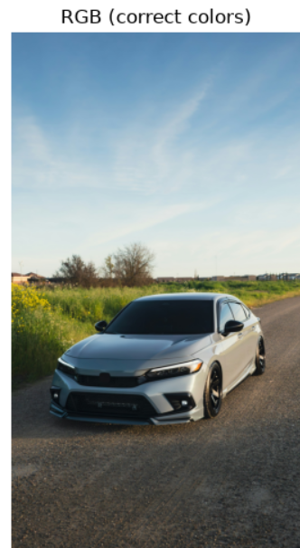
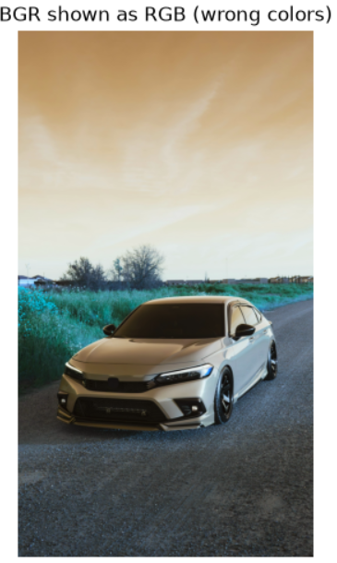

Observations on the channels and grayscale
Each channel image shows how much of one color is present at every pixel, where white means a high value and black means a low value. In the red channel the sky is dark, because a blue sky contains little red, while the grass, the bushes and the car body are brighter. In the green channel the sky and the grass have a similar medium-to-light brightness, because both contain a fair amount of green, and the dark windshield and road stay dark. In the blue channel the sky is the brightest part of the image, almost white, while the grass and bushes become dark, since they contain very little blue. The silver car body is light in all three channels, because gray is made of roughly equal amounts of red, green and blue, and the tires, windshield and road stay dark in all of them. The grayscale image combines the three channels into a single brightness value for each pixel. It keeps the light and dark structure of the scene, such as the bright sky, the mid-tone grass and the dark road, but it removes the color information. In the last panel, the BGR array displayed without conversion has swapped red and blue, so the blue sky appears orange-brown and the green grass appears teal, which shows why the conversion to RGB is necessary.
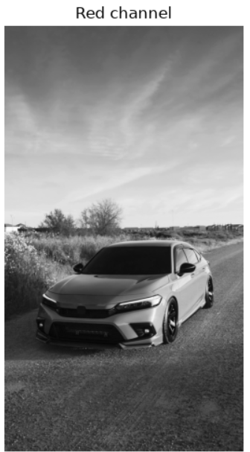
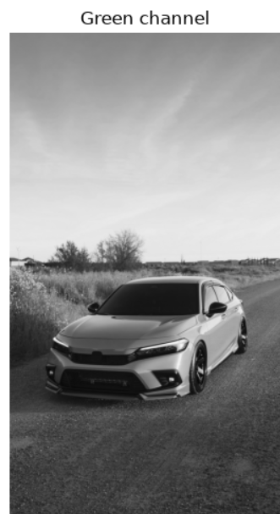

Step 5: Crop, Resize, and Save
An exact 100 × 100 region around the center of the image was cropped with slicing, image_rgb[y_start:y_end, x_start:x_end]. The crop was enlarged to 200 × 200 pixels with cv.resize() (which takes the size as width, height). Because OpenCV saves files assuming BGR order, the RGB result was converted back to BGR before saving with cv.imwrite().
Code: crop and resize
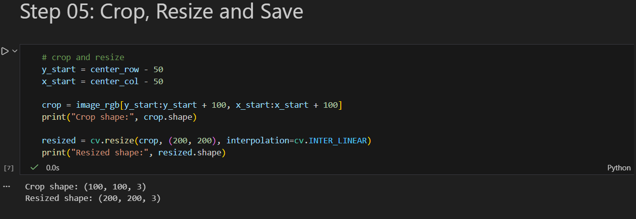
y_start = center_row - 50
x_start = center_col - 50

crop = image_rgb[y_start:y_start + 100, x_start:x_start + 100]
print("Crop shape:", crop.shape)

resized = cv.resize(crop, (200, 200), interpolation=cv.INTER_LINEAR)
print("Resized shape:", resized.shape)

Code: side-by-side display
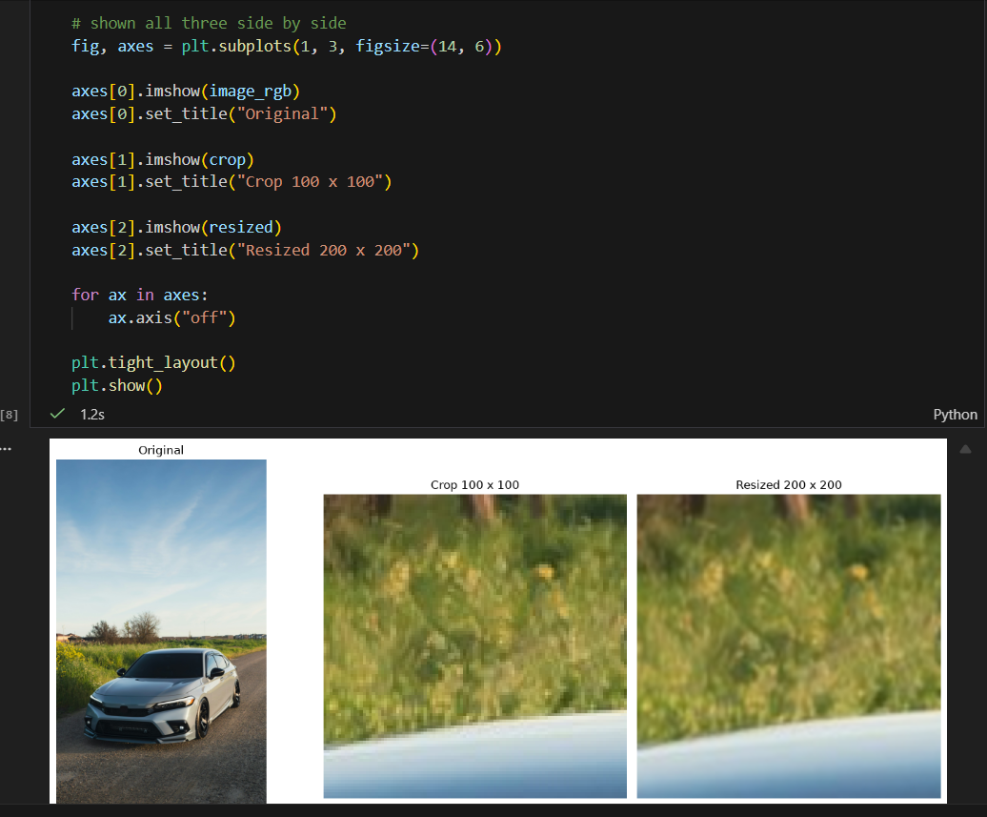

fig, axes = plt.subplots(1, 3, figsize=(14, 6))

axes[0].imshow(image_rgb)
axes[0].set_title("Original")

axes[1].imshow(crop)
axes[1].set_title("Crop 100 x 100")

axes[2].imshow(resized)
axes[2].set_title("Resized 200 x 200")

for ax in axes:
ax.axis("off")

plt.tight_layout()
plt.show()

Code: convert back to BGR and save

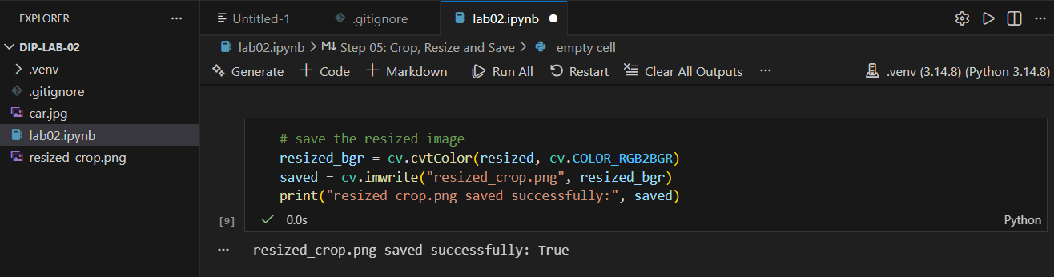

resized_bgr = cv.cvtColor(resized, cv.COLOR_RGB2BGR)
saved = cv.imwrite("resized_crop.png", resized_bgr)
print("resized_crop.png saved successfully:", saved)

Result
Printed item | Value
Crop shape | (100, 100, 3)
Resized shape | (200, 200, 3)
resized_crop.png saved successfully | True
The crop is exactly 100 × 100 pixels and the resized image is exactly 200 × 200, and cv.imwrite() returned True, so resized_crop.png was saved. The crop shows grass with yellow flowers and the edge of the car body at the bottom. The resized image is the same content at twice the size, and it looks smoother and slightly blurrier than the crop. This is because cv.resize() with linear interpolation estimates the new pixels by blending neighboring pixels. It cannot add real detail, so enlarging an image does not make it sharper.

Step 6: Grayscale Histogram
The grayscale image was flattened into a one-dimensional array and plotted as a 256-bin histogram over the range 0 to 256, so that each possible brightness value has its own bin. The plot has a title and axis labels and was saved as grayscale_histogram.png. The figure is saved before it is shown, otherwise the saved file can be blank.
Code
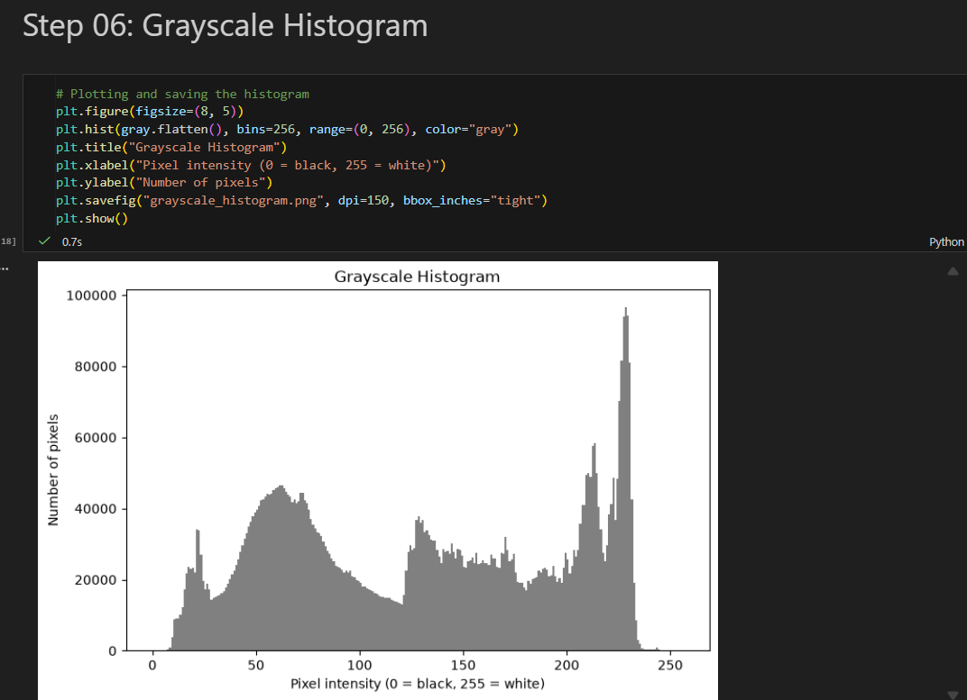
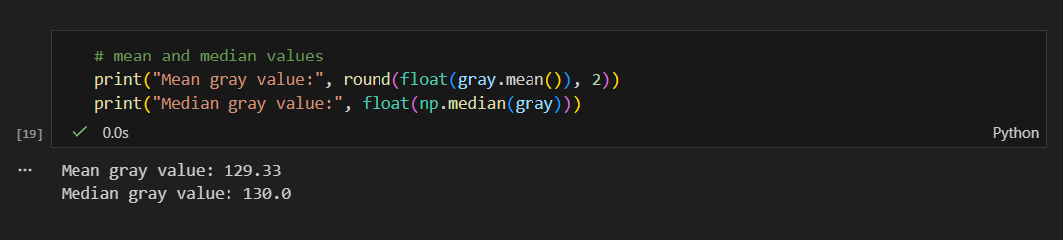

plt.figure(figsize=(8, 5))
plt.hist(gray.flatten(), bins=256, range=(0, 256), color="gray")
plt.title("Grayscale Histogram")
plt.xlabel("Pixel intensity (0 = black, 255 = white)")
plt.ylabel("Number of pixels")
plt.savefig("grayscale_histogram.png", dpi=150, bbox_inches="tight")
plt.show()

print("Mean gray value:", round(float(gray.mean()), 2))
print("Median gray value:", float(np.median(gray)))

Result
Statistic | Value
Mean gray value | 129.33
Median gray value | 130.0

Interpretation: is the image dark, bright, or balanced?
The image is balanced. The mean gray value is 129.33 and the median is 130.0, both close to the middle of the 0 to 255 range. The histogram has several separate groups instead of one: a small peak near 20 from the darkest areas such as the tires and shadows, a broad hump between about 50 and 80 from the dark road, a plateau between about 125 and 190 from the grass and the car, and a tall narrow peak between about 210 and 230 from the bright sky. Very few pixels fall below about 10 or above about 235, so there is almost no pure black or pure white after the grayscale conversion.

What a histogram shows and what it does not show
A histogram shows how many pixels in the image have each brightness value. It shows the overall brightness of an image, how spread out the values are (the contrast), and whether the image is dark, bright, or balanced. It does not show where the pixels are located in the image, so it cannot show shapes, objects, or the arrangement of the picture. A grayscale histogram also does not show color. Two very different images can have the same histogram.

Step 7: Bit Depth
An 8-bit horizontal gradient with the values 0 to 255 was created and then quantized to 4-bit, 2-bit and 1-bit. An N-bit image has 2^N possible intensity levels, so the number of levels is 16, 4 and 2 respectively. Quantizing merges nearby values into the same level and then scales the levels back to the 0 to 255 range so that they can be displayed. The gradient is generated by code and does not use the car photograph.
Code: create and quantize the gradient
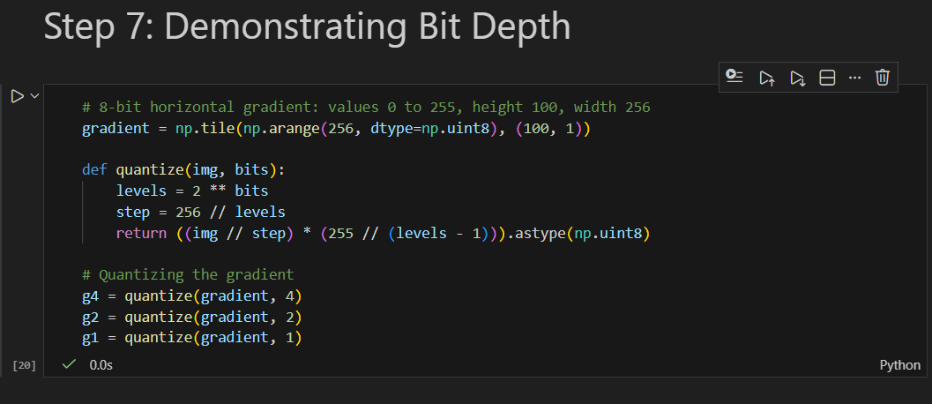

# 8-bit horizontal gradient: values 0 to 255, height 100, width 256
gradient = np.tile(np.arange(256, dtype=np.uint8), (100, 1))

def quantize(img, bits):
levels = 2 ** bits
step = 256 // levels
return ((img // step) * (255 // (levels - 1))).astype(np.uint8)

# Quantizing the gradient
g4 = quantize(gradient, 4)
g2 = quantize(gradient, 2)
g1 = quantize(gradient, 1)
Code: display all four gradients
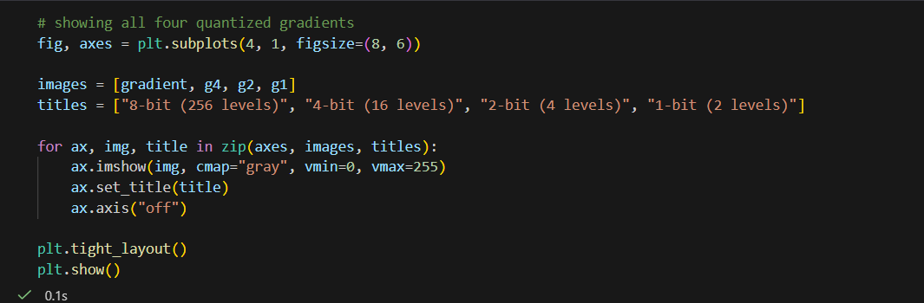
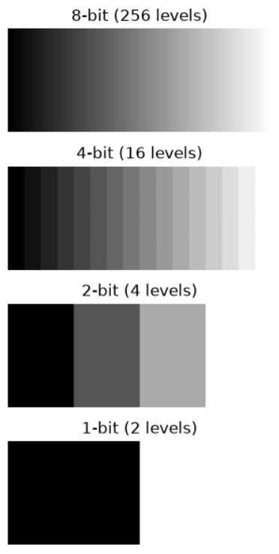
fig, axes = plt.subplots(4, 1, figsize=(8, 6))

images = [gradient, g4, g2, g1]
titles = ["8-bit (256 levels)", "4-bit (16 levels)", "2-bit (4 levels)", "1-bit (2 levels)"]

for ax, img, title in zip(axes, images, titles):
ax.imshow(img, cmap="gray", vmin=0, vmax=255)
ax.set_title(title)
ax.axis("off")

plt.tight_layout()
plt.show()

Code: unique-value counts
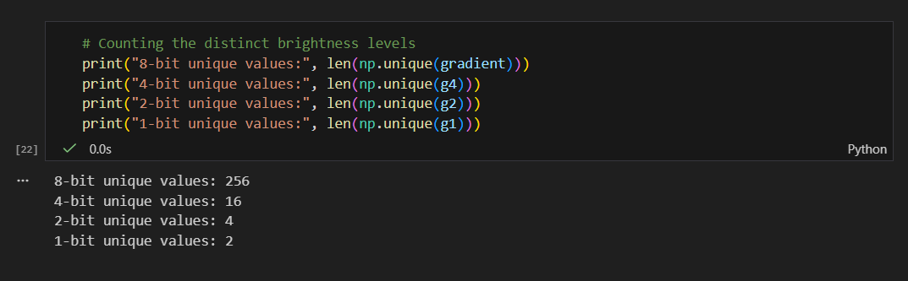
print("8-bit unique values:", len(np.unique(gradient)))
print("4-bit unique values:", len(np.unique(g4)))
print("2-bit unique values:", len(np.unique(g2)))
print("1-bit unique values:", len(np.unique(g1)))

Result

Bit depth | Possible levels | Unique values counted
8-bit | 256 | 256
4-bit | 16 | 16
2-bit | 4 | 4
1-bit | 2 | 2
The 8-bit gradient is smooth. At 4 bits, bands become visible, at 2 bits only four wide stripes remain, and at 1 bit the gradient becomes just a black half and a white half.

Explanation: resolution versus bit depth
Resolution is the number of pixels in an image, its width times its height, and it controls how much spatial detail the image can hold. Bit depth is the number of bits used to store the value of each pixel, and it controls how many different brightness or color levels each pixel can have. An 8-bit grayscale pixel has 256 possible levels. Lowering the resolution makes the image blocky because there are fewer pixels, while lowering the bit depth makes smooth areas show visible bands because there are fewer possible levels.

Step 8: Final Successful Run and Submission
After all steps were written, the kernel was restarted and all cells were run from the top with Restart followed by Run All. Every cell ran in order with no errors, and the output files were created in the project folder. The virtual environment was then deactivated with the following command.
Command

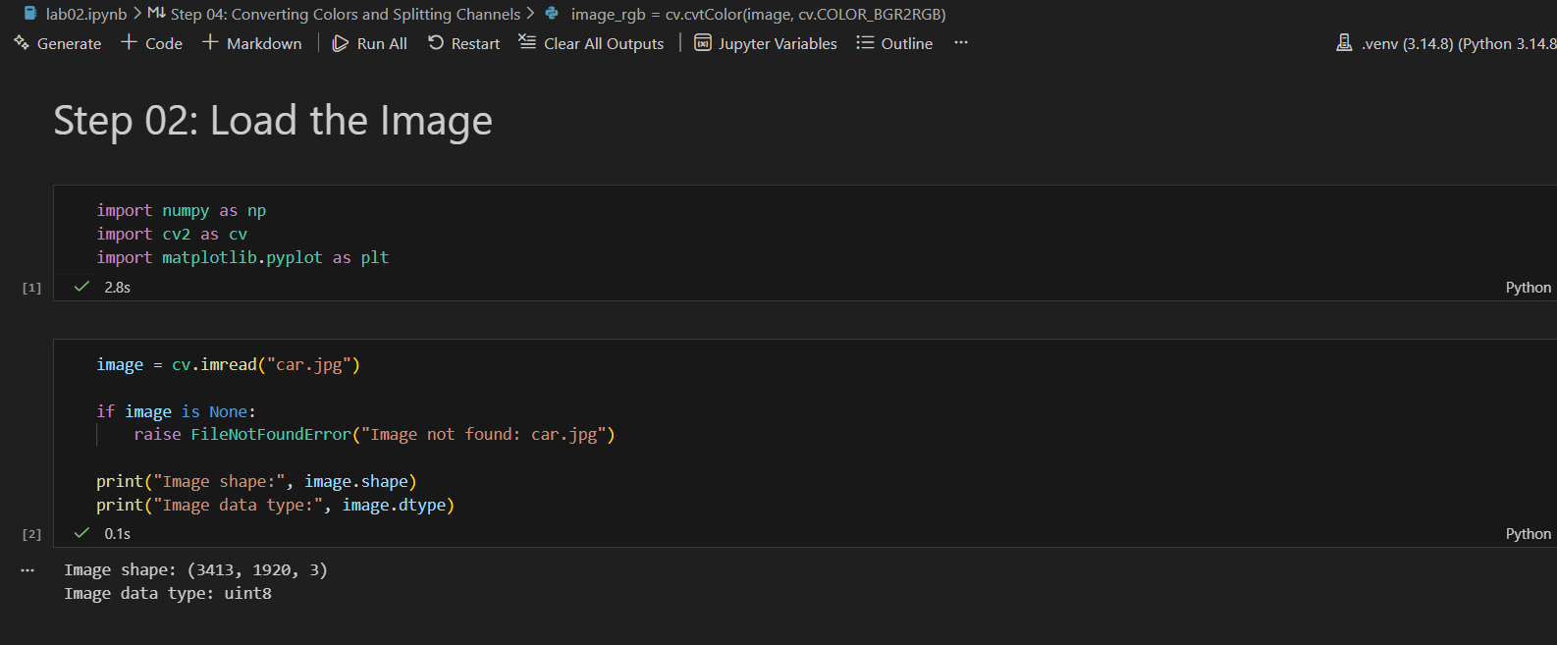
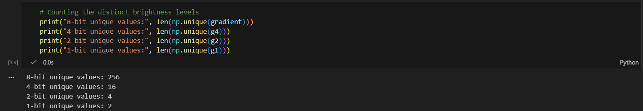

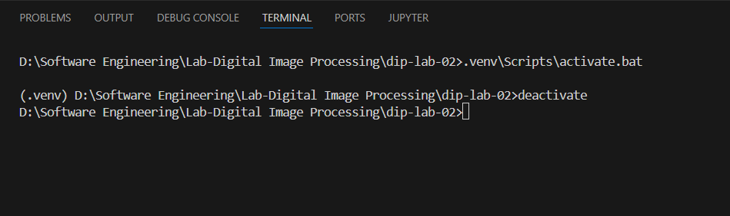
deactivate

