Instructions for working with Zipped files
In the zipped file there are seven(7) files present in the zipped folder
- Readme file; which is this document that helps the reader navigate through the files in the folder
- The Netflix_Analysis.ipynb file which is the python file that contains all the python codes to clean the file and all and also display the visuals for the most watched genre and also the ratings distribution.
- Netflix_shows_movies_clean; the csv file containing the dataset that has been cleaned, missing values handled and all.
- Netflix_shows_movies: which is the un-cleaned data
- my_data_profile_report.html: which is the profiling report that was printed using Y-data profiling library
- ExtractionScript: This is the python script that extracts the zipped file, searches through to locate the csv and then converts it to a dataframe
- Visuals.R; which is the file that has the R version for the visuals displayed (most genre watched, ratings distribution)

To Run the Python codes
Open a python IDE, jupiter notebook, jupyter lab or Pycharm afterwards try to navigate to where the folder is saved, I believe for the reader, that would be in the download

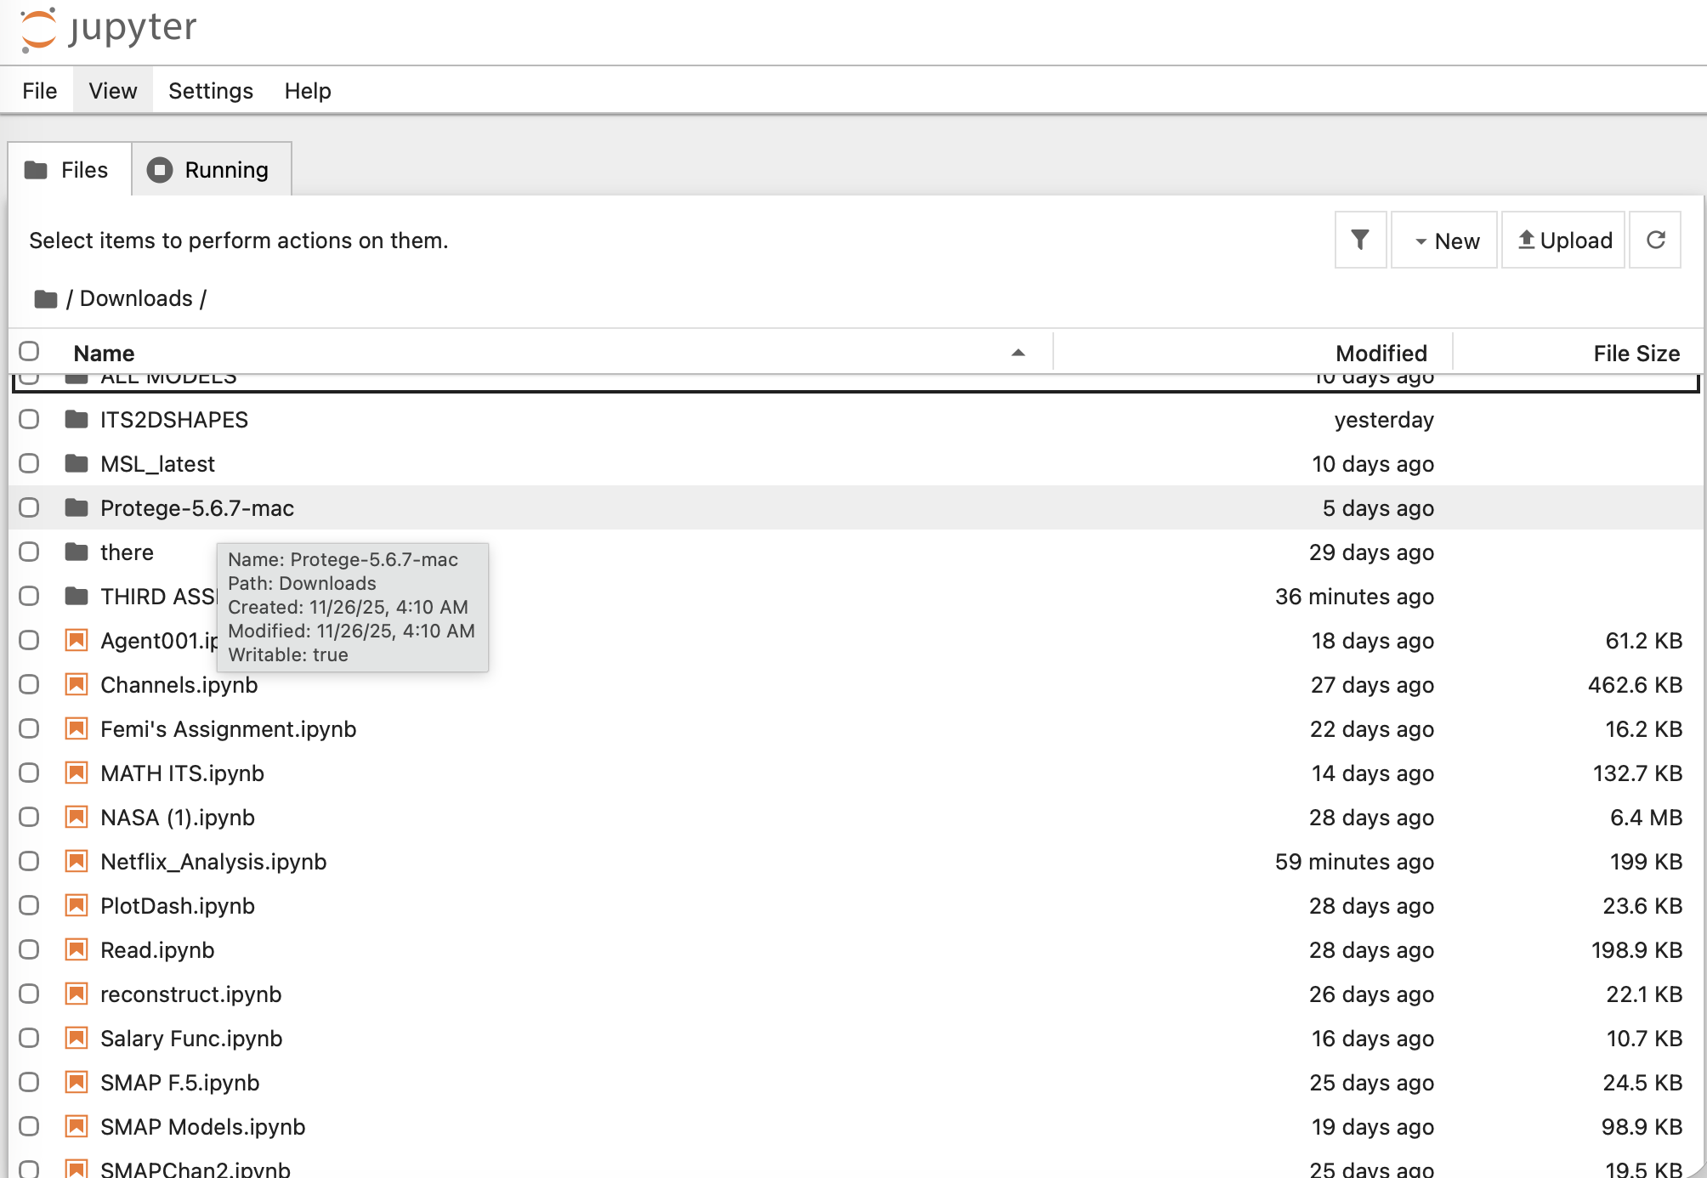

When the notebook is seen double click on it for it to run on the server, then run each cell one by one
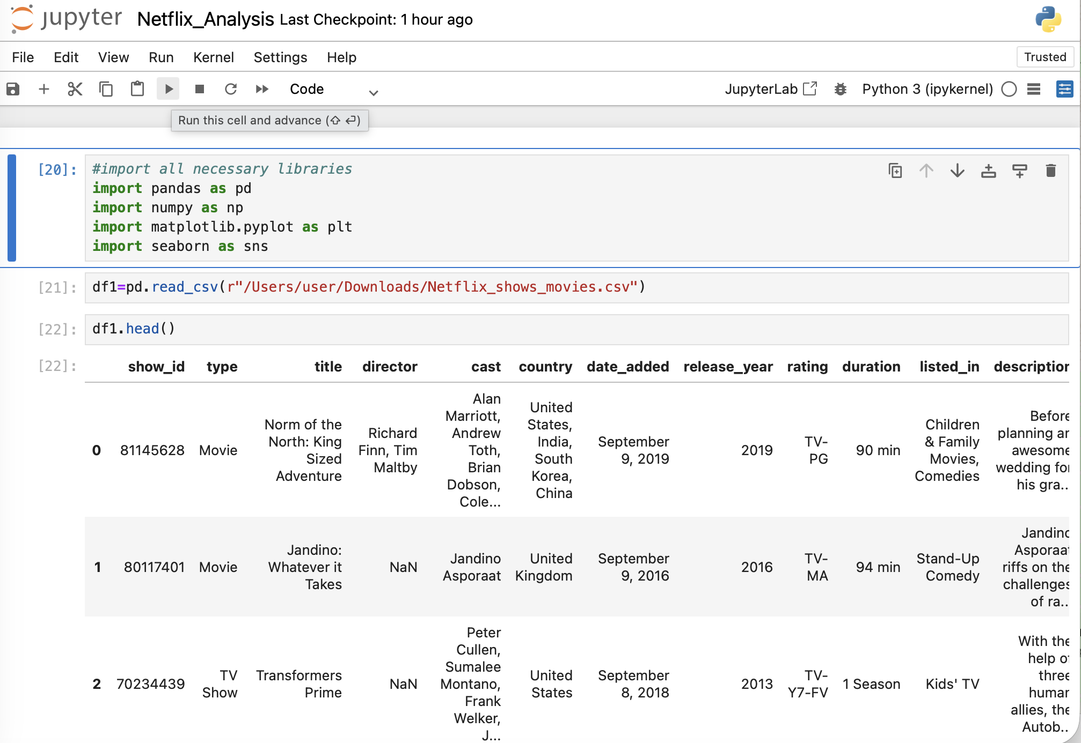

Just like that, you should see a number by the side when a cell runs
To run R open the R console and click on file to open the specified download file and then run it and these are the windows that should pop up

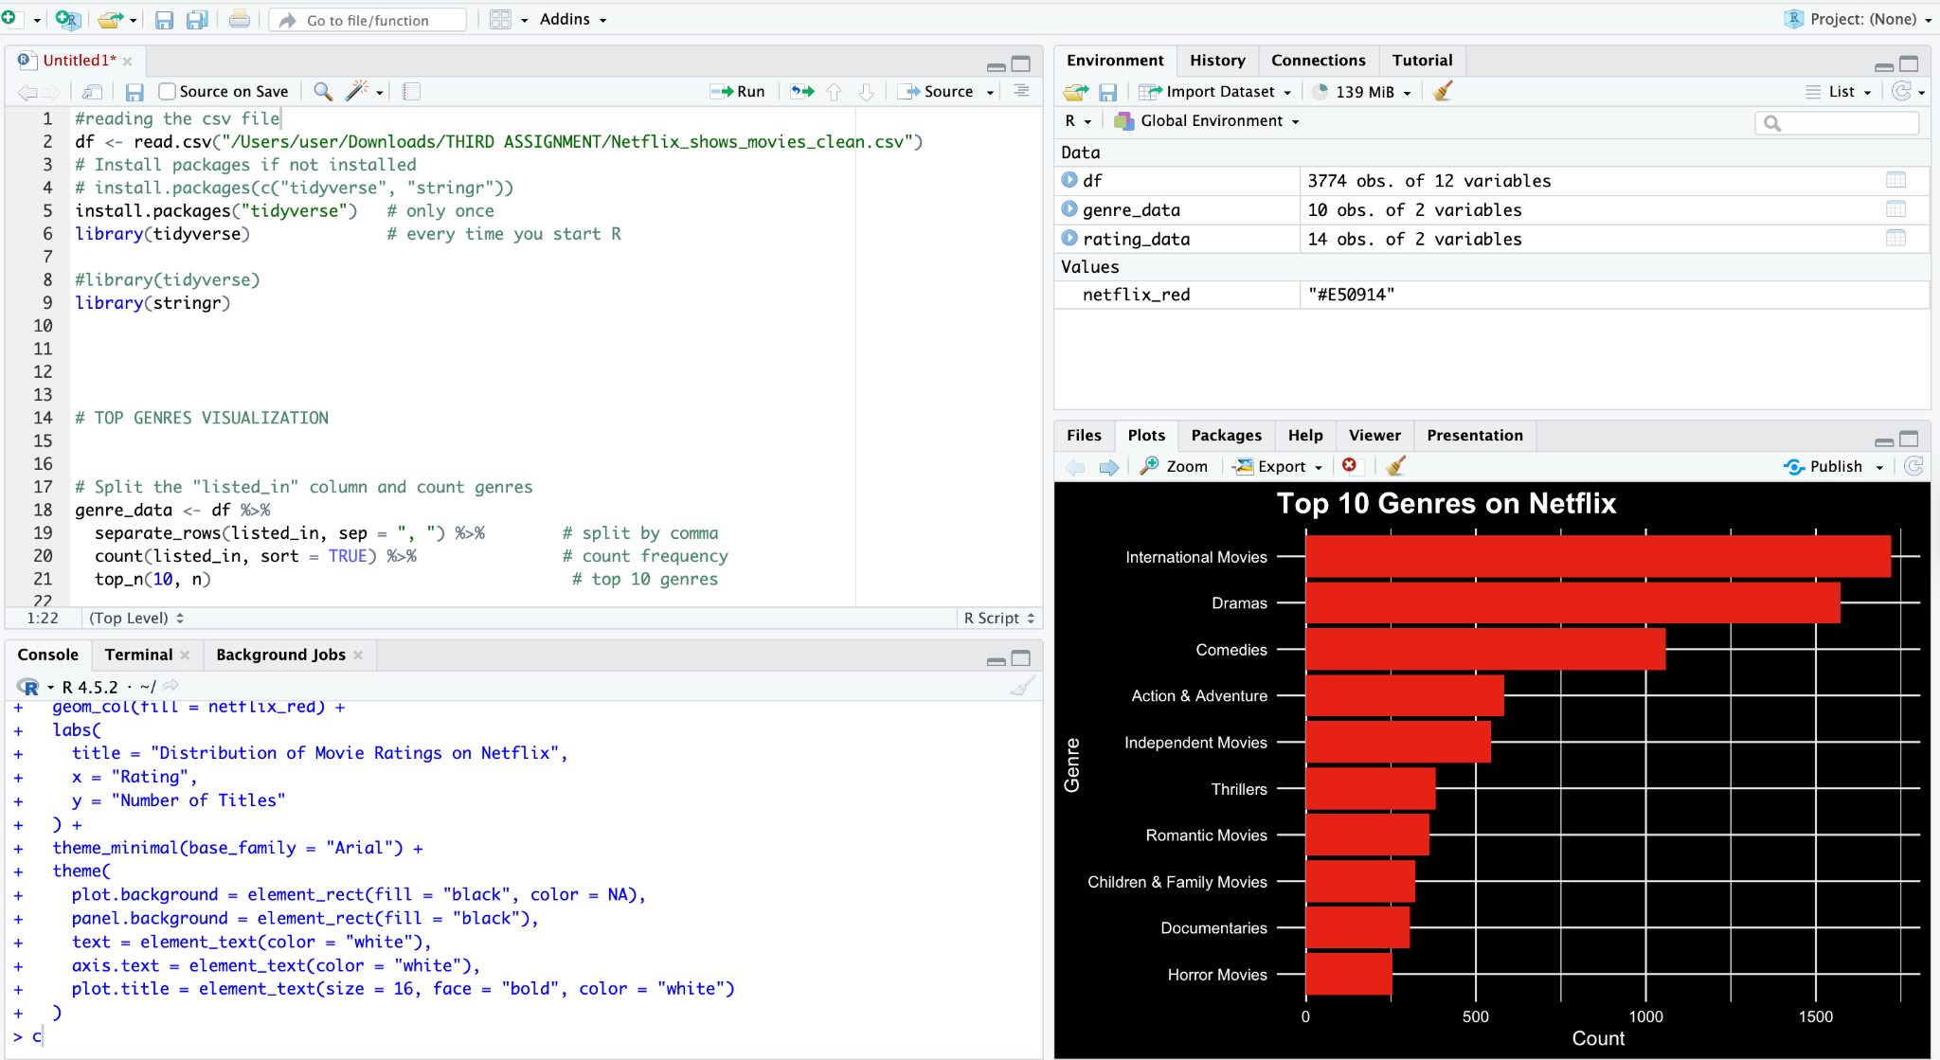
R-visual1(Top Genre)
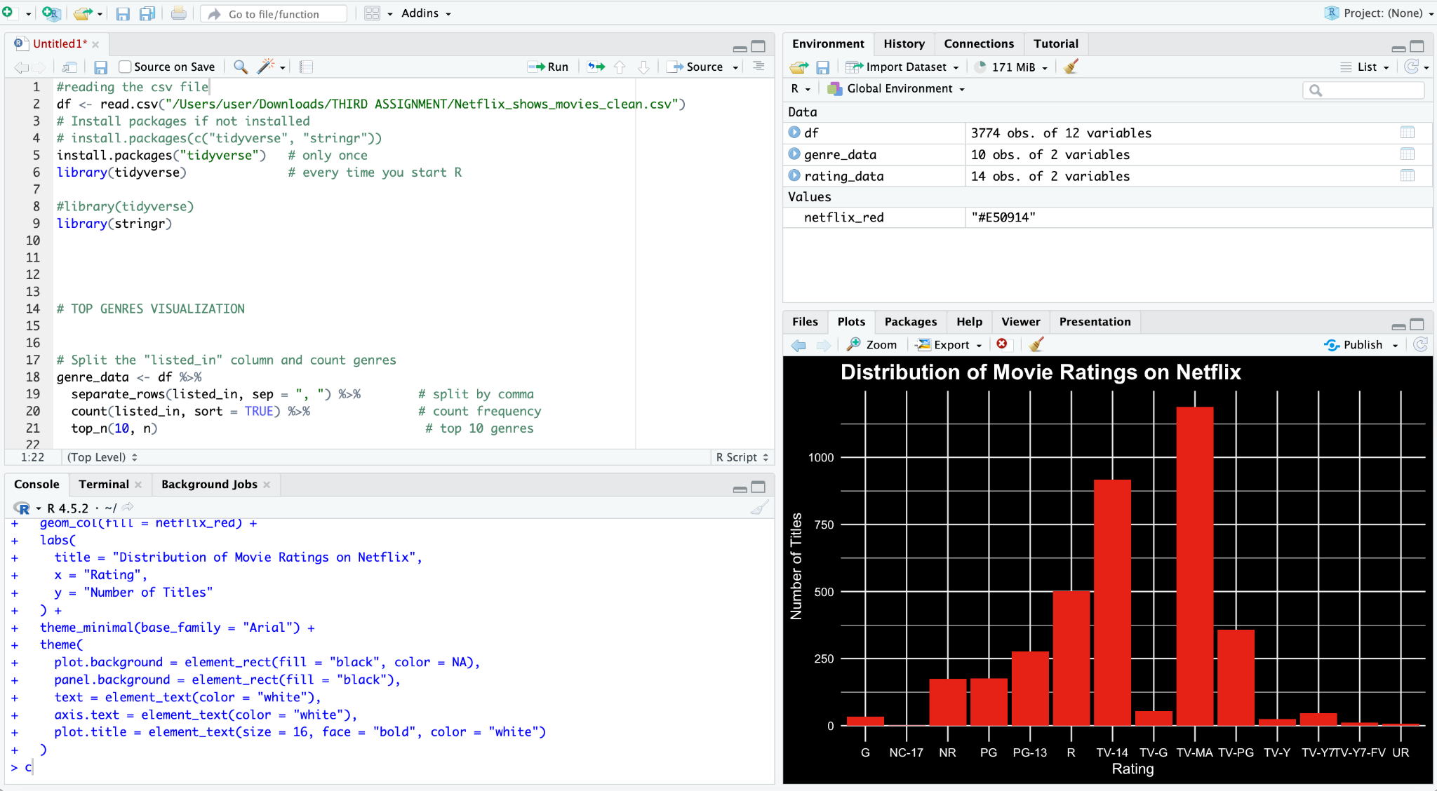
R-visual2-(Rating Distribution)

