Tasks
Learners have to develop a dashboard to support the answers to the following questions.

Objective Questions:

- What is the total no. of tables present in the data?
1
- What is the total no. of attributes present in the data?
Earlier given data had 35 attributes. After modifying it has 46 attributes.
- The data consists of some inconsistent and missing values so ensure that the data used for further analysis is cleaned.
Interestingly there were no duplicates.
Filled ‘N/A’ where there is no need for data to be present, like call related attributes for chat records and vice versa.
Filled ‘Missing’ where data should have been present but is not present.
Filled 0’s in numeric columns like ‘amount’ and ‘earnings’ where the value is sure to be zero because of being a free call or chat, or if the status is cancelled, failed or incomplete etc.
- What is the change in daily call volume day by day and also find the average daily call volume.
Average Call Volume per day is 250.24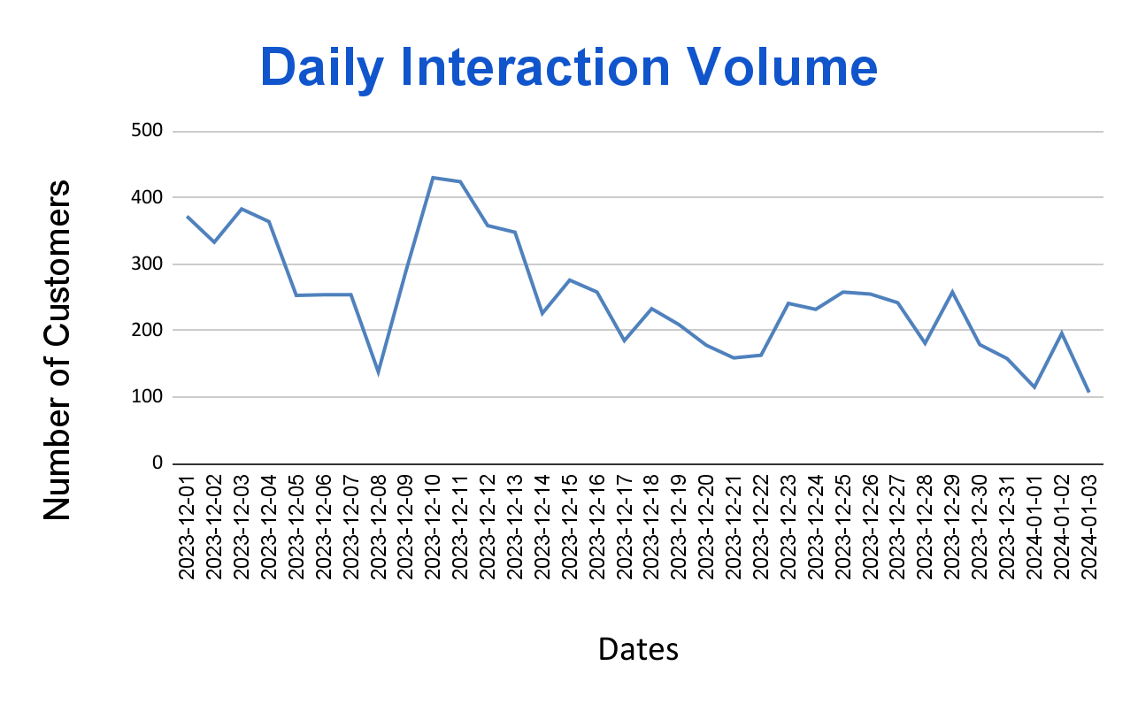

Daily change in call volume compared to the previous day is calculated using the pivot table and value differences below. We can see that it is fluctuating.
(Excluded N/A, Missing values in callsID)
createdAt Date | COUNTA of CallSid | Daily Change

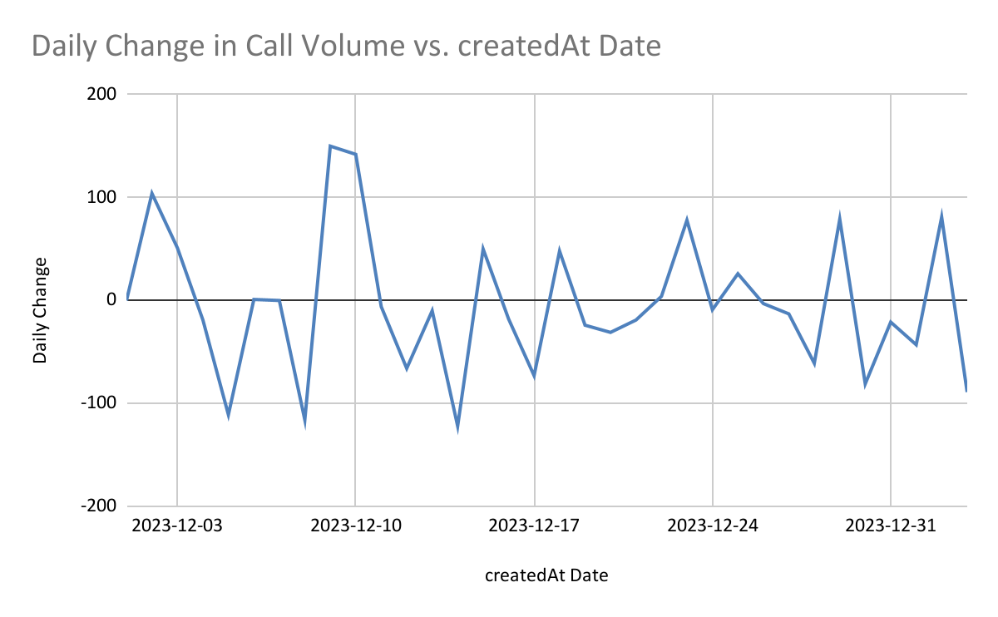
- Which months experienced the highest and lowest call volumes?
There is literally only two months. Dates starting from 2023-12-01 to 2024-01-03.
Dec 2023 has higher call volume with value 8090
& Jan 2024 has value 418
createdAt year-month | COUNTA of _id
2023-Dec | 8090
2024-Jan | 418
Grand Total | 8508

- What is the total operational cost for that month?
Operation cost for DEC 2023 is 93786.16 (Highest)
Operation cost for JAN 2024 is 5360.41 (Lowest)
(Astrologers Earnings column considered as operational cost)
createdAt year-month | COUNTA of _id | SUM of astrologersEarnings
2023-Dec | 26488 | 93786.16295
2024-Jan | 1539 | 5360.408
Grand Total | 28027 | 99146.57095
CCOUNTA of _idOUNTA of _id
- What is the average number of calls handled per agent per day?
The average number of calls handled per agent per day is 1.88
Formula = Number of calls / ( (Number of days)*(Number of gurus) )

Total Calls | 8508
No of gurus | 133
No of days | 34
Call per guru | 1.88

- How many repeat callers are there, and what percentage of total calls do they represent?
1277 repeated callers out of 3629 callers. They represent 35.19% of the total.

User_Type | COUNTA of Unique_user_id_call
Repeated_Caller | 35.19%
Unique_Caller | 64.81%
Grand Total | 100.00%

Total repeated calls = Total calls - total first calls
= Total calls - number of unique callers
= 8508 - 3629 = 4879
% of repeated calls = (Total repeated calls / Total calls)*100
= (4879/8508)*100
= 57.35%

Total calls | 8508
Total callers | 3629
Total repeated calls | 4879
% of repeated calls | 57.35

- What are the total sales generated by the call centre for each product category?
consultationType | SUM of netAmount
Call | 168442.04
Chat | 45494.68
Complementary | 0
public_live_Call | 50.60
Grand Total | 213987.32

- How many calls were made for each user ID and guru ID?
Pivot tables generated. Click on the header link below to go to the sheet.

user | COUNTA of _id |  | guru | COUNTA of _id

- What is the correlation between call duration and customer satisfaction?
Out of 8508 call records, 145 user_call_duration values are missing, so considering remaining 8363 records for finding correlation
Correlation between user_call_duration and rating is -0.0004909444949
Meaning there is no trend/ proportionality between both columns
Correlation
-0.0004909444949

Further I have checked if there is a correlation between userOnCallDuration and average rating, using the below pivot table
userOnCallDuration | AVERAGE of rating

Correlation
-0.04120990304

We can conclude that there is no correlation
- Which guru has the highest and lowest customer satisfaction scores?

Highest Avg Rating guru | Tarot Mystical | 7.5
Lowest Avg rating guru | Tarot Rittika | 0

- What is the average customer satisfaction score by month?

createdAt month | AVERAGE of rating
Dec | 2.949637572
Jan | 2.676413255
Grand Total | 2.93463446

- How many categorical columns are there in the data? [Search about categorical and continuous data, and try to answer this question]
31 Categorical columns and 15 continuous data columns out of 46 columns.

Categorical count | 31
Continuous count | 15

Subjective Question:

- Should the investment be used to hire more agents, improve training programs, or upgrade call center technology?
Hire More agents?
The number of agents present in dataset = 133
Daily average no of users handled per day per guru = no_of_unique_users/(no_of gurus * no_of_days)
= 10344/(133*34)
= 2.28
So on an average a guru handles 2.28 interactions per day, be it call or chat.

Also as per AStroSage website there are 700,000 registered gurus and 1.2 Million daily active users. Meaning 1.714 interactions per guru everyday.

The number is very low, indicating, either there is no need for hiring more gurus or, we need to make more customers on our current platform to fully utilize the current gurus.

Improve training programs?
We can see that the majority of the customers gave 0 ratings. And the average rating is 2.93. Nearly 72.51% of ratings are below 4.
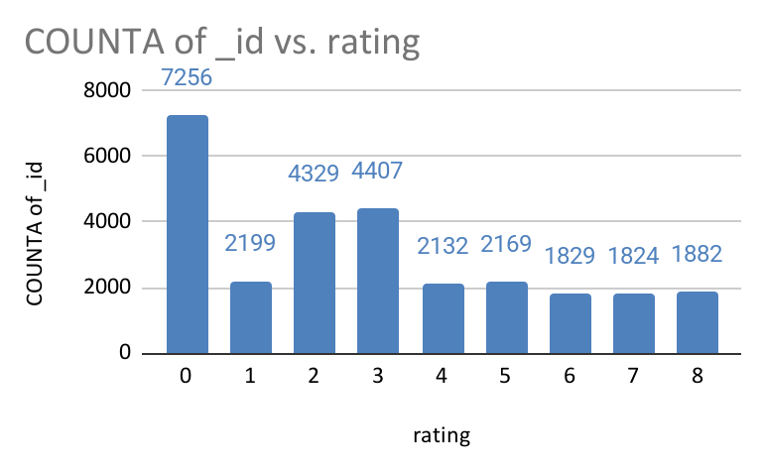

We can see that only 28% of chat sessions are marked complete and 40% of call sessions are marked complete, which means there is either an inefficiency from the astrologers, or the technical side.
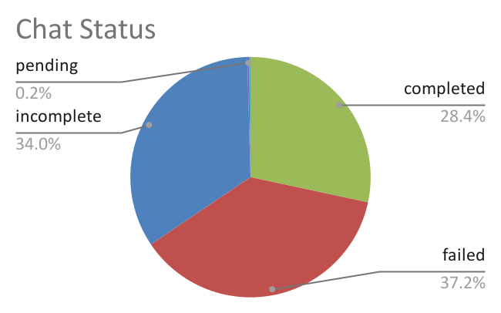
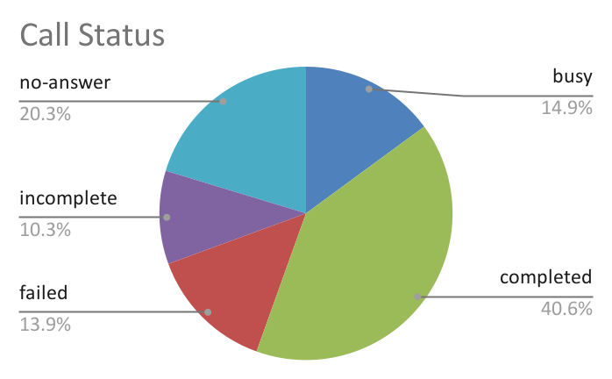

So investing in training the gurus how to properly use the platform, conducting training sessions on building knowledge and how to handle customer queries to get better ratings, will help improve the customer experience.

Upgrade Call centre Technology?
There are a lot of missing values where the data should have been present. No proper indication of N/A for where the data shouldn't be present.

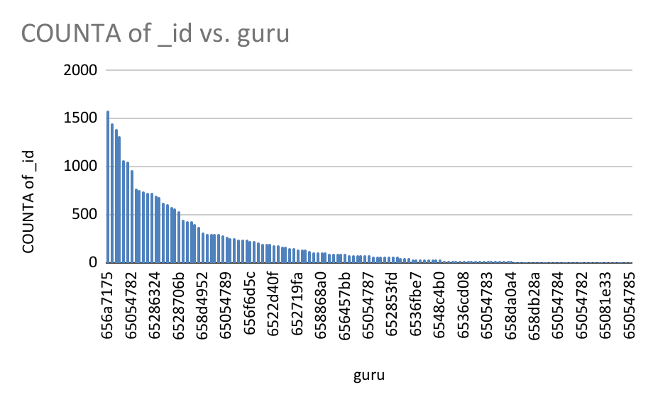
As you can see there is a highly uneven distribution of interactions per guru. It makes sense because Astrosage follows a pay per interaction method rather than a fixed per month salary for giving flexibility to their gurus to work at their own pace. Few of them do it as their bread and butter, most of them do it for their pocket money. But what we can do is implement technology to divert the customers to actively logged in and few customers having gurus, especially if they have good ratings to reduce the load during peak hours.

Also AI gurus can be a game changer to make answering basic queries instantly reducing user waiting times. We can already see the impact of Ai on similar platforms like Chegg where 90% of business dropped, because LLMs like Chat GPT could solve their queries for free. So Chegg adopted AI to stay in the game. Same goes for Astrosage, you can improve ratings and status of completion with AI handling the generic queries with fast response time and error free.

Conclusion: Don’t hire more agents by paying a monthly salary. Onboard gurus for paid per session model if needed.
Provide training for all gurus, like a guru onboarded should only take up customers after finishing training modules & passing skill assessment tests.
Adopt AI extensively, prepare for AI and human gurus coexisting in the future.

- What are the potential risks of each investment option (hiring, training, technology upgrades), and how can they be mitigated?
Name the chart/spreadsheet function you will use for solving the problem.
Risk of hiring:
AstroSage already has plenty of gurus for the Indian audience. Hiring more means the average interaction per guru drops further, also the quality and user ratings drop if the new gurus aren’t trained well.
Mitigation:
Convert well performing gurus into full time employees by paying monthly salary plus commission per interaction, so that they consider AStroSage as a stable income.
Hire for expansion into other countries that have people who believe in Astrology. That is an untapped Market, compared to the saturated Indian Market. A significant amount will also go into marketing AstroSage in new countries.

Risk of Training:
If you make training compulsory for everyone and gurus will be unable to take up customers till they finish training, it will mean reduced active gurus count. Many may find the training cumbersome and leave for platforms that have low entry barriers.
Also the gurus who are just winging it till now, will find training a steep learning curve for them.

Mitigation:
You can make training to be done at their own pace for well performing gurus, but compulsory to finish it before, for underperforming gurus & new hires before they take up customers.

Risk of Technology upgrades:
If AI gurus take over the audience, the human gurus will be out of income and business. But human gurus not only act as employees, but also free word of mouth marketing agents, just like LIC agents or teachers of a school bringing in students for the school from their circle every new academic year

Investing in CRM and Tech stack that captures data without any discrepancies, analyzing call audio/Chat text using LLMs to find out the quality of call, KPIs of the gurus like the approach/tone he used, etc can become a costly investment, but will contribute to improved customer satisfaction and ratings.

Mitigation:
AI adoption shouldn’t be at the cost of human capital. Even though you use AI to answer basic queries, in the end the AI should ask the customer if they want to talk to an experienced human astrologer that will understand their case better, and connect with well performing gurus. Human connection cannot be replaced. So the guru must build a rapport with the customer to ensure they prefer them over AI for most important decisions of their life.

Analytical Tools and Functions

Spreadsheet Function:

WHAT-IF Analysis / Goal Seek

Use: To analyze how results change with different inputs — for example, how many agents are needed to reach a specific service level or what the break-even point is for investing in technology.

Visualization Tools:

Charts (Bar, Pie, Waterfall, etc.)

Use: To visually compare risks, costs, and projected benefits. A Waterfall chart, in particular, helps illustrate how each investment choice adds or subtracts from overall efficiency or revenue.

- How does AstroSage's call center performance compare to AstroGuru's average call volume, customer satisfaction, and agent performance?
Will you use any aggregation function or a visualization here to solve the problem?
No data provided for AstroGuru, so can’t be compared.
- How can the call center improve its handling of peak call periods to ensure high customer satisfaction?
Mention the functionality you will use for giving the suggestions, will it be any aggregated function or a visualization?
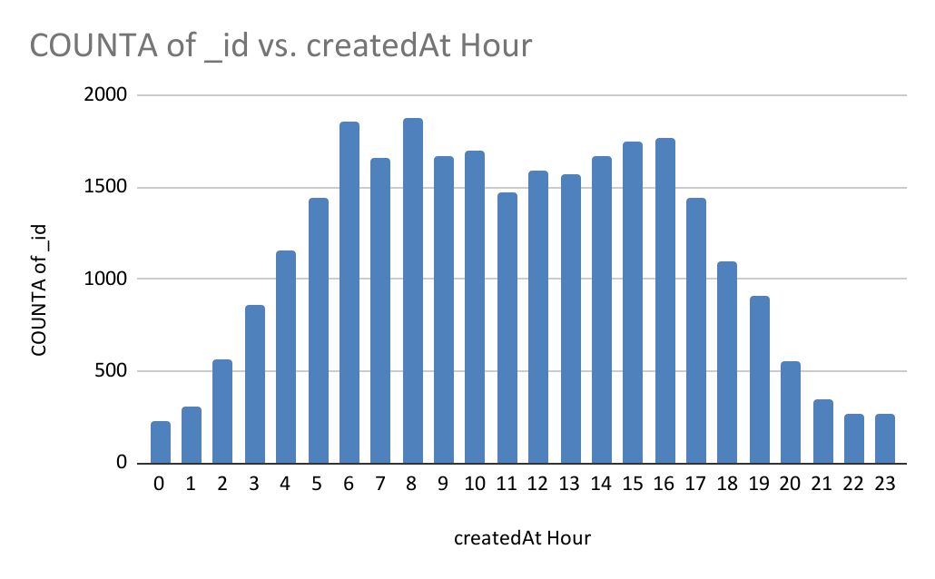
As you can see the peak hours are from 4 am to 6 pm where the count of interactions is more than 1000.
Average interaction(call/chat) per guru per day in peak hours Calculated by
= (Average of count_id during peak hours/ (no_of_guru * no_of_days))*(24/no_of_peak_hours)
=( 23734 / (133 * 34) ) * ( 24 / 15)
= 8.40 interactions per guru per day (at peak hours)
(Click the header below to go to sheet)

guru | COUNTA of _id

Average interactions per guru at peak hour per day | 8.40
Average interactions per guru per day | 6.20

Again not a huge number compared to the workforce, but trouble arises due to customers preference of certain gurus over others.
So to mitigate it, we can increase the cost of interaction with gurus in peak hours, keeping the prices for other gurus the same as usual, this will help distribute the traffic.
Also with the AI handling basic daily queries, the load on peak hours is anyway going to come down,

- Based on historical data, what strategic initiatives should be prioritized to improve efficiency and customer satisfaction?
Insights and Recommendations

Agent Performance and Training Improvement
An examination of past performance data shows that a few agents consistently face higher failure rates and receive below-average customer ratings. Providing specialized, data-driven training to these agents can enhance their skill sets, minimize errors, and ultimately lead to improved customer satisfaction.
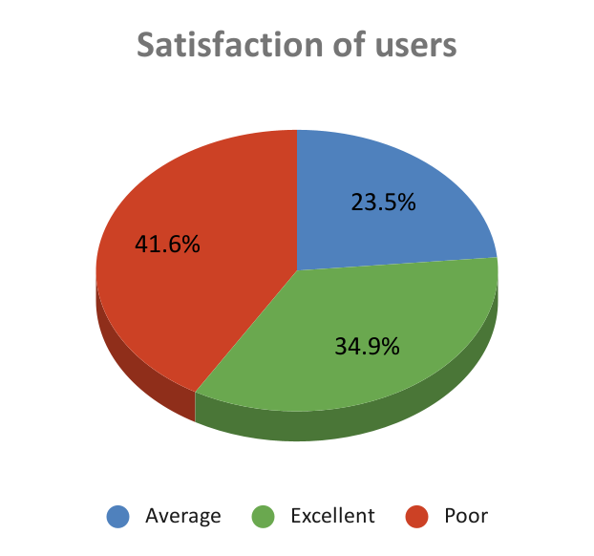

Proposed Action Plan:

Identify agents with frequent failures or poor ratings through performance analytics.

Design customized training sessions that target specific weaknesses such as communication, problem-solving, and technical handling.

Evaluate the results post-training by comparing ratings, completion rates, and feedback to measure the effectiveness of the initiative.

Optimized Call Management and Prioritization

Implementing skill-based routing ensures that incoming calls are automatically assigned to the most qualified agents, leading to faster and more effective issue resolution. In addition, priority queuing allows premium or high-value customers to receive quicker responses during busy periods. Continuous monitoring of performance reports helps refine routing logic and enhance overall call-handling efficiency.

Reducing Chat / Call Failures Through Technological Upgrades

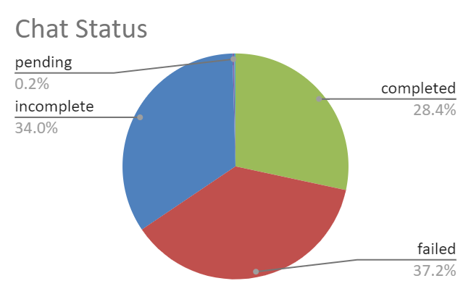

Analysis of call records highlights a notable percentage of call failures — around 13.9%, which is concerning. Also there is a staggering 37.2% failed chat records, all of them were given rating 0. Many of these failures stem from outdated systems or connectivity issues. Investing in improved call center infrastructure and modern communication technology can enhance call clarity, minimize technical breakdowns, and increase operational reliability.

Enhancing Self-Service Options

Empowering users with self-help tools can significantly reduce the workload on call agents, especially during peak hours. Deploying IVR menus, AI chatbots, or online help centers enables customers to quickly resolve common issues on their own.

Additional Recommendations

To improve engagement and reduce unanswered calls, it’s essential to analyze the causes of low response rates and optimize call timing or follow-up procedures accordingly. Introducing AI-driven chatbots across multiple platforms—such as WhatsApp, the website, and social media—will provide users with instant responses to common queries. This multi-channel support approach will:

- Lower the overall call volume,

- Improve accessibility for users, and

- Strengthen customer satisfaction and brand trust.

Conclusion

Focusing on personalized training, technological advancements, efficient call routing, and data-driven workforce optimization can substantially enhance operational efficiency, reduce call failures, and elevate the overall customer experience for AstroSage’s users.

- What can be the key factors contributing to high customer satisfaction scores, and how can these be leveraged to improve overall performance?
What is the basis for the suggestions? And mention how you decide if the satisfaction score affects the ratings.
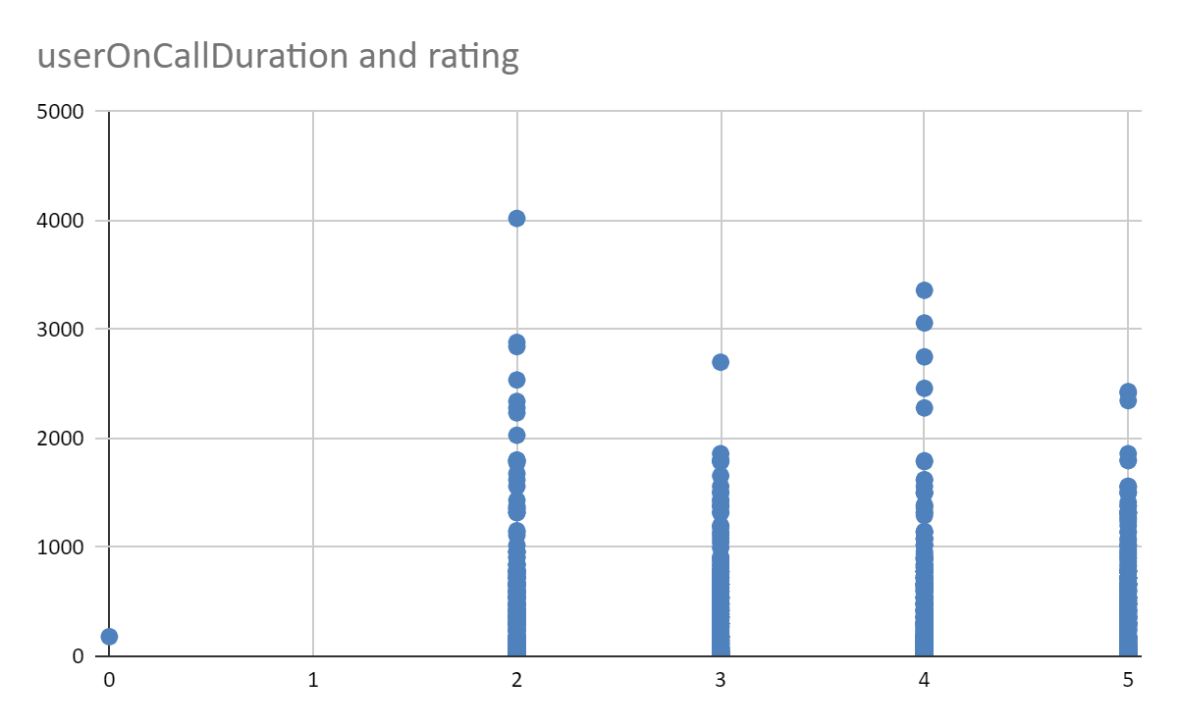
As you can see, customers have given ratings from range 1-5. 1 being the lowest and 5 being the highest

call ratings pivot
rating | COUNTA of _id
0 | 1
2 | 2136
3 | 2114
4 | 2113
5 | 2144
Grand Total | 8508
avg rating | 3.500940291

This shows that call data is not that bad as it appeared. More focus should be made for chat based data. Also calls generated more revenue than chats.

callStatus | COUNTA of _id | AVERAGE of rating
busy | 1270 | 3.496062992
completed | 3453 | 3.490587895
failed | 1214 | 3.444810544
incomplete | 875 | 3.556571429
no-answer | 1729 | 3.48004627
Grand Total | 8541 | 3.489521133

As we can see from the above table that there is no direct correlation between call status and ratings because, most of the times the callStatus “failed” due to the user not picking up the call, not the guru. You can check this by applying necessary filters to the working table.
What usually happens is, when a user requests a call with a particular astrologer, the IVR first checks the astrologer availability, if he is available it calls him and takes him on the line, so the guru is the first to be on call. then only the IVR calls the user, if the user picks up the call they are connected and time is counted.
Mitigation measures: Engage the customer using chatbot/ AI while the guru is connected and the user receives a callback.

chatStatus | COUNTA of _id | AVERAGE of rating
completed | 5535 | 7.009575429
failed | 7255 | 0
incomplete | 6641 | 2.010691161
pending | 48 | 3.604166667
started | 35 | 3.457142857
Grand Total | 19514 | 2.687557651

We can see that chat completion rates are bad. There are a staggering 7255 failed & 6641 incomplete chats out of 19514. Also rating is 0 only when the chatStatus is “failed”. The reason may be the tech used to evaluate the chat status. Like if a user asks a query the system counts it as chart started, and the astrologer responds it takes as pending/incomplete, when does it mean the chat is finished?All failed chats are defaultly considered as 0, that rating must not have been given by the user. Is there a prompt window that the user has to tick mark,or respond to rate us message that shows/counts as chat is ended? WIth better tech upgrades these might be resolved.
We can see that when the chat is completed the average rating is 7.0095 out of 8 which is pretty good actually.

conclusion:
So basically the gurus are doing well, and it is the improper usage of tech, or the tech itself is failing, causing the low chats ratings.

- How should the call center balance the workload among agents to ensure optimal performance and avoid burnout?
Mention your approach and spreadsheet function for the answer.
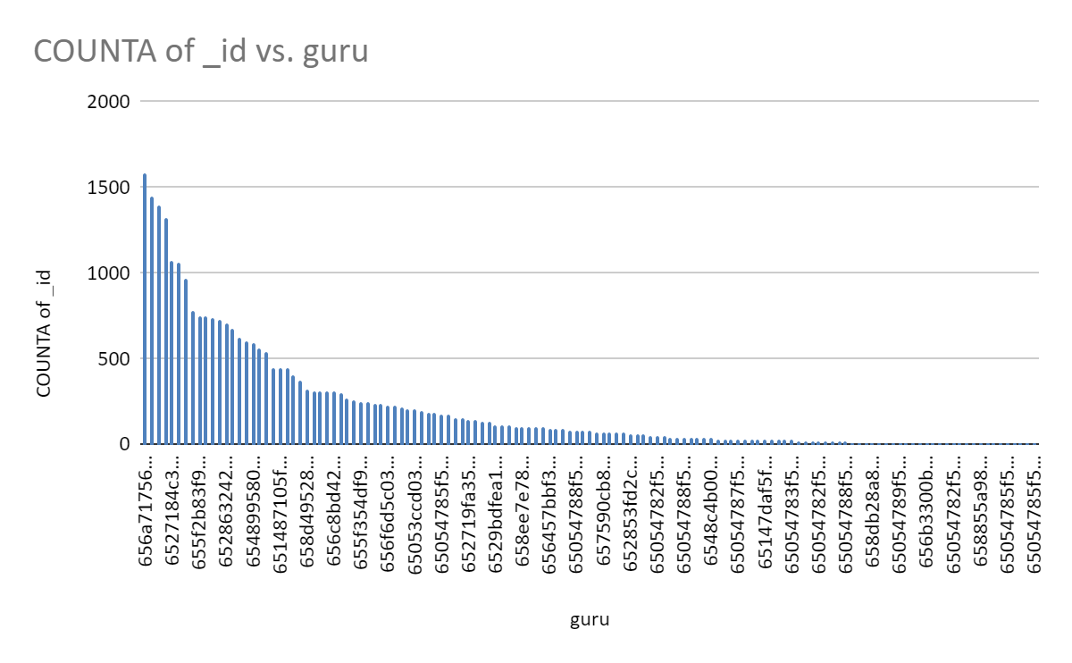
The distribution of query volume among the gurus is not uniform; some gurus are overutilized, while others are severely underutilized. This imbalance may lead to overexhaustion or overburdening, causing decreased productivity or even gurus/agents seeking better opportunities.

Workforce Management and Operational Efficiency Recommendations

Forecast Call Volume Using Historical Data:
Conduct an analysis of historical call records to identify peak hours and high-demand periods. This insight will enable management to schedule sufficient staff during busy times, ensuring smooth operations and reduced customer wait times.

Implement Rotational Shift Scheduling:
Introduce a structured shift rotation system to prevent agents from consistently working during high-stress periods. Rotating duties across team members promotes fairness, enhances morale, and reduces fatigue among employees.
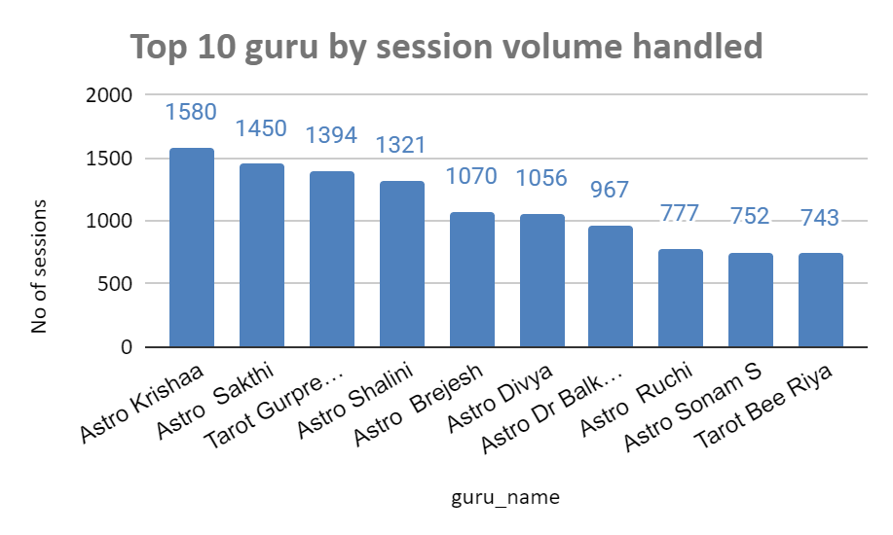

Adopt Skill-Based Call Routing:
Utilize intelligent routing systems that assign incoming calls based on agent expertise. Complex or high-priority queries should be directed to senior or specialized agents, while routine or straightforward issues can be managed by less experienced staff. This approach ensures both efficiency and service quality.

Provide Mental Health and Support Resources:
Establish access to mental wellness programs and counseling services to help agents manage workplace stress effectively. Regular check-ins, relaxation sessions, and stress management workshops can significantly reduce burnout rates and improve retention.

Monitor Performance in Real Time:
Employ real-time performance tracking tools to oversee key metrics such as call handling time, queue lengths, and agent workload distribution. In cases where an agent handles a disproportionately high number of calls, supervisors can promptly redistribute assignments to maintain balanced workloads and consistent service levels.

- What new technologies or tools could be implemented to enhance call center operations and customer service?
Emerging Technologies and Tools to Enhance Call Center Operations

1. Artificial Intelligence (AI) and Machine Learning (ML)

AI Chatbots and Virtual Assistants:
AI-driven chatbots can handle routine customer queries 24/7 through website chat, WhatsApp, or mobile apps. This reduces call volume and ensures faster responses.

Predictive Analytics:
ML algorithms can analyze historical call and chat data to forecast demand, identify service bottlenecks, and optimize staffing schedules.

Sentiment Analysis:
AI tools can detect customer emotions in real time, allowing supervisors to intervene in difficult interactions or guide agents on how to handle sensitive calls.

2. Interactive Voice Response (IVR) Enhancements

Intelligent IVR Systems:
Modern IVRs use speech recognition and natural language understanding (NLU) to let customers state their needs in plain language, reducing frustration caused by long menu options.

Personalized IVR Menus:
Integration with CRM systems allows IVRs to recognize returning customers and offer customized options based on their history or preferences.

3. Customer Relationship Management (CRM) Integration

Unified Customer Profiles:
Integrating CRM tools like Salesforce, Zendesk, or Freshdesk helps agents access all customer information (past interactions, purchases, feedback) in one place.

Automated Follow-Ups:
CRM automation ensures timely follow-ups, reminders, and updates, improving consistency in customer service.

4. Cloud-Based Call Center Solutions

Remote Access and Scalability:
Cloud-based platforms such as Amazon Connect, Five9, or Genesys Cloud enable agents to work remotely and allow the business to scale up or down based on call volume.

Real-Time Data and Reporting:
These platforms provide live dashboards showing queue lengths, call durations, and performance KPIs for faster decision-making.

5. Workforce Management (WFM) Tools

Smart Scheduling Software:
Tools like Calabrio, Verint, or Nice WFM can forecast workload, optimize agent shifts, and reduce idle time using predictive analytics.

Performance Dashboards:
WFM systems provide insights into agent productivity, helping identify training needs and reward top performers.

6. Voice Analytics and Quality Monitoring

Speech-to-Text Transcription:
Automated transcription of calls helps in reviewing customer interactions for training and compliance.

Quality Assurance Automation:
AI tools can scan thousands of call recordings to identify trends in tone, language, and problem resolution effectiveness.

7. Omnichannel Communication Platforms

Unified Communication Systems:
Integrate calls, chats, emails, and social media into a single interface so that customers can seamlessly switch between channels without repeating information.

Multi-Platform Chatbots:
Deploy chatbots on platforms like WhatsApp, Telegram, Instagram, and websites to provide instant support wherever customers are active.

8. Robotic Process Automation (RPA)

Automating Repetitive Tasks:
RPA tools can automate data entry, ticket creation, and CRM updates, freeing agents to focus on solving customer issues rather than manual work.

9. Real-Time Analytics Dashboards

Live Monitoring:
Supervisors can track active calls, customer satisfaction scores, and queue lengths in real time.

Decision Support:
Dashboards provide actionable insights to improve resource allocation, training, and performance.

Conclusion

Adopting a combination of AI, automation, cloud technology, and data-driven tools can transform call center operations from reactive to proactive. These technologies not only improve operational efficiency but also elevate customer satisfaction, agent productivity, and long-term business scalability.

- What metrics should be included in the final dashboard to comprehensively view call center performance and guide investment decisions?

1. Key Performance Indicators
Metric | Description | Decision Insight
No. of Sessions | Total customer interactions (calls + chats) | Indicates overall workload and engagement volume.
No. of Users | Total unique customers who interacted | Measures user base size and retention growth.
No. of Gurus (Astrologers) | Total astrologers handling consultations | Reflects manpower availability and coverage.
Revenue Generated | Total revenue from consultations | Shows business performance and income generation.
Astrologer Earnings | Total payout to astrologers | Helps assess profitability and partner compensation fairness.
Profit (%) | Revenue minus payouts and costs | Indicates business sustainability and margin strength.

2. Interaction and Volume Metrics
Metric | Chart Type | Purpose
Daily Volume of Interactions | Line Chart | Identifies peak and low activity days; useful for resource planning.
Top 10 gurus by session Volume | Bar Chart | Highlights top-performing astrologers and workload imbalance.
Volume by Hour of the Day | Column Chart | Shows busiest hours — helps optimize shift scheduling and staffing.
Platform(website) | Pie Chart | Shows platform choice of users-helps decide which platform needs more investment/ development

3. Quality and Satisfaction Metrics
Metric | Chart Type | Purpose
Rating Distribution Over Sessions | Bar Chart | Monitors service quality and user satisfaction trends.
Satisfaction of Users (Poor/Average/Excellent) | Pie Chart | Provides overall satisfaction overview — vital for service improvement.

4. Operational Efficiency Metrics
Metric | Chart Type | Purpose
Chat Status Distribution (Completed, Failed, Incomplete) | Pie Chart | Tracks chat success rate and identifies technical or behavioral issues.
Call Status Distribution (Completed, Busy, No-Answer, Failed) | Pie Chart | Evaluates call handling efficiency and technical connectivity.
Revenue vs. Consultation Type (Call vs. Chat) | Doughnut Chart | Helps assess which mode drives higher revenue, guiding platform investment.

5. User Behavior Metrics
Metric | Chart Type | Purpose
User Type & Count of Sessions | Bar Chart | Indicates customer retention — crucial for marketing and loyalty investment.
User Frequency / Platform / Weekday Filters (via Slicers) | Filter Controls | Allow dynamic segmentation for deeper analysis (e.g., platform-wise revenue).

- How would you allocate a 1 crore rupee investment to optimize operational efficiency, enhance customer satisfaction, and boost profitability, and what analysis-based recommendations would you offer to support this?
[you have to give bullet pointers to answer this question]

1. Training and Quality Improvement — ₹25 Lakhs (25%)

- Identify astrologers (“gurus”) with high failure rates and low ratings from the dashboard analytics.

- Develop targeted, data-driven training to improve communication, empathy, and platform handling.

- Implement periodic skill assessments and reward programs for high performers.

- Introduce soft-skill and customer-psychology modules to improve trust and reduce drop-offs.

Expected Impact:

- Increased customer satisfaction and retention.

- Reduction in incomplete or failed sessions.

- Enhanced credibility of AstroSage’s guru network.

2. Technology and AI Integration — ₹40 Lakhs (40%)

- Upgrade backend call/chat infrastructure to address the current ~14% call failure rate & 37.2% chat failure rate seen in the data.

- Integrate AI-powered chatbots for basic astrology queries and FAQs — reducing queue length and load on human gurus.

- Implement skill-based call routing so that complex issues reach experienced astrologers, while simpler cases go to newer ones.

- Add real-time analytics dashboards for live tracking of call volumes, agent performance, and satisfaction scores.

Expected Impact:

- Sharper response times and lower wait periods.

- Better session routing and improved completion rates.

- Foundation for scalable automation and future cost savings.

3. Customer Experience & Self-Service Platforms — ₹15 Lakhs (15%)

- Build self-service options (IVR, WhatsApp bots, website chat widgets) for common customer queries.

- Implement AI-driven recommendations for guru selection, based on past satisfaction scores.

- Use multilingual chatbot support to improve accessibility for diverse Indian users.

Expected Impact:

- Reduced dependency on live agents for repetitive queries.

- Increased accessibility and faster resolutions.

- Stronger engagement and improved NPS (Net Promoter Score).

4. Marketing, Retention & Engagement — ₹10 Lakhs (10%)

- Run campaigns promoting high-rated human astrologers, AI astrologers and customer success stories.

- Introduce loyalty programs and subscription models for repeat users.

- Use insights from slicers and pivot data to target campaigns by region, consultation type, and user behavior patterns.

Expected Impact:

- Improved customer retention and conversion rate.

- More traffic during off-peak hours through offers and re-engagement.

- Brand reputation boost among satisfied users.

5. Data Analytics, Monitoring & Contingency — ₹10 Lakhs (10%)

- Strengthen data collection pipelines for real-time performance monitoring.

- Allocate a buffer fund for A/B testing AI tools, unforeseen technical expenses, or data protection compliance.

- Use continuous feedback loops to refine the dashboard metrics and investment priorities.

Expected Impact:

- Smarter, data-backed decisions in future.

- Financial flexibility to adapt quickly to evolving needs.

Ensure that you put the slicers for choosing the country and year to observe the dashboard since the management will have a long discussion that can go on for weeks.

Note: The dashboard would be more interactive and user-friendly, allowing management to explore data in detail and make informed decisions.

