RJ@RJ:~$ sudo apt update

Hit:1 http://azure.archive.ubuntu.com/ubuntu noble InRelease

Hit:2 http://azure.archive.ubuntu.com/ubuntu noble-updates InRelease

Hit:3 http://azure.archive.ubuntu.com/ubuntu noble-backports InRelease

Hit:4 http://azure.archive.ubuntu.com/ubuntu noble-security InRelease

Reading package lists... Done

Building dependency tree... Done

Reading state information... Done

4 packages can be upgraded. Run 'apt list --upgradable' to see them.

RJ@RJ:~$ sudo apt install git

Reading package lists... Done

Building dependency tree... Done

Reading state information... Done

git is already the newest version (1:2.43.0-1ubuntu7.1).

0 upgraded, 0 newly installed, 0 to remove and 4 not upgraded.

RJ@RJ:~$ sudo apt install nginx

Reading package lists... Done

Building dependency tree... Done

Reading state information... Done

nginx is already the newest version (1.24.0-2ubuntu7).

0 upgraded, 0 newly installed, 0 to remove and 4 not upgraded.

RJ@RJ:~$ sudo systemctl start nginx

RJ@RJ:~$ sudo systemctl enable nginx

Synchronizing state of nginx.service with SysV service script with /usr/lib/systemd/systemd-sysv-install.

Executing: /usr/lib/systemd/systemd-sysv-install enable nginx

RJ@RJ:~$ cd /var/www/html

-bash: cd: /var/www/html: No such file or directory

RJ@RJ:~$ sudo mkdir -p /var/www/html

RJ@RJ:~$ sudo chown -R www-data:www-data /var/www/html

sudo chmod -R 755 /var/www/html

RJ@RJ:~$ ls -la /var/www/html

total 8

drwxr-xr-x 2 www-data www-data 4096 Aug 9 07:32 .

drwxr-xr-x 3 root root 4096 Aug 9 07:32 ..

RJ@RJ:~$ cd /var/www/html

RJ@RJ:/var/www/html$ ls

RJ@RJ:/var/www/html$ sudo rm -rf *

RJ@RJ:/var/www/html$ sudo git clone https://github.com/Raja-shereep/portfolio.git .

Cloning into '.'...

remote: Enumerating objects: 27, done.

remote: Counting objects: 100% (27/27), done.

remote: Compressing objects: 100% (25/25), done.

remote: Total 27 (delta 6), reused 0 (delta 0), pack-reused 0

Receiving objects: 100% (27/27), 1.24 MiB | 45.25 MiB/s, done.

Resolving deltas: 100% (6/6), done.

RJ@RJ:/var/www/html$ sudo chown -R www-data:www-data /var/www/html



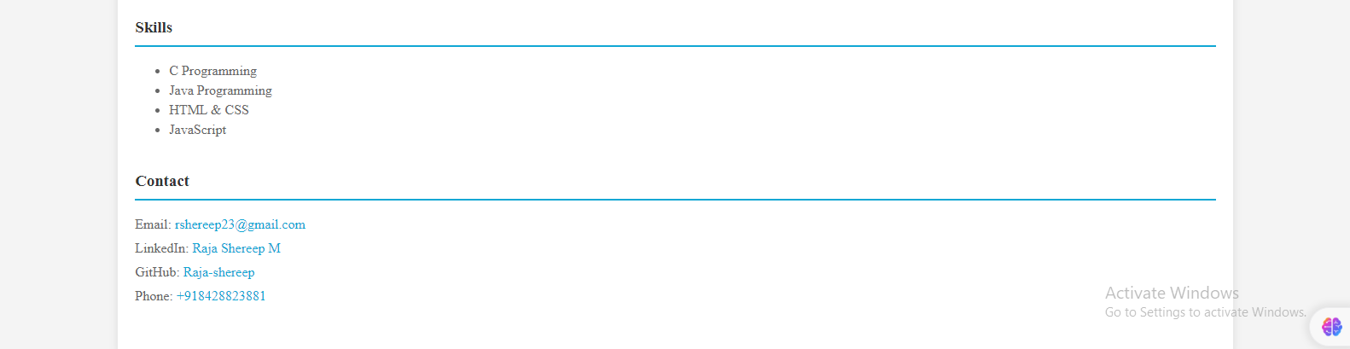

**BLOB STORAGE:**

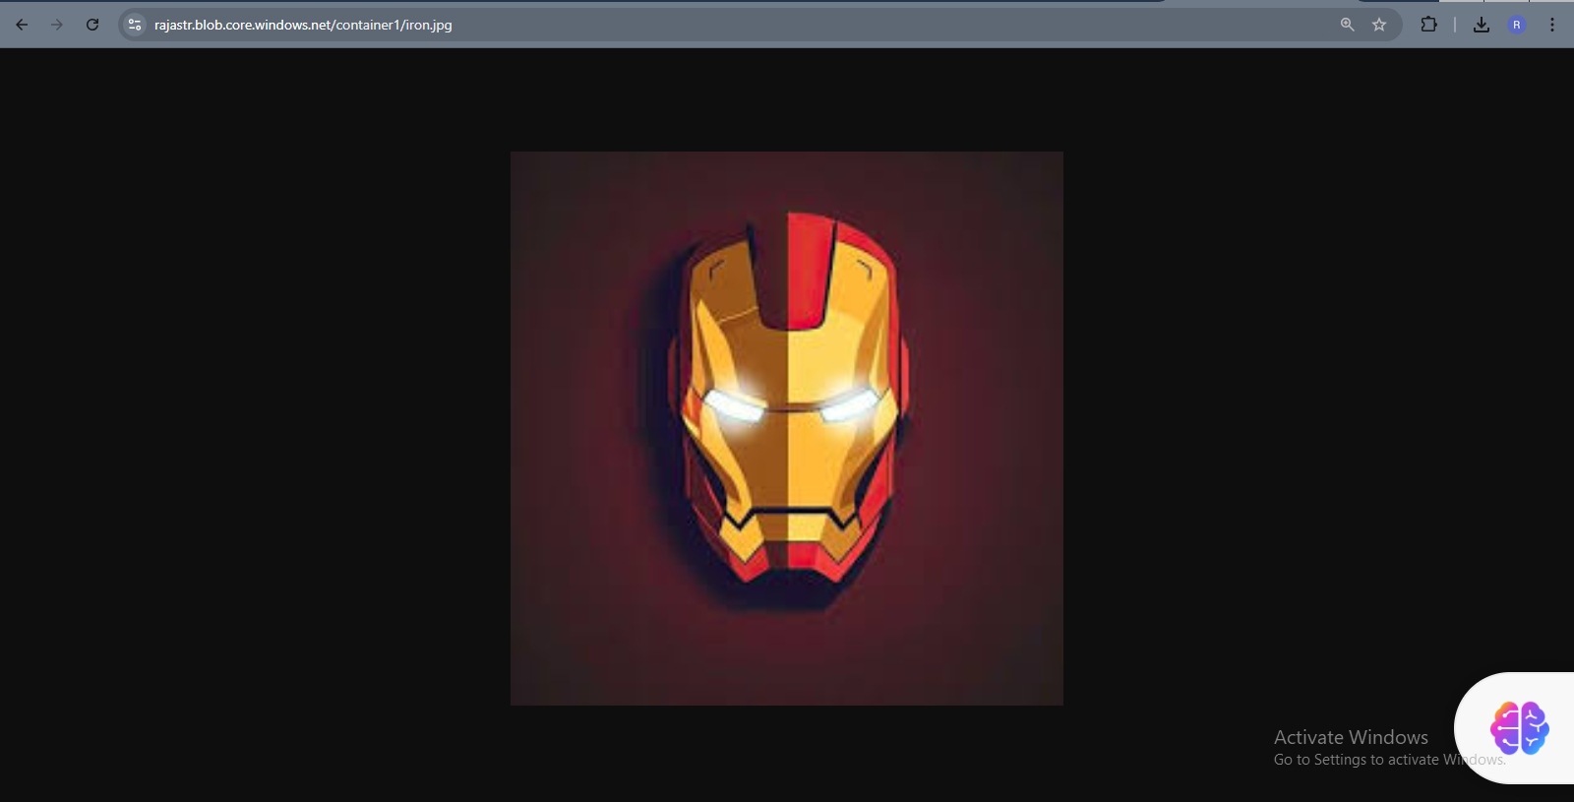

[**https://rajastr.blob.core.windows.net/container1/iron.jpg**](https://rajastr.blob.core.windows.net/container1/iron.jpg) **.**

**Connecting github without using virtual machine from Azure:**

<https://gentle-island-023406d03.5.azurestaticapps.net/>



