**LAB-8**

**Aim of the Experiment:  
To demonstrate the communication between two devices using a wireless LAN.  
  
Topology:  
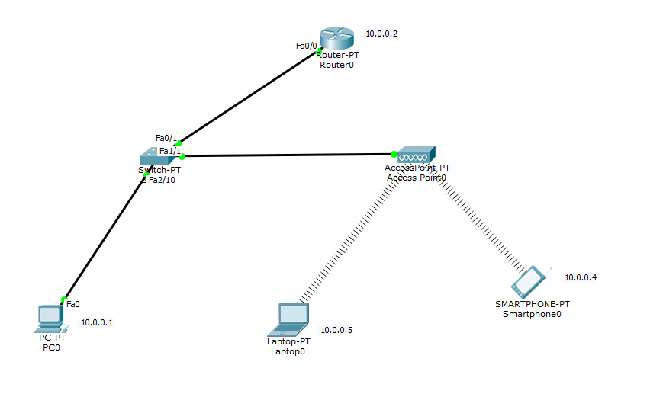Configuration:**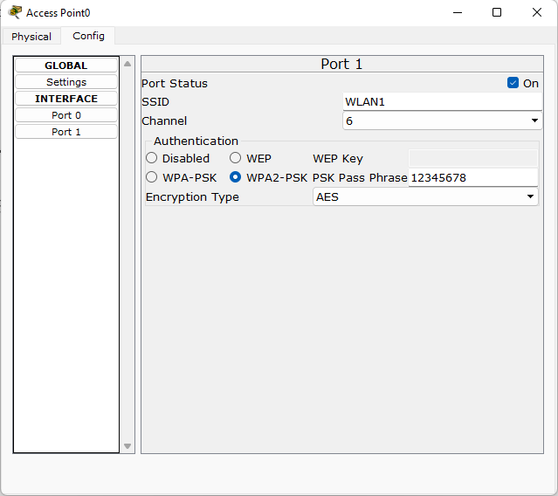

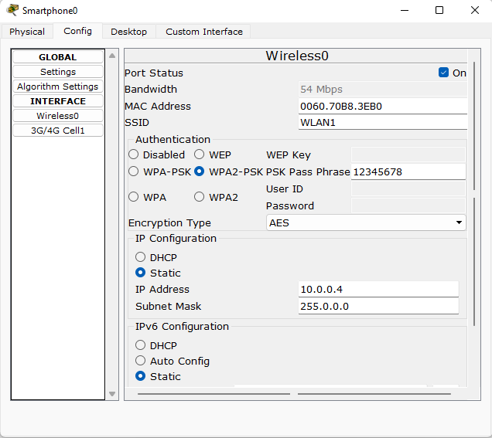

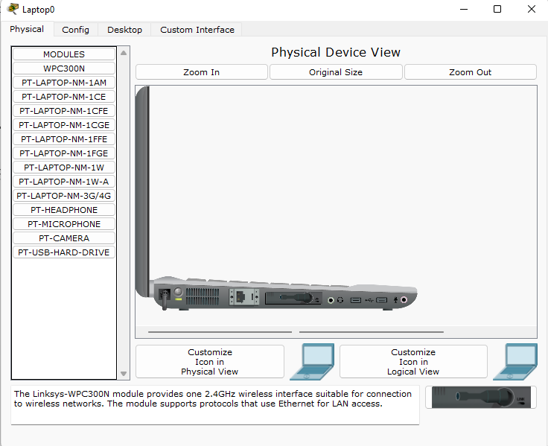

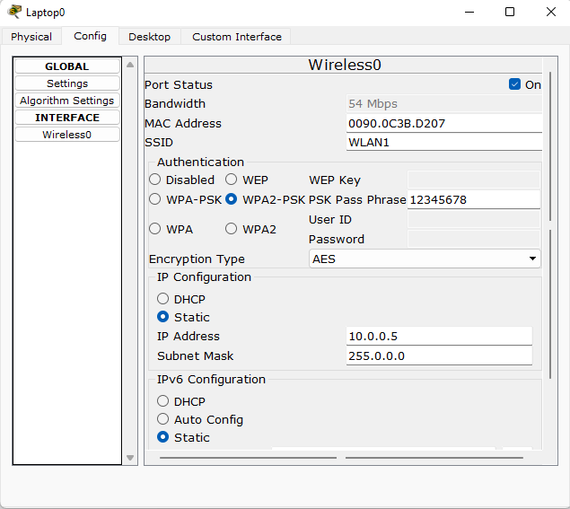

**Output:  
  
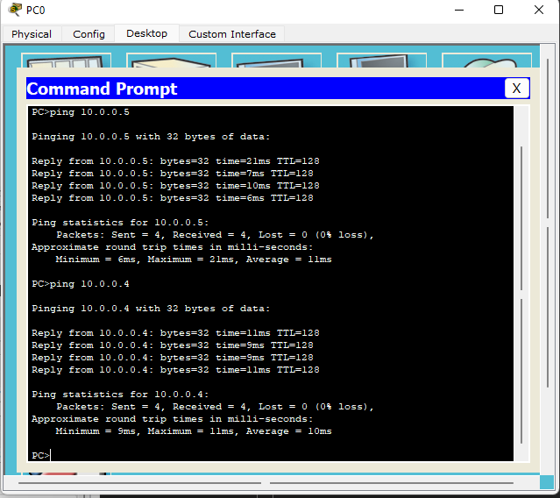**

**Aim of the Experiment:**

**To demonstrate the working of ARP for communication within a LAN.  
  
Topology:  
  
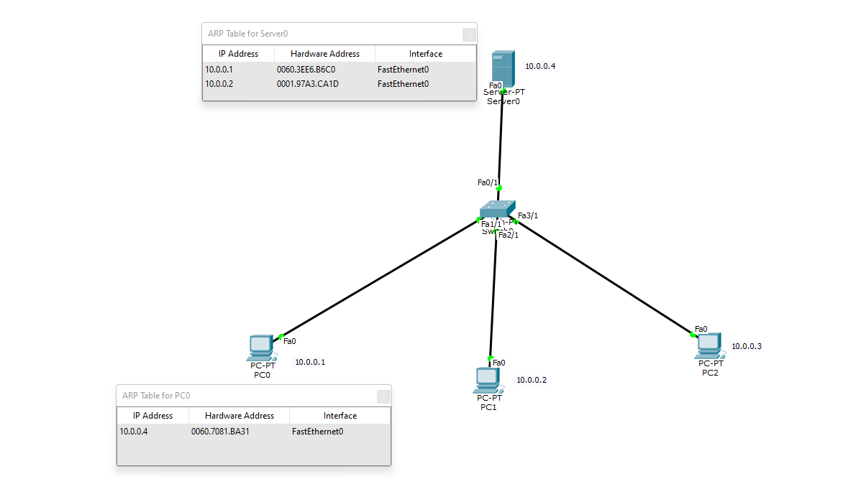  
  
Simulation:  
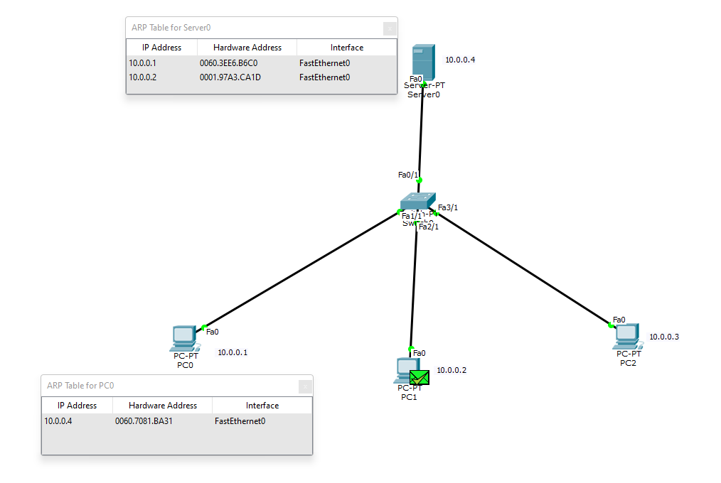**

**Configuration:**

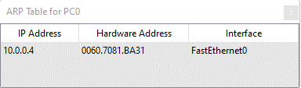

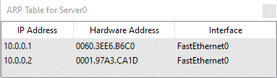

**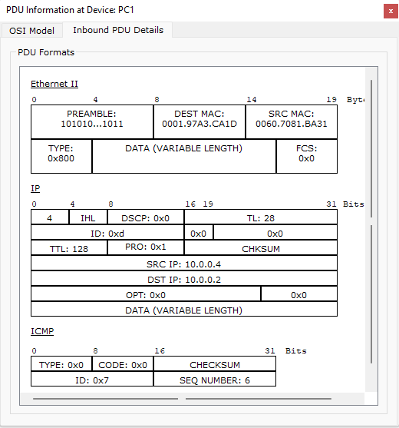  
  
  
Output:**

