1.AdminLogin Page

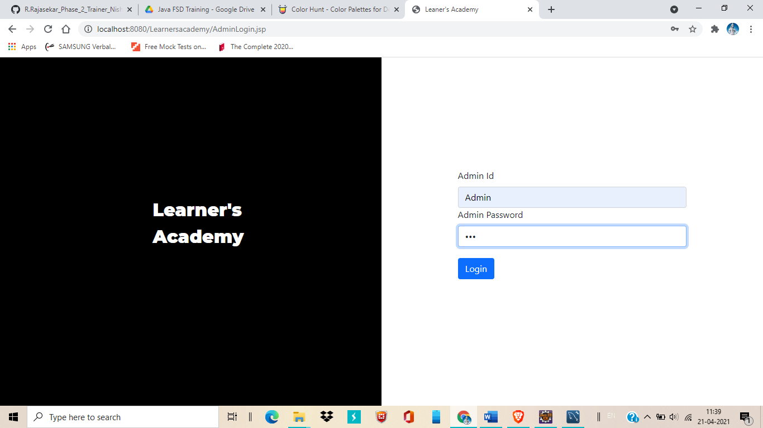

2.Home Page (Class Report)

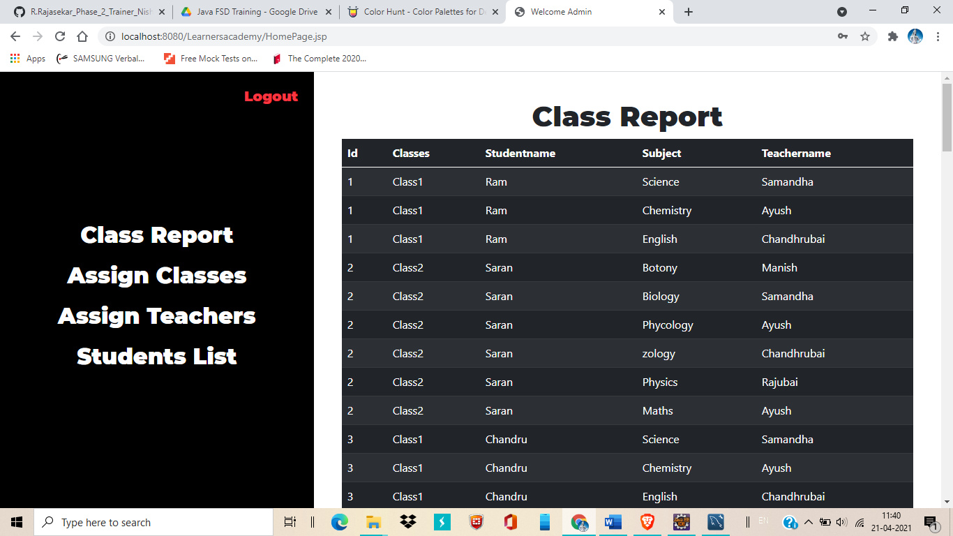

3.Assign Classes for Subject

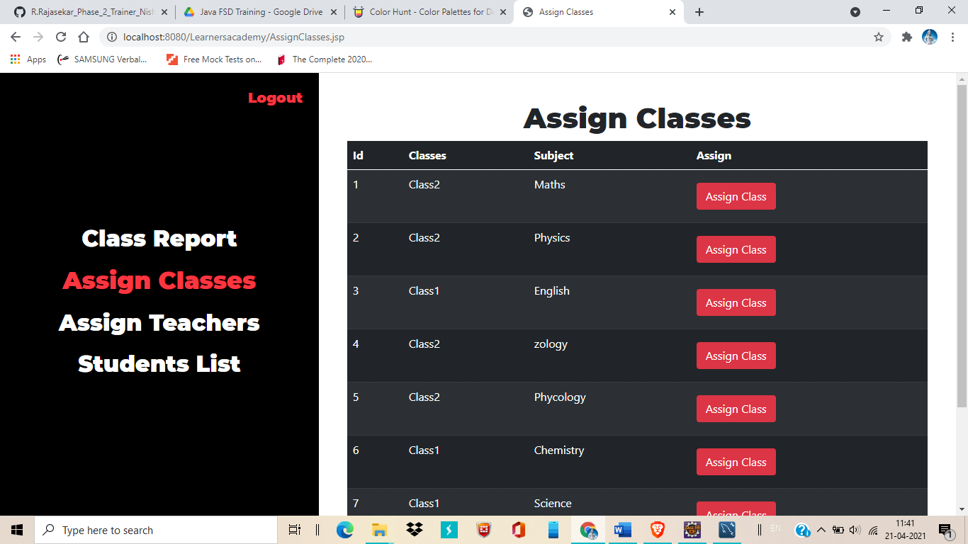

4.Click on Assign Class option to change the Class name for particular subject, the data will be reflected in Class Report and other related databases.

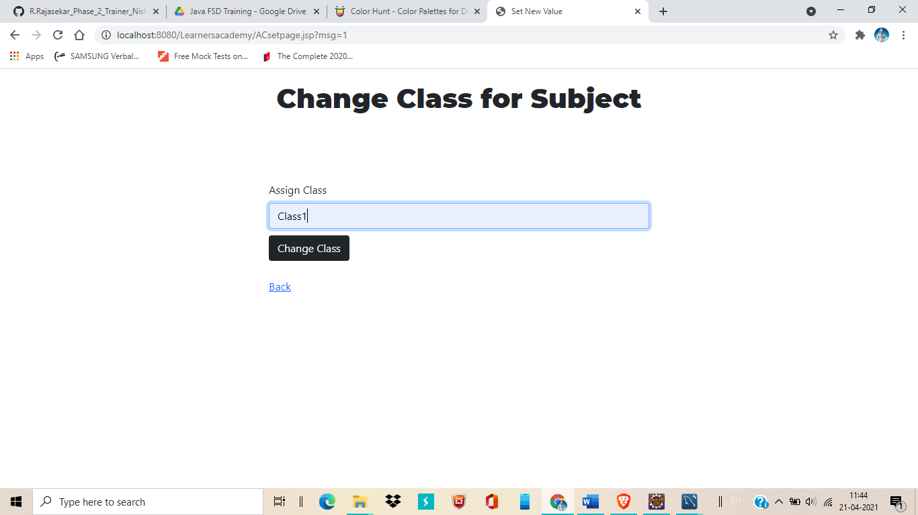

5.Data successfully changed

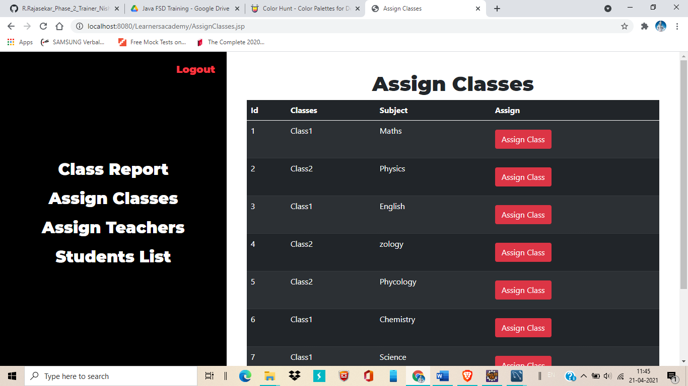

6.Assign Teachers table

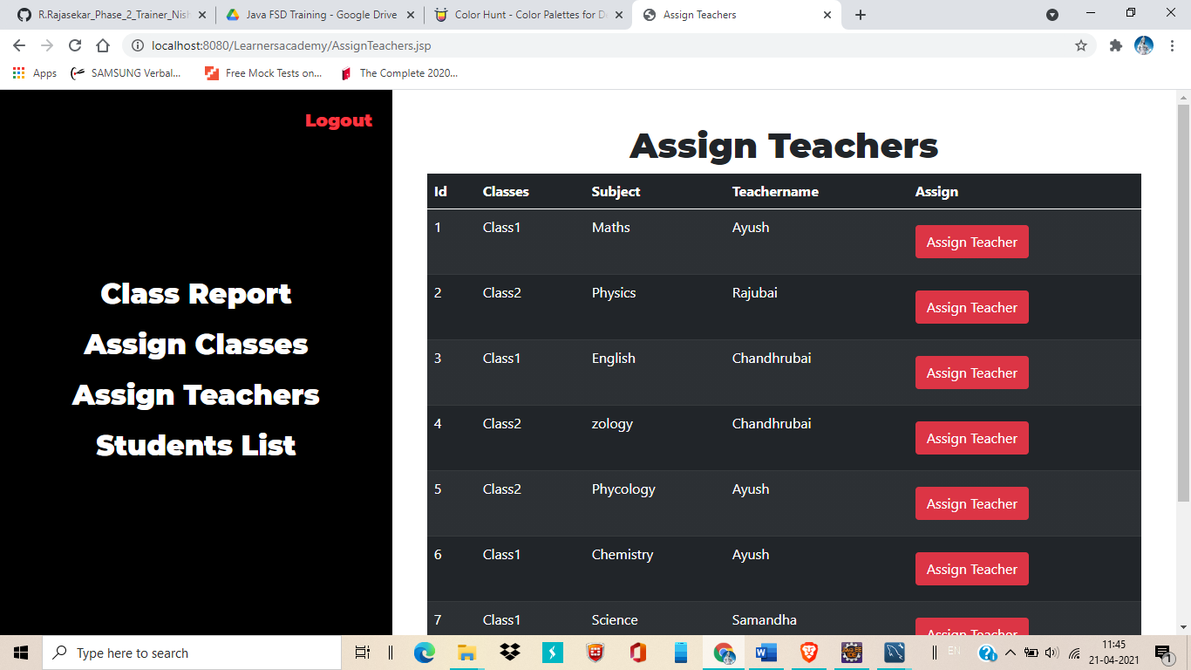

7.Click on Assign Teachers option to change the teacher name for a particular subject

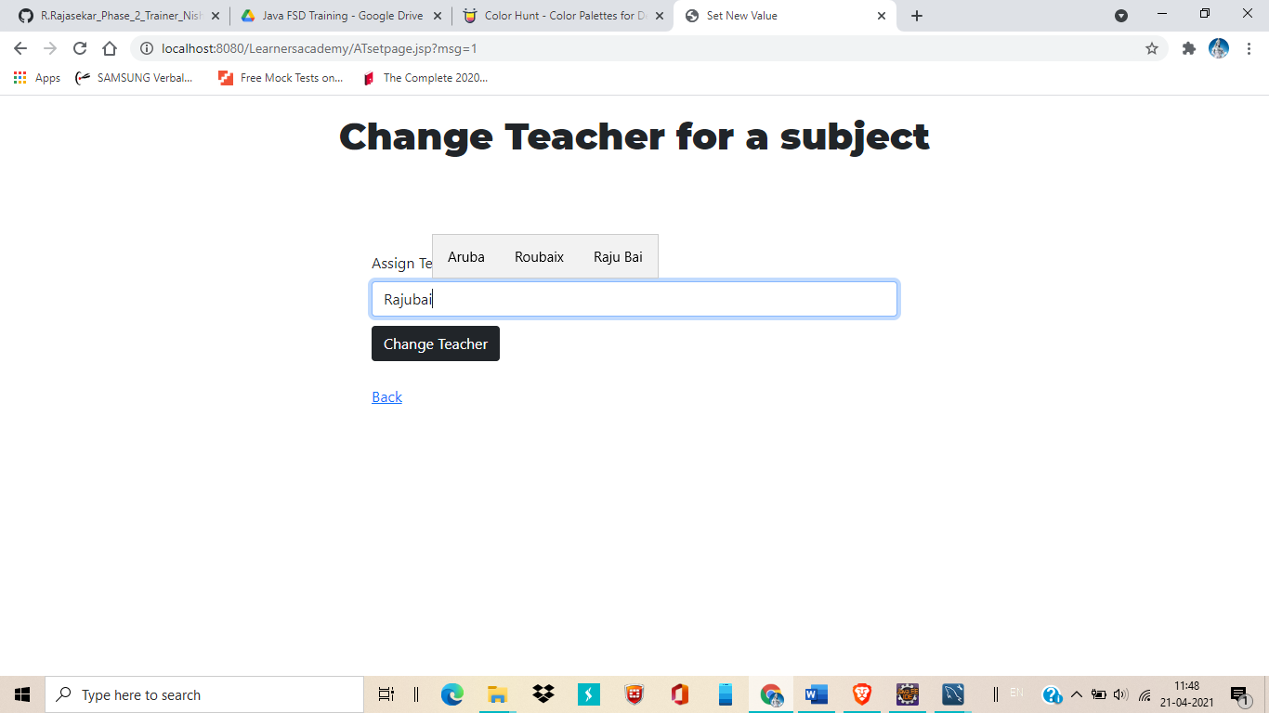

8.Changed data will be displayed

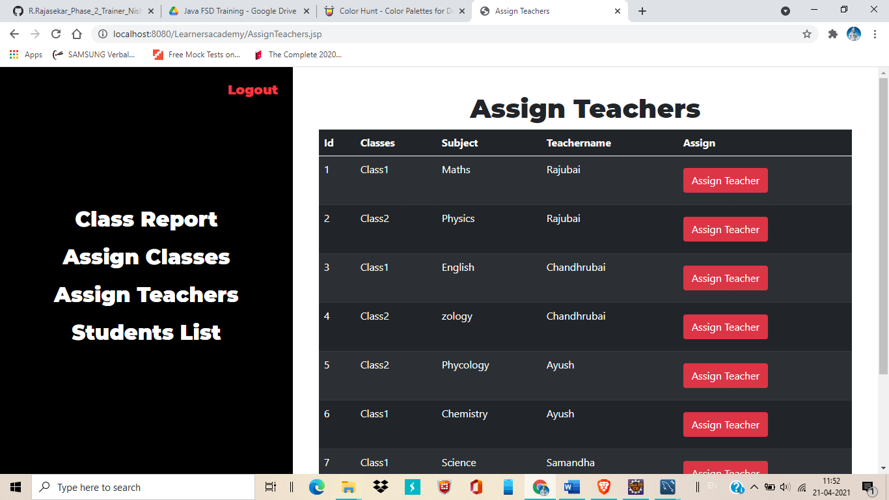

9. Changed class and Teacher data also will be reflected in Class Report

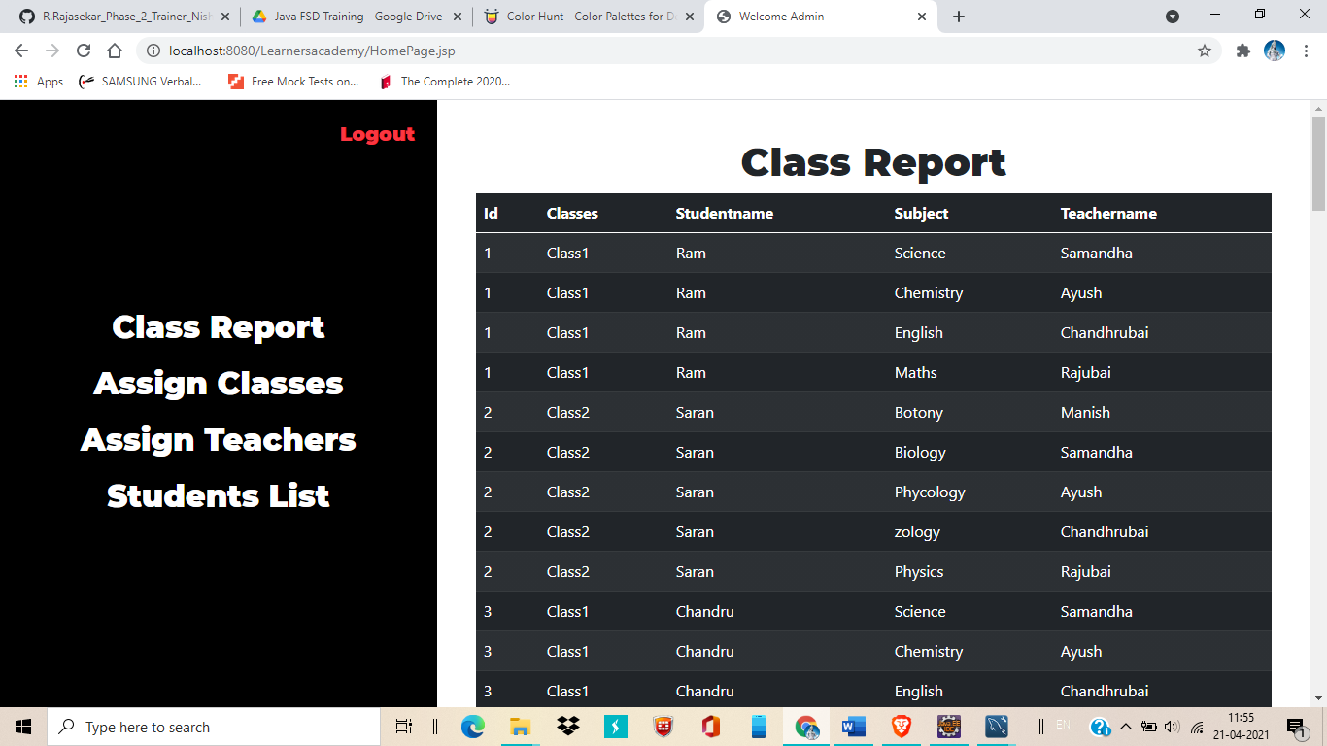

10.Student List

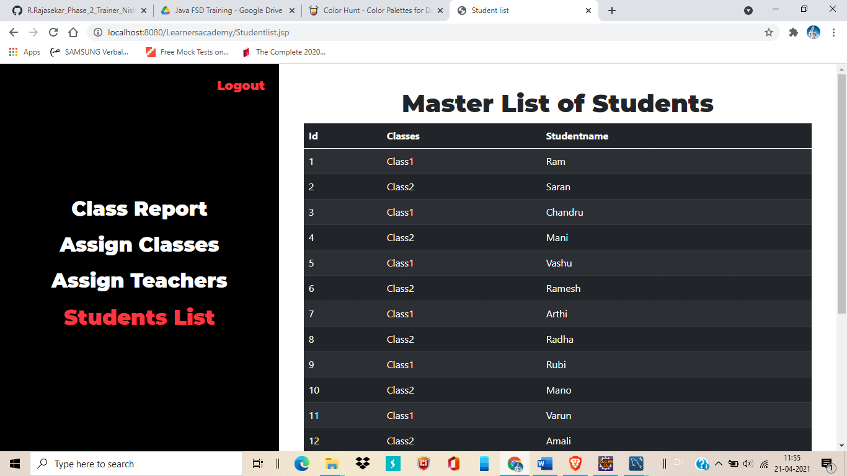

11.Logout option for logout from admin

