CSCI N317 Spring 2018 Lab 3

**MatLab Matrix and Functions**

Use the following distance chart and design a problem that can be solved based on this chart, e.g. finding the total distance of a person who travelled on a trip with *n* stops; finding the total cost of all trips in the last month (in this case, you may create another chart that reflects the cost of travelling from one city to another); finding the shortest distance of travelling between two cities that don’t have a direct flight (in this case, each distance on the chart means a direct flight).

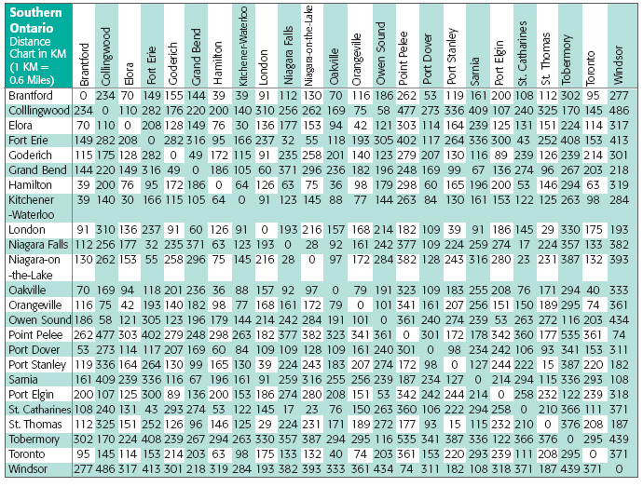

Your program must meet the following requirements.

1. Have comments that
   1. describes the problem (5’)
   2. states the author of the program and the date that the program was written or completed (5’)
   3. describes the purpose for each code block (5’)
2. Problem makes sense and has a practical purpose, e.g. a program that simply adds up all the distances on the chart doesn’t serve a practical purpose. (15’)
3. Use matrix. (20’)
4. Have user-defined functions. You can create multiple functions if you like. (20’)
5. Program runs and generates correct output(s) (20’)
6. Program saved in a script (.m) file and the file name format is *lastname*_lab3_.m (10’)

Submit your script file on Canvas.