Approach

1. Univariate analysis is done to understand each features distribution. Please refer UNIVARIATE_EDA_REPORT.html
2. Age, Vintage, Avg_balance are Continuos features but with skewed distribution
For e.g. As show in the fig,
Age distribution is skewed and more or less bimodal.

Data Transformation and feature engineering:
Log-Transformation and GMM application
Features having skewed distribution are log transformed to scale it closer to normal distribution
But still these distributions are multi model. So Gaussian mixture modelling is used to find the different gaussian component in the distributions. This is used for feature engineering e.g. Age_cluster variable
Localized normalization is done for these log transformed features using gaussian components Here Age has to gaussian components with mean at 28.79 and 51.00

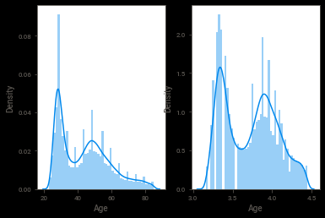

One hot encoding and Missing values
Categorical features are one hot encoded. Variable like credit product has 12% missing values so these missing values are encoded as separate category

Model design and training:
Light GBM cross validation with Fold=10
Model calibration with sigmoid output
Grid search for optimal parameter

