**Network Types**

|  |  |  |  |
| --- | --- | --- | --- |
| **Local area network (LAN)** | Common network type | Allows users to connect within a short distance in a common area | Users have access to the same resources |
| **Personal area network (PAN)** | Small-scale network | Connects few devices in a small localized area. Revolves around single person/device | Connecting from Bluetooth is an example |
| **Wireless local area network (WLAN)** | Similar to LAN | Less secure | Flexibility to use their devices in various locations |
| **Campus area network (CAN)** | Combine several independent networks into one cohesive unit | Connecting different departments | Used in Universities and Educational institution’s |
| **Metropolitan area network (MAN)** | Larger than a CAN | Costly network | Efficient connectivity between devices across a wide geographical range |
| **Wide area network (WAN)** | Extensive network | Corporations and international companies may use WANs | Remote users to connect to their company |
| **Storage area network (SAN)** | Use to store mass amounts of sensitive data | Provides a way to centralize data on a non-localized network | Example: If your team stores customer information on a separate network to maintain the high speeds of your main network |
| **Passive optical local area network (POLAN)** | Low-cost network | Link various locations to one central network |  |
| **Enterprise private network (EPN)** | Exclusive network | Share company resources at high speeds | High-security technology company might use an EPN to reduce the risk of data breaches |
| **Virtual private network (VPN)** | Private network that's available through the internet | Functions similar to EPN | Both the general public and companies can use VPNs to ensure privacy and security |
| **System-area network (SAN)** | Broad local network | Provides connections in clusters | Newly developing networks that operate at high speeds |

**Internet Protocol Address**

An Internet Protocol (IP) address is a unique numerical identifier for every device or network that connects to the internet. Typically assigned by an internet service provider (ISP), an IP address is an online device address used for communicating across the internet. Example: IPV4 (four dotted decimals) and IPV6 (eight dotted hexadecimals)

**Web protocols:**

* TCP/IP(Transmission Control Protocol/ Internet Protocol)
* SMTP(Simple Mail Transfer Protocol)
* PPP(Point-to-Point Protocol)
* FTP (File Transfer Protocol)
* SFTP(Secure File Transfer Protocol)
* HTTP(Hyper Text Transfer Protocol)
* HTTPS(Hyper Text Transfer Protocol Secure)
* TELNET(Terminal Network)

**Markup Language**

* Standard text-encoding system consisting of a set of symbols inserted in a text document to control its structure, formatting, or the relationship between its parts
* The most widely used markup languages are SGML (Standard Generalized Markup Language), HTML (Hypertext Markup Language), and XML (Extensible Markup Language)
* The markup symbols can be interpreted by a device (computer, printer, browser, etc.) to control how a document should look when printed or displayed on a monitor
* A marked-up document thus contains two types of text: text to be displayed and markup language on how to display it

**HTML/CSS**

|  |  |
| --- | --- |
| **HTML** | **CSS** |
| HTML is a markup language used to create static web pages and web applications. | CSS is a style sheet language responsible for the presentation of documents written in a markup language. |
| Consists of tags surrounding content. For Example:  <p>Welcome to Simplilearn</p> | Consists of selectors succeeded by a declaration mark. For Example:  header{ background-color: green; } |
| HTML cannot be used in a CSS file. | CSS can be used in an HTML file. |
| It is used to build the structure of the web pages. | It is used to make web pages more presentable. |

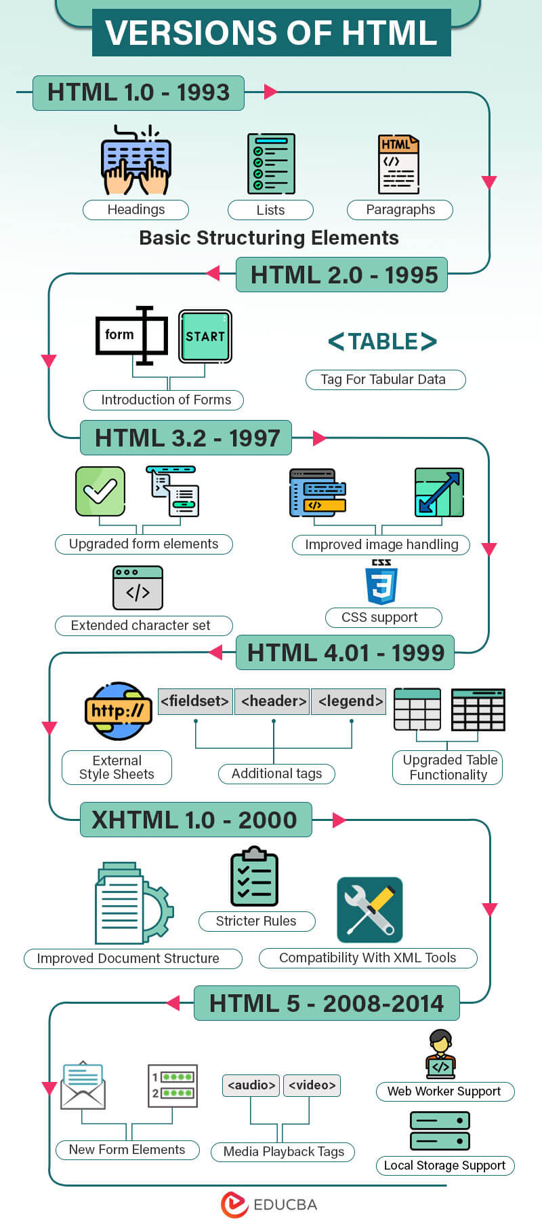

**HTML history and Timeline**

In 1980, physicist **Tim Berners-Lee**, a contractor at CERN, proposed and prototyped ENQUIRE, a system for CERN researchers to use and share documents