***Linkedin***

( [www.linkedin.com/in/raja-muhammad-arbab-91a062372](http://www.linkedin.com/in/raja-muhammad-arbab-91a062372) )

**NO :01**

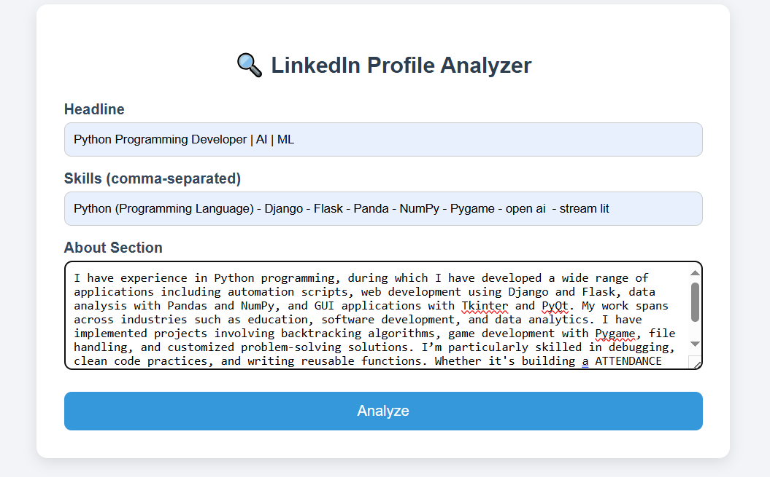

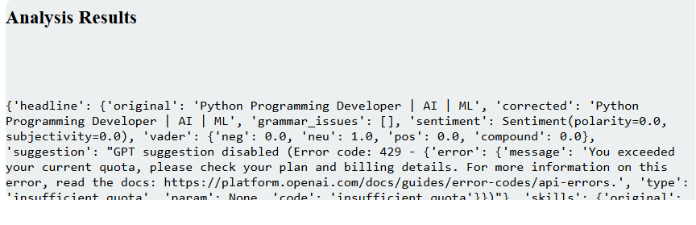

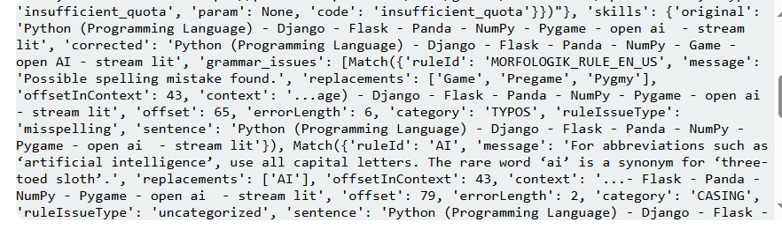

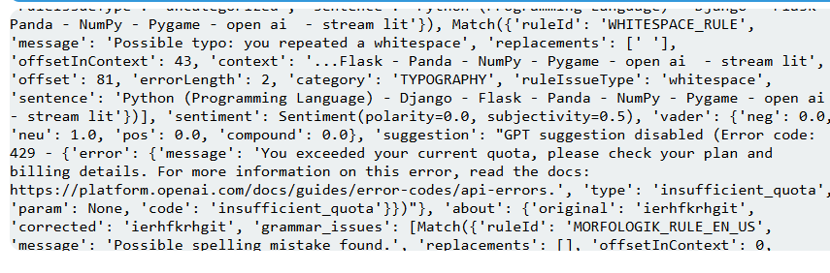

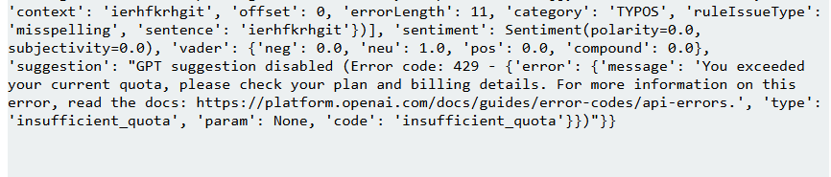

**IMPROVEMENTS-SUMMARY**

The paragraph effectively demonstrates a broad and impressive range of Python experience, covering automation, web development, data analysis, GUI apps, and algorithmic problem-solving. It showcases real projects like an Attendance Management System (AMS), Sudoku solver, and 2D maze game, which help validate your skills.

However, for a more **professional and polished** presentation, consider the following improvements:

1. **Grammar & Consistency**:
   * a ATTENDANCE MANAGEMENT SYSTEM should be an Attendance Management System (correct article and casing).
   * Use consistent capitalization
2. **Flow & Structure**:
   * Break long sentences into smaller ones for clarity.
   * Use parallel structure when listing skills or projects for readability.
3. **Tone**:
   * Consider a slightly more formal tone to enhance professionalism.
4. **Highlight Results or Impact**:
   * You could briefly mention outcomes (e.g., improved efficiency, saved time, etc.) to show the value of your work

***NO :02***

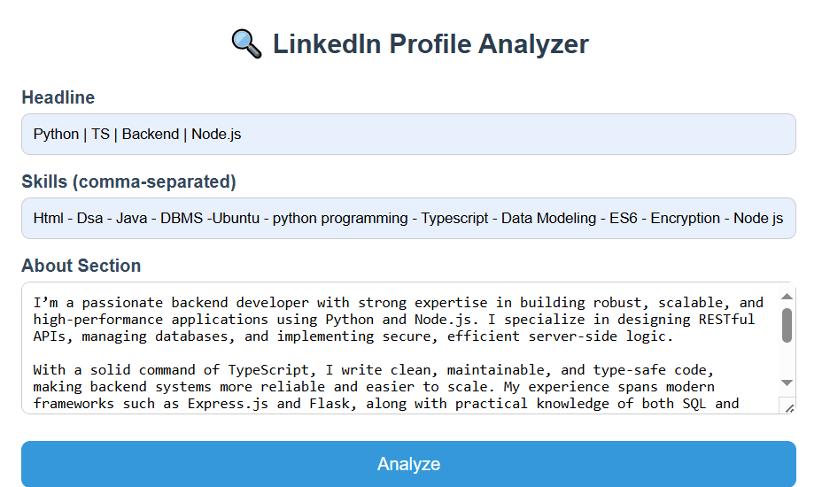

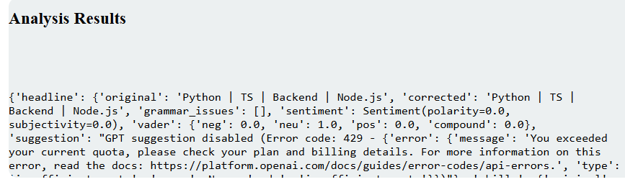

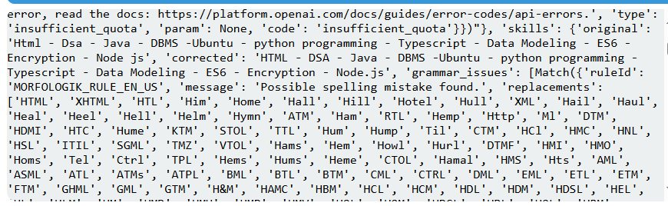

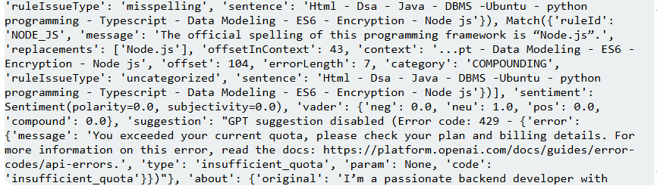

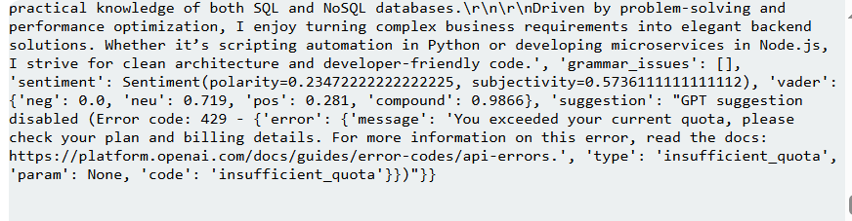

**IMPROVEMENTS-SUMMARY**

The profile demonstrates a strong technical foundation in **backend development**, especially with **Python**, **Node.js**, and **TypeScript**. The **"About" section** is well-written, clearly structured, and sentiment analysis shows it is **positive and confident**, with no major grammar issues. However, the **headline** is too generic and lacks a personal or value-driven element — it could be improved by adding a role/title (e.g., “Backend Developer | Python | Node.js | TypeScript”) to make it more professional and searchable. The **skills section** contains minor grammar and formatting issues (e.g., “Html” should be “HTML”, “Node js” should be “Node.js”). Overall, the content is strong, but could benefit from more **personality, specificity, and proper capitalization/formatting** for a polished and impactful presentation.