**ICIN BANK**

**Index:**

**Git URL:** [**https://github.com/RajaRajeswari12/CapstoneProj.git**](https://github.com/RajaRajeswari12/CapstoneProj.git)

**Jsp Pages:**

1. header.html
2. adminHeader.html
3. adminHomePage.html
4. adminLogin.html
5. chequeBkRequest.html
6. Deposit.html
7. FundTransfer.html
8. homePage.html
9. userLogin.html
10. UserRegistration.html
11. viewChequeBkRequestList.html
12. ViewCustomerDetail.html
13. viewMoneyTransferRequest.html
14. viewTransactionDetails.html
15. viewUserDetails.html
16. welcome.html
17. WithDraw.html
18. **Servlets [com.ICINBank.ICINbanking.controller]**
    1. AccountTransactionController.java
    2. AdminController.java
    3. ChequeBookController.java
    4. CustomerController.java
    5. DepositOrWithdrawController.java
    6. FundsTransferController.java
    7. UserController.java
19. **Repositories [com.ICINBank.ICINbanking.repository]**
    1. ChequeBookRepository.java
    2. CurrentAccountRepository.java
    3. CurrentAccountTransactionRepository.java
    4. CustomerRepository.java
    5. DepositOrWithdrawRepository.java
    6. SavingsAccountRepository.java
    7. SavingsAccountTransactionRepository.java
    8. UserRepository.java
20. **Models[com.ICINBank.ICINbanking.model]**
    1. ChequeBook.java
    2. CurrentAccount.java
    3. CurrentAccountTransaction.java
    4. Customer.java
    5. DepositOrWithdraw.java
    6. SavingsAccount.java
    7. SavingsAccountTransaction.java
    8. User.java
21. **Service[com.ICINBank.ICINbanking.service]**
    1. ChequeBookService.java
    2. CurrentAccountService.java
    3. CurrentAccountTransactionService.java
    4. CustomerService.java
    5. DepositOrWithdrawService.java
    6. SavingsAccountService.java
    7. SavingsAccountTransactionService.java
    8. UserService.java
22. **Service Implementation [com.ICINBank.ICINbanking.serviceImpl]**
    1. ChequeBookServiceImpl.java
    2. CurrentAccountServiceImpl.java
    3. CurrentAccountTransactionServiceImpl.java
    4. CustomerServiceImpl.java
    5. DepositOrWithdrawServiceImpl.java
    6. SavingsAccountServiceImpl.java
    7. SavingsAccountTransactionServiceImpl.java
    8. UserServiceImpl.java
23. **POJOS[com.ICINBank.ICINbanking.POJO]**
    1. DepositOrWithdrawPOJO.java
    2. TransferDetailPOJO.java
24. **Validators[com.ICINBank.ICINbanking.validators]**
    1. FundsTransferValidator.java
    2. UserRegistrationValidator.java
25. Jsp Pages
26. **header.html**

Header Html contains the link to all the pages. It checks whether the user has logged in or not. If the User logs in then it allows access to the following header links.



Or else only the below header links are active.

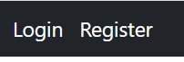

1. **adminHeader.html**

Header Html contains the link to all the pages. It checks whether the user has logged in or not. If the Admin logs in then it allows access to the following header links.



Or else only the below header links are active.



1. **adminHomePage.html**

Before Admin logs in

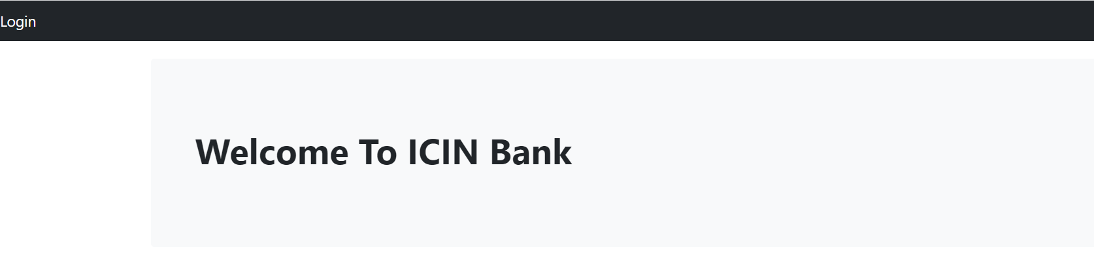

After Successful Admin log-in

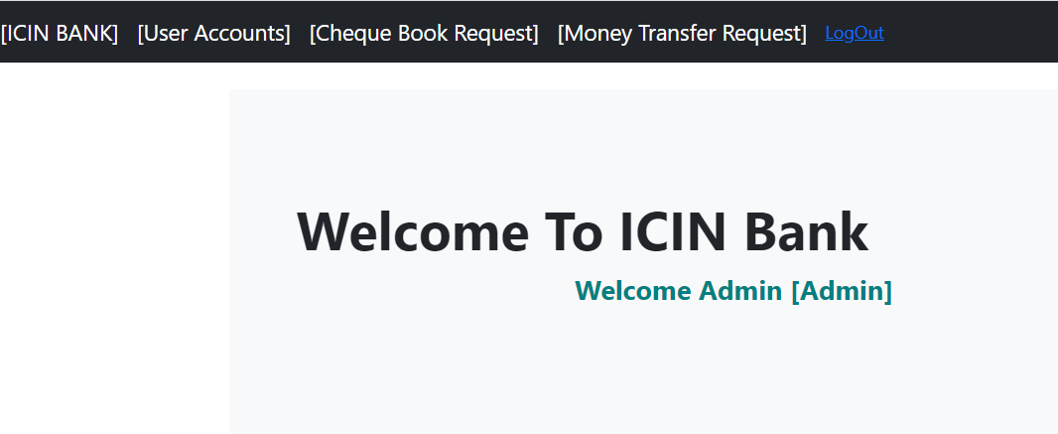

1. **adminLogin.html**

Login Page is used by the Admin to Login into ICIN Bank Portal.

If the Admin logins with his/her credentials then it is navigated to the admin page where the admin can view the list of customers who have signed up, cheque book request list and money [deposit & withdraw] request list. The admin can activate or deactivate customer account, approve or disapprove cheque book request,amount deposit and amount withdraw request.

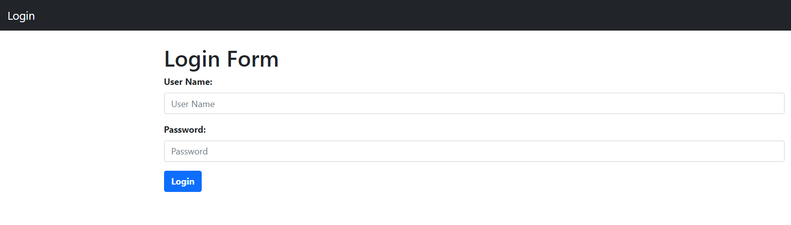

1. **chequeBkRequest.html**

This page is available to the Bank customer to raise the cheque book request. On successful submit the request goes to the Admin for approval.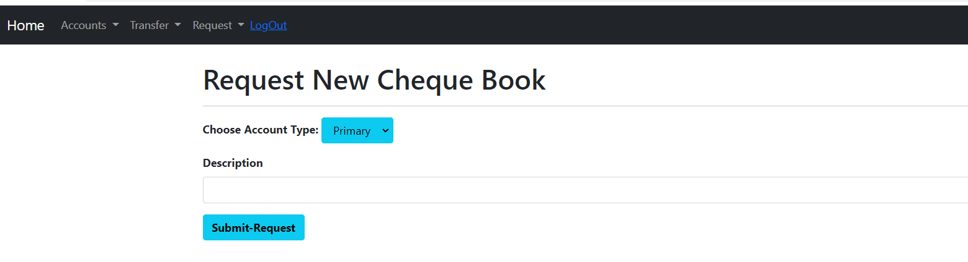

1. **Deposit.html**

This page is available to the Bank customer to raise amount deposit request. On successful submit the request goes to the Admin for approval.

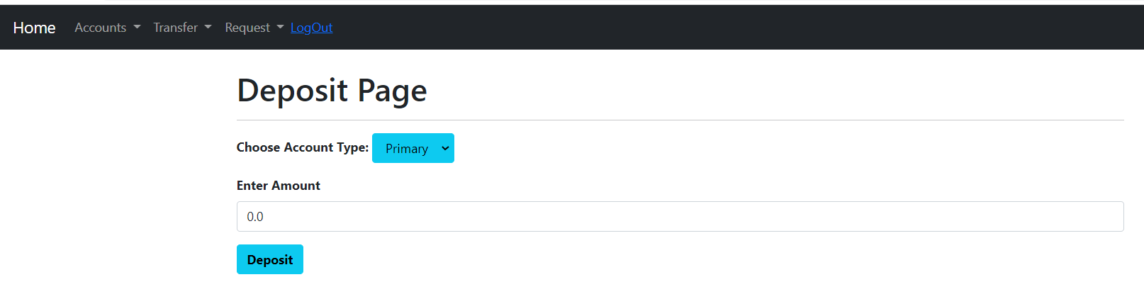

1. **FundTransfer.html**

This page is available to the Bank customer to transfer amount from their account to another valid account. On successful submit the amount gets debited from the customer and gets credited in the requested account. The transaction details are captured and can be seen.

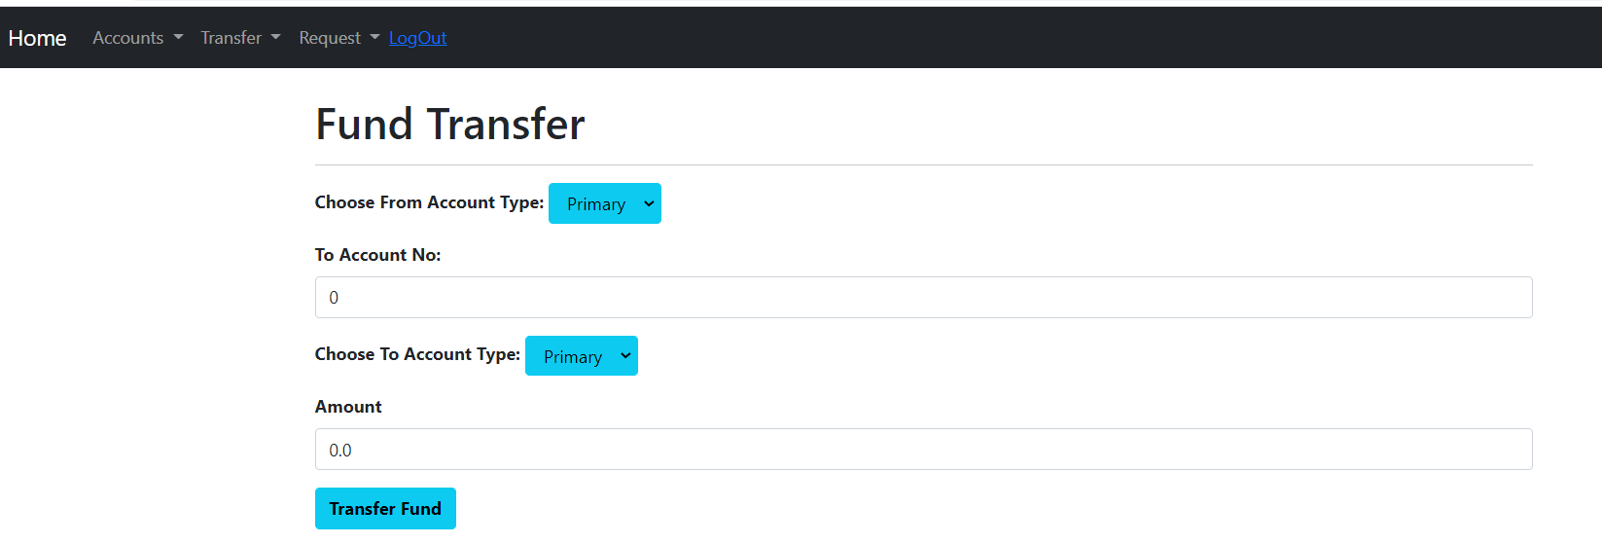

1. **homePage.html**

Before User log-in

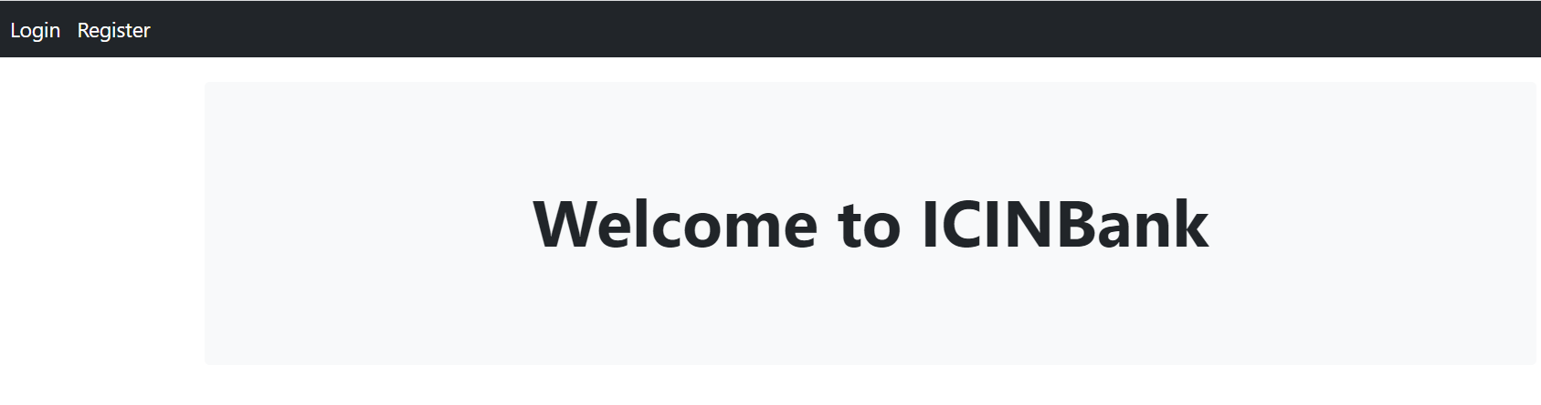

After User log-in

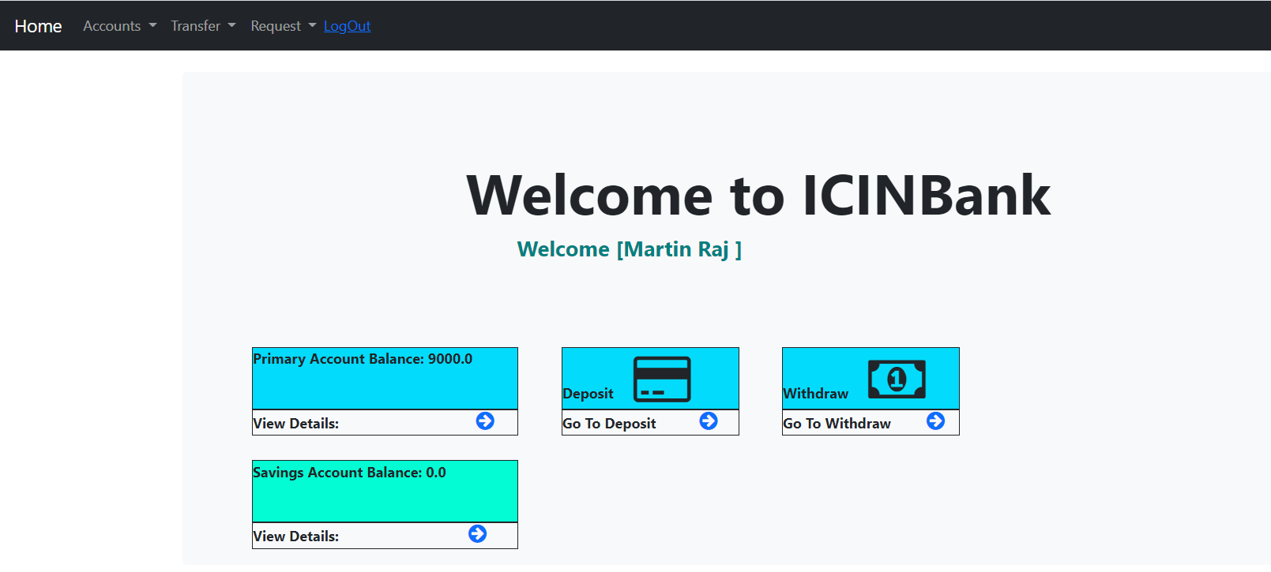

1. **userLogin.html**

Login Page is used by the User to Login into their respective account page.

If the User logs in with his/her credentials then it is navigated to the home page where the user can see his/her account details, raise a cheque book request, raise deposit amount request, withdraw request, transfer funds to another valid account and view their account transaction details.

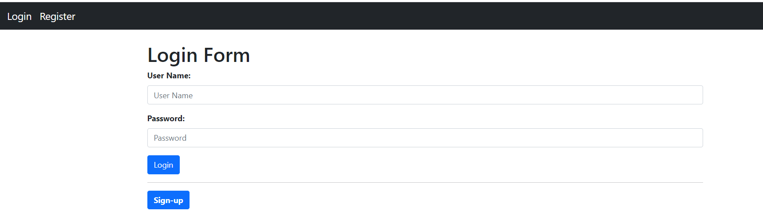

1. **UserRegistration.html**

**User** Registration page is used to register new user as Bank customer.

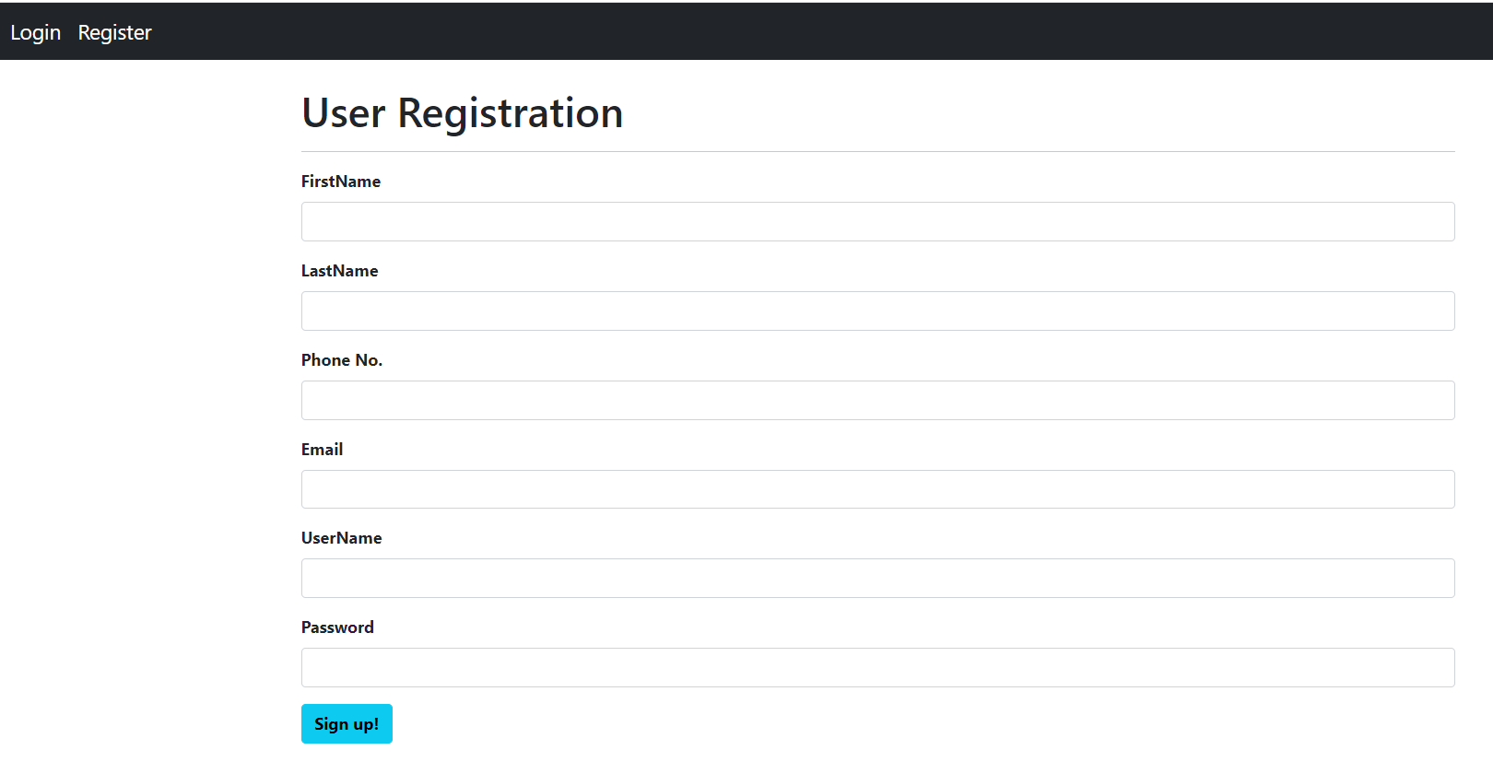

1. **viewChequeBkRequestList.html**

This page is used to view the list of cheque book request raised by the bank customer. This page is only available for the admin. Admin can further approve the request.

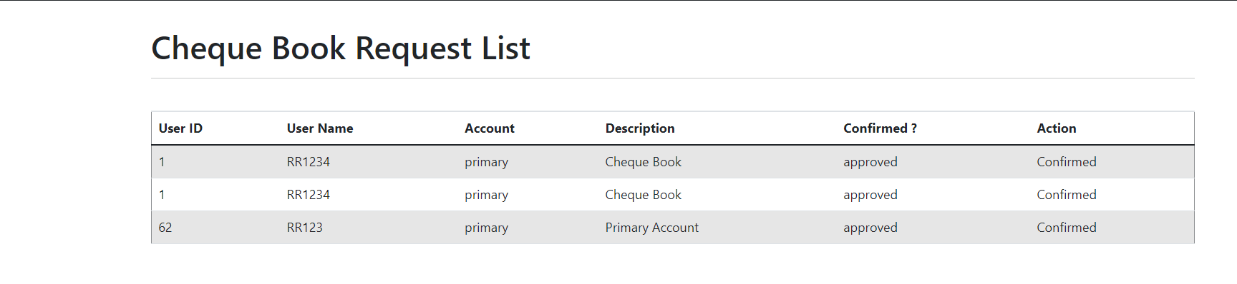

1. **ViewCustomerDetail.html**

This page is used to display the details of the Customer with their bank account numbers. This page is available for the Bank customer only.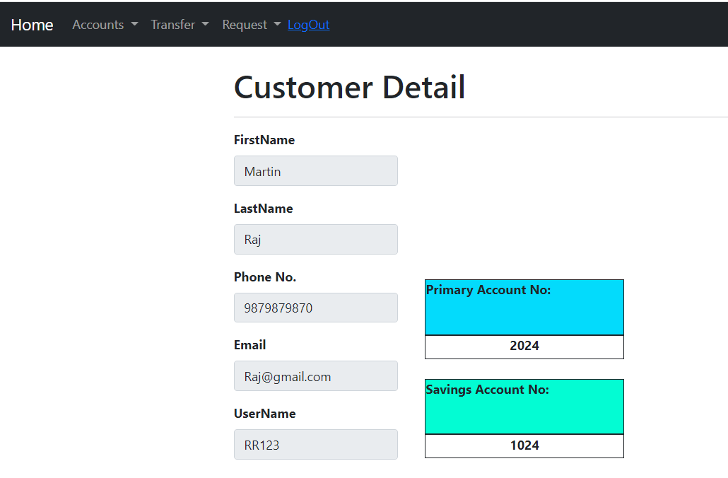

1. **viewMoneyTransferRequest.html**

This page is used to view the list of deposit request and withdraw request raised by the bank customer. This page is only available for the admin. Admin can further approve/reject the request.

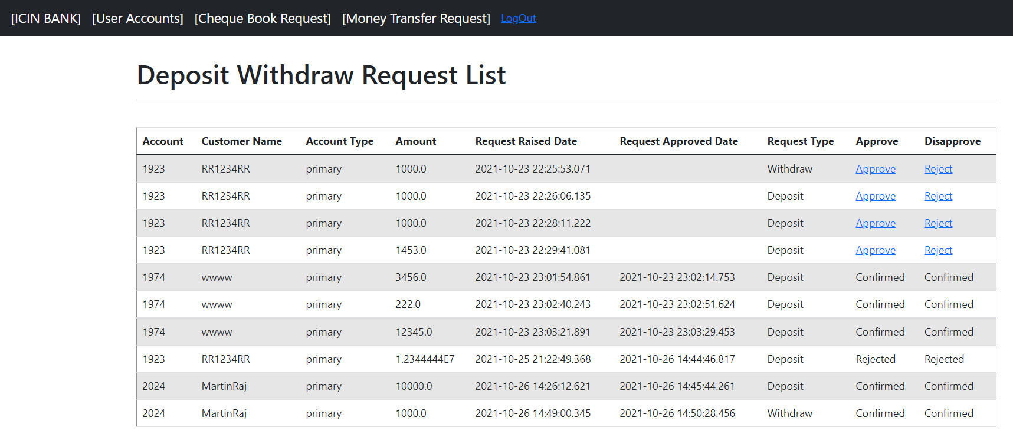

1. **viewTransactionDetails.html**

This page displays the details of transactions done in that account. This page is only available for the Bank user.

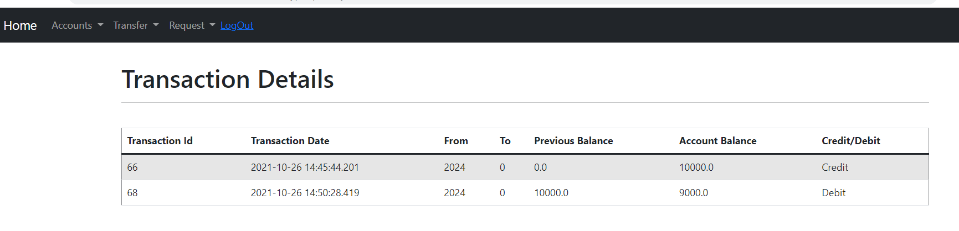

1. **viewUserDetails.html**

This Page is used to view the list of bank customer signed up. This page is only available for the admin. The admin can enable/disable the bank user account.

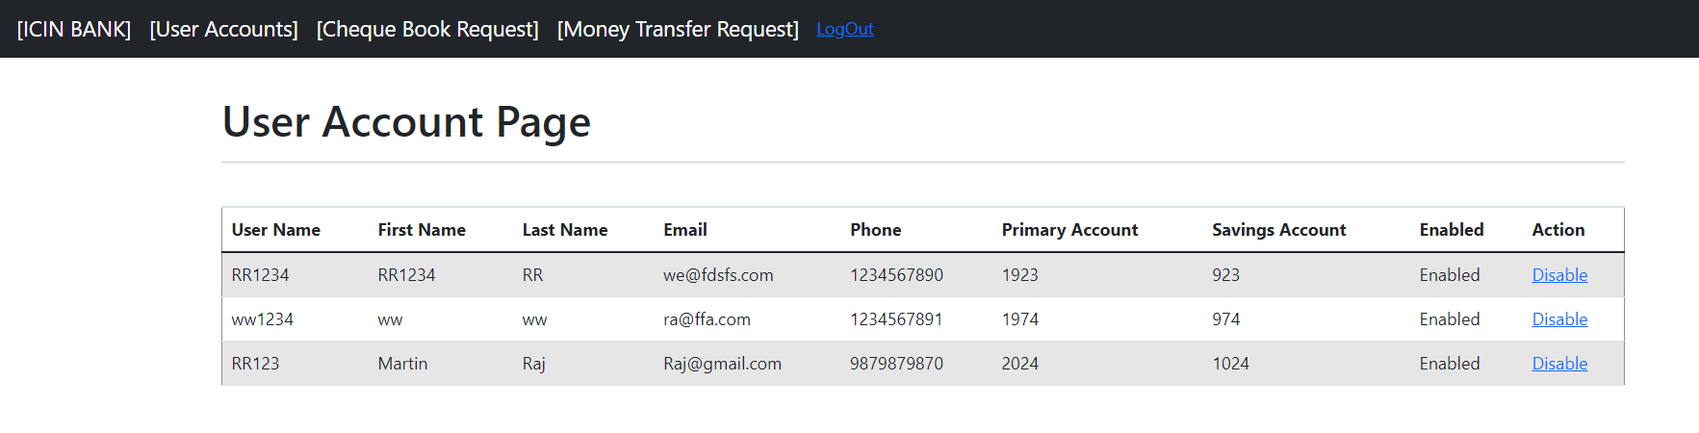

1. **welcome.html**

This page is displayed after the successful user account registration.

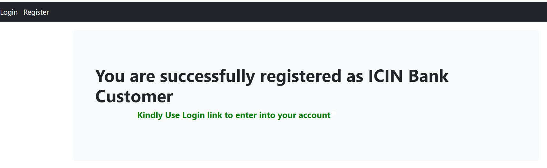

1. **WithDraw.html**

This page is available to the Bank customer to raise amount withdraw request. On successful submit the request goes to the admin for approval.

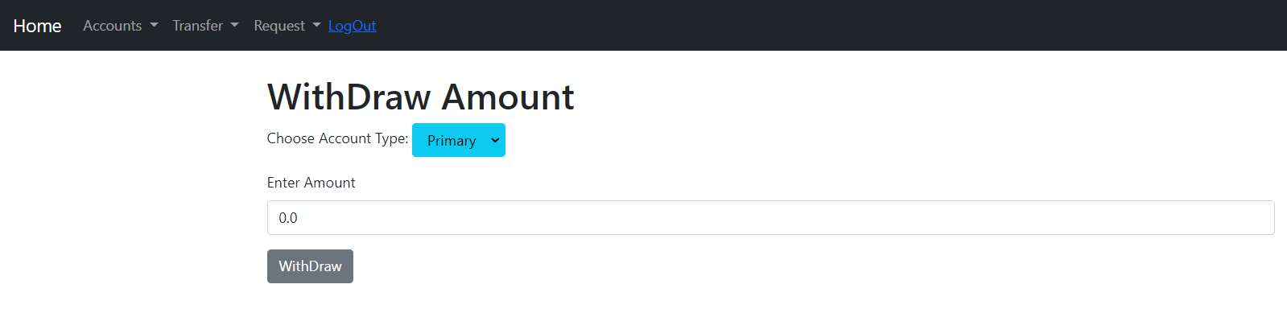

1. **Controller[com.ICINBank.ICINbanking.controller]**
2. **AccountTransactionController.java**

AccountTransactionController receives the savings and primary account transaction request and takes the required action to capture the transaction details and return corresponding response.

1. **AdminController.java**

AdminController receives admin related request like view user list and enable/disable user thenforward the request to their corresponding services to process the request and return corresponding response.

1. **ChequeBookController.java**

ChequeBookController receives cheque book related request like create cheque book request, list cheque book request, approve request thenforward the request to their corresponding services to process the request and return corresponding response.

1. **CustomerController.java**

CustomerController receives request like customer registration, login, etc, then takes the required actions and navigate it to the appropriate pages.

1. **DepositOrWithdrawController.java**

DepositOrWithdrawController receives request like withdraw amount, deposit amount, list deposit and withdraw request, approve request, reject request, then takes the required actions and navigate it to the appropriate pages.

1. **FundsTransferController.java**

FundsTransferController receives request like transfer amount from current account / savings account to another valid account, then takes the required actions and navigate it to the appropriate pages.

1. **UserController.java**

UserController receives request to login or logout from user account or admin account, then takes the required actions and navigate it to the appropriate pages.

1. **Repositories [****com.ICINBank.ICINbanking.repository]**
   1. ChequeBookRepository.java
   2. CurrentAccountRepository.java
   3. CurrentAccountTransactionRepository.java
   4. CustomerRepository.java
   5. DepositOrWithdrawRepository.java
   6. SavingsAccountRepository.java
   7. SavingsAccountTransactionRepository.java
   8. UserRepository.java
2. **Models[com.ICINBank.ICINbanking.model]**
   1. ChequeBook.java
   2. CurrentAccount.java
   3. CurrentAccountTransaction.java
   4. Customer.java
   5. DepositOrWithdraw.java
   6. SavingsAccount.java
   7. SavingsAccountTransaction.java
   8. User.java
3. **Service[com.ICINBank.ICINbanking.service]**
   1. **ChequeBookService.java**

ChequeBookService performs the backend operations to raise cheque book request, list the request details and request approval.

* 1. **CurrentAccountService.java**

CurrentAccountService performs the service related to the current account like transferring amount from current account to other valid account, view the account balance, account creation etc.

* 1. **CurrentAccountTransactionService.java**

CurrentAccountTransactionService performs the service related to the current account transactions like capturing the transaction details, list the transaction details, etc.

* 1. **CustomerService.java**

CustomerService performs services related to user registration, user account validation,etc

* 1. **DepositOrWithdrawService.java**

DepositOrWithdrawService performs background operations like raising a deposit/withdraw request, listing the request details and request approval/disapproval.

* 1. **SavingsAccountService.java**

SavingsAccountService performs the service related to the Savings account like transferring amount from savingsaccount to other valid account, view the account balance, account creation etc.

* 1. **SavingsAccountTransactionService.java**

SavingsAccountTransactionService performs the service related to the savings account transactions like capturing the transaction details, list the transaction details, etc.

* 1. **UserService.java**

UserService performs the backend operations for the admin and user login, logout,

1. **Service Implementation [com.ICINBank.ICINbanking.service.implementation]**
   1. ChequeBookServiceImpl.java
   2. CurrentAccountServiceImpl.java
   3. CurrentAccountTransactionServiceImpl.java
   4. CustomerServiceImpl.java
   5. DepositOrWithdrawServiceImpl.java
   6. SavingsAccountServiceImpl.java
   7. SavingsAccountTransactionServiceImpl.java
   8. UserServiceImpl.java
2. **POJOS[com.ICINBank.ICINbanking.POJO]**
   1. **DepositOrWithdrawPOJO.java**

This POJO is used to load the deposit account no, account type and amount using which the respective request is raised.

* 1. **TransferDetailPOJO.java**

This POJO used to load the transfer details like fromAccountType, toAccountNo , toAccountType, AmountToBeTransfered using which the funds are transferred to that particular account.

1. **Validators[com.ICINBank.ICINbanking.validator]**
2. **FundsTransferValidator.java**

FundsTransferValidator is used to validate the data entered by the customer while transferring the amount.

1. **UserRegistrationValidator.java**

UserRegistrationValidator is used to validate the data entered by the Bank user while registration.