Git URL:

My Project Folder Name:

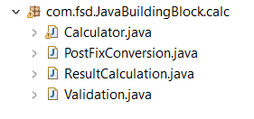

Calculator.Java is a main class which gets input from the user and invokes the other class to do the validation, PostFix expression conversion and result calculation.

Validation.Java is a next class which the calculator class invokes once it receives the input from the user. Here expression validation is done with the help of patterns. If user gives wrong values or wrong input or wrong expression, then this method again redirects the user to enter valid expression for calculation. Thus, it eliminates exceptions occurrence in the coming class.

PostFixConversion.java is a class which converts the given string expression into a proper postfix expression stack. This method follows BODMAS rule while converting the infix to postfix expression.

ResultCalculation.java is a class which takes postfix expression stack as a input and calculate the result. This method return the final calculated value.