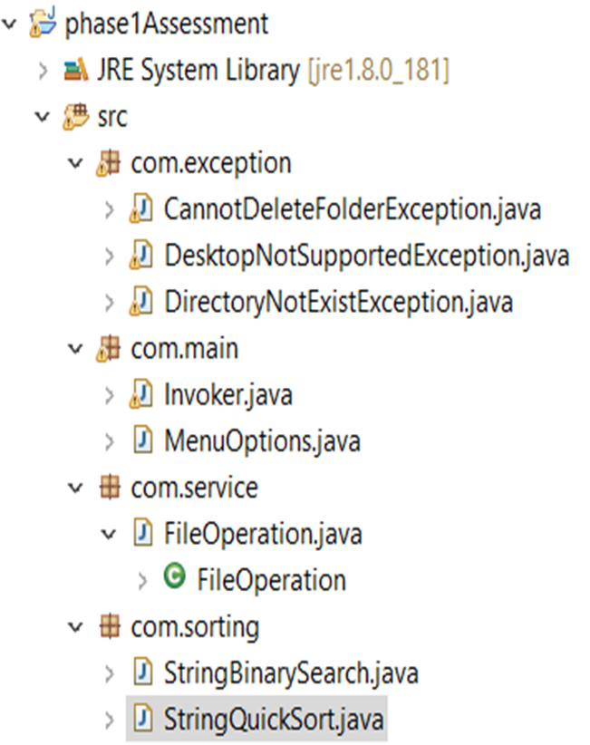



Com.main.Invoker.Java File

Invoker() constructor to set the Scanner class to read input from the console.

fileListSorting() method is used to list the options given below. And do the required actions.Calls Method recursively.

\* 1.Sorted File List in Ascending Order

\* 2.Sorted File List in Descending Order

\* 3.Return to Main Menu

\* openFileOption() method is used to get input from the user whether to open the added/searched file in the desktop for (updating or cross checking) the file content.

\* getValidFileName() method is used to check whether the given fileName for adding/deleting/searching a file is a valid name or not.

\* addFile() method is used to add the new file using FileOperation.createFile method. Once created successfully it ask the user to open the new file or not.Finally goes back to the fileOperationMenu().[Recursive call]

\* fileOperationMenu() method is used to list the options given below. And do the required actions.Calls Method recursively.

\* 1.Add File

\* 2.Delete File

\* 3.Search File

\* 4.Return to Main Menu

\* searchFile() method is used to search file using FileOperation.searchFile method. Once searched successfully it ask the user to open the searched file or not. Finally goes back to the fileOperationMenu().[Recursive call]

\* jumpToMainMenu() method is called from the delete method. It is used to give options to the user either goes to the MainMenu or fileOperationMenu or deleteFile option itself.

\* deleteFile() method is used to delete file using FileOperation.deleteFile method.If file name does not exists then it informs the user and ask whether to go to the MainMenu or fileOperationMenu or again go to deleteFile option itself to try some other filename. Finally goes back to the fileOperationMenu().[Recursive call]

\* getOption() method is validate whether the given input is a valid numbers or not.If the user gives some other input except numbers then it recursively call the respective methods by using the input methodCalled and with the help of the method switchToMethods.

\* switchToMethods() method is used to call the respective methods by using the input methodCalled.

\* mainMenu() method is used to list the options given below. And do the required actions.Calls Method recursively.

\* 1.Sorted Files List

\* 2.File Operation (Add,Delete&Search)

\* 3.To Change the destination Folder path

\* 3.Quit

\* endFunction() method is used to Quit the File Handling application.

\* getDestFolderPath() method is used to get the Folder Path and check whether the given path is valid folder or not by calling the method FileOperation.setFolderPath() method.

\* main() method is used to run the application.

Com.main.MenuOption.java file contains the menu list arrays and one display method.

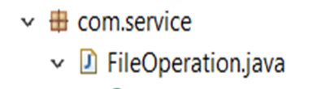

*Com.service.FileOperation.Java*

*\* setFileNameList Method is used to store the list of files exist in the mentioned folder.*

\* setFolderPath Method is used to check whether the given folder Path exists or not.

\* createFile Method is used to create the files in the mentioned folder. If created the file, then add the file Name to the linked list (fileNameList). If the file already exist throws FileAlreadyExistsException.

\*@throws FileAlreadyExistsException

\* @throws IOException

\* deleteFile Method is used to delete the files exist in the mentioned folder.If deleted the file, then delete the file Name from the linked list (fileNameList).

\* @throws IOException

\* @throws NoSuchFileException

\* @throws CannotDeleteFolderException

\* listFiles method is used to list the files available in the given folder.

\* @throws NotDirectoryException

\* @throws DirectoryNotExistException

\* display method is used to display the files available in the given folder.

\* searchFile Method is used to search the given file in the mentioned folder using binarySearch method.If file exist in that folder return true and if not then returns false.

\* openFileInDesktop Method is used to open the given file in the Desktop.

\* @throws IOException

\* @throws DesktopNotSupportedException

\* sortByAscending Method is used to ascend the list of files available in the mentioned folder using quickSort method.If the folder is empty then "Folder is Empty". Otherwise return the files list in A-Z Order. sortByDescending Method takes file List as a array. As array sorting takes time when compared to sorting a LinkedList.

\* sortByDescending Method is used to list files available in the mentioned folder in descending order using quickSort method.If the folder is empty then "Folder is Empty". Otherwise return the files list in Z-A Order. sortByDescending Method takes file List as a array. As array sorting takes time when compared to sorting a LinkedList.

\* getFilesNameArray Method is used to store the updated linked list(fileNameList) fileNames in the array(fileNameArray) before sorting and searching the files.

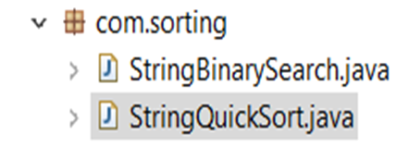

Com.sorting.StringBinarySearch.Java

\* binarySearch Method is used to find whether the given file is exist in the given list or not. Used binary search technique(i.e by finding the mid Index and comparing).

Com.Sorting.StringQuickSort.Java

\* Swap Method is used to swap the files in the given List.

\* quickSort method is used to sort the given array List in either ascending order or descending order depending on the ordering input.

\* listPartitionDescending Method is used to partition the given list by finding the pivot element and helps to arrange the list in descending order.

\* listPartitionAscending Method is used to partition the given list by finding the pivot element and helps to arrange the list in ascending order.