*Project Opening Page*

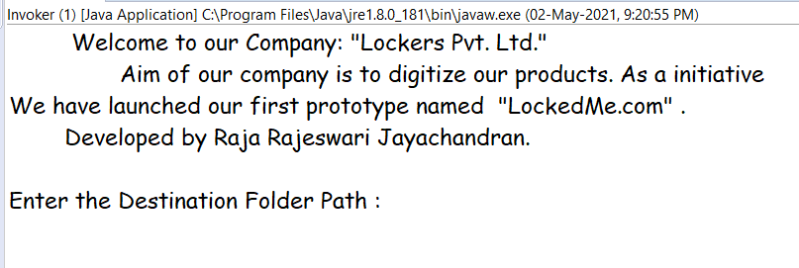

Entered a None Exist Folder Name and Got Directory not exist message and asked for a valid folder path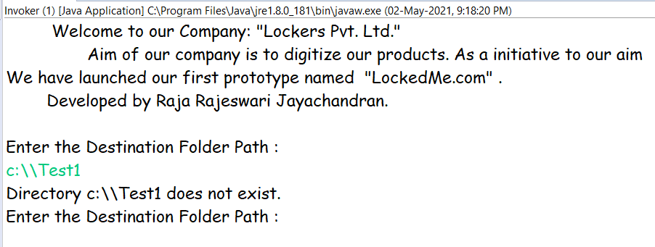

Again entered a Non exist directory path and a same message.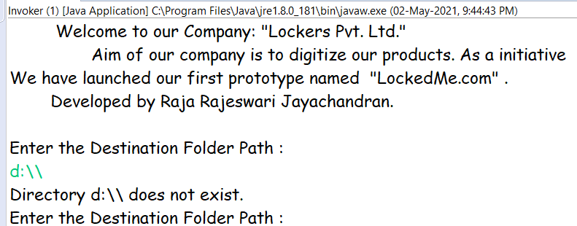

Entered Invalid Folder Path, so system doesn’t accept that input. It asks for the Valid Folder Path.

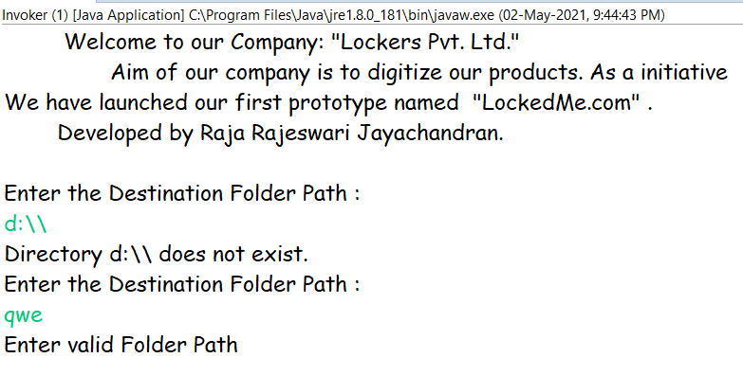

Entered Valid Path and it enters into the Main Menu.

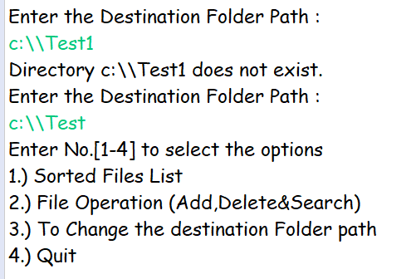

Entered into the sub–Menu Sorted Files List by typing the option 1.

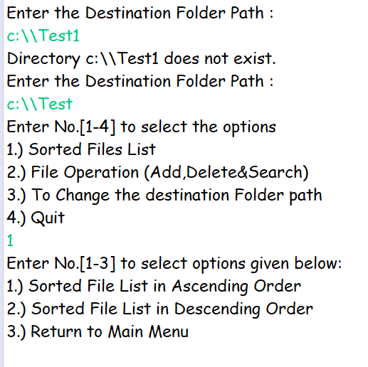

Again Entered 1 to sort in ascending order. As it is an Empty Folder, it displays the Folder is Empty.Goes back to Sorted Files List Menu.

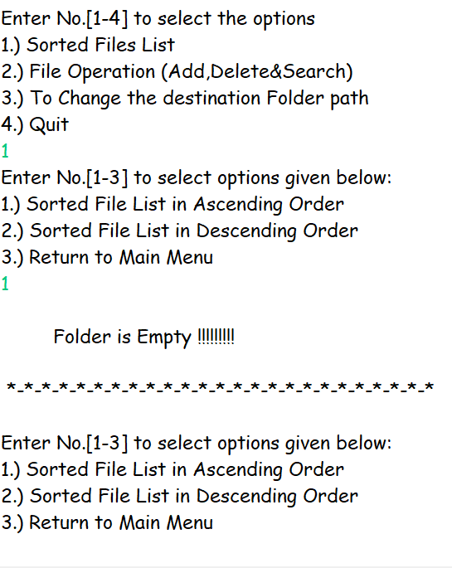

Entered 3 to Return to the Main Menu.

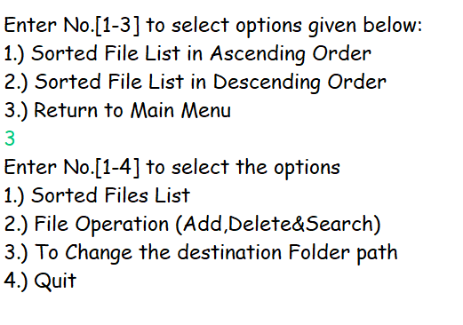

Entered Value 2 to enter into File Operation sub menu.

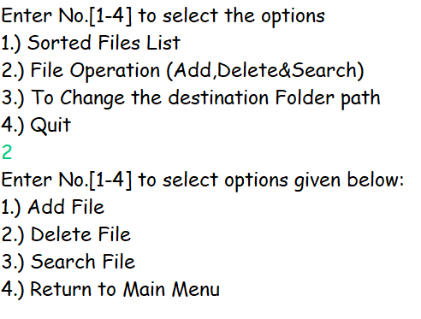

Entered value 1 to Add File. It ask for the File Name and create it successfully and ask the user whether to open the created file or not.

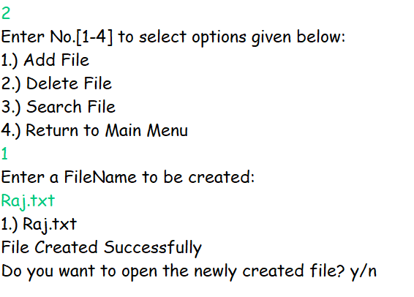

Gave y for yes and .txt file is opened .

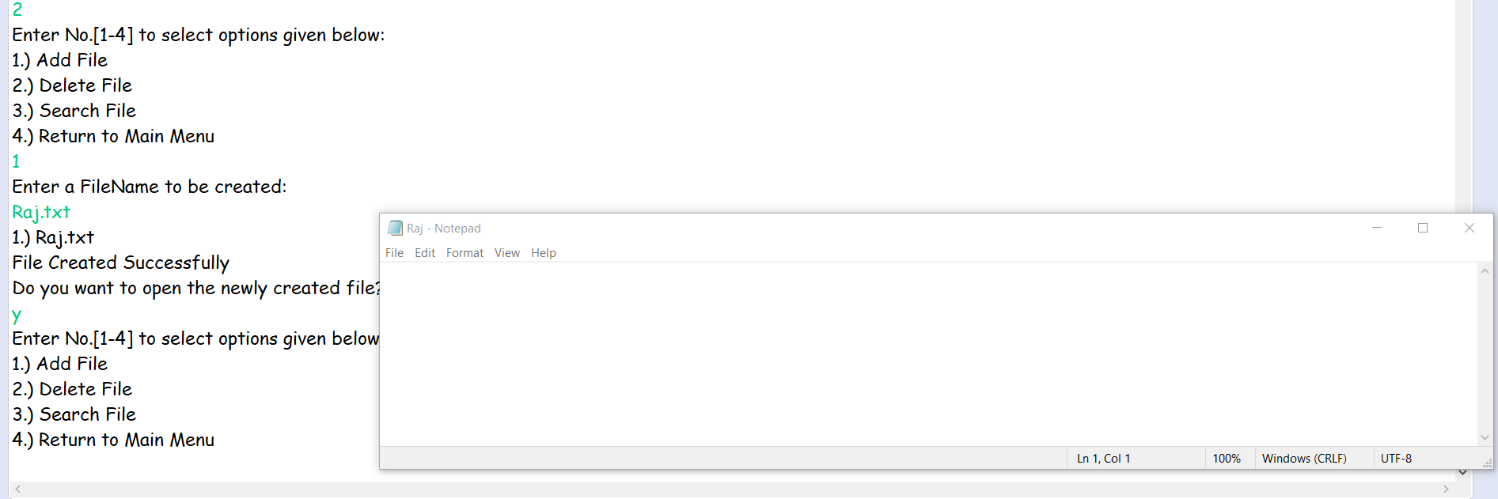

When we give a filename to addFile,deleteFile or searchFile. It verifies whether the given name is valid or not.

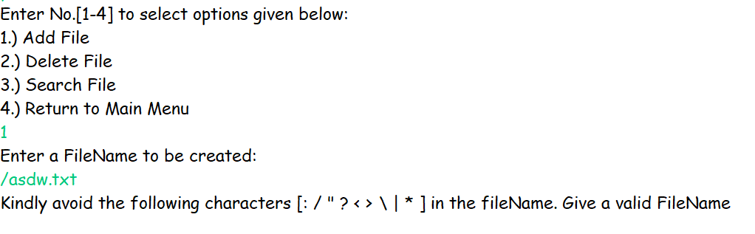

Once when Files are added. Again, went back to the sorting and got the sorted list in both Ascending and Descending Order by giving the respecting option No.

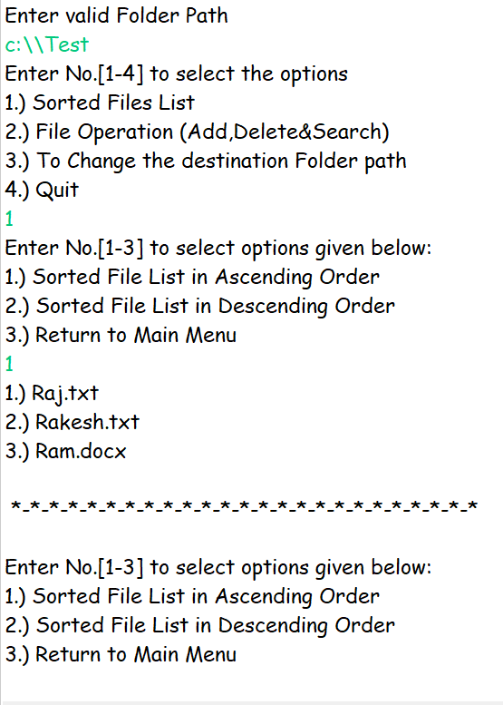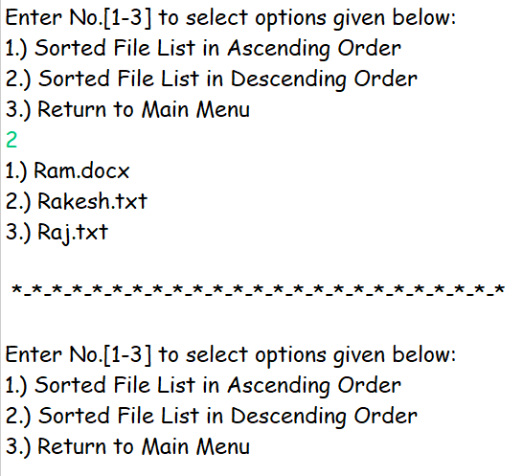

Again went back to the main Menu and went inside the File Operation menu to search for a file. First gave a filename which does not exist and then entered a existing File Name. Here I have Used Binary Searching technique. Once the file name is found, it ask whether to open the searched File or not.

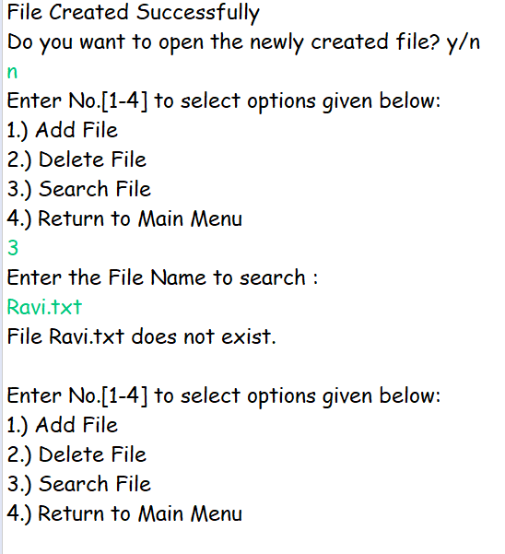 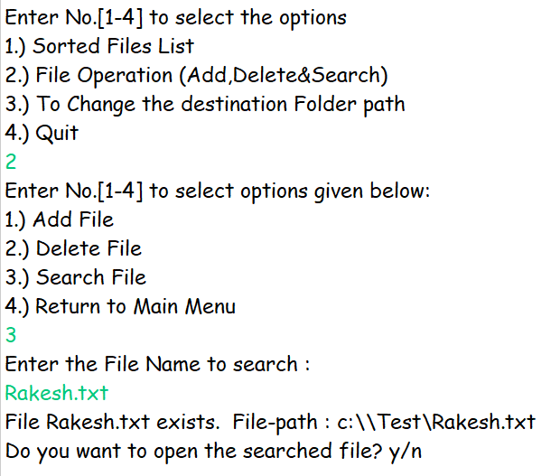

Next selected the delete option and gave a file name which is not exist. When File doesn’t exist it ask the user whether to go to previous menu or delete File option itself.

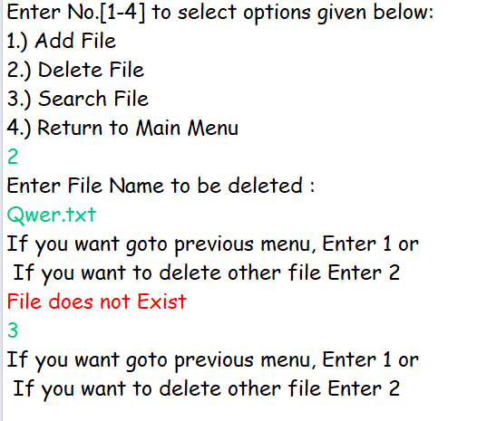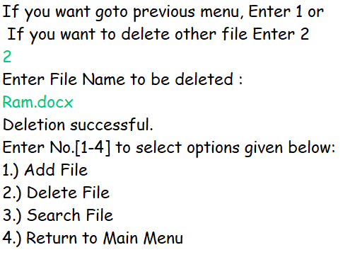

Again Searched for the deleted file Ram.docx and got file doesn’t exist message. 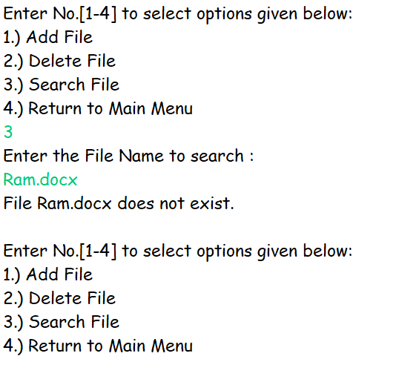

Now below picture shows the sorted file List after file deletion ”Ram.docx”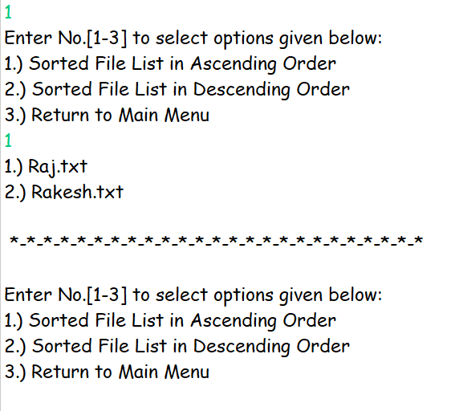

Now Entered the 3rd option in the main menu to change the destination Folder Path.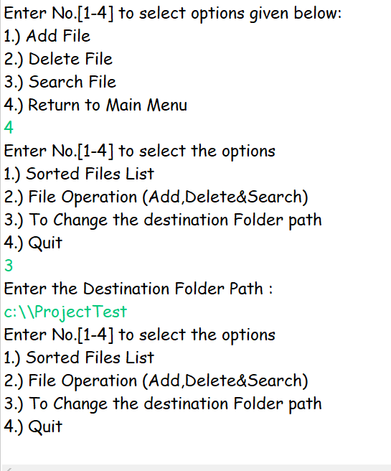

Finally Entered option 4 to Quit the application.

