HomePage URL: http://localhost:4200

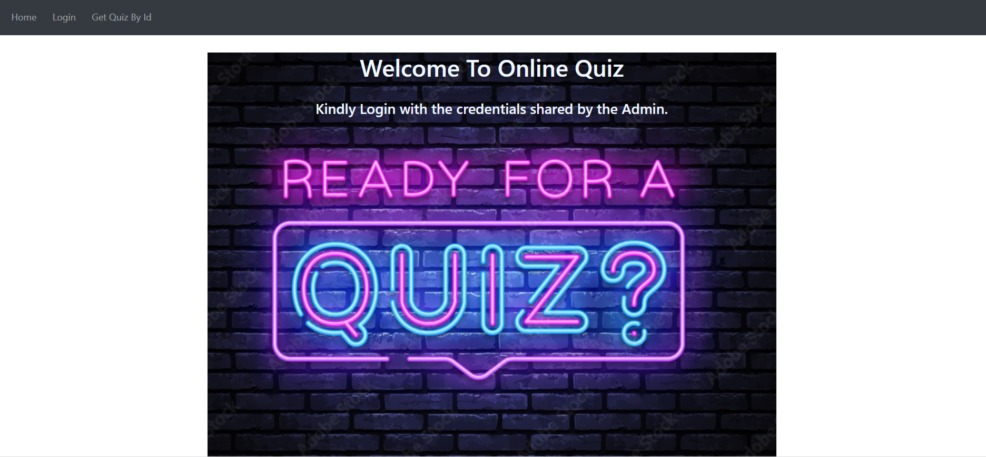

Click Login Link to login to the page

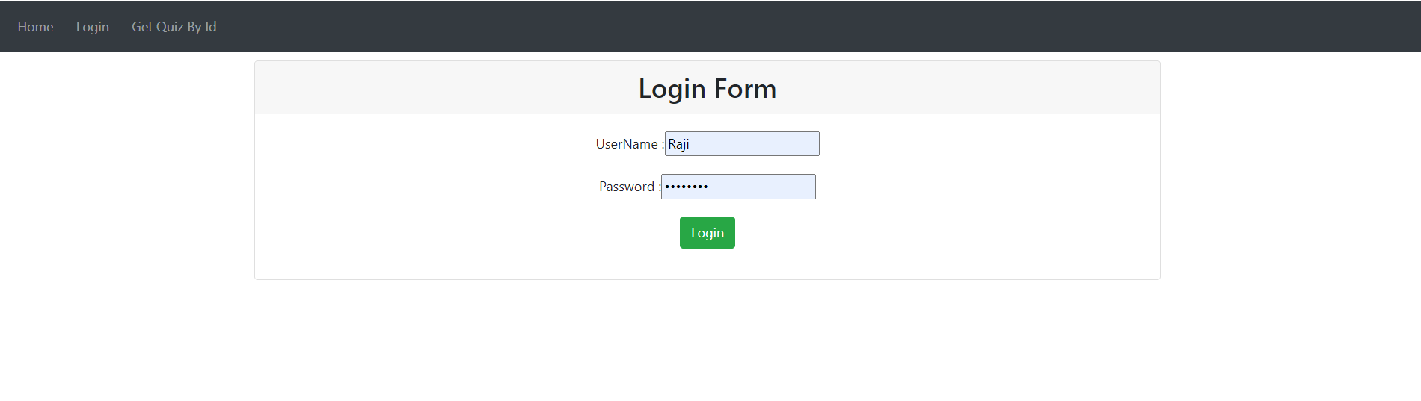

On Entering Valid User Details it navigates to the get Quiz by Id page

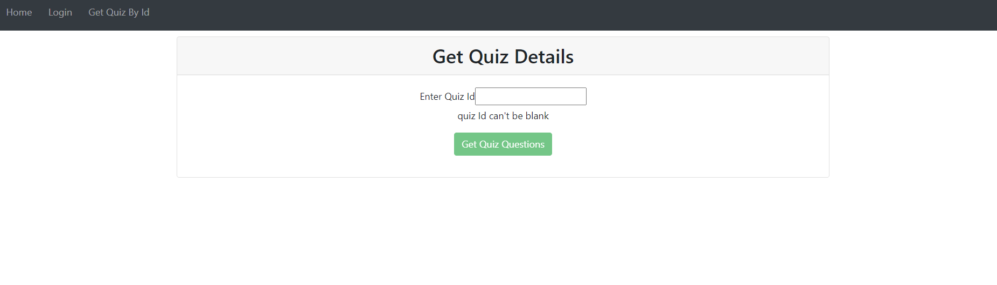

On Entering Valid Quiz ID it navigates to the Quiz page

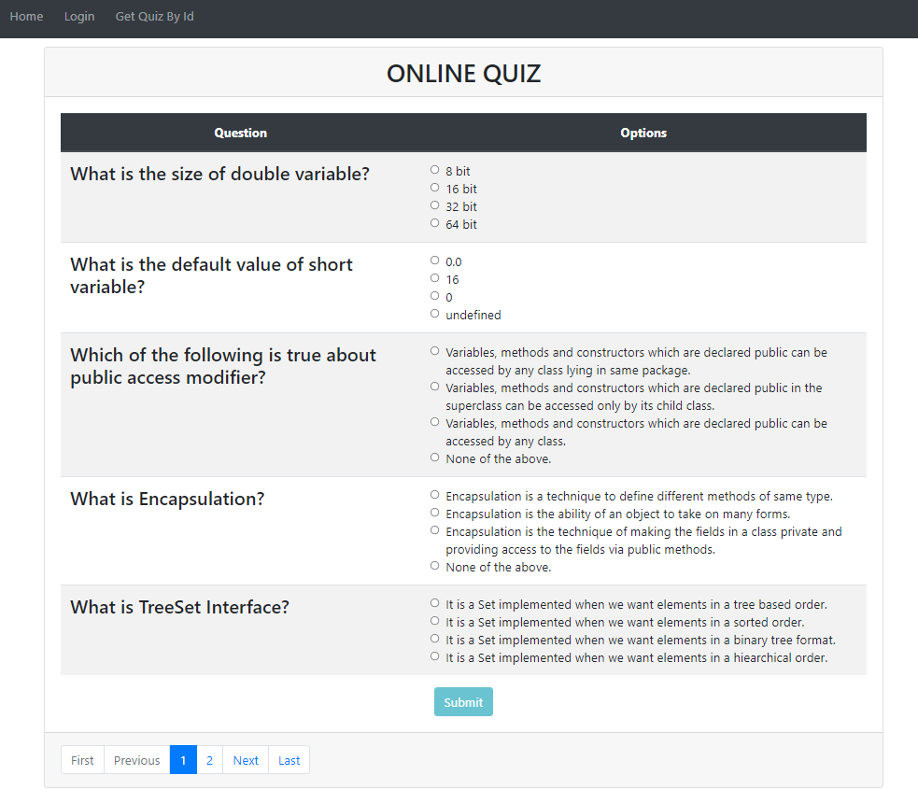

Input Validations are handled by alerting the user with the appropriate message. Handled Invalid Login credentials too.

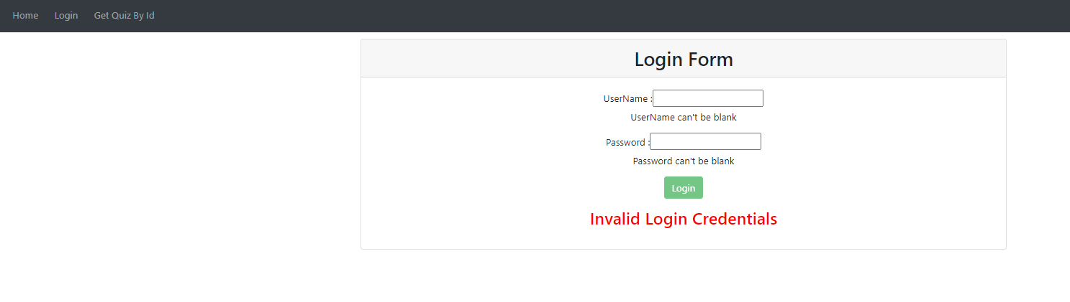

Invalid Quiz-id Validation is handled in the getQuiz Page

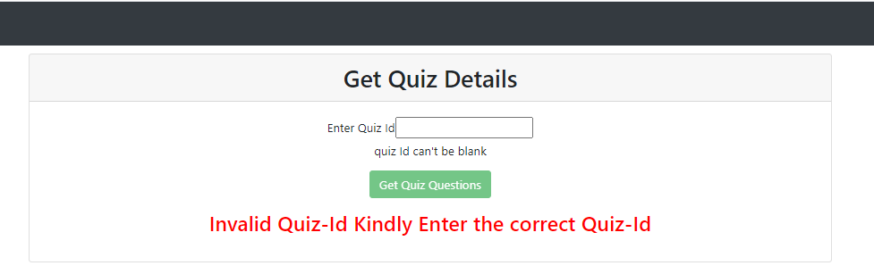

Submit button will be in disabled state till the user answers all the quiz question.

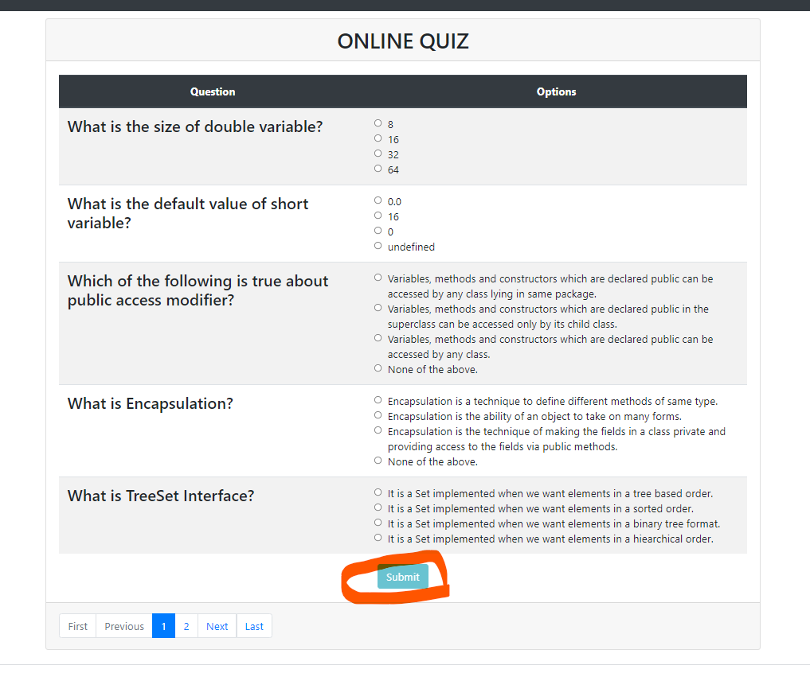

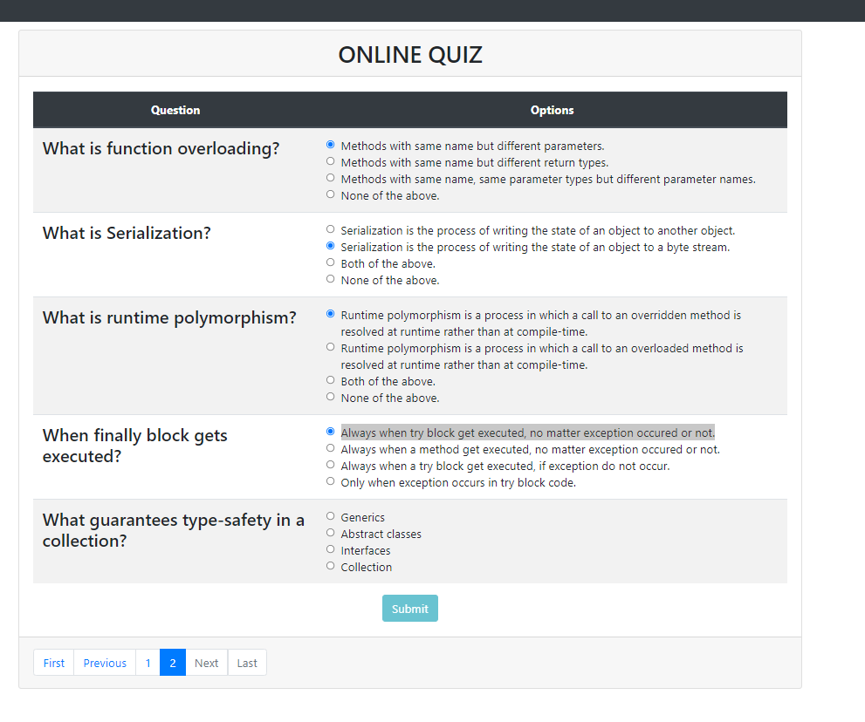

Now the submit button is enabled as all the question are answered

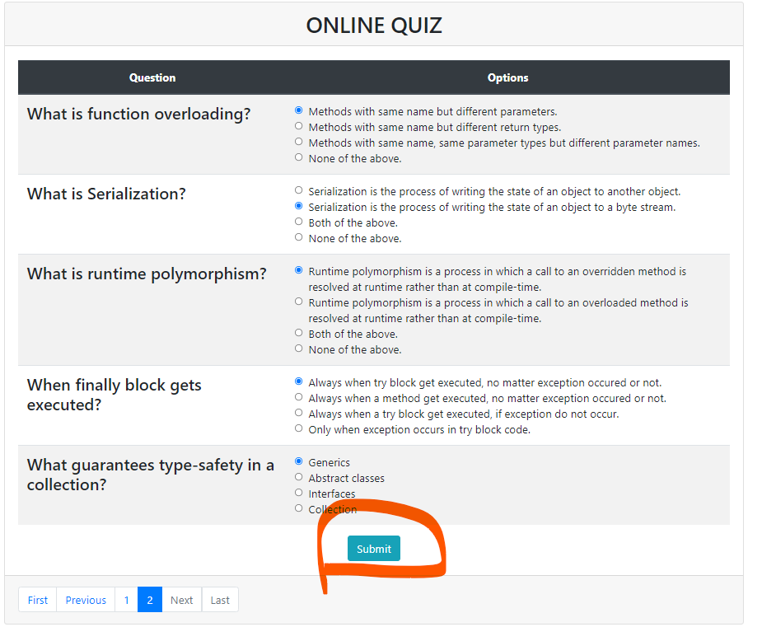

Once the user click submit button, the result is displayed with the answers.

