HomePage URL: <http://localhost:8188/FlightTicketBooking/HomePage.jsp>

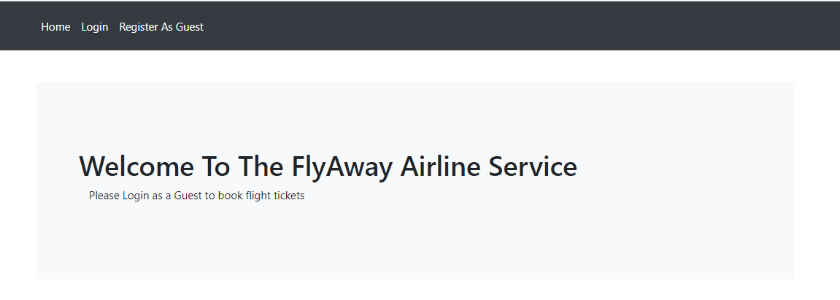

**Registering New User as Guest:**

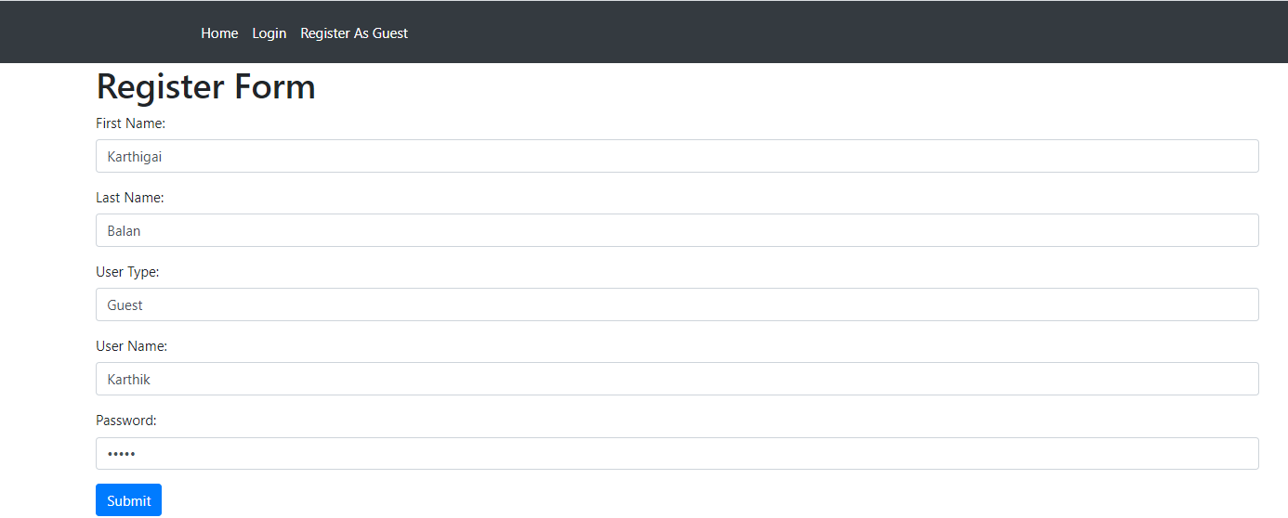

**Directs To Login Page:**

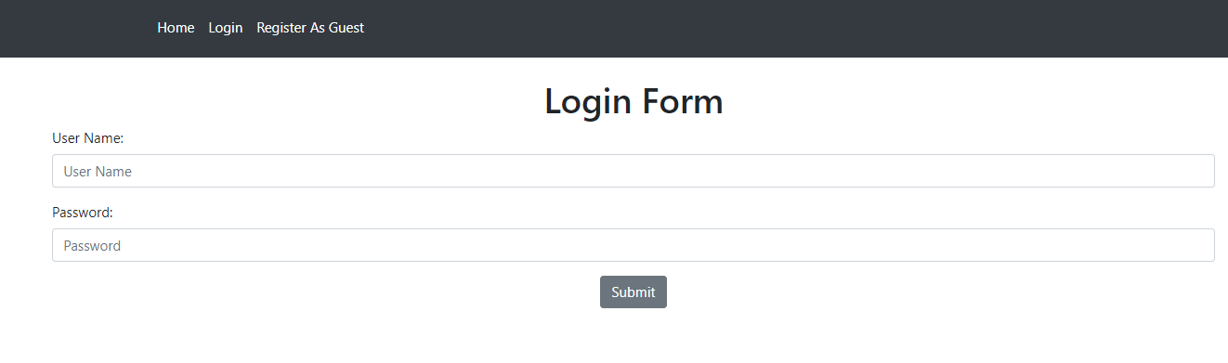

Logged in As User. So Redirected to the UserMenu

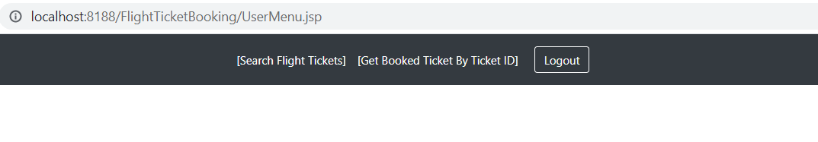

SearchForm Page

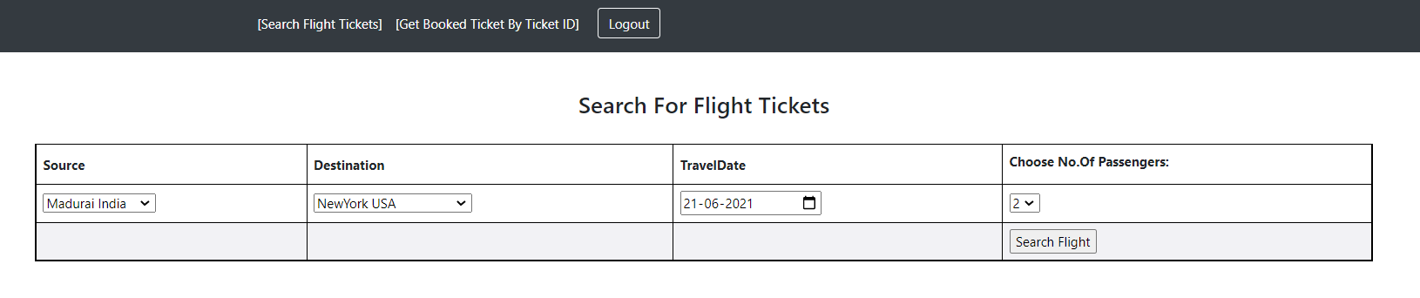

Redirects to SearchResult Page:

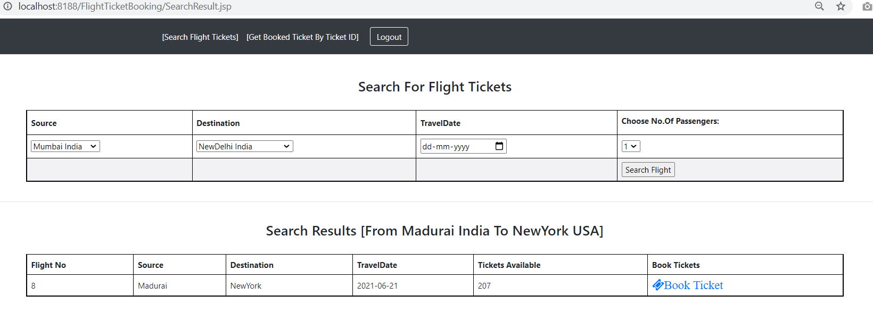

By Booking Confirmation redirects to BookTicket Jsp

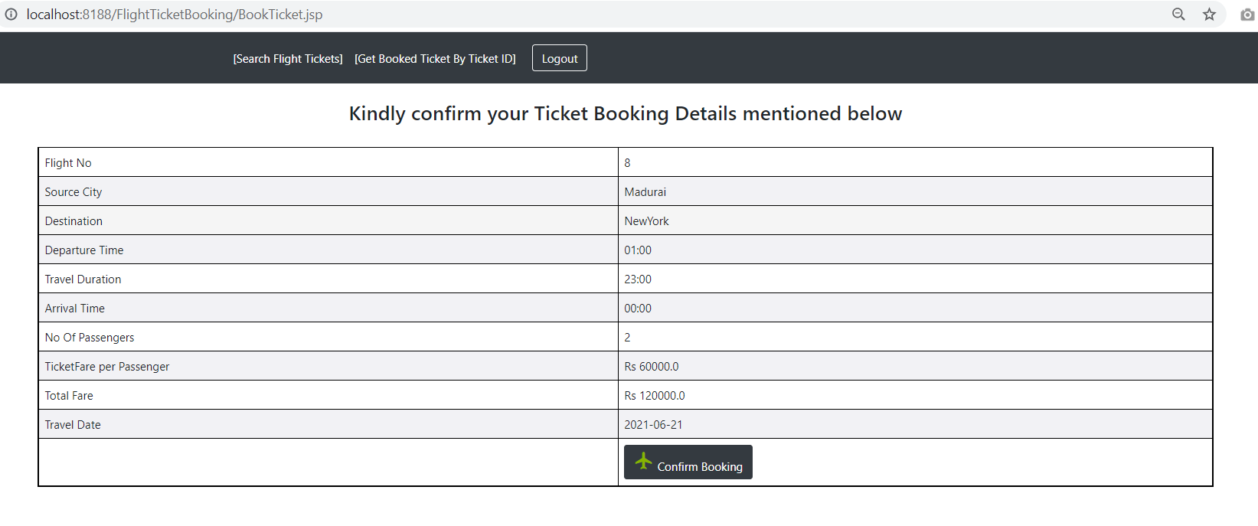

After Confirming gets the passengers detail:

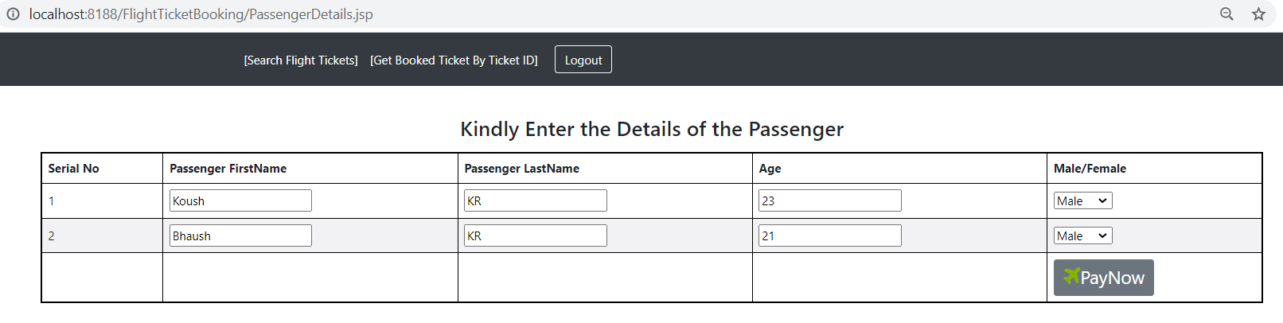

Then Enters the dummy credit card payment site:

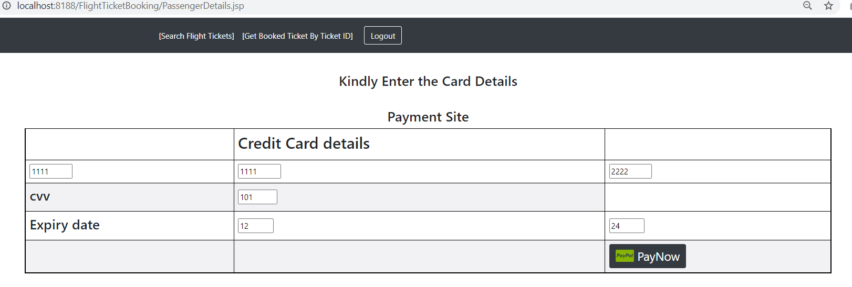

After clicking PayNow ticket gets booked and directs to the Ticket.jsp

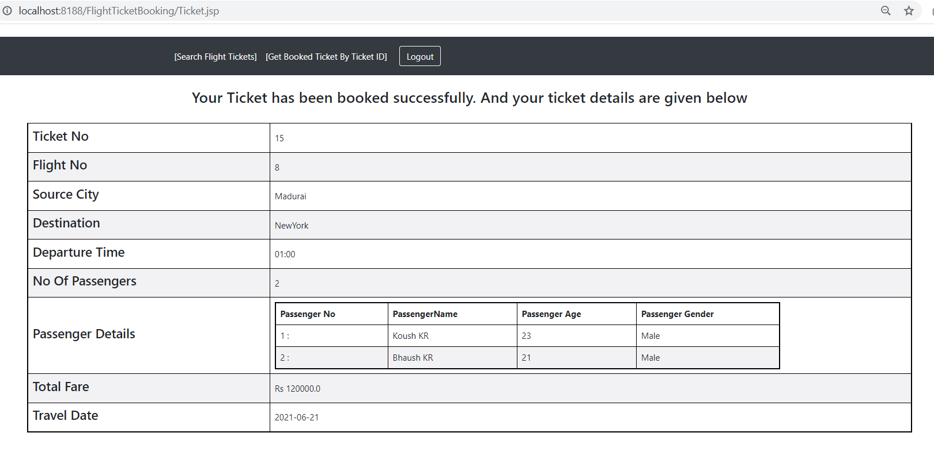

To Get the booked ticket detail Click the Get Booked ticket by Ticket Id link in the menu bar

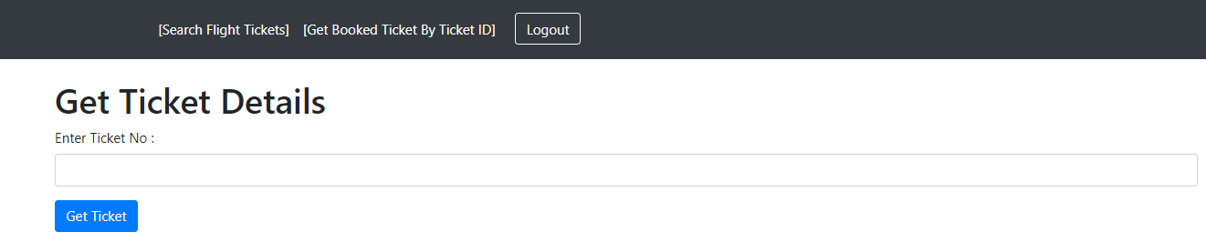

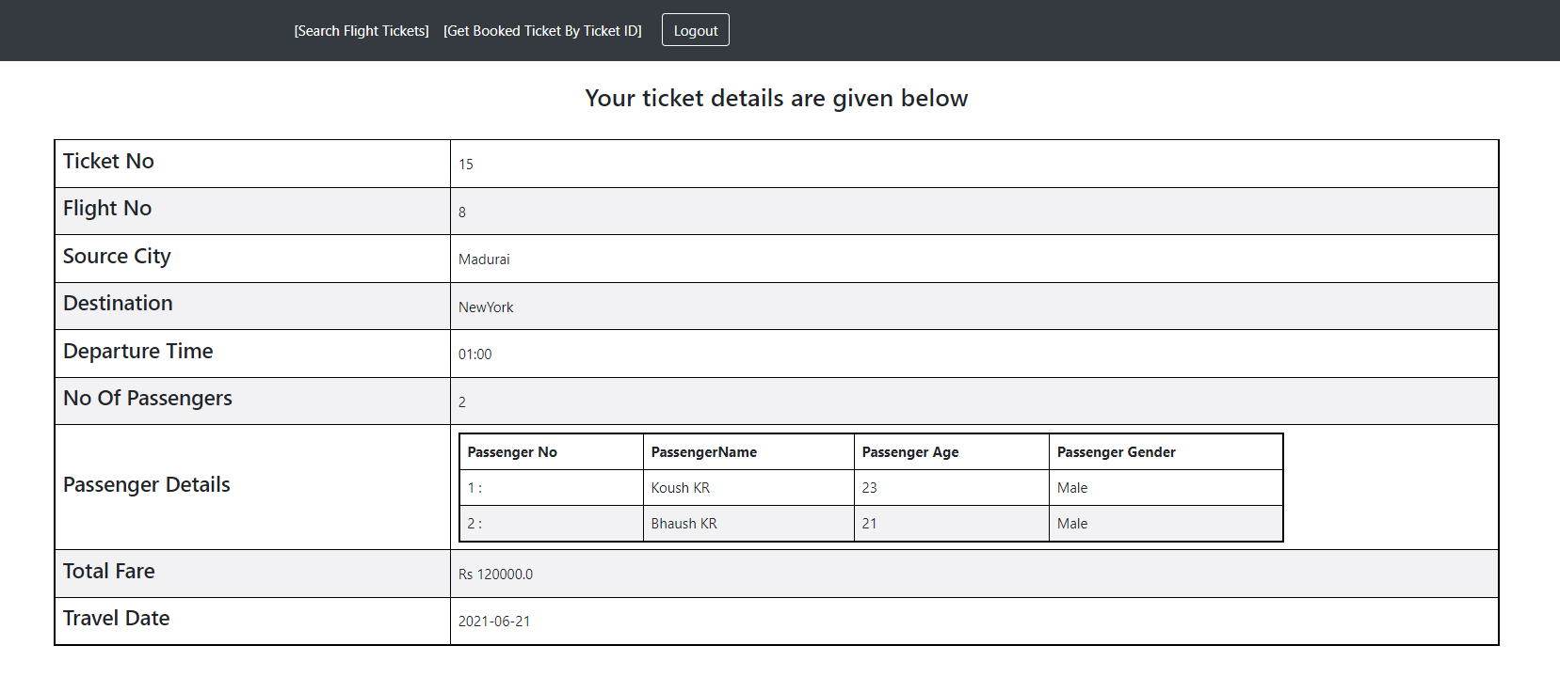

To Enter as a Admin. First need to create one admin login credentials in the backend. As the Admin user registration is available inside the admin session.

Logging in as a Admin

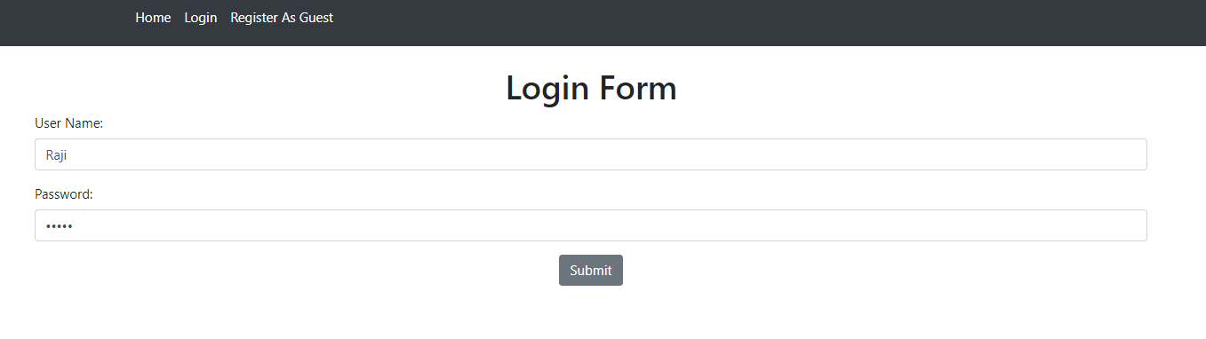

Redirects to AdminMenu

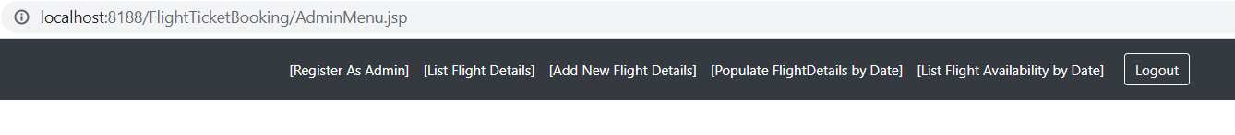

Admin User Registration

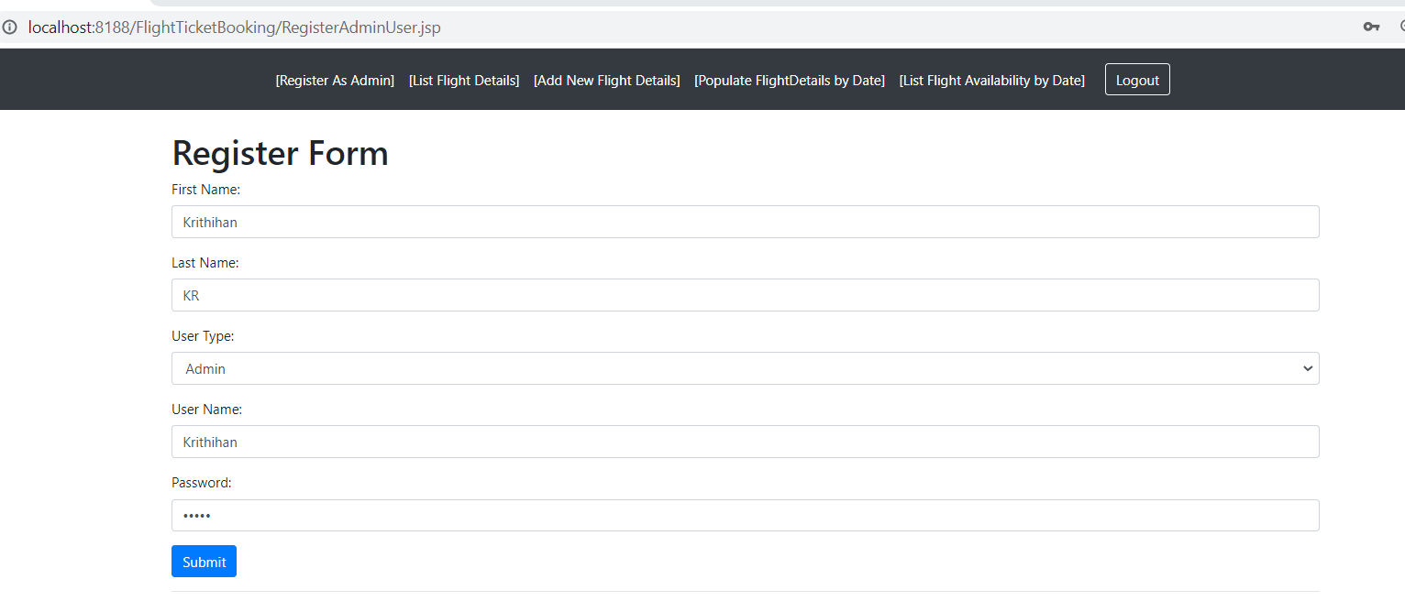

On successful registration redirects to Login Form

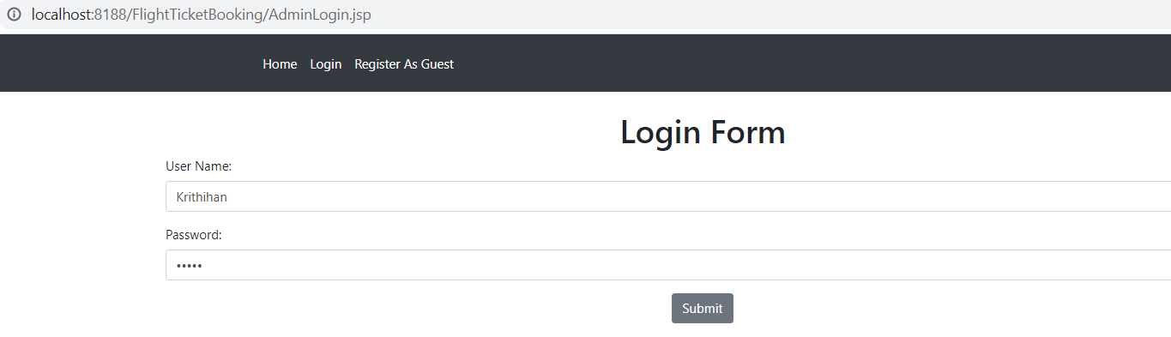

List Flight Detail Link list the flightDetails:

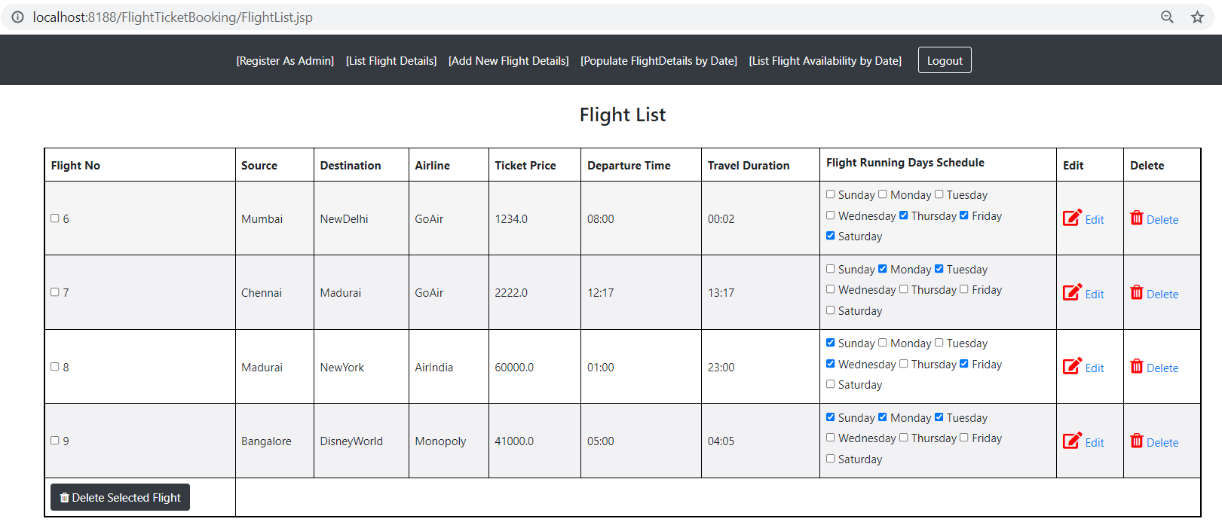

On clicking edit redirects to editFlightdetail page:

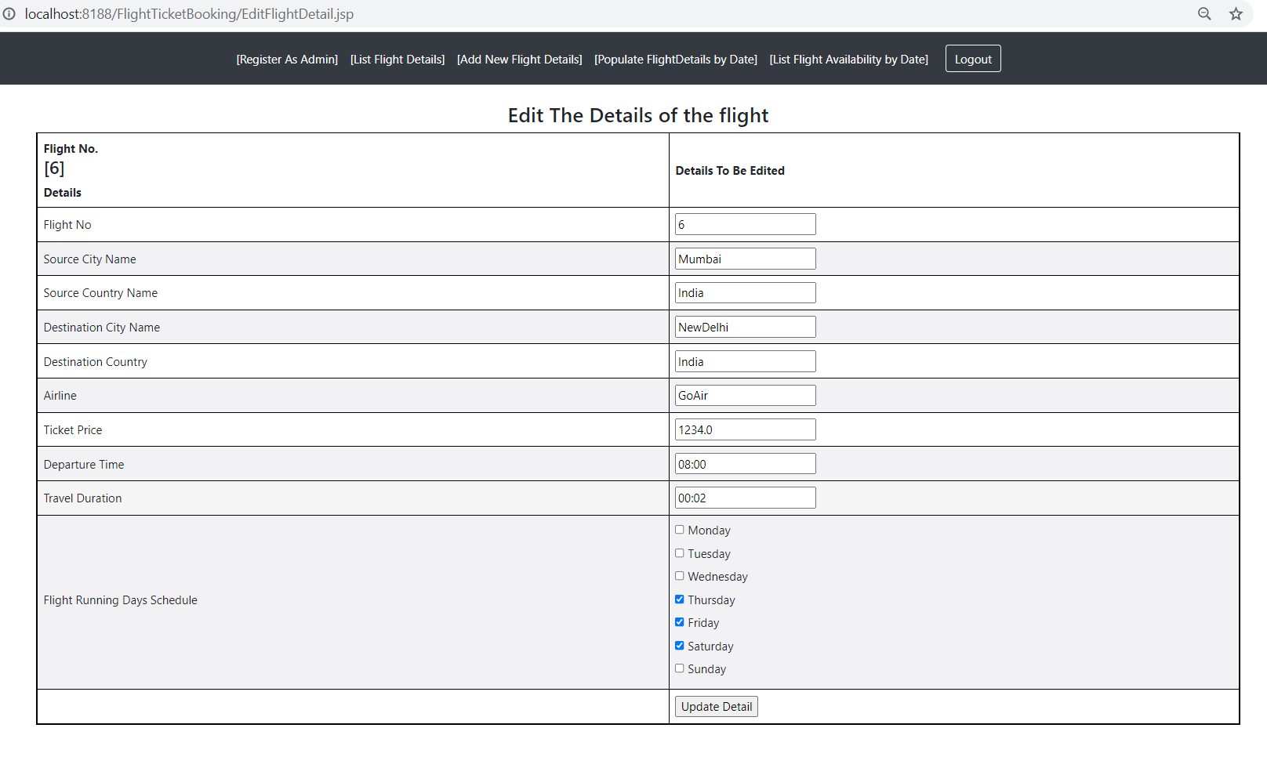

On successful updation :

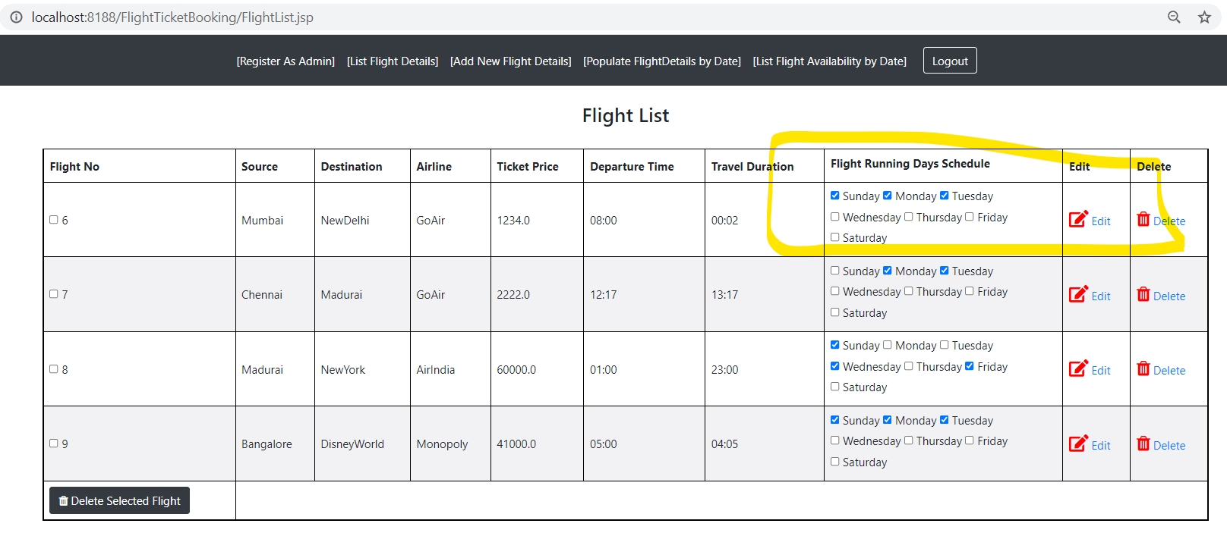

List Flight Tickets Available by Date by clicking the link [List FlightAvailability by Date]

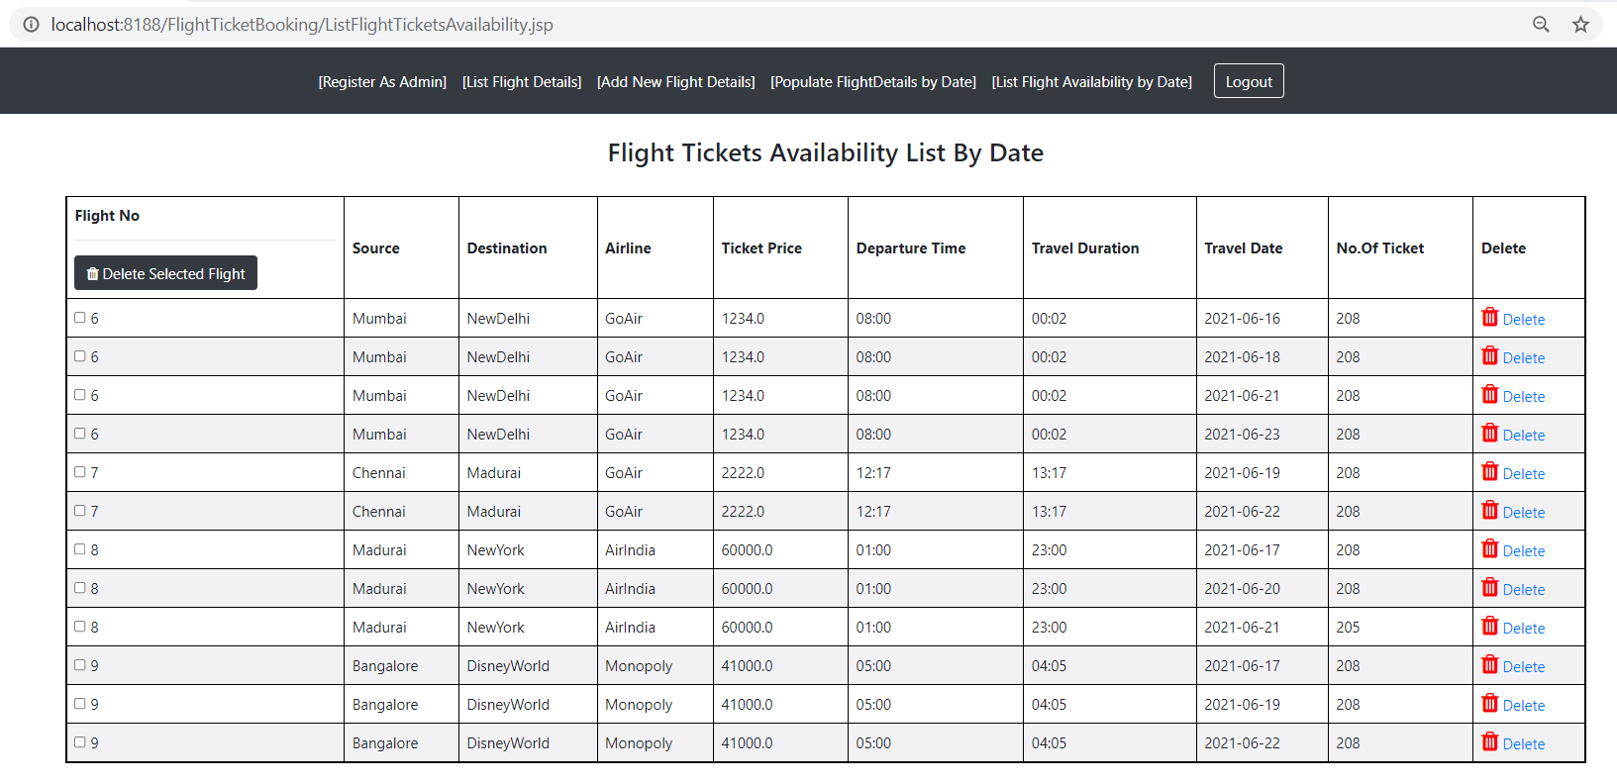

First record deleted by clicking delete link

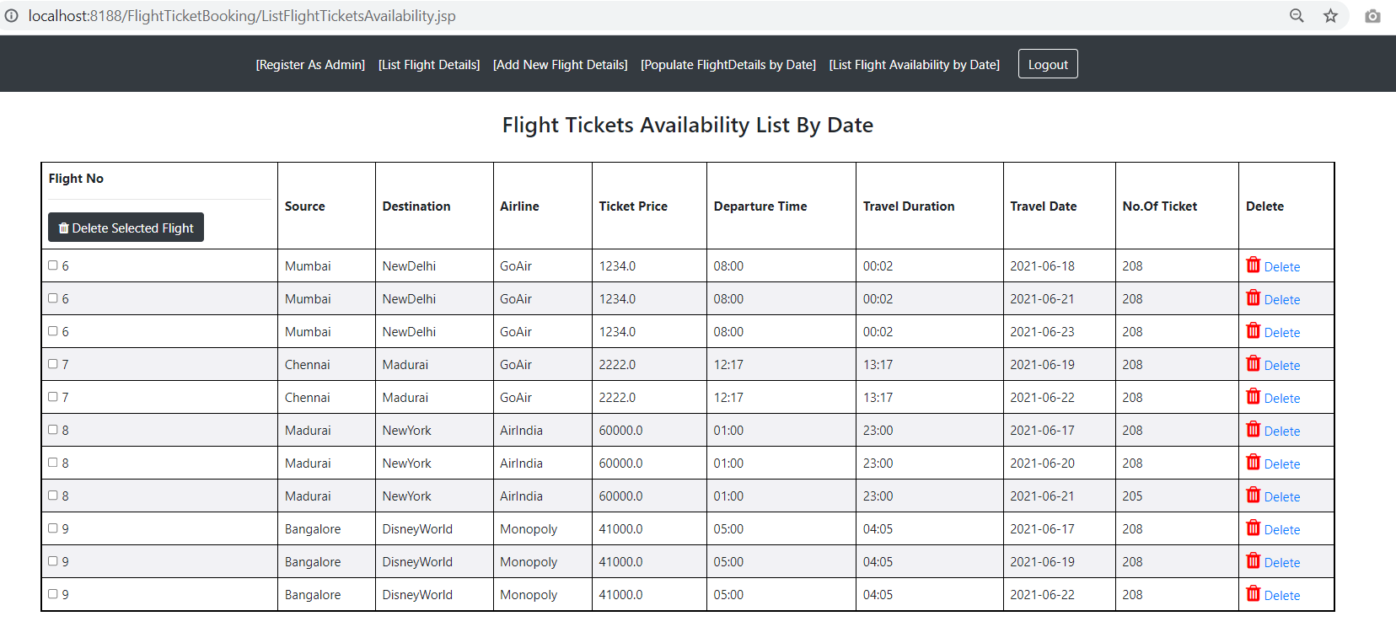

To Populating the flight tickets from the available data click the link[Populate flight Details by date]

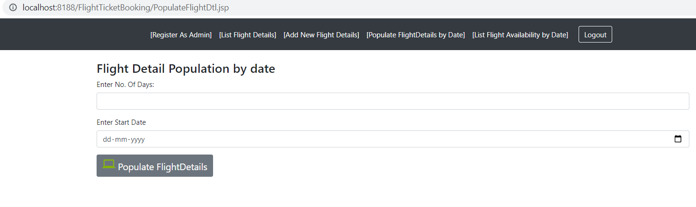

After Populating the Details

