**CI/CD Deployment for Springboot Application**

**GitURL: https://github.com/RajaRajeswari12/Phase5CICD.git**

**Steps to create AWS EC2 Instance:**

1. Click EC2 in the Aws page.
2. Click **LaunchInstance**. Select **Ubuntu Server 18.04 LTS (HVM), SSD Volume Type** - ami-0747bdcabd34c712a (64-bit x86) / ami-08353a25e80beea3e (64-bit Arm).
3. Select t2 Micro. Click Next
4. In Step 5 Add Tags. Click Add Tag and give name for that EC2 Instance.

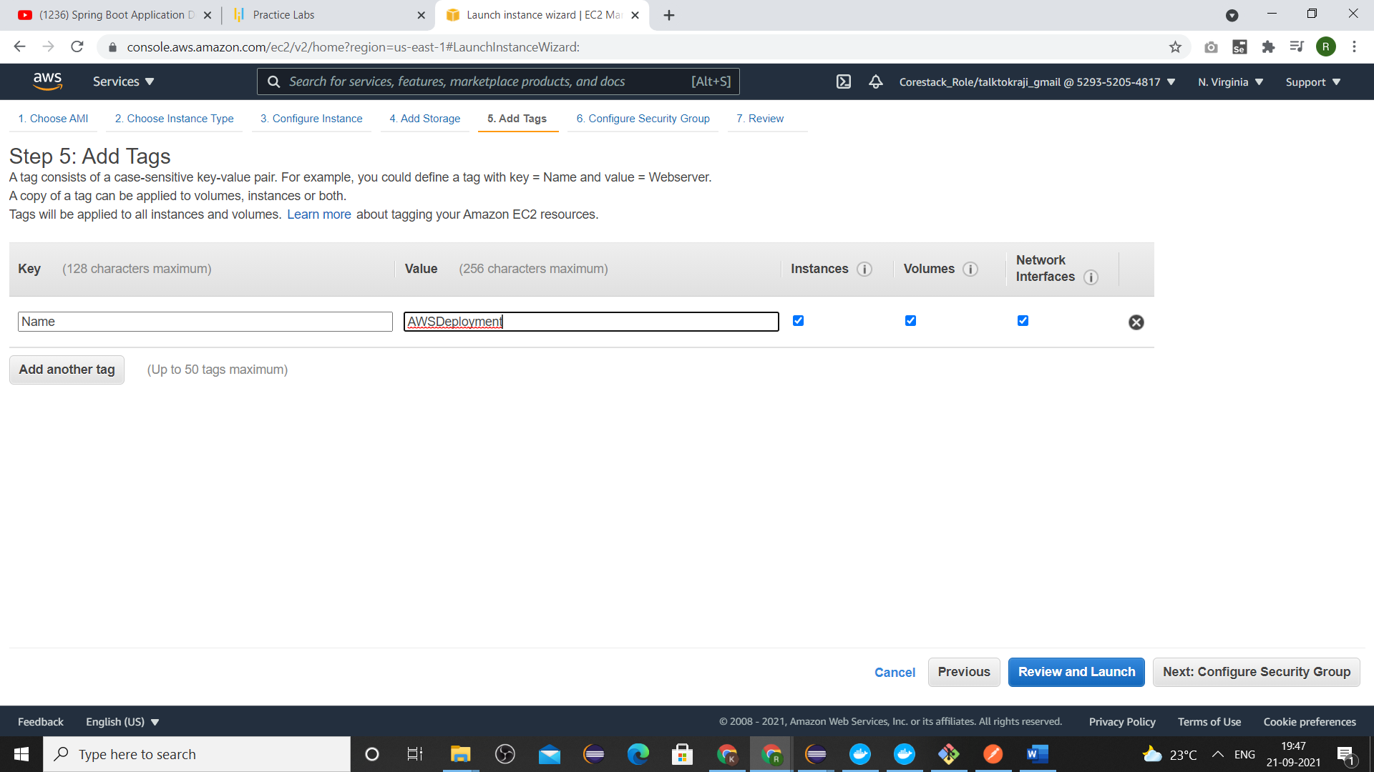

1. In the Step6: Configure Security Group. Select All Traffic from the Type drop down. And anywhere from the source drop down.

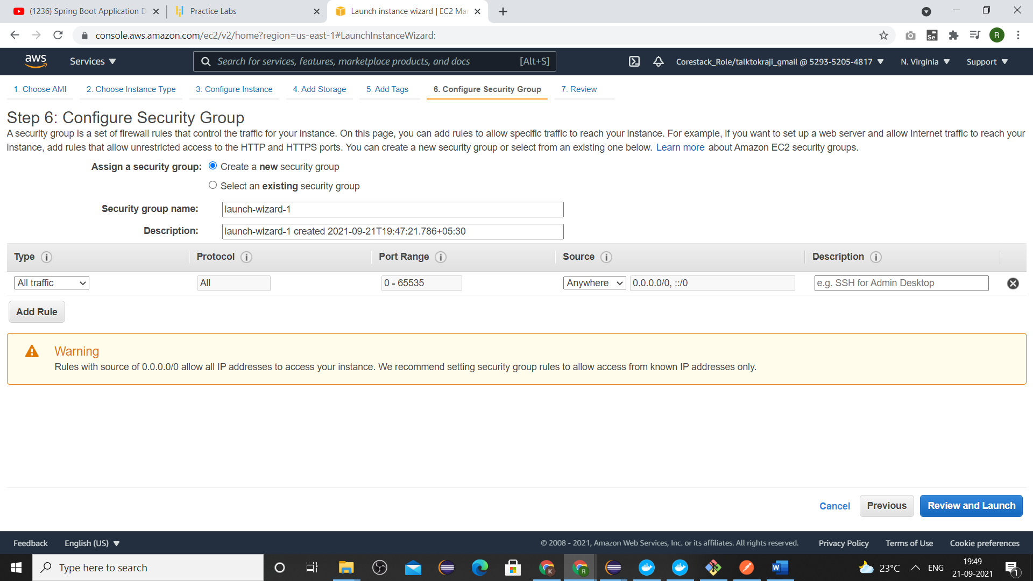

1. Click Review and Launch Button. Then again Click Launch Button.
2. The Below page is displayed
3. 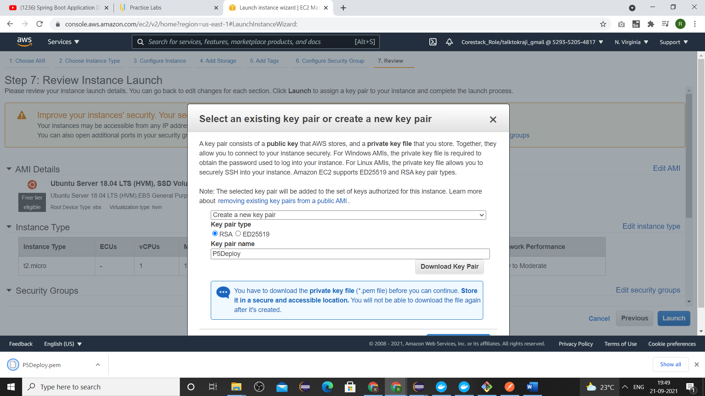
4. Select create a new key pair, give a name and click Download Key Pair. Then Click Launch Instances button to launch the Ec2 Instance.
5. In the desktop. Select puttyGen to generate the keys .
6. Use putty to connect to that EC2 instances.
7. Type the following commands to update and install docker.
   1. **Sudo apt-get update**
   2. **Sudo apt-get install docker.io**
8. Type the following command to configure mysql in aws Ec2 Instance.
   1. **sudo docker run --name mysql-standalone -e MYSQL_ROOT_PASSWORD=password -e MYSQL_DATABASE=sldb -e MYSQL_USER=sa -e MYSQL_PASSWORD=password -d mysql:5.6**
9. Type **sudo docker ps** to check the running process.
10. Now go to the AWS console select s3. Create s3 bucket and load the jar file in the s3 bucket.
11. Copy the Object URL of that jar file <https://myawsdeploymentbucket.s3.amazonaws.com/users-mysql.jar>.
12. Go to the putty console and type the following command to load the jar in that Ec2 Instance.
    1. **Wget** [**https://myawsdeploymentbucket.s3.amazonaws.com/users-mysql.jar**](https://myawsdeploymentbucket.s3.amazonaws.com/users-mysql.jar)
13. Type **vi Dockerfile** – to create a docker image with the name users-mysql
    1. Inside the Dockerfile type the following commands.

**FROM openjdk:8**

**ADD users-mysql.jar users-mysql.jar**

**EXPOSE 80**

**ENTRYPOINT ["java", "-jar", "users-mysql.jar"]**

1. Type **sudo docker build . -t users-mysql** => to build the docker image.
2. Type the following command to deploy the SpringApplication
   1. **sudo docker run -p 8086:8086 --name users-mysql --link mysql-standalone:mysql users-mysql**