**GitURL: https://github.com/RajaRajeswari12/Phase5CICD.git**

AWS Console to create a new EC2 Instance

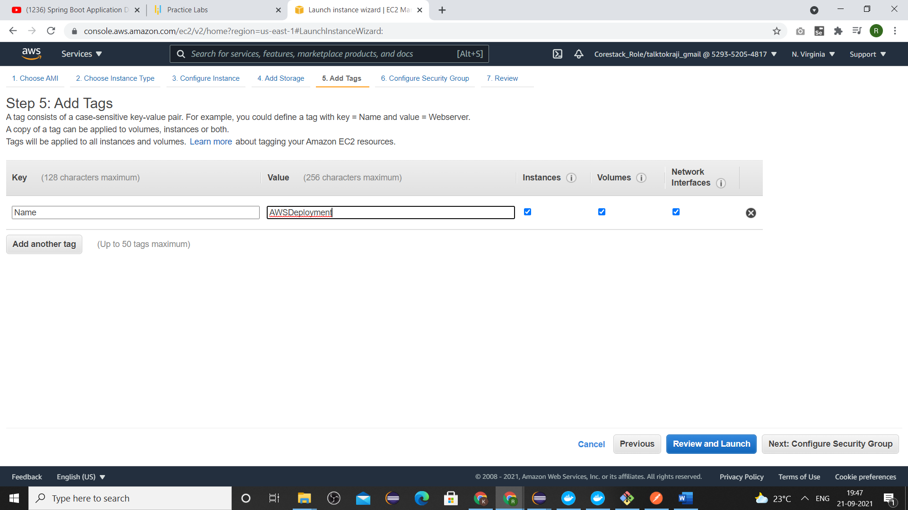

Last step in the Ec2 Instance creation

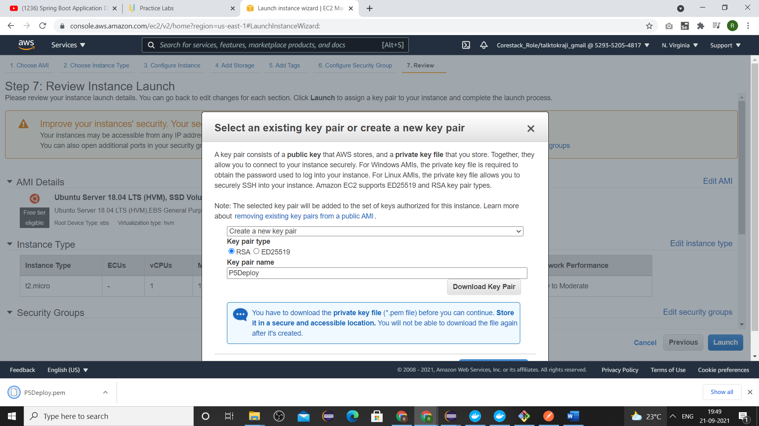

Sudo command typed in putty to load mysql instance.

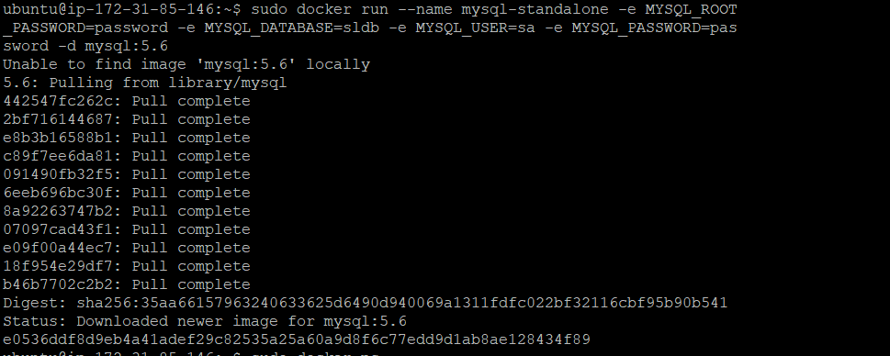

Sudo command to view the running container

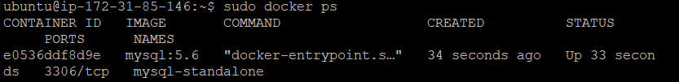

Downloading the jar file from aws s3 bucket

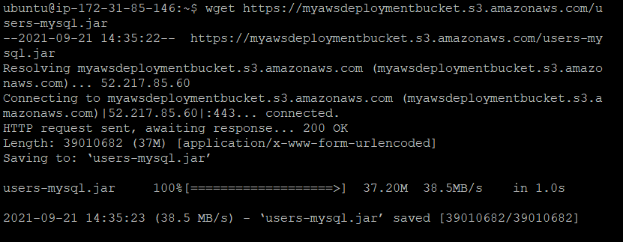

Dockerfile

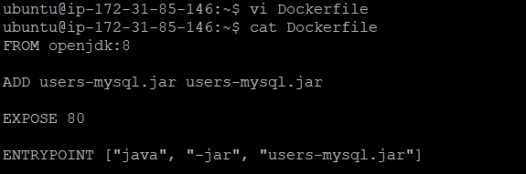

Sudo command to build the docker image

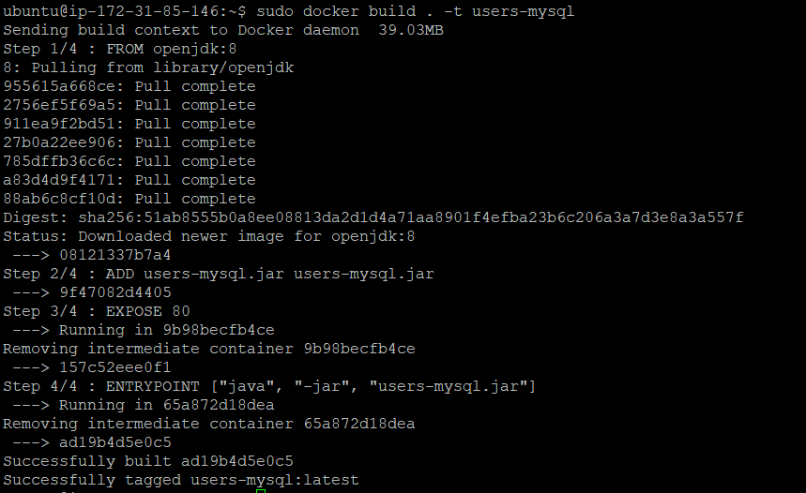

Typed sudo command to deploy the springboot app

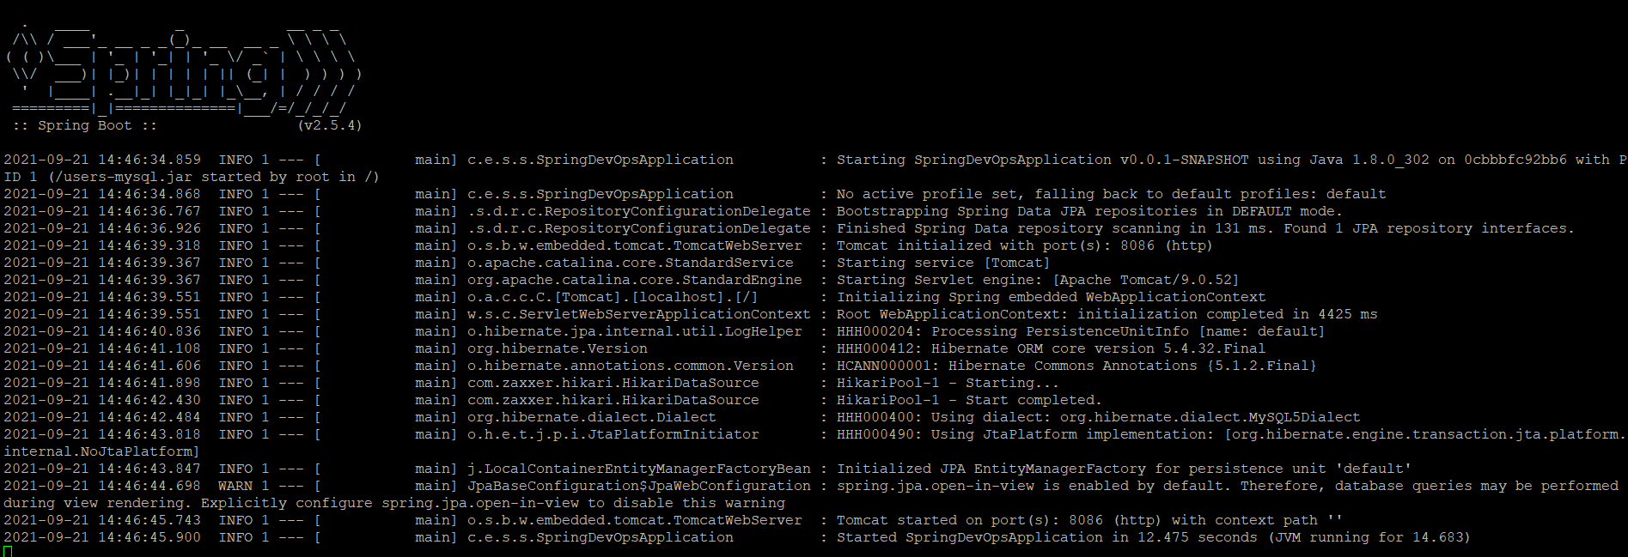

Accessed from the POSTMAN using the aws EC2 instance public IP number. And added the employee detail.

