User HomePage URL: http://localhost:8085/home

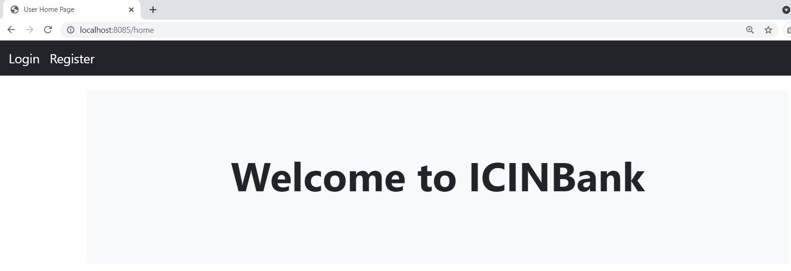

Enter into Registration Page by clicking the register link

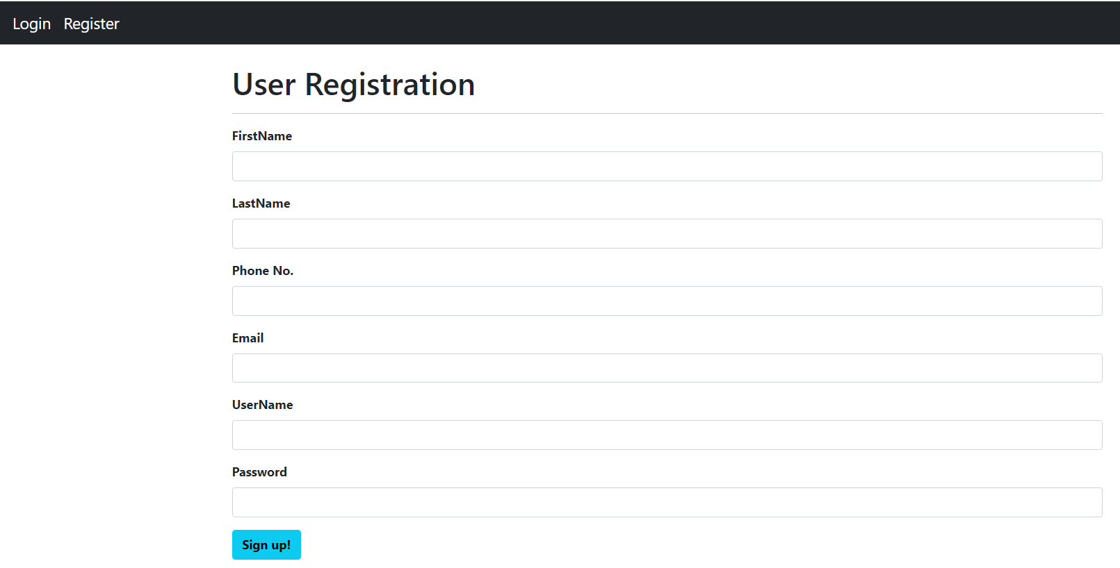

On Entering Valid User Details

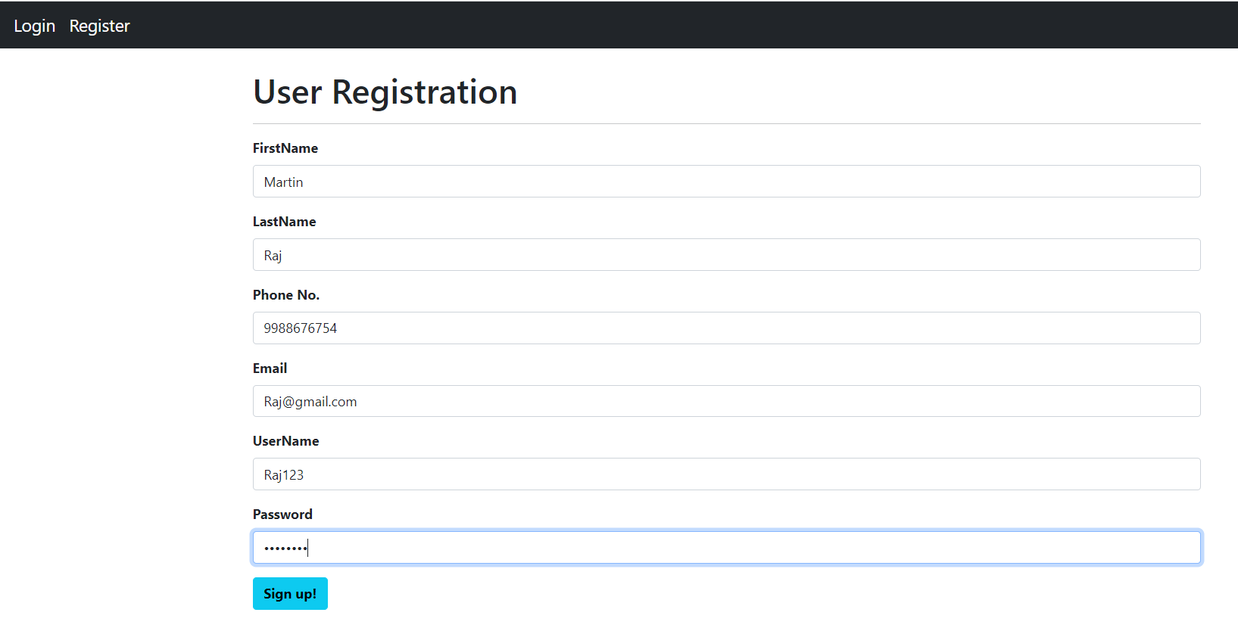

The Link navigates to the successful registration page.

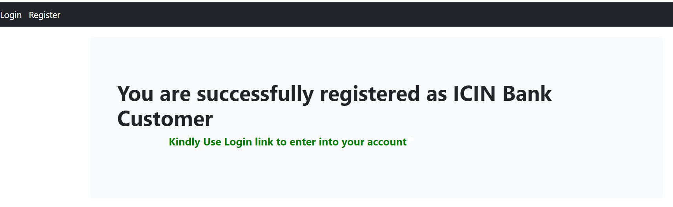

Input Validations are handled by alerting the user with the appropriate message.

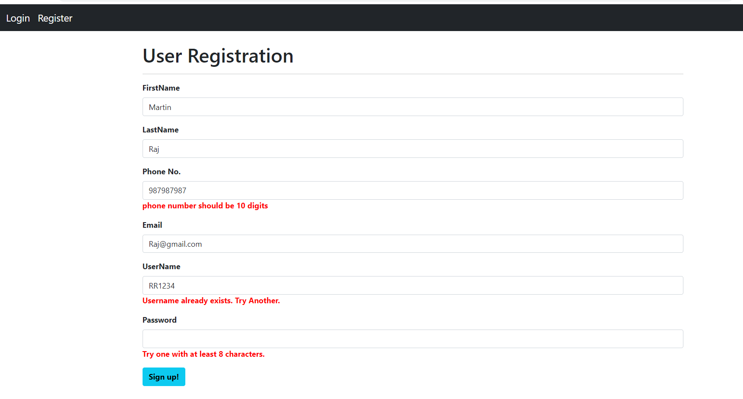

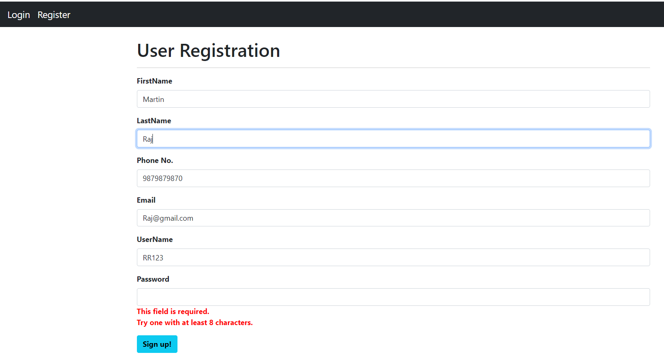

Enter into the Login Page by clicking the Login link

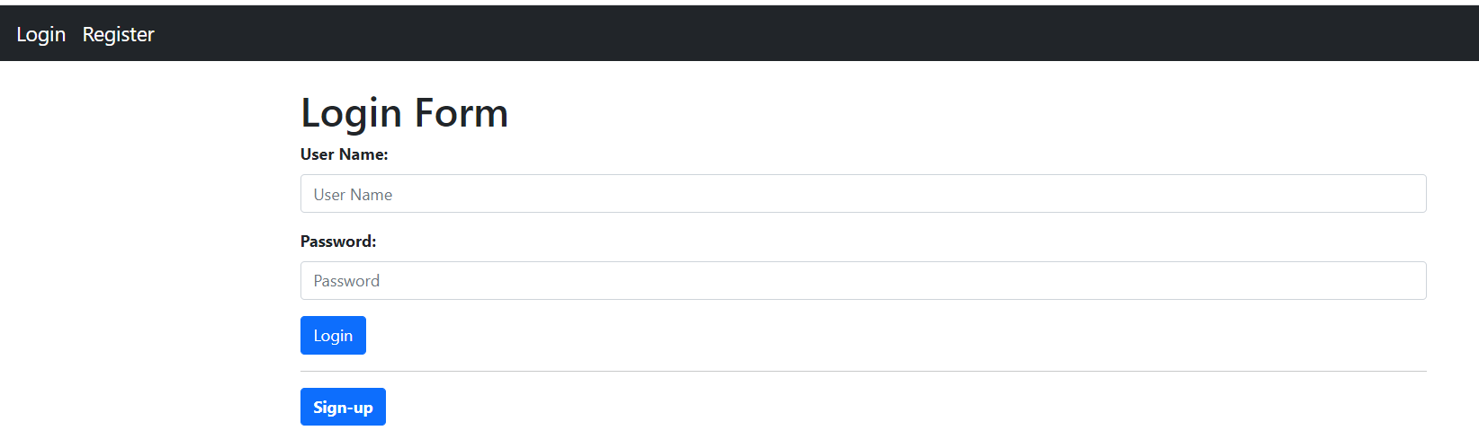

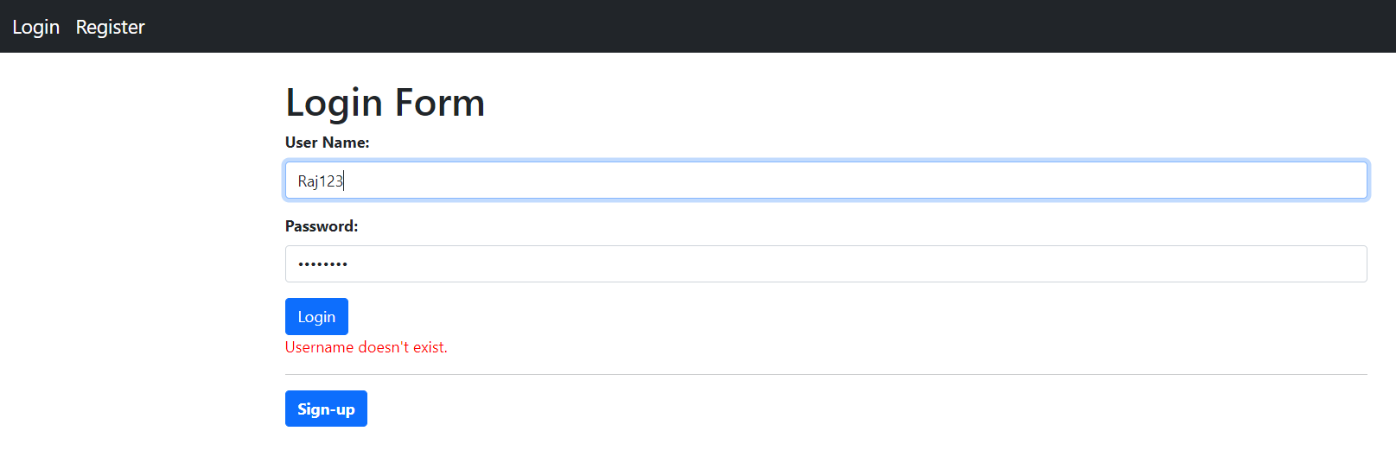

Navigates to the Welcome Home Page as shown below

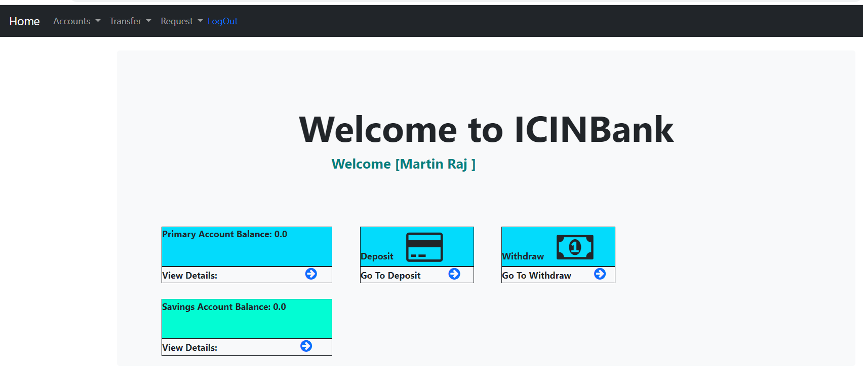

Click Profile link under the Request menu to view the Profile

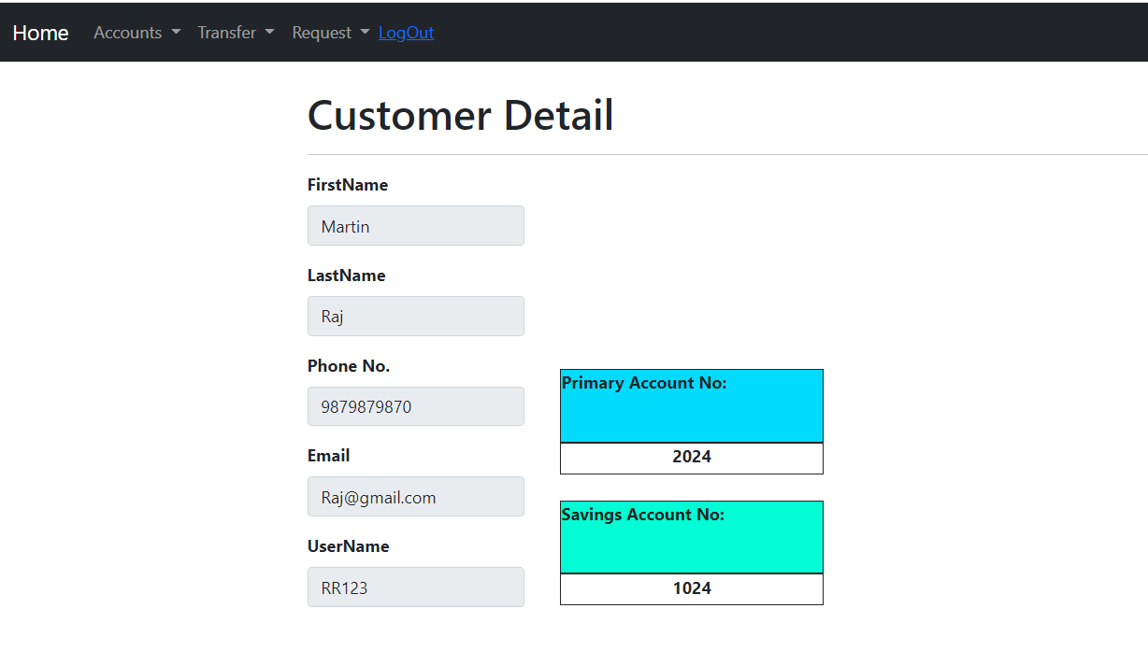

Click Cheque Book link under the Request menu to go the Cheque book request page

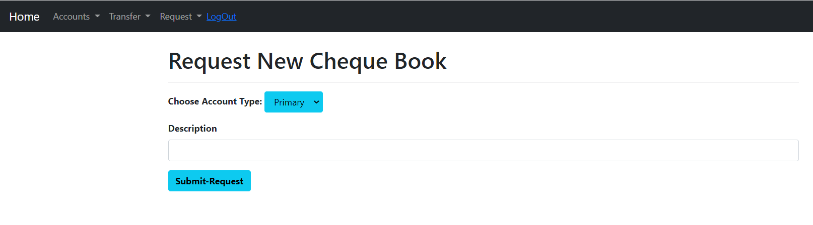

On Successfully accepting the cheque book request, the link is navigated to the home page.

Fund Transfer

Click Primary Account / Savings Account under Transfer menu to transfer fund from one account to another

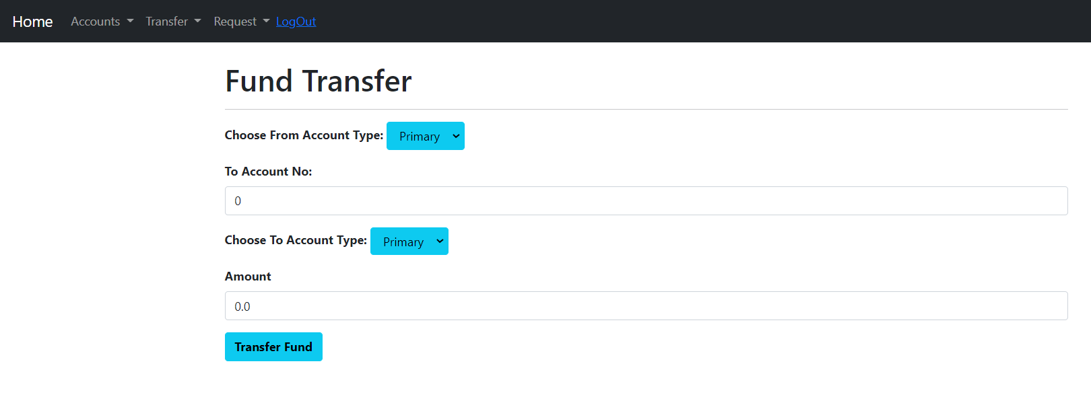

Fund Transfer Page Validations

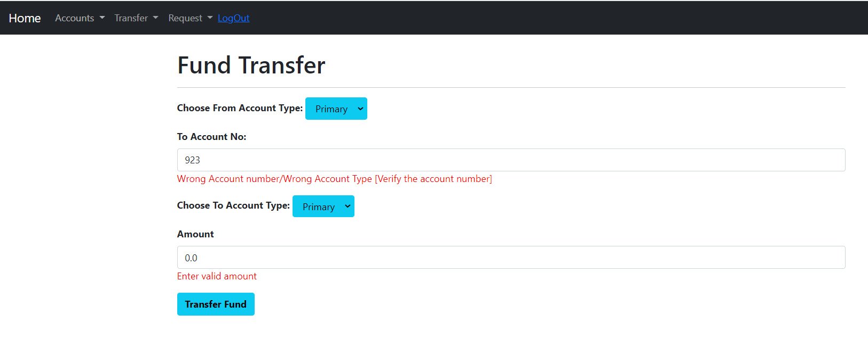

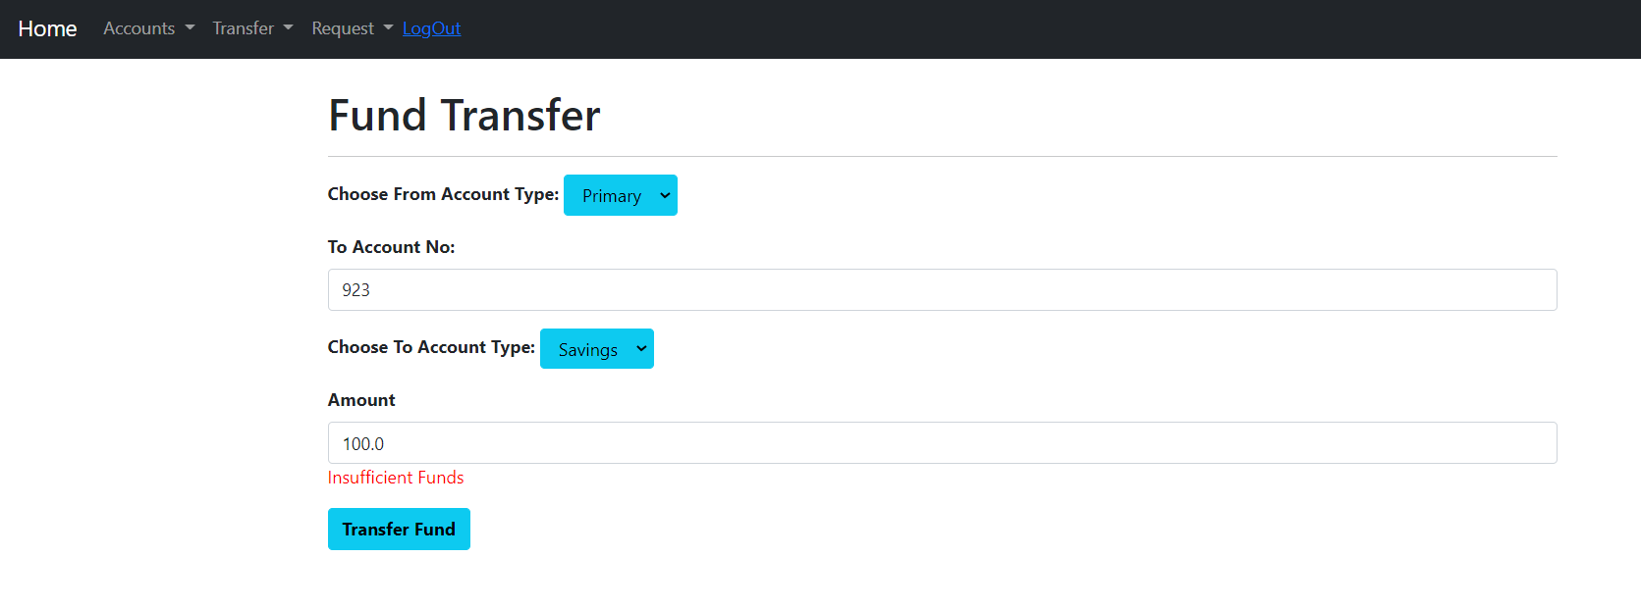

On Successfully transferring the amount, the link is navigated to the home page.

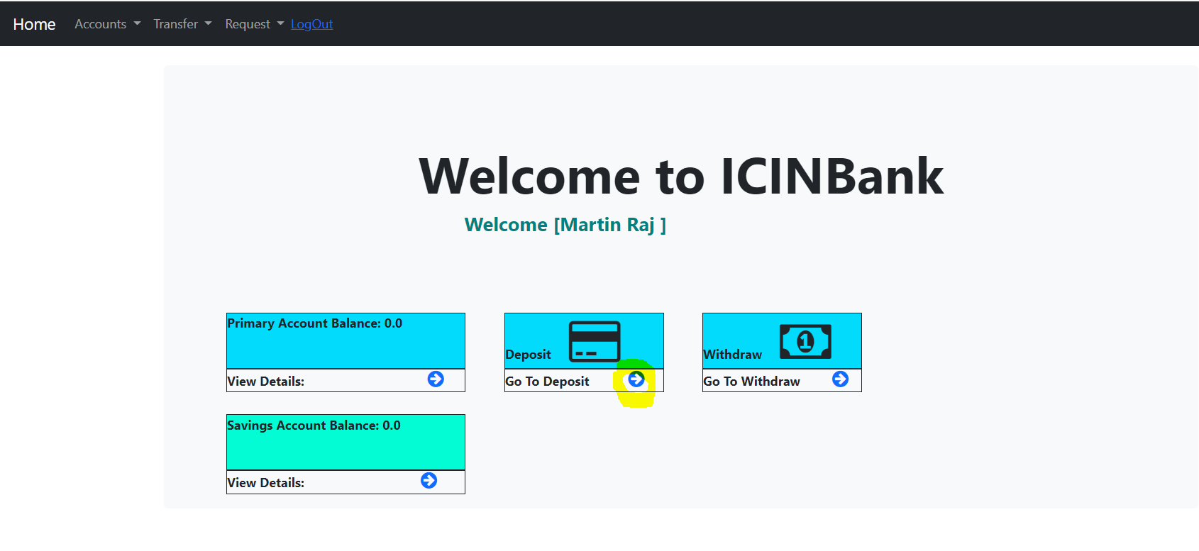

Click on the arrow next to “Go to Deposit” to enter the deposit page.

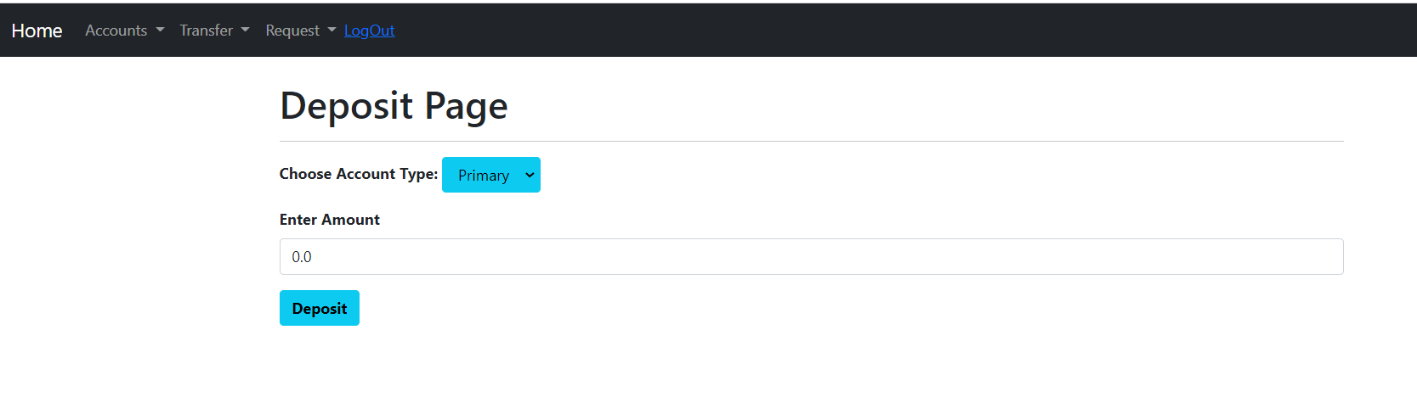

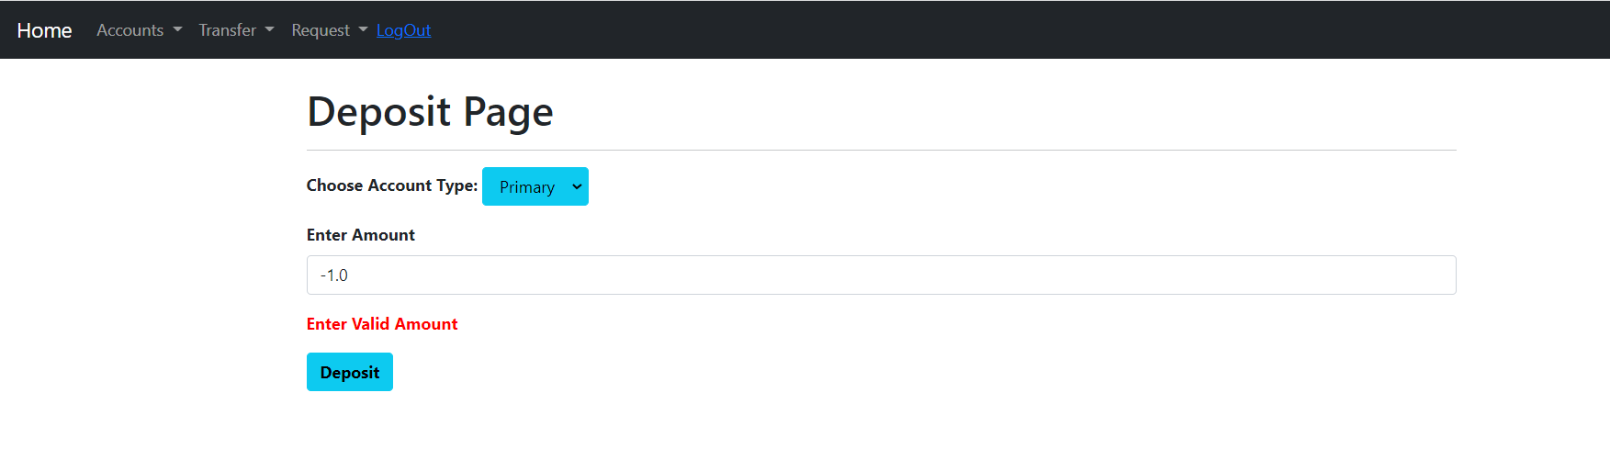

On Successfully placing the deposit request, the link is navigated to the home page. The Deposit Request has to be approved by the admin. After that only the amount gets reflected in the customer account.

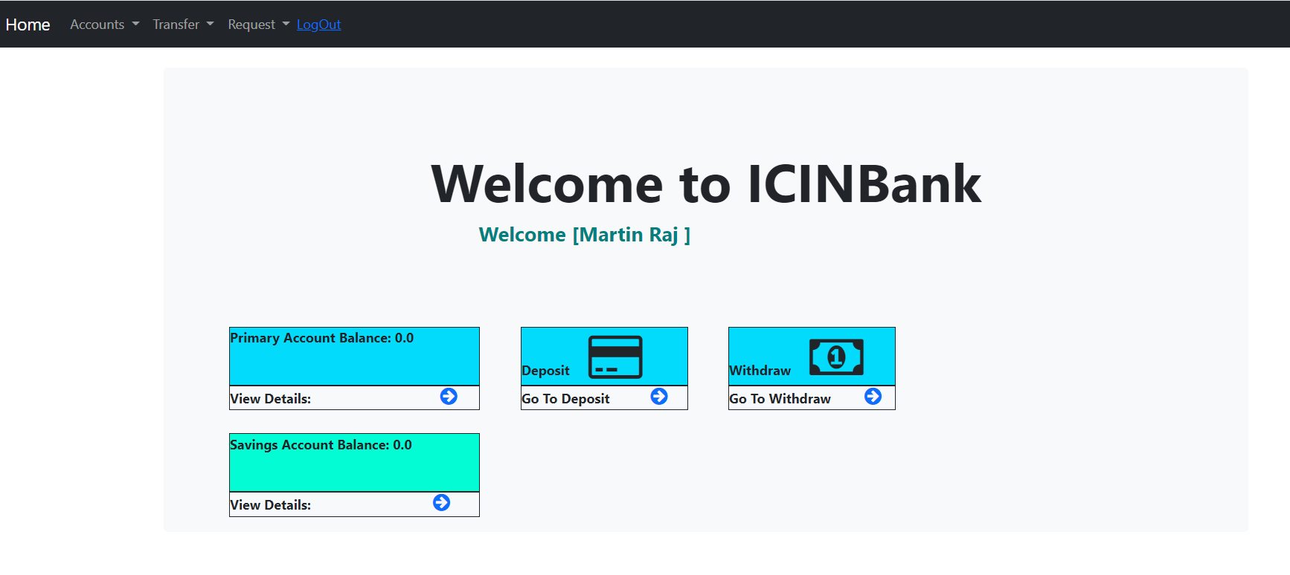

After Admin Approval

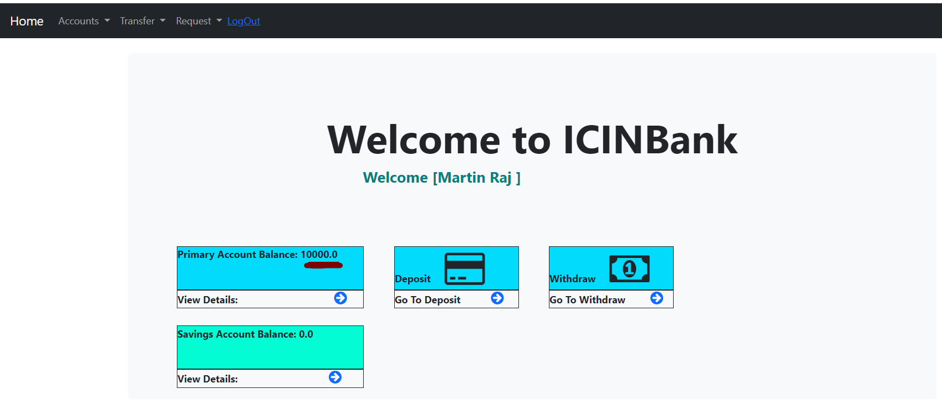

Click on the arrow next to “Go to WithDraw” to enter the withdraw page.

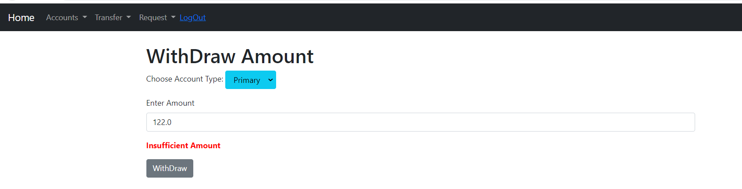

On Successfully placing the withdraw request, the link is navigated to the home page. The Withdraw Request has to be approved by the admin. After that only the amount gets reflected in the customer account.

Admin View:

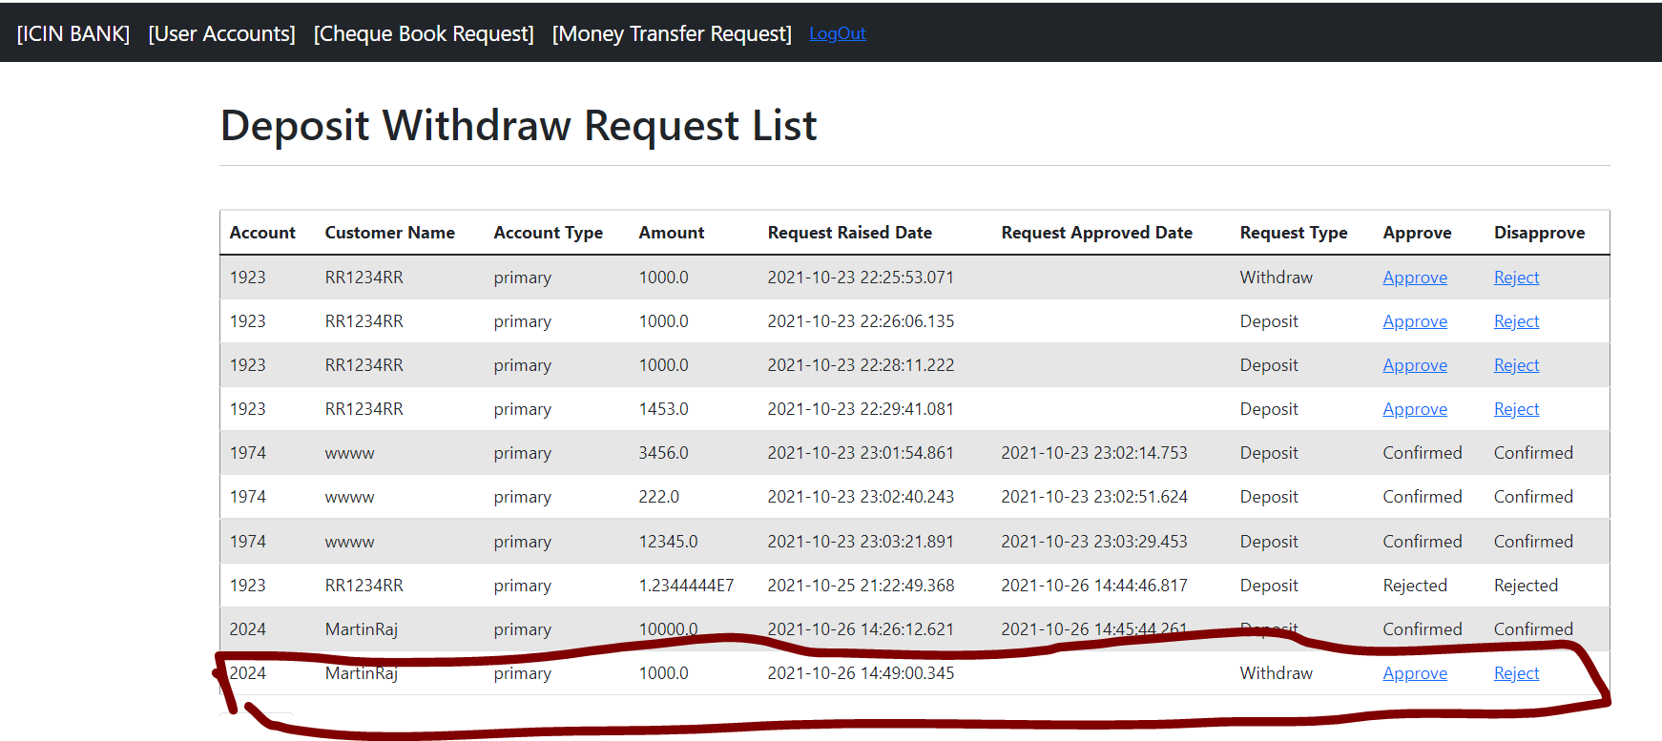

After Admin Approval



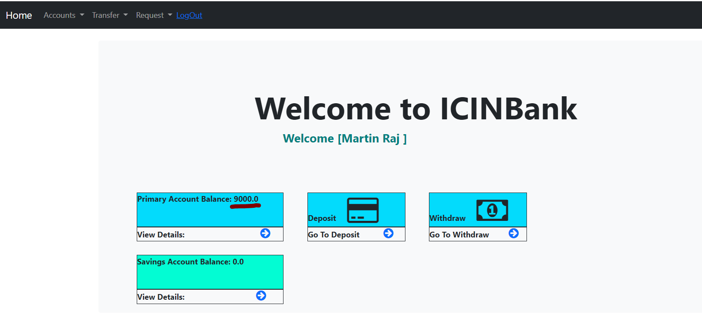

Amount Reflected

Either click the Primary Account/Savings Account link under the Account menu to view the respective account transaction

[OR] Click the arrow under Primary Account box/Savings Account Box in the home page to view the transaction details.

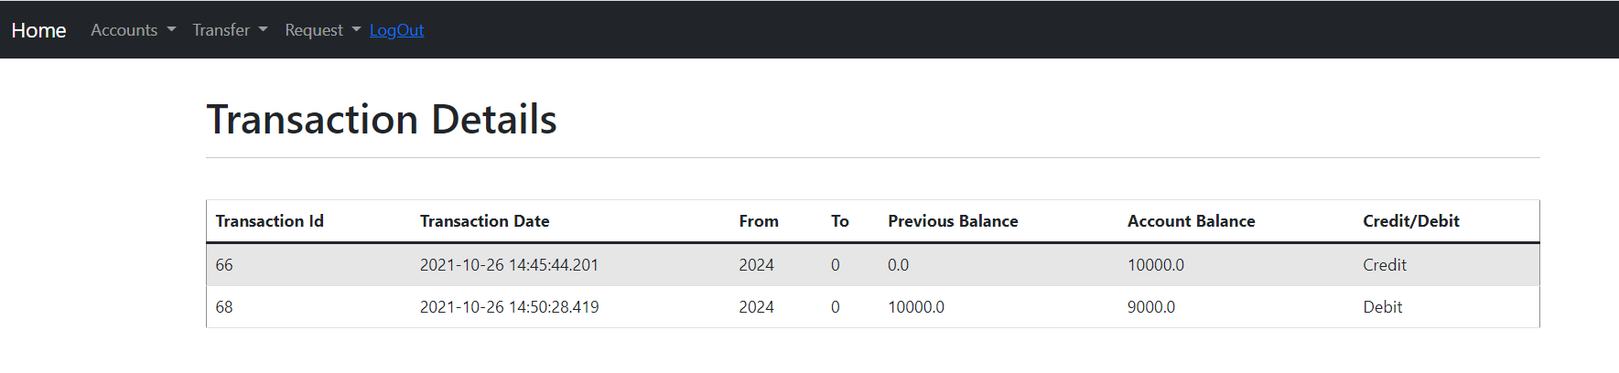

On Clicking logout in the menu it logs out and go to the login page

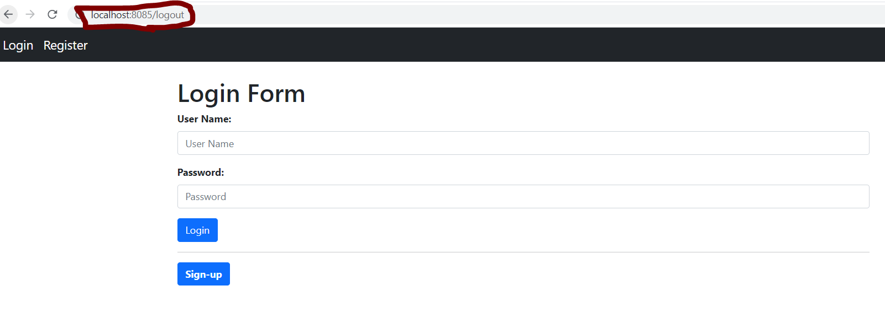

Admin Login Page

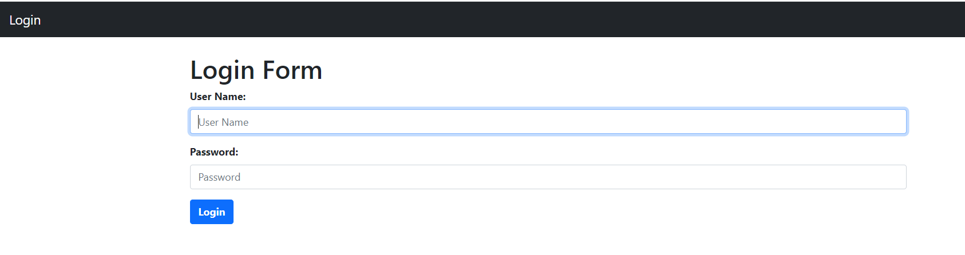

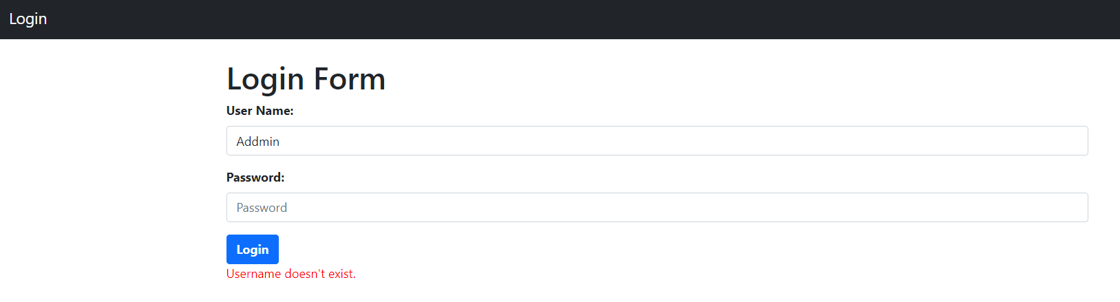

On Successful login the following page is displayed

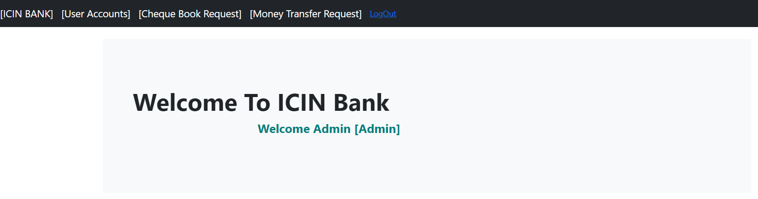

Click Cheque Book Request in the menu to view all the deposit and withdraw request

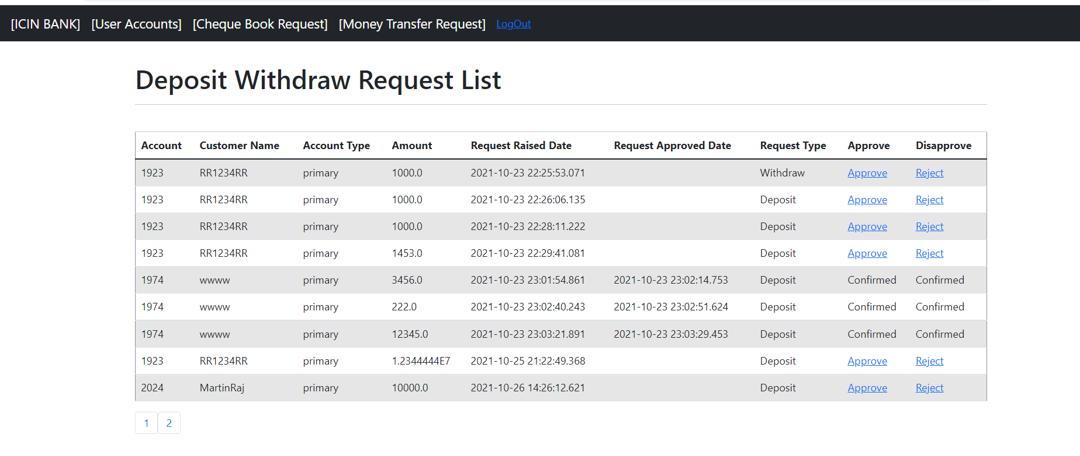

Admin can approve the request by clicking Approve or reject the request by Clicking Reject

Request Rejected

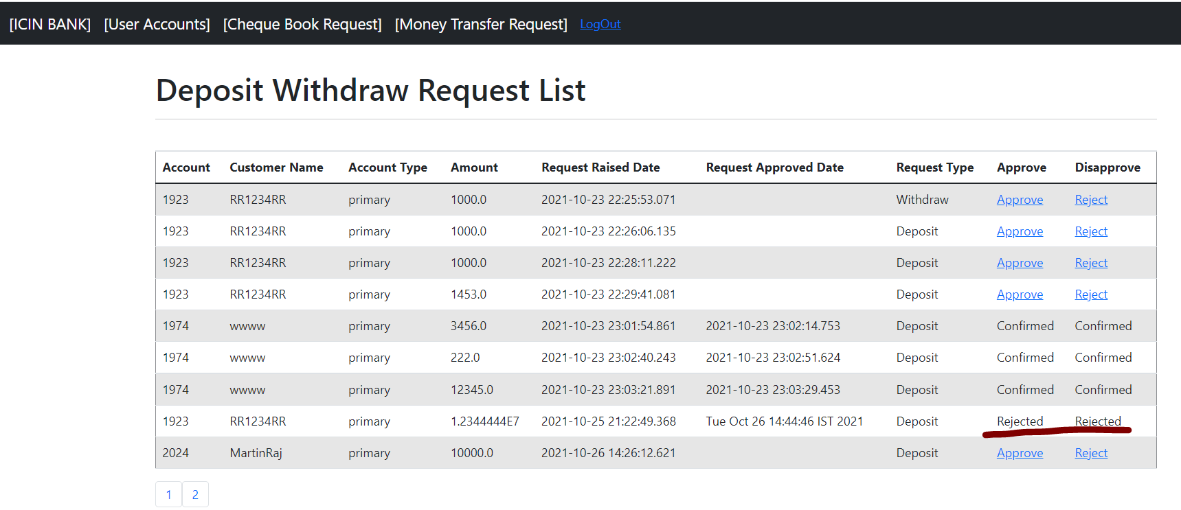

Request Approved

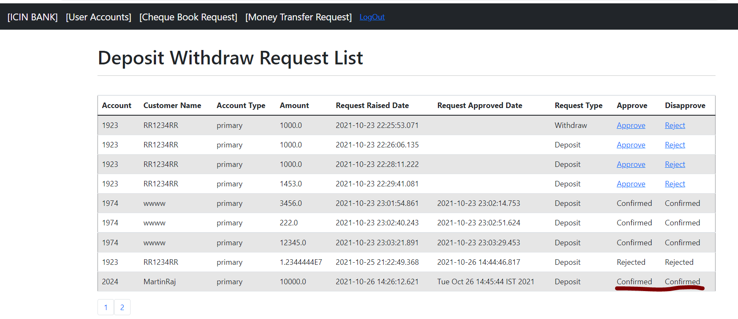

Pagination is done for all the pages inside the Admin login

Click User Accounts link in the main menu to view all the Bank users

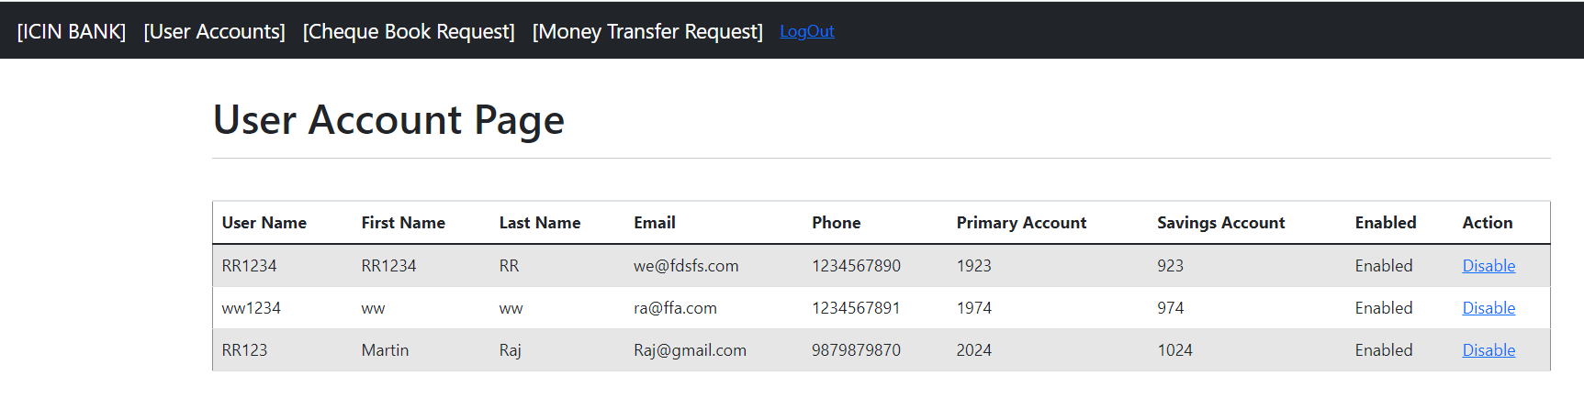

Admin can deactivate the user account by clicking the disable link under the action column.

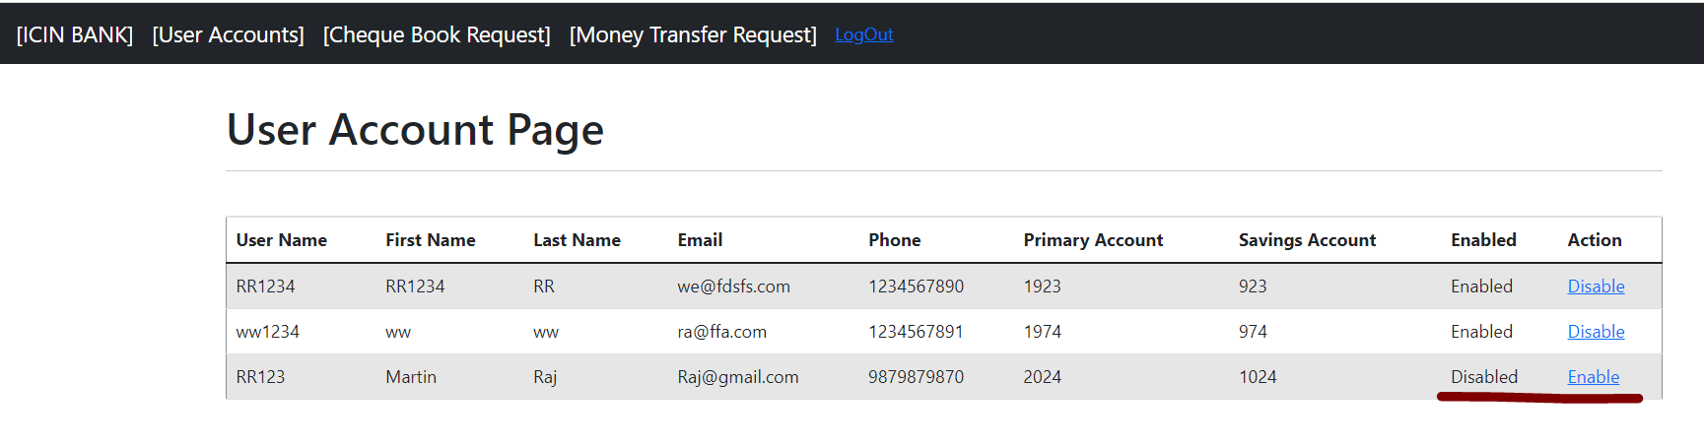

User View : [As the admin has disabled the user account]

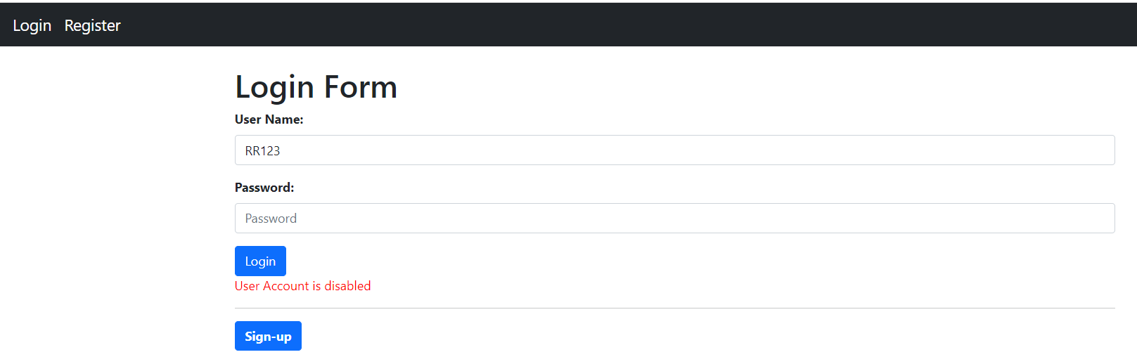

On Clicking the Cheque book Request link in the main menu, the Admin can view all the Cheque Book request raised by the

Customer.

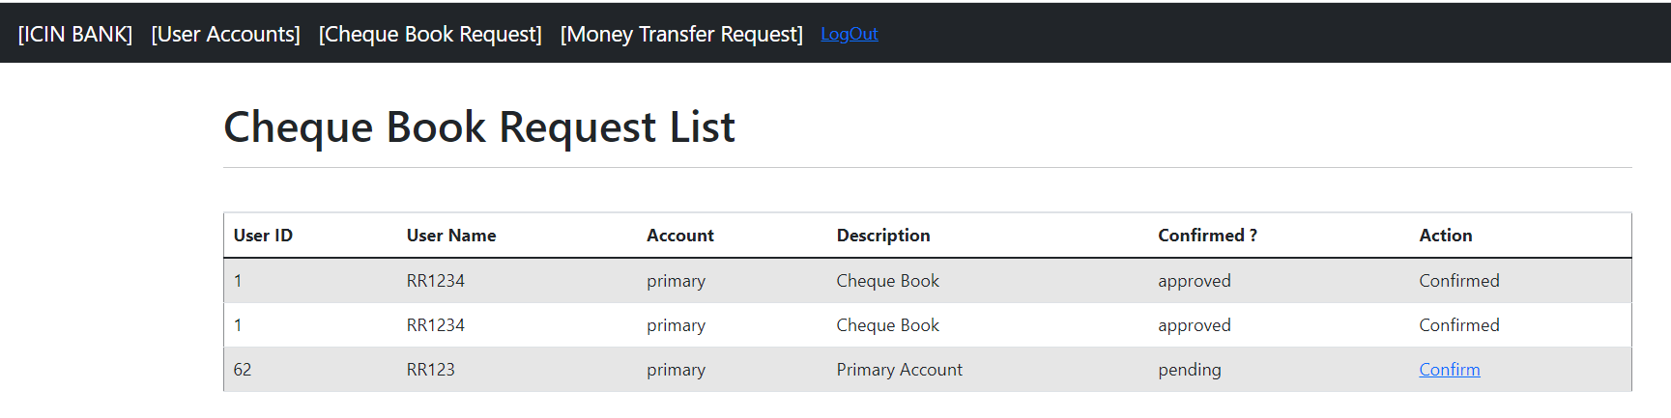

Admin approves the request by clicking the Confirm link

