**Requirements**

**Introduction**

This is project is about how an online Banking system works,where i have created bank page called Raj Bank Pvt Limited ,in which first

you can register your an then youn can login to your account and from you can add money to your account and withdraw money from your account

and do all other transcations.

**Advantages:**

1) Can be accesed from your mobile phone

2)No need to go to bank Personally to do transcations

3)Proof for every transcations

**Disadvantages:**

1)GUI is needed

**Cost And Access**

Low cost

eassier acceses

**High Level Requirements**

1)In the first go the user has to register with the bank with account number and mobile number and has to create password .

2)The user has to login with the credentilas

3)here account number and mobile number along with password comes under high level Requirements

**Low Level Requirements**

1)After the login the user will get options to do Banking

i)Balance enquiry

ii)Adding money

iii)Money withdraw

iv)Online Transfer

V)Passwordchange

**Architecture**

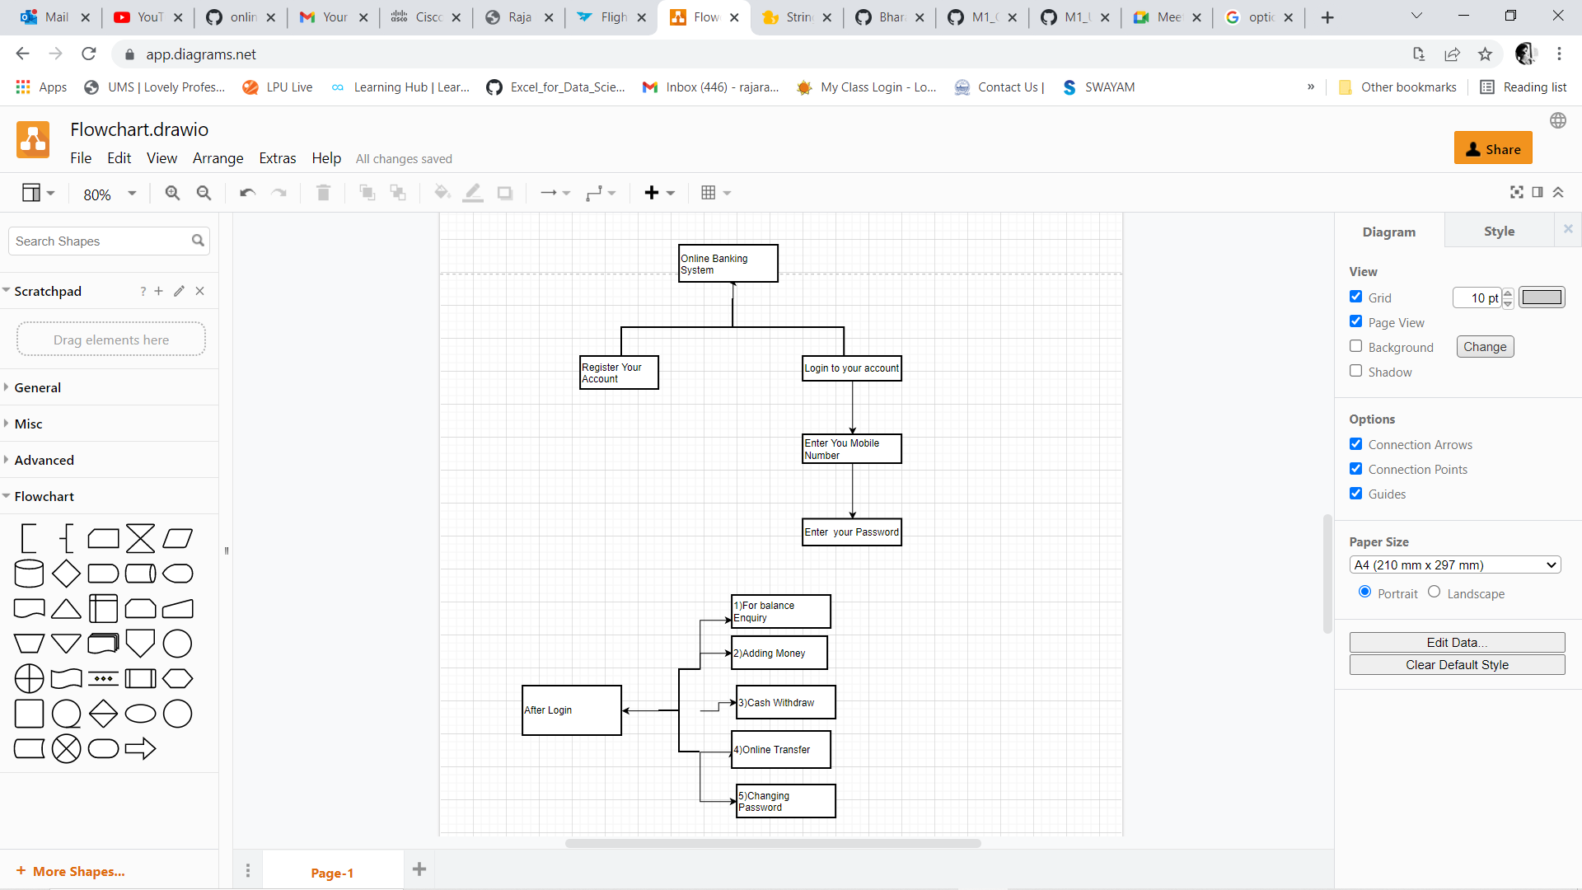

**Test Plan And Output**

After building the code

when you run the program you will prompt with 2 options whther you want to login or you want register

for registering you will be akked your account number and number asked to set new password

if you have already registered with you can login with mobile number and password ,after entering the credentials you will be given with options

to do banking i)Balance enquiry

ii)Adding money

iii)Money withdraw

iv)Online Transfer

V)Password change

For example if you enter i the you will shown your balance amount in the bank in the same remaining options will work

**Images**

