LAB - 1
Part A – Numpy
Question 1
Create a NumPy array containing the integers from 1 to 20.
Perform the following operations:
1. Display the array.
2. Find the shape of the array.
3. Find the maximum and minimum values.
4. Calculate the mean and standard deviation.
5. Reshape the array into a 4 × 5 matrix.
6. Display the second row of the matrix.
7. Display the third column of the matrix.

Code :
import numpy as np
arr=np.arange(1,21)
print(arr)
print("shape of the array is")
print(arr.shape)
print("maximum value of array is",np.max(arr))
print("minimum value of array is",np.min(arr))
print("mean of the data",np.mean(arr))
print("standard deviation of the data is",np.std(arr))
print("The 4x5 Matrix is")
new_arr = arr.reshape(4,5)
print(new_arr)
print("The 2nd Row is",new_arr[1,:])
print("The 2nd Column is",new_arr[:,2])
Output :
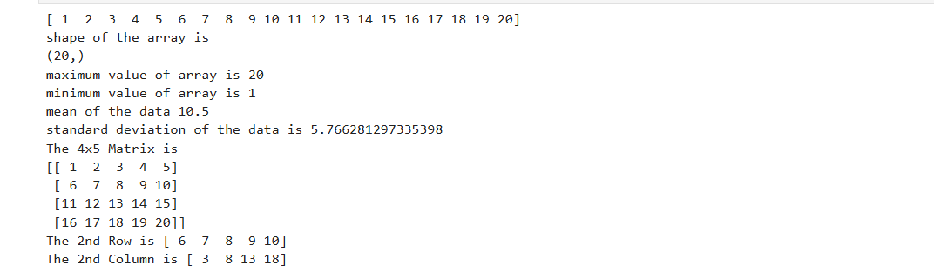
Question 2
Create two NumPy arrays:
A = [10, 20, 30, 40, 50]
B = [5, 10, 15, 20, 25]
Perform:
1. Addition of A and B.
2. Subtraction of B from A.
3. Element-wise multiplication.
4. Element-wise division.
5. Find the sum of all elements in A.
Code :
import numpy as np
A = np.array([10,20,30,40,50])
B = np.array([5,15,15,20,65])
print("Addition")
print(A+B)
print("Subtraction")
print("Multiplication")
print(A*B)
print("Division")
print(A/B)
print("Sum of all values of A")
print(sum(A))
print(A-B)Output :
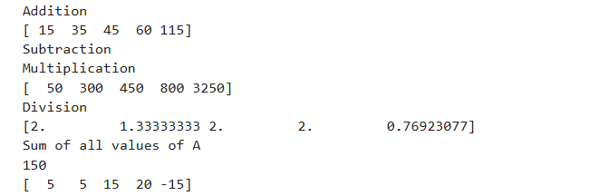

Part B – Pandas
Question 3
Create a DataFrame using the following student data:
Roll No Name Marks
101 Ravi 85
102 Priya 92
103 Kiran 78
104 Anu 88
105 Sita 95

Perform the following operations:
1. Display the DataFrame.
2. Display the first three records.
3. Find the average marks.
4. Find the student with the highest marks.
5. Find the student with the lowest marks.
6. Add a new column called "Grade" using:
o A for Marks ≥ 90
o B for Marks between 80 and 89
o C for Marks < 80

Code :
import pandas as pd
import numpy as np
data = {
"Roll no" : [101,102,103,104,105],
"Name" : ["Ravi","Priya","Kiran","Anu","Sita"],
"Marks" : [85,92,78,88,95]
}
df = pd.DataFrame(data)
print(df)
print(df.loc[[0,1,2]])
average_marks = df["Marks"].mean()
print("Average marks:",average_marks)
highest_marks = df["Marks"].max()
print("Highest marks:",highest_marks)
lowest_marks = df["Marks"].min()
print("Lowest marks:",lowest_marks)
conditions = [
(df['Marks'] >= 90),
(df['Marks'] >= 80) & (df['Marks'] < 89),
(df['Marks'] < 80)
]

choices = ["A","B","C"]
df['Grade'] = np.select(conditions,choices,default="Fail")
print(df)
Output :
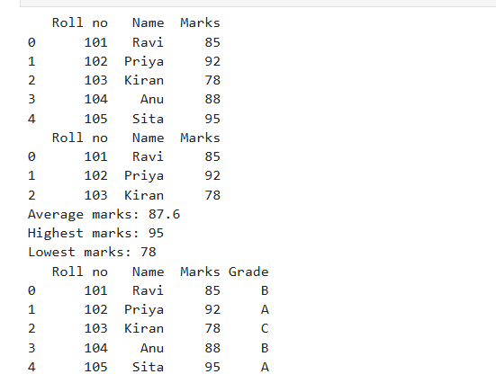

Question 4
Create a DataFrame containing the following information:
Product Price Quantity
Laptop 50000 10
Mouse 500 50
Keyboard 1200 30
Monitor 10000 15

Perform:
- Calculate the total value of each product using:
Total Value = Price × Quantity
2. Add the Total Value column.
3. Find the product with the highest total value. 4. Calculate the overall inventory value.

Code :
import pandas as pd
data = {
"Product": ["Laptop", "Mouse", "Keyboard", "Monitor"],
"Price": [50000, 500, 1200, 10000],
"Quantity": [10, 50, 30, 15]
}
df = pd.DataFrame(data)

# Display DataFrame
print("Original DataFrame:")
print(df)
# 1 & 2. Calculate and add Total Value column
df["Total Value"] = df["Price"] * df["Quantity"]
print("\nDataFrame with Total Value:")
print(df)

# 3. Product with highest total value
highest = df.loc[df["Total Value"].idxmax()]
print("\nProduct with Highest Total Value:")
print(highest)

# 4. Overall inventory value
inventory_value = df["Total Value"].sum()
print("\nOverall Inventory Value:", inventory_value)
Output :
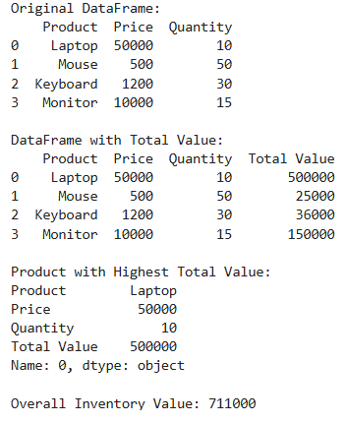

Part C – Dataset Exploration
Question 5
Download the Iris dataset from Scikit-learn and perform the following:
1. Load the dataset into a Pandas DataFrame.
2. Display the first five records.
3. Find the number of rows and columns.
4. Display column names.
5. Check for missing values.
6. Generate summary statistics using describe().
7. Find the number of samples belonging to each class.

Code :
from sklearn.datasets import load_iris
import pandas as pd

# 1. Load the Iris dataset into a Pandas DataFrame
iris = load_iris()
df = pd.DataFrame(iris.data, columns=iris.feature_names)

# Add target class names
df["species"] = [iris.target_names[i] for i in iris.target]

# 2. Display the first five records
print("First Five Records:")
print(df.head())

# 3. Find the number of rows and columns
print("\nNumber of Rows and Columns:")
print(df.shape)

# 4. Display column names
print("\nColumn Names:")
print(df.columns)

# 5. Check for missing values
print("\nMissing Values:")
print(df.isnull().sum())

# 6. Generate summary statistics
print("\nSummary Statistics:")
print(df.describe())

# 7. Find the number of samples belonging to each class
print("\nSamples in Each Class:")
print(df["species"].value_counts())

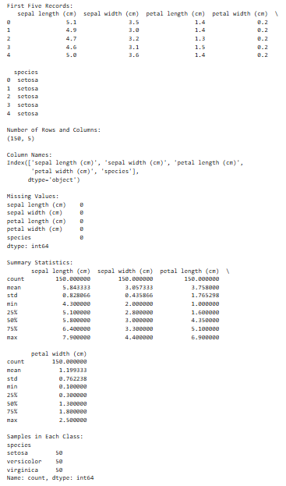
Output :

LAB - 2
To perform exploratory data analysis (EDA) on a student performance dataset using Pandas and Matplotlib.
Dataset
Create a CSV file named student_data.csv with the following data:
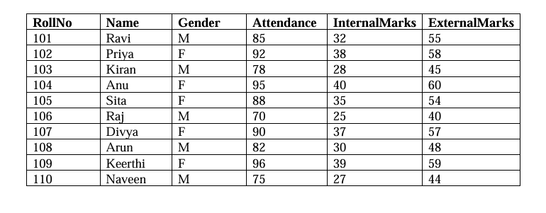
Task A :
Dataset Loading and Inspection
1. Import the necessary Python libraries.
2. Load the dataset into a Pandas DataFrame.
Code :
import pandas as pd
df=pd.read_csv('student_data.csv')
df

3. Display the first five records.
Code :
# to print first 5 rows
# df.head()
# print(df.iloc[0:5])
df.head()
Output :
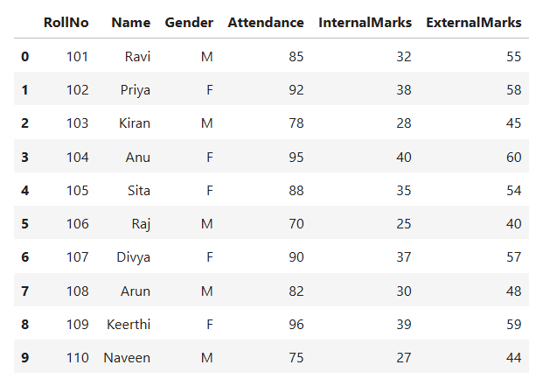

4. Display the last five records.
Code :
df.tail(5)
Output :
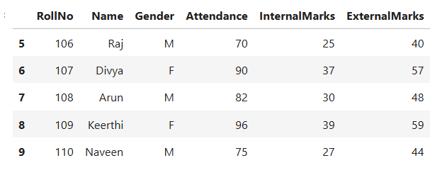
5. Find the total number of rows and columns.
Code :
df.shape
Output :
(10, 6)

6. Display the names of all columns.
7. Display the data type of each column.
Code :
df.columns
Output :
Index(['RollNo', 'Name', 'Gender', 'Attendance', 'InternalMarks',
'ExternalMarks '],
dtype='object')

8. Generate dataset information using info().
Code :
df.info()

Output :
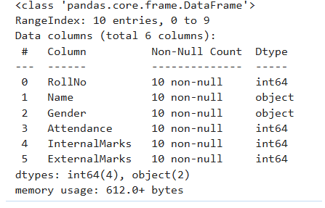

Task B :
Statistical Analysis
1. Calculate the mean attendance of all students.
Code :
df['Attendance'].mean()
Output :
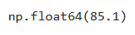

2. Calculate the average Internal Marks.
Code :
df['InternalMarks'].mean()
Output :
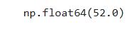

3. Calculate the average External Marks.
Code :
df['ExternalMarks '].mean()
Output :
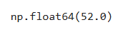

4. Find the maximum Internal Marks.
Code :
df['InternalMarks'].max()
Output :
40

5. Find the minimum Internal Marks.
Code :
df['InternalMarks'].min()
Output :
25

6. Find the maximum External Marks.
Code :
df['ExternalMarks '].max()
Output :
60
7. Find the minimum External Marks.
Code :
df['ExternalMarks '].min()
Output :
40

8. Calculate the standard deviation of Internal Marks.
Code :
df['InternalMarks'].std()
Output :
5.425249610233001

9. Generate summary statistics using describe().
Code :
df.describe()
Output :
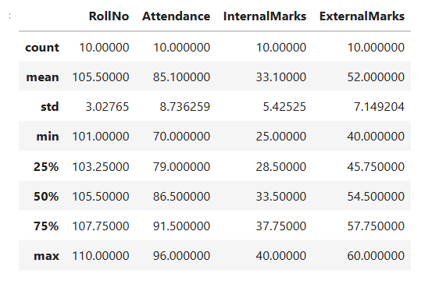

Task C:
Data Manipulation
1. Create a new column named TotalMarks.
2. TotalMarks=InternalMarks+ExternalMarks
Code :
df['TotalMarks']=df['InternalMarks']+df['ExternalMarks ']
df
Output :
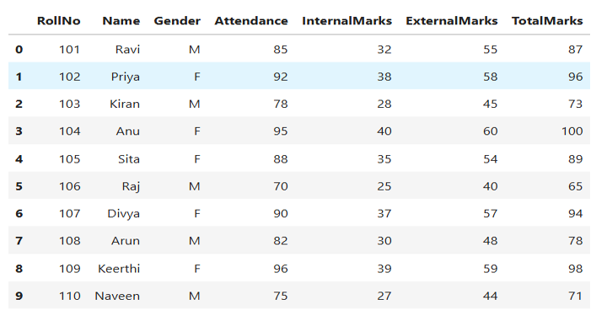
3. Create a new column named Percentage.
- Percentage=TotalMarks/100×100
4. Display the updated DataFrame.
Code :
df['Percentage']=(df['TotalMarks'] %100)/100
df

Output :
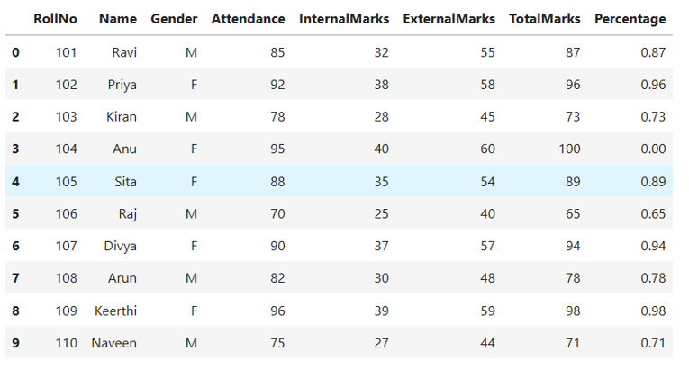

Task D:
Filtering and Searching
1. Display the details of students whose attendance is greater than 90%.
Code :
BETTER_ATTENDANCE=df[df['Attendance']>90]
print(BETTER_ATTENDANCE)
Output :
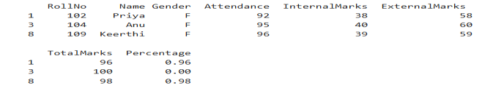

2. Display the details of students whose TotalMarks exceed 90.
Code :
TOTAL_MARKS=df[df['TotalMarks']>90]
print(TOTAL_MARKS)
Output :
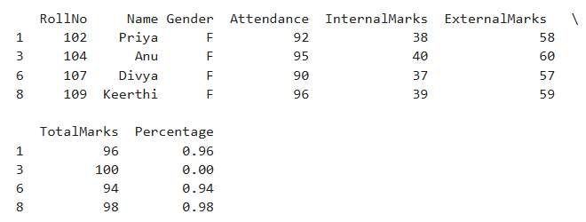

3. Display the details of female students.
Code :
FEMALE_STUDENTS=df[df['Gender']=='F']
print(FEMALE_STUDENTS)
Output :
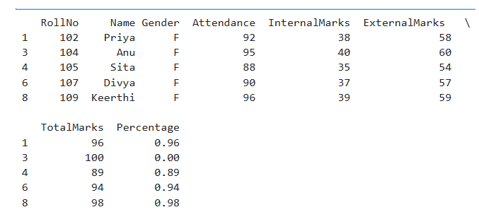
4. Display the details of male students.
Code :
MALE_STUDENTS=df[df['Gender']=='M']
print(MALE_STUDENTS)
Output :
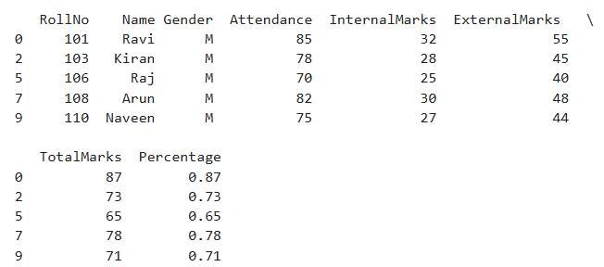

5. Display students whose ExternalMarks are less than 50.
Code :
EXTERNAL_MARKS=df[df['ExternalMarks ']<50]
print(EXTERNAL_MARKS)
Output :
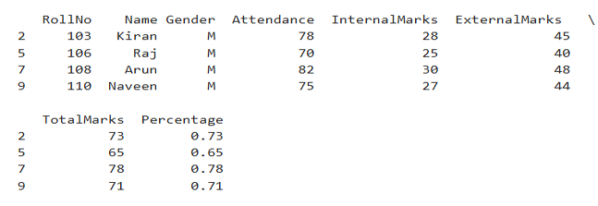

Task E:
Ranking and Comparison
1. Identify the student with the highest TotalMarks.
Code :
highest = df.loc[df["TotalMarks"].idxmax()]
print(highest)
Output :
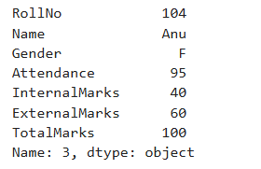

2. Identify the student with the lowest TotalMarks.
Code :
lowest = df.loc[df["TotalMarks"].idxmin()]
print(lowest)
Output :
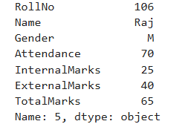

3. Display the top three performers based on TotalMarks.
Code :
top3 = df.sort_values(by="TotalMarks", ascending=False).head(3)
print(top3[["RollNo","Name","TotalMarks"]])
print()
Output :
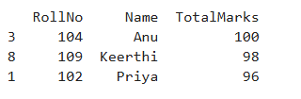

4. Display the bottom three performers based on TotalMarks.
Code :
bottom3 = df.sort_values(by="TotalMarks", ascending=False).tail(3)
print(bottom3[["RollNo","Name","TotalMarks"]])
print()
Output :
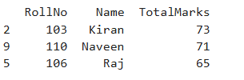

5. Determine how many students scored above the class average.
Code :
average_marks = df["TotalMarks"].mean()
above_average = df[df["TotalMarks"] > average_marks]
print("Class Average Total Marks:", average_marks)
print("Number of Students Above Average:", len(above_average))
print()
print("Students Above Average:")
print(above_average[["RollNo","Name","TotalMarks"]])
Output :
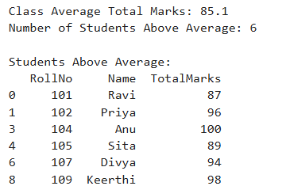

Task F:
Group-wise Analysis
1. Calculate the average TotalMarks of male students.
Code :
male_avg = df[df['Gender'] == 'M']['TotalMarks'].mean()
print(male_avg)
Output :
74.8

2. Calculate the average TotalMarks of female students.
Code :
female_avg = df[df['Gender'] == 'F']['TotalMarks'].mean()
print(female_avg)
Output :
95.4

3. Compare the average attendance of male and female students.
Code :
avg_attendance = df.groupby('Gender')['Attendance'].mean()
print(avg_attendance)
Output :
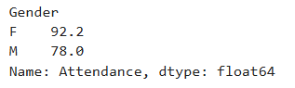

Task G:
Data Visualization
1. Plot a bar chart showing TotalMarks of all students.
Code :
import matplotlib.pyplot as plt
plt.figure(figsize=(8,5))
plt.bar(df['Name'], df['TotalMarks'])
plt.title("Total Marks of All Students")
plt.xlabel("Student Name")
plt.ylabel("Total Marks")
plt.xticks(rotation=45)
plt.show()
Output :
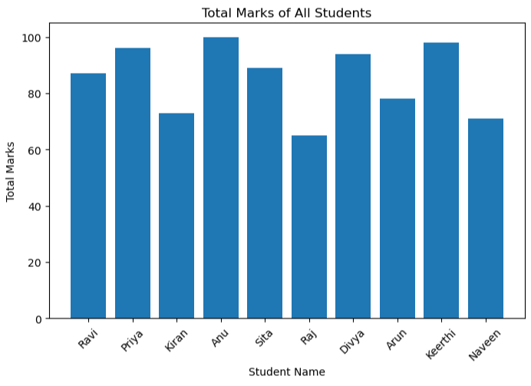

2. Plot a histogram of Attendance.
Code :
import matplotlib.pyplot as plt
plt.figure(figsize=(8,5))
plt.hist(df['Attendance'], bins=10, edgecolor='black')
plt.title("Attendance Distribution")
plt.xlabel("Attendance")
plt.ylabel("Number of Students")
plt.show()
Output :
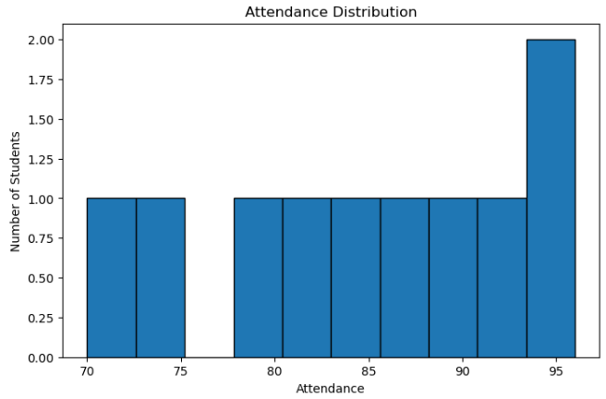
3. Plot a pie chart showing the distribution of male and female students.
Code :
import matplotlib.pyplot as plt
gender_count = df['Gender'].value_counts()
plt.figure(figsize=(6,6))
plt.pie(gender_count,
labels=gender_count.index,
autopct='%1.1f%%',
startangle=90)
plt.title("Distribution of Male and Female Students")
plt.show()
Output :
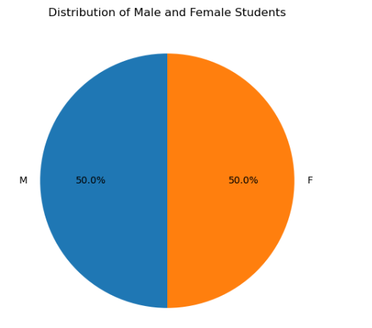

4. Plot a scatter plot between Attendance and TotalMarks.
Code :
import matplotlib.pyplot as plt
plt.figure(figsize=(8,5))
plt.scatter(df['Attendance'], df['TotalMarks'])
plt.title("Attendance vs Total Marks")
plt.xlabel("Attendance")
plt.ylabel("Total Marks")
plt.show()

Output :
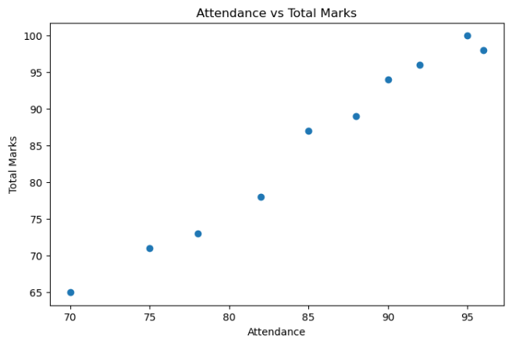
5. Interpret the relationship between Attendance and TotalMarks.
Code :
correlation = df['Attendance'].corr(df['TotalMarks'])
print("Correlation:", correlation)
Output :
Correlation: 0.9893549196682807

LAB-3
Problem Statement
Implement the ID3, C4.5, and CART decision tree algorithms from scratch (without using any machine learning libraries) for a suitable classification dataset. Develop the complete training procedure by implementing the required attribute selection measures, construct the decision trees, and use the generated models to classify test instances. Compare the three algorithms in terms of classification accuracy, precision, recall, F1-score, tree depth, number of leaf nodes, and training time, and summarize your observations on their performance and the resulting tree structures.

Code :

Output :

LAB – 4
Implement Navie Bayes
Code :
import pandas as pd
data = [
['Sunny','Hot','High','Weak','No'],
['Sunny','Hot','High','Strong','No'],
['Overcast','Hot','High','Weak','Yes'],
['Rain','Mild','High','Weak','Yes'],
['Rain','Cool','Normal','Weak','Yes'],
['Rain','Cool','Normal','Strong','No'],
['Overcast','Cool','Normal','Strong','Yes'],
['Sunny','Mild','High','Weak','No'],
['Sunny','Cool','Normal','Weak','Yes'],
['Rain','Mild','Normal','Weak','Yes'],
['Sunny','Mild','Normal','Strong','Yes'],
['Overcast','Mild','High','Strong','Yes'],
['Overcast','Hot','Normal','Weak','Yes'],
['Rain','Mild','High','Strong','No']
]

columns = [
'Outlook',
'Temperature',
'Humidity',
'Wind',
'PlayTennis'
]
df= pd.DataFrame(data, columns=columns) #all rows
print(df)

#test sample
X = {
'Outlook': 'Sunny',
'Temperature': 'Cool',
'Humidity': 'High',
'Wind': 'Strong'
}

#maximum aposteriori implementation
classes = df['PlayTennis'].unique() #get all distinct values from the target column playtennis
scores= {}

for c in classes:
class_df = df[df['PlayTennis'] == c] #yes and no class rows separately

prior= len(class_df)/len(df) #prior probability of yes and no classes
print(f"\nClass: {c}")
print("Prior =",prior)

score= prior #formula is that we multiply prior with the likelihoods.. so initial score would be the prior prob

#likelihoods
for feature, value in X.items(): #X has key-value pairs.. so traverse through each pair
count= len(class_df[class_df[feature]==value])

likelihood = count/len(class_df)

print(
f"P({feature}={value}|{c})= "
f"{likelihood}"
)

score = score*likelihood

scores[c]= score
print("Posterior score =", score)

prediction = max(scores, key= scores.get)
print("\nScores")
print(scores)
print("\nPrediction =", prediction)

Output:
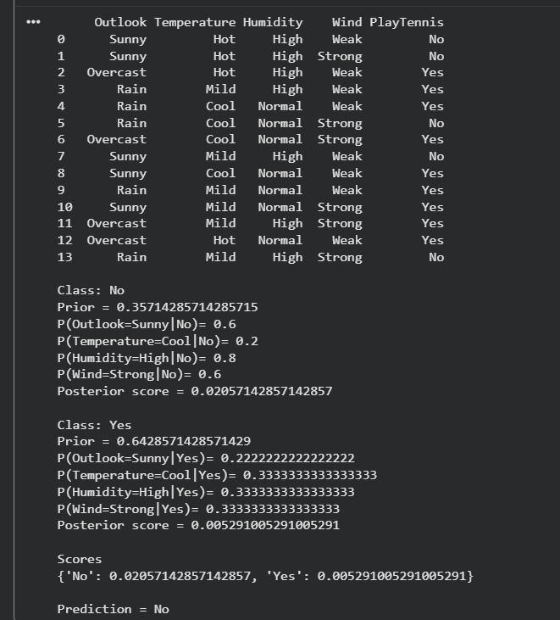

LAB – 5
Task 1 :
Hidden Markov Model for Human Activity Recognition
Problem Statement
A wearable fitness tracker is used to monitor a person’s physical activity based on sensor readings. The actual activity being performed is hidden, while the wearable records the intensity of movement during fixed time intervals. The movement intensity is categorized as Low, Medium, or High.
The Hidden Markov Model (HMM) is defined as follows.

Hidden States:
S = {Walking, Running, Resting}

Observation Symbols:
V = {Low, Medium, High}

Initial State Probability Vector:
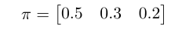

State Transition Probability Matrix:

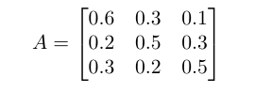
where each row represents the current hidden state and each column rep-resents the next hidden state.

Emission Probability Matrix:
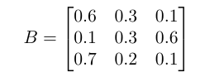
where each row represents a hidden state (Walking, Running, Resting) and each column represents an observation symbol (Low, Medium, High).

Observation Sequence:
O = (High, Medium, Low, High)

TASK :
1.Compute the forward probabilities for each time step using the Forward Algorithm.
2.Construct the complete Forward Probability (α) table.
3.Determine the likelihood of the given observation sequence.
4.Implement the Forward Algorithm in Python and verify the computed likelihood.

Code :
import numpy as np
states = ["Walking", "Running", "Resting"]
obs_symbols = {"Low": 0, "Medium": 1, "High": 2}
pi = np.array([0.5, 0.3, 0.2])
A = np.array([
[0.6, 0.3, 0.1],
[0.2, 0.5, 0.3],
[0.3, 0.2, 0.5]
])
B = np.array([
[0.6, 0.3, 0.1],
[0.1, 0.3, 0.6],
[0.7, 0.2, 0.1]
])
observations = ["High", "Medium", "Low", "High"]
O = [obs_symbols[o] for o in observations]
N = len(states)
T = len(O)
alpha = np.zeros((T, N))
for i in range(N):
alpha[0][i] = pi[i] * B[i][O[0]]
for t in range(1, T):
for j in range(N):
alpha[t][j] = np.sum(alpha[t-1] * A[:, j]) * B[j][O[t]]
likelihood = np.sum(alpha[T-1])
print("Forward Probability Table:")
print(alpha)
print("\nLikelihood =", likelihood)

Output :
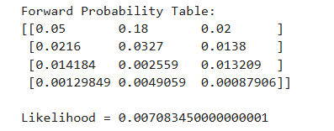

TASK 2 :
Human Activity Recognition using hmmlearn

Problem Statement
Using the Hidden Markov Model parameters provided in Task 1, implement the HMM using the hmmlearn Python library.

TASKS :
1.Install the hmmlearn library and import the required modules.
2.Construct a Categorical Hidden Markov Model using the given initial state probabilities, transition probability matrix, and emission probability ma-trix.
3.Compute the likelihood of the observation sequence
O = (High, Medium, Low, High).

4.Compute the llikelihood for each of the following observation sequences:
- O₁ = (Low, Medium, High, Medium)
- O₂ = (High, High, High, High)
- O₃ = (Low, Low, Low, Low)
- O₄ = (Medium, Medium, Medium, Medium)
5.Briefly explain the relationship between the observation likelihood com-puted using the Forward Algorithm and the likelihood obtained using hmmlearn.
6.Predict the most probable hidden state sequence.
7.Train the model using the Baum–Welch algorithm on the given observation sequence.
8.Display the learned: (i)Initial state probability vector (ii)Transition prob-ability matrix (iii) Emission probability matrix (iv) Compare the learned parameters with the given HMM parameters and briefly discuss your ob-servations.

Using hmmlearn Library :
1.Install hmmlearn
Code :
pip install hmmlearn
2.Then run
import numpy as np
from hmmlearn import hmm

# Create model
model = hmm.CategoricalHMM(n_components=3)

# Initial probabilities
model.startprob_ = np.array([0.5, 0.3, 0.2])

# Transition matrix
model.transmat_ = np.array([
[0.6, 0.3, 0.1],
[0.2, 0.5, 0.3],
[0.3, 0.2, 0.5]
])

# Emission matrix
model.emissionprob_ = np.array([
[0.6, 0.3, 0.1],
[0.1, 0.3, 0.6],
[0.7, 0.2, 0.1]
])

# Observation sequence
obs = np.array([[2], [1], [0], [2]]) # High, Medium, Low, High

# Likelihood
log_prob = model.score(obs)

print("Log Likelihood =", log_prob)

# Hidden state prediction
hidden_states = model.predict(obs)

print("Hidden States =", hidden_states)

Output :
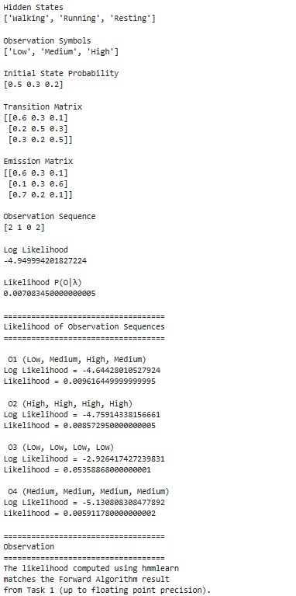

Q4 : Likelihood of Multiple Sequences

Code :
sequences = {
"O1": [[0], [1], [2], [1]], # Low Medium High Medium
"O2": [[2], [2], [2], [2]], # High High High High
"O3": [[0], [0], [0], [0]], # Low Low Low Low
"O4": [[1], [1], [1], [1]] # Medium Medium Medium Medium
}

for name, seq in sequences.items():
seq = np.array(seq)
print(name, "=", model.score(seq))

Output :

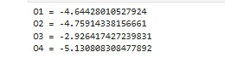

Q7 : Baum Welch Training
Code :
model = hmm.CategoricalHMM(
n_components=3,
n_iter=20,
init_params=""
)

model.startprob_ = np.array([0.5, 0.3, 0.2])

model.transmat_ = np.array([
[0.6, 0.3, 0.1],
[0.2, 0.5, 0.3],
[0.3, 0.2, 0.5]
])

model.emissionprob_ = np.array([
[0.6, 0.3, 0.1],
[0.1, 0.3, 0.6],
[0.7, 0.2, 0.1]
])

obs = np.array([[2], [1], [0], [2]])

model.fit(obs)

print("Learned Initial Probabilities")
print(model.startprob_)

print("\nLearned Transition Matrix")
print(model.transmat_)

print("\nLearned Emission Matrix")
print(model.emissionprob_)

Output :

