Assignment – 1

1. Install Power BI Desktop and share the final screenshot of the report view page which appears when power desktop starts.

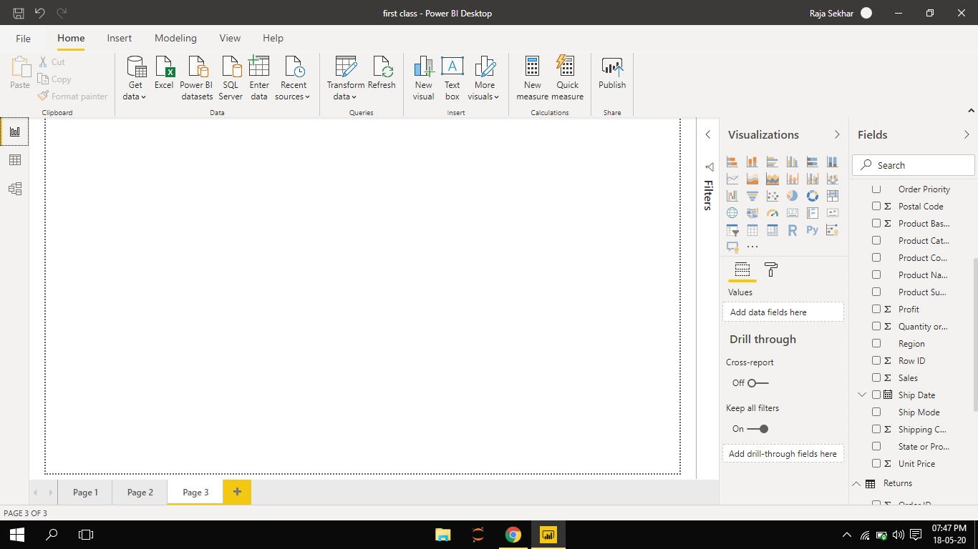

1. Prepare a document and with the following screenshot − Report View − Data View − Model View − Power Query Editor − Advance Editor.

* **Report View:**

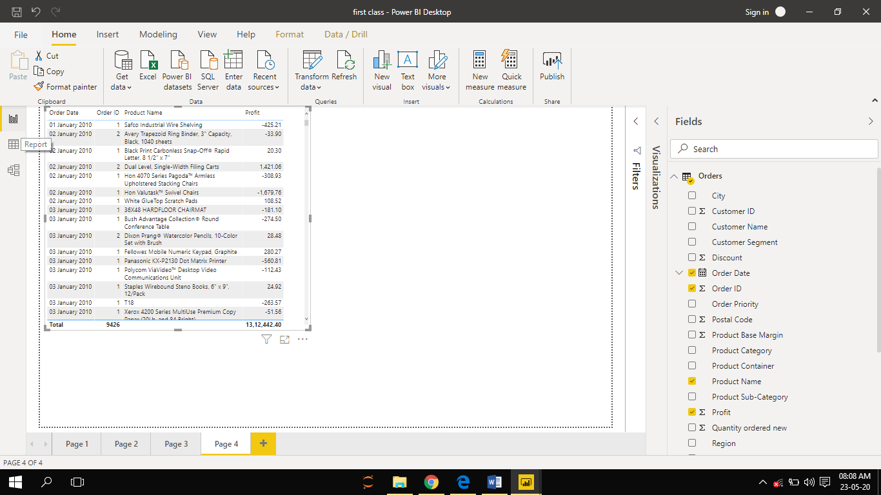

* **Data View:**

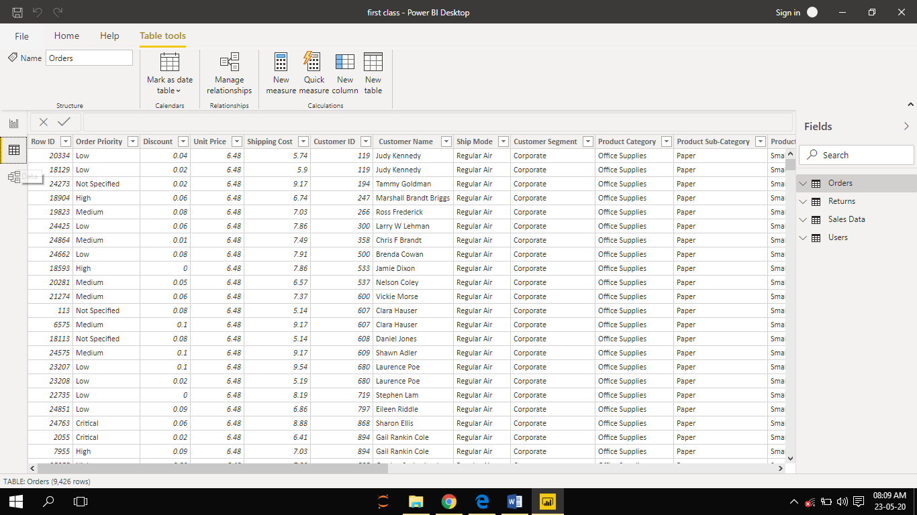

* **Model View:**

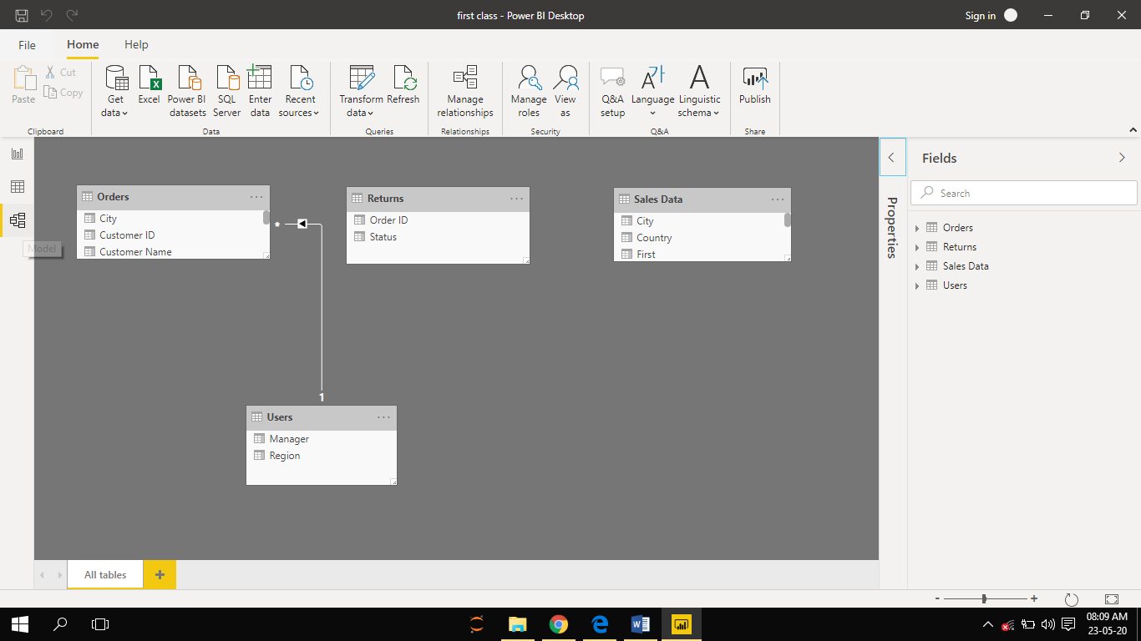

* **Power Query Editor:**

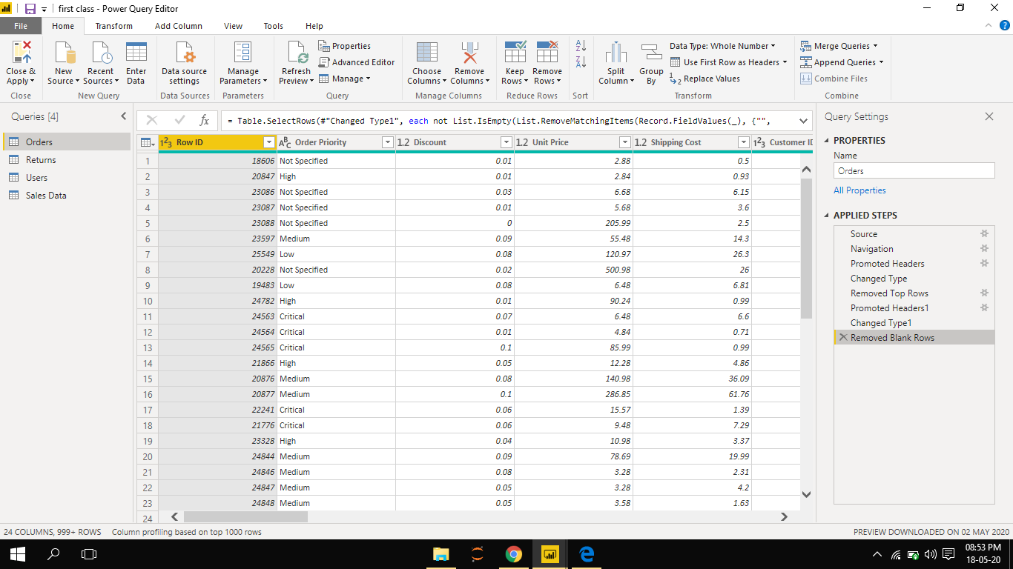

* **Advance Editor:**

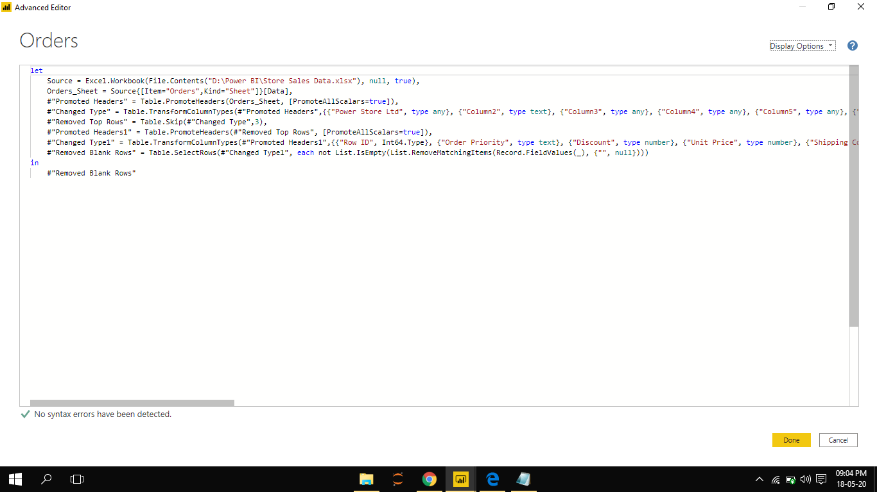

1. Prepare a document with details of the following along with their price

− Power BI Desktop − Power BI Pro − Power BI Premium

* **Power BI Desktop**: This is a **Free** version available to any single user and includes data cleaning and preparation, custom visualizations and the ability to publish to the **Power BI** service.

## **Power BI pro**: The Pro plan costs **$9.99** or **₹660.00/**user/month. It includes data collaboration, data governance, building dashboards with a 360-degree real-time view and the ability to publish reports anywhere. Users can try it a free trial for 60 days before purchasing the subscription.

* **Power BI Premium:** The Premium plan starts at **$4,995** a month per dedicated cloud compute and storage resource. Premium grants all users in the workplace a license (unlike Power BI Pro, which is an individual license), supports larger data volumes (you can publish datasets up to 10GB) and sports greater performance (refresh up to 48x per day).

