**Administrative-portal-for-Learner-s-Academy**

**Project' Details**

This project aims to design and develop a backend administrative portal for the Learner’s Academy using Java EE technologies. I developed it as a project of phase 2 for the Become a back-end expert course. The goal of this project is to apply servlet, jsp and JDBC concepts.

**Product Backlog:**

1. Create database and tables.
2. Connect the database to the project.
3. Create models classes.
4. Create a database utility class to retrieve data.
5. Create login page.
6. Create JSP files for all pages of the project.
7. Create a servlet to get requests and send responses to the JSP files.
8. Add cookies.
9. Create a CSS file to format the contents.
10. Debug and Test the project.

**Technologies and tools Used**

• Servlet: to do the business logic and works a controller for the project.

• JSP: to handle the presentation view.

• SQL: to create and manage the database.

• JDBC: to make operations on the database for the project.

• CSS: to format the contents.

• phpMyAdmin: to administrate and manage the database manually.

• Eclipse: to write and run the code.

• Tomcat: to run and deploy servlet application.

## Flowcharts of The Application

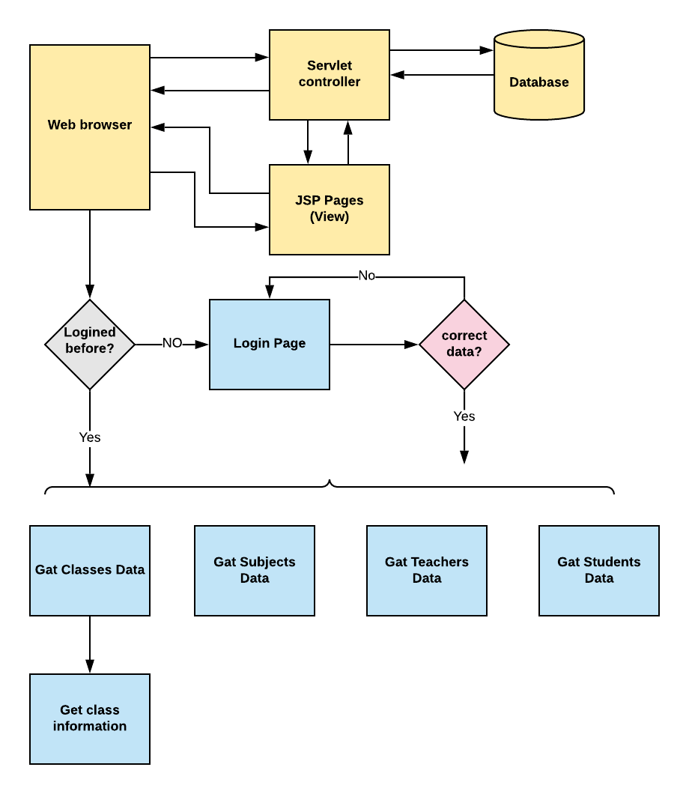

## Core concepts used in the project.

• Object-Oriented: used to create and model objects for users and their credentials.

• Databases: used to store and retrieve data.

• Data Sources: used to define a set of properties required to identify and access the database.

• Collections: used some collections such arraylist to store collection of data.

• Exception Handling: used to catch problems that arises in the code especially in I/O blocks.

• Cookies: to store log-in data on the client browser.

## How to run the program

• clone project

• Import the “database\database.sql” file to your database administration tool.

• Go to “\src\main\webapp\META-INF\context.xml” file and open it.

• Edit the database’ properties such as username, password and driverClassName to be suit to your database administration tool.

• Now run program on a server.

• To login you must enter admin for both username and password.

**Git Link:**

