**Web-based Assignment Evaluator**

**Design Document**

**Version 1.0**



**Group ID: <Mention your Group ID>**

**Supervisor Name :< Mention your Supervisor Name>**

**Revision History**

|  |  |  |  |
| --- | --- | --- | --- |
| **Date (dd/mm/yyyy)** | **Version** | **Description** | **Author** |
| Current date | 1.0 | Introduction of this Design document | Write student(s) ID |
|  |  |  |  |
|  |  |  |  |
|  |  |  |  |

Table of Contents

List of Figures 3

1. Introduction of Design Document 4

2. Entity Relationship Diagram (ERD) 5

3. Class Diagram 6

4. Architecture Design Diagram 6

5. Sequence Diagrams 7

5.1 Sequence Diagram for Login 8

5.1 Sequence Diagram for Registration 8

5.3 Sequence Diagram for Assignment Upload 9

6. Database Design 9

7. Interface Design 10

8. Test Cases 10

8.1 Test Cases for Login Page: 11

8.2 Test Cases for Registration Page: 12

8.3 Test Cases for file upload 13

# List of Figures

Figure 1.1: Entity Relationship for Web-based Assignment Evaluator project. 5

Figure 1.2: Class diagram for Web-based Assignment Evaluator 6

Figure 1.3: Architecture design diagram for Web-based Assignment Evaluator 7

Figure 1.4: Sequence Diagram of Login for Web-based Assignment Evaluator 8

Figure 1.5: Sequence Diagram of Registration for Web-based Assignment Evaluator 8

Figure 1.6: Sequence Diagram of Assignment Upload for Web-based Assignment Evaluator 9

Figure 1.7: Database design for Web-based Assignment Evaluator 10

# 1. Introduction of Design Document

Design documentation is a collection of documents and resources that covers all aspects of our product design. Documentation should include information about users, product features, all essential implementation details and design decisions about product development.

The purpose of the design document is to provide a description of the design of a system fully enough to allow for software development to proceed with an understanding of what is to be built and how it is expected to build This document includes Entity Relationship Diagram (ERD), Class Diagram, Design Diagram, Sequence Diagrams, Database Design and Test Cases for Web-based Assignment Evaluator project these uml diagrams not only  helps us in assessing performance, security, tracking, and provides important guidelines for the assignment under operation but also project development.

Design documents not only help us to understand our system and provide documentation for future projects, but it also forces us to think through the entire system architecture. This ensures us to go through every possible roadblock or challenge we might face, thereby exposing all gaps in our thinking and developing project.

# 2. Entity Relationship Diagram (ERD)

ER diagram is a pictorial representation of the real-world entities and their relationships with each other Database design: ER diagrams are used to model and design relational databases, in terms of logic and business rules (in a logical data model) and in terms of the specific technology to be implemented. Figure 1.1 show about Entity Relationship for Web-based Assignment Evaluator project.

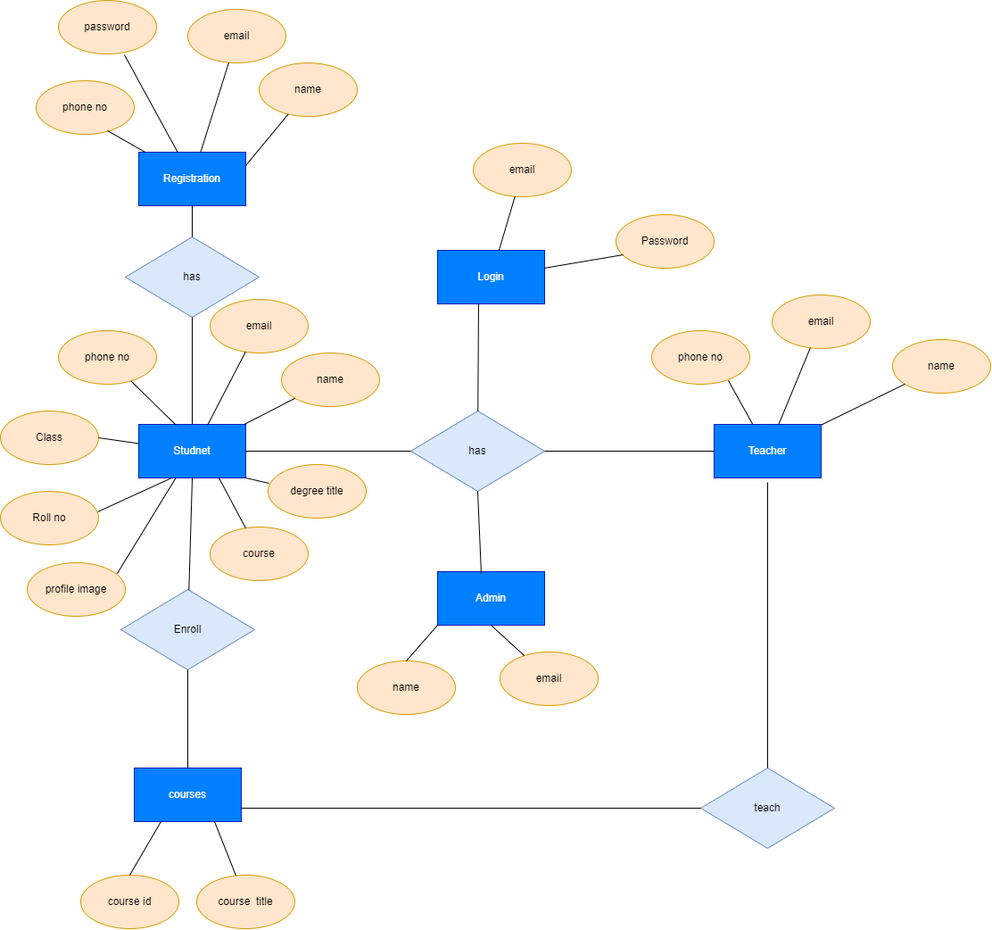

Figure 1.1: Entity Relationship for Web-based Assignment Evaluator project.

# 3. Class Diagram

Class diagrams are the blueprints of our system or subsystem. we can use class diagrams to model the objects that make up the system, to display the relationships between the objects, and to describe what those objects do and the services that they provide. Class diagrams are useful in many stages of system design. Class model is considered important as it represents the graphical representation of the entire system and helps in analysis while communicating with the users. Figure 1.2 shows Class diagram for Web-based Assignment Evaluator.

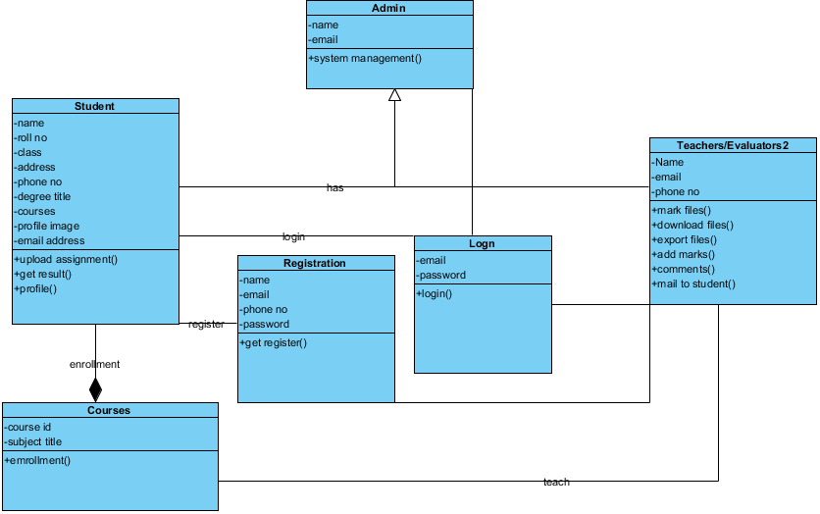

Figure 1.2: Class diagram for Web-based Assignment Evaluator

# 4. Architecture Design Diagram

Architectural design diagram is a visual representation that maps out the physical implementation for components of a software system. It shows the general structure of the software system and the associations, limitations, and boundaries between each element. Software environments are complex, and they aren't static. Architectural design diagram aim is to combine the technological and the aesthetic, despite the general belief that architecture is only a technological task. Figure 1.3 shows architecture design diagram for Web-based Assignment Evaluator.

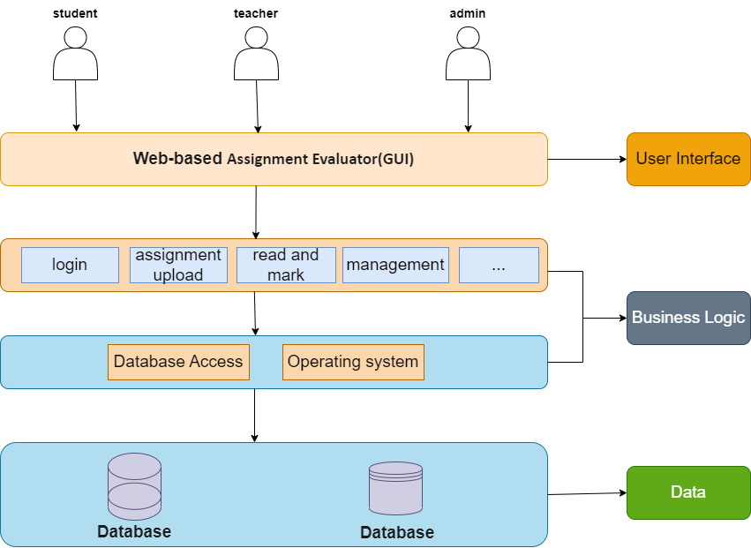

Figure 1.3: Architecture design diagram for Web-based Assignment Evaluator

# 5. Sequence Diagrams

A sequence diagram consists of a group of objects that are represented by lifelines, and the messages that they exchange over time during the interaction. A sequence diagram shows the sequence of messages passed between objects. Sequence diagrams can also show the control structures between objects. Sequence diagrams, commonly used by developers, model the interactions between objects in a single use case A project has multiple sequence diagrams. Sequence diagram is flow of specific activities. Figure 1.4 show about sequence diagram of login process for Web-based Assignment Evaluator project.

## 5.1 Sequence Diagram for Login

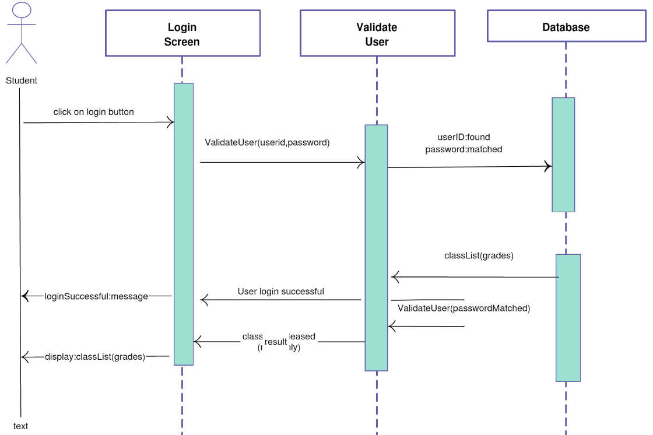

Figure 1.4: Sequence Diagram of Login for Web-based Assignment Evaluator

## 5.1 Sequence Diagram for Registration

Figure 1.5 show about Sequence Diagram of Registration process for Web-based Assignment Evaluator project.

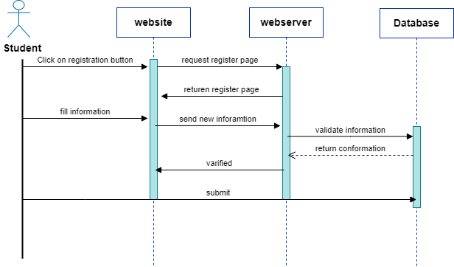

Figure 1.5: Sequence Diagram of Registration for Web-based Assignment Evaluator

## 5.3 Sequence Diagram for Assignment Upload

Figure 1.6 show about Sequence Diagram of Assignment Upload process for Web-based Assignment Evaluator project.

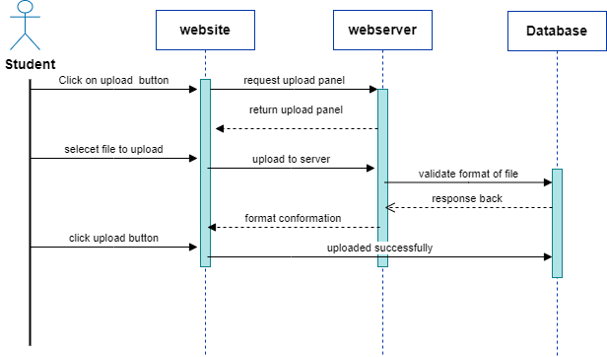

Figure 1.6: Sequence Diagram of Assignment Upload for Web-based Assignment Evaluator

# 6. Database Design

Database diagrams graphically show the structure of the database and relations between database objects. Database design is designing, creating a database or data model, and analyzing requirements and their intents as raw data or pictorial. Database design aims to create a structure that will allow for the efficient storage and retrieval of data. Being a blueprint for the database, it should meet the needs of business. Figure 1.7 Database design for Web-based Assignment Evaluator.

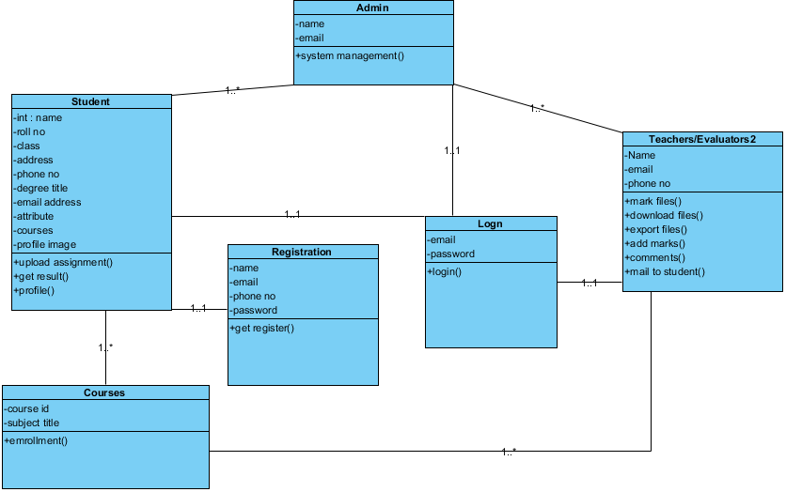

Figure 1.7: Database design for Web-based Assignment Evaluator

# 7. Interface Design

# 8. Test Cases

Test Cases are test scenario measuring functionality across a set of actions or conditions to verify the expected result. The purpose of a test case is to determine if different features within a system are performing as expected and to confirm that the system satisfies all related standards, guidelines and customer requirements. The process of writing a test case can also help reveal errors or defects within the system. A project has many functionalities and each functionality have test cases. Login, registration and file upload are the specific one.

Test Cases for a Registration and Login Page

following fields are common in the registration and login page:

* Username.
* Password.
* First Name.
* Last Name.
* Email Address.
* Phone Number.

## 8.1 Test Cases for Login Page:

|  |  |
| --- | --- |
| **Features to be Tested** | **Test Cases** |
| **Email field** | 1. Test that the email is present. 2. The email field should accept valid email addresses. 3. The email field should not accept invalid email addresses. 4. The email field should display an error message when an invalid email address is entered. 5. The email field should be case-insensitive. |
| **Password** | 1. Test that the password field  is present. 2. Test that the password field is masked. 3. Test that a username field may allow for alphanumeric characters. 4. Test that the password field may require only numbers or letters. 5. Make sure that the password field is present and that it is labeled correctly. 6. Test that the password field accepts input. 7. Ensure that the password field masks input so that it is not visible as plain text. 8. Confirm that the password field has the correct level of security by testing for minimum length and character type requirements. 9. Verify that the password field does not auto-fill when using a password manager. 10. Test that the password field correctly validates input when submitting the form. |
| **Login Form** | 1. Test that the user is able to login with the correct credentials. 2. Test that the email and password fields are mandatory. 3. Test that the user is redirected to the correct page after login. 4. Enter all invalid details in the login form and check if the user is able to log in successfully. 5. Test that the user can see a forgot password link on the login page. 6. Try to log in with an already existing username and check if the user is able to log in successfully. |
| **Error message** | Test that the user receives an error message if the login details are incorrect. |

## 8.2 Test Cases for Registration Page:

|  |  |
| --- | --- |
| **Features to be Tested** | **Test Cases** |
| **Email field** | 1. Test that the email field is in the correct format 2. Test that the email address is in the correct format 3. Enter an invalid email address in the email field. 4. Enter an email address with special characters in the email field. 5. Enter an email address with spaces in the email field. 6. Leave the email field blank. |
| **Terms and conditions** | 1. Test that the terms and conditions are accepted 2. The user should be able to read the terms and conditions before ticking the checkbox. 3. The user should be able to tick the checkbox only if they have read and agreed to the terms and conditions. 4. The user should be able to see a confirmation message after ticking the checkbox and submitting the form. 5. Verify that the terms and conditions are visible on the registration page. 6. Verify that the terms and conditions can be scrolled through. 7. Verify that the terms and conditions can be printed. 8. Verify that the terms and conditions can be downloaded as a PDF. 9. Verify that the terms and conditions can be emailed to a user. |
| **Password** | 1. Password should be a minimum of 8 characters long. 2. Password should have at least 1 uppercase letter. 3. Password should have at least 1 lowercase letter. 4. Password should have at least 1 number. 5. Password should have at least 1 special character. 6. Password should not be same as username. 7. Test the password and confirm password fields match. |
| **Confirmation message** | Test that the user can see a confirmation message after a successful registration |
| **Registration form** | 1. Enter all valid details in the registration form and check if the user is able to register successfully 2. Enter all invalid details in the registration form and check if the user is able to register successfully 3. Try to register with an already existing username and check if the user is able to register successfully |
| **Login page** | Test that the user is redirected to the login page after a successful registration |

## 8.3 Test Cases for file upload

|  |  |
| --- | --- |
| **Features to be Tested** | **Test Cases** |
| **File upload** | 1. Verify that the "choose file " Option with the Upload Button Are Showing or not. 2. Verify whether the cancel button is available or not. 3. Verify that the cancel button has working or not when the upload process is going on. 4. Check whether the selected file Name Showing or not. 5. Verify that when the user uploads a file size more than the defined size MB. 6. Verify the file extension when the user uploads a file DOC, XLXS, PNG JPGE etc. 7. Verify that the user is able to upload multiple files at one time. 8. Verify the upload progress bar. 9. Verify the alert message when the user clicks on the upload button without selecting any file. 10. Verify the alert message when the user uploads a wrong extension file. 11. Verify the alert message when the user uploads a file more than the defined size. 12. verify for session time out. 13. Verify the upload if the selected image has Space, special char in the file name 14. Verify the upload by selecting the Duplicate file. 15. Verify whether the upload button is disabled or not when the upload of a file is already in progress. 16. Verify the progress bar resume or not when there is any network issue. |