**EX-1- JAVA OOPS**

1. **REVERSING THE DIGITS**

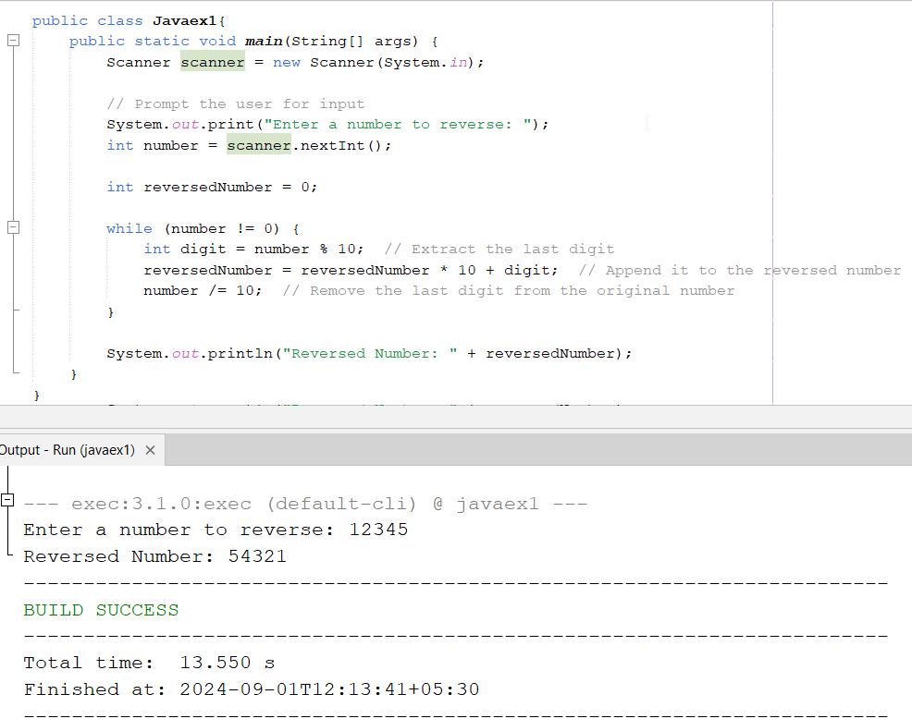

1. **LEAP YEAR OR NOT**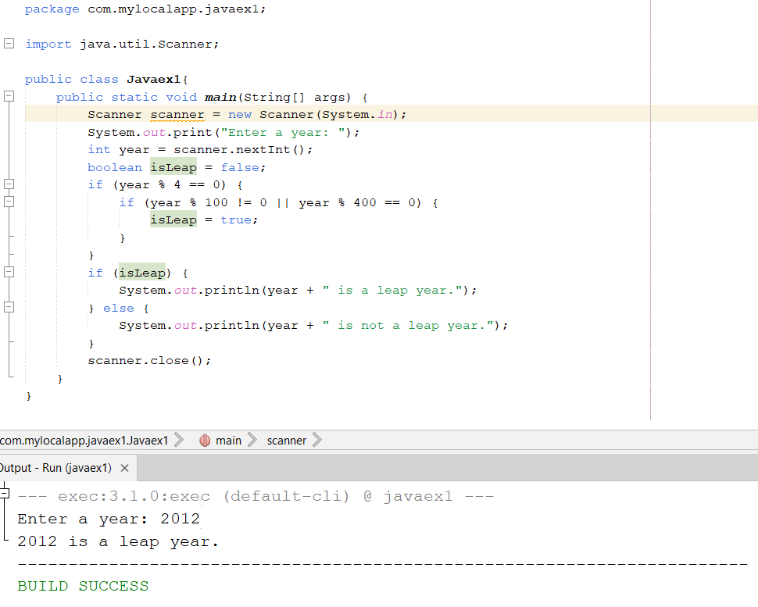
2. **PRINTING UPTO N PRIME NUMBERS**

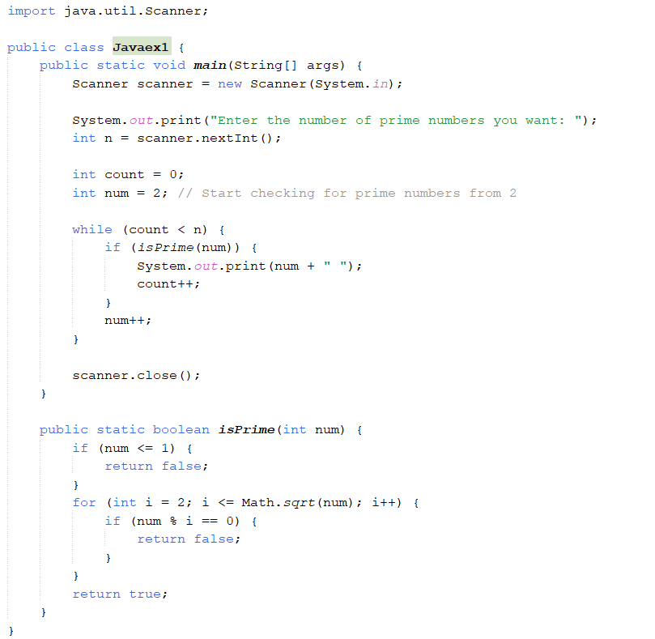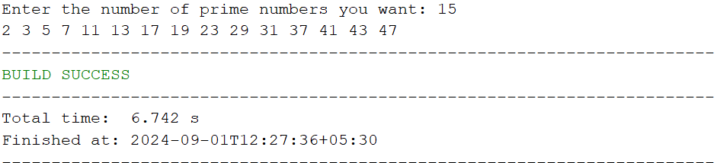

**4. GIVEN NUMBER IS PRIME OR NOT**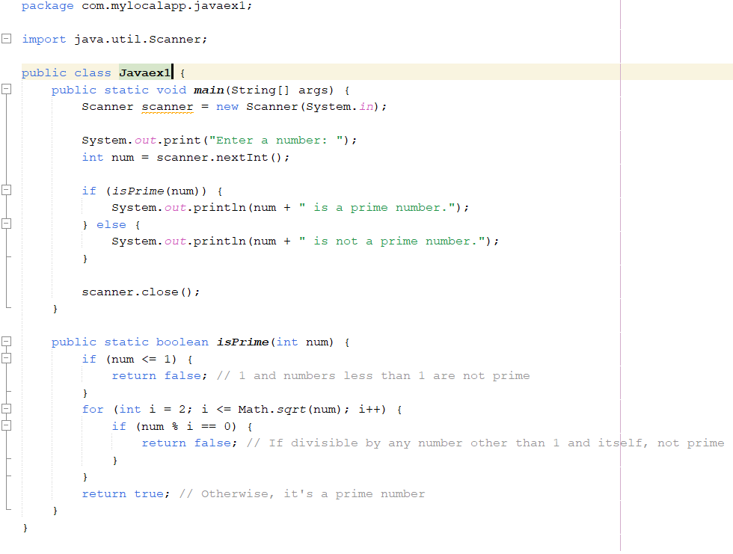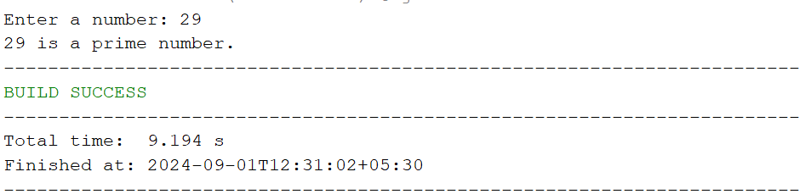

1. **FIBONACCI SERIES DISPLAY UPTO N**

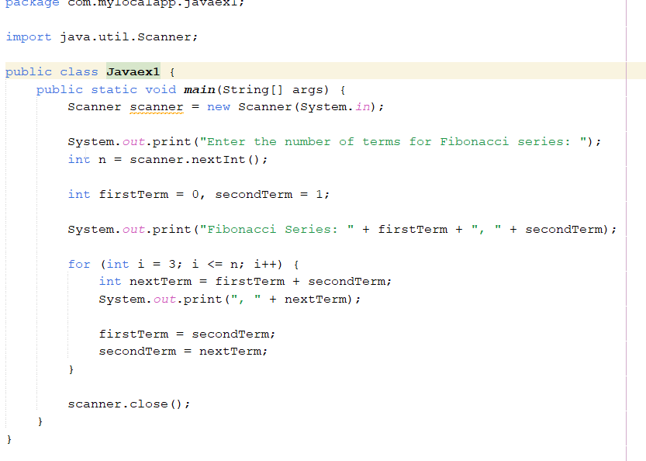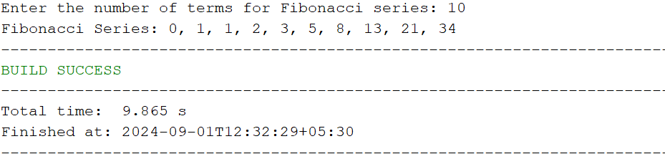

1. **SERIES OF ODD AND EVEN NUMBERS UPTO N SEPARATELY**

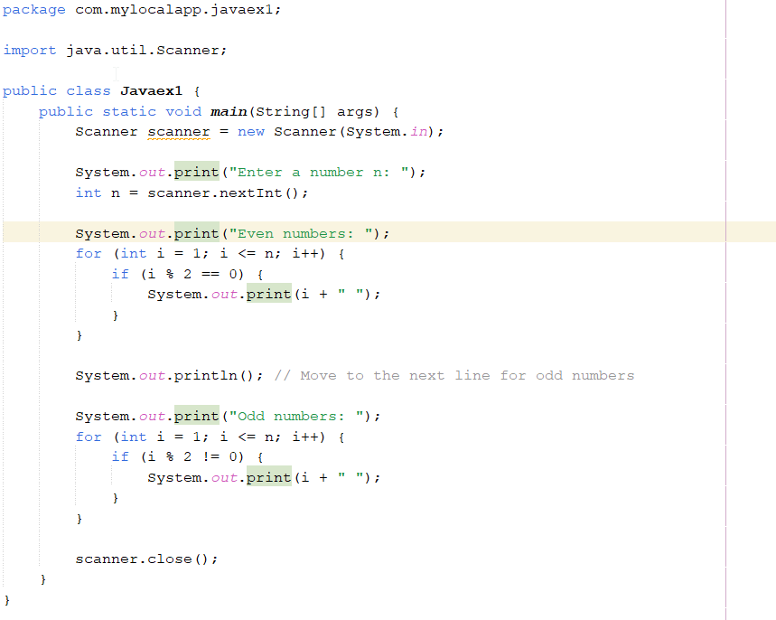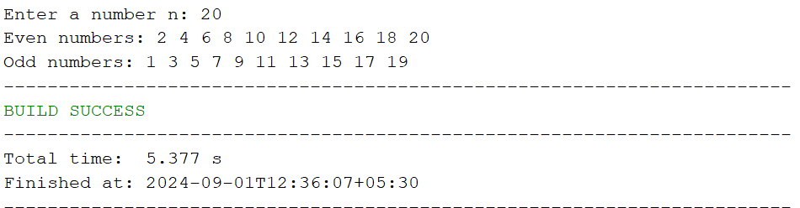

1. **EVEN OR NOT**

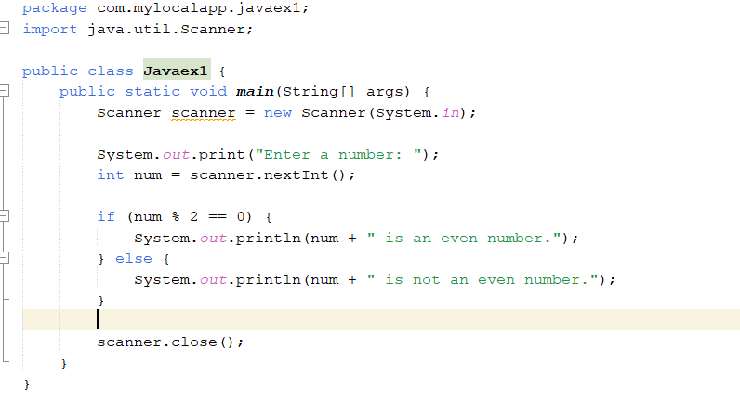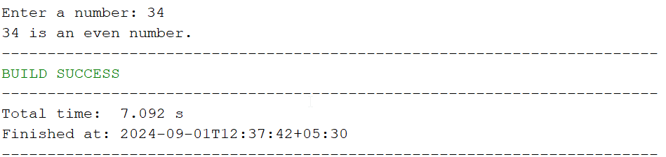

1. **FACTORIAL**

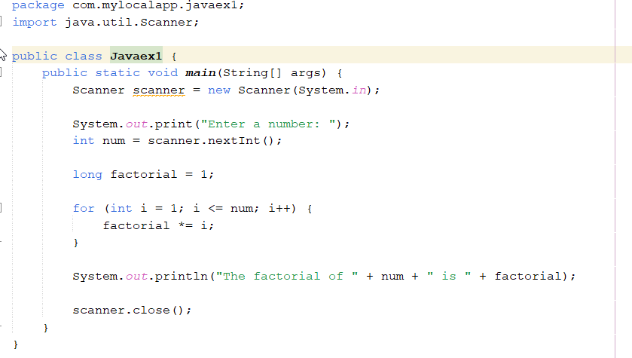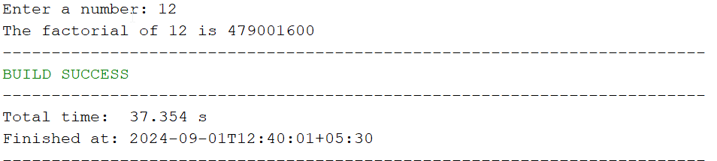

1. **AREA OF CIRCLE AND PARALLELOGRAM**



1. **CALCULATOR FUNCTION WITH CLASS**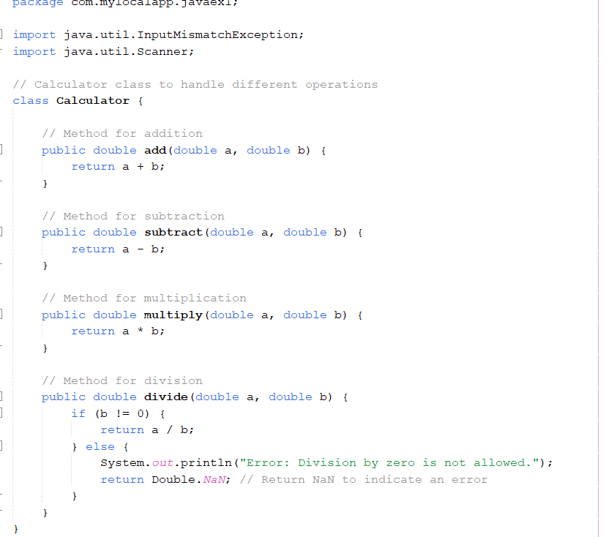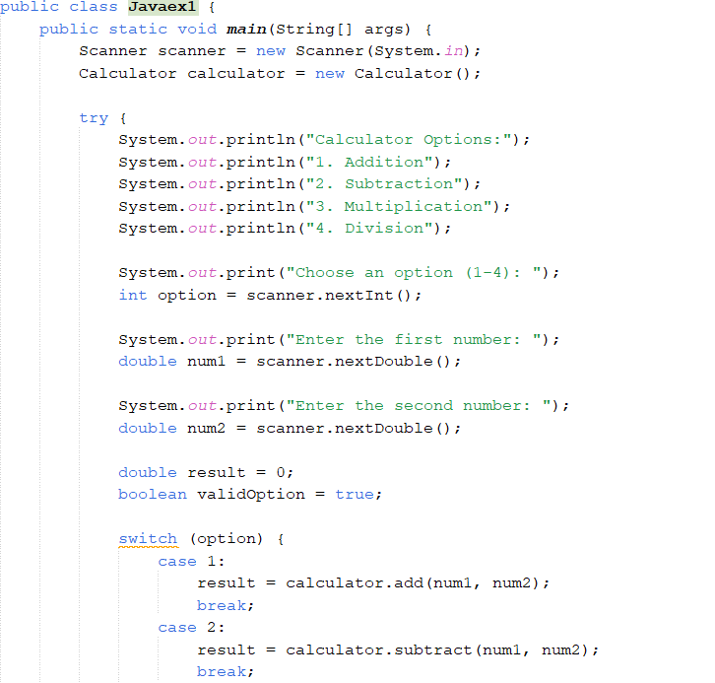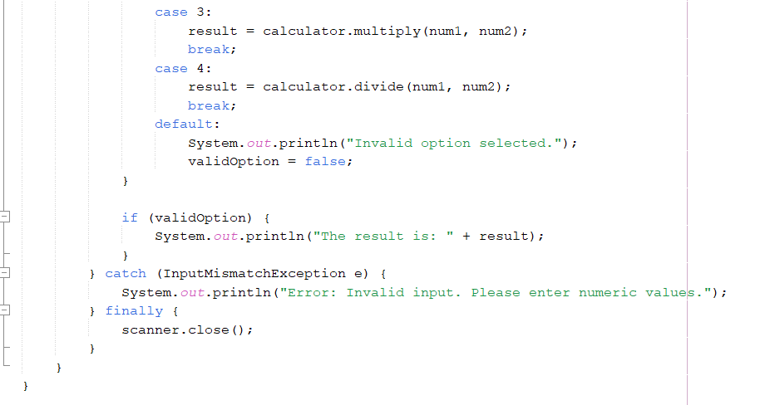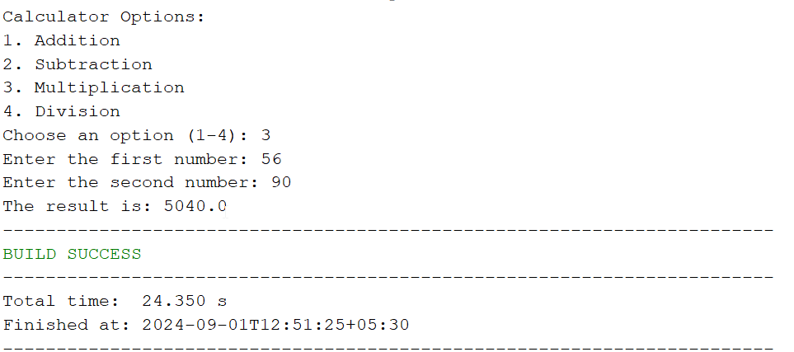
2. **STUDENT GRADE MANAGER**

